Business Intelligence Lab
Unit 1 | Session 1
Experiment 1
Data Acquisition and Data Profiling using BI Tools

Aim
To acquire data from multiple sources and perform data profiling using Microsoft Power BI in order to assess data quality, understand data structure, identify anomalies, and prepare data for further analytical processing.

Tools / Software Used
- Microsoft Power BI Desktop
- Datasets used: Sales_Data.csv (flat file) and Employee_DB.xlsx (workbook, “Employees” sheet)

Theory

Business Intelligence (BI)
Business Intelligence refers to a set of technologies, processes, and practices that enable organizations to collect, integrate, analyse, and present business information. BI helps transform raw data into meaningful, actionable insights that support better decision-making across an organization.
Key components of a BI system include:
- Data Sources: Databases (SQL/NoSQL), flat files, cloud stores, and APIs
- ETL Pipeline: Extract, Transform, Load processes that move data from source to destination
- Data Warehouse / Data Lake: Centralized repositories for structured or unstructured data
- BI & Reporting Tool: Microsoft Power BI for data connection, transformation, and visualization
- Analytics Layer: Descriptive, diagnostic, predictive, and prescriptive analytics

Data Acquisition
Data Acquisition is the process of collecting and importing data from various heterogeneous sources into a unified environment for processing. It is the first and foundational step in any BI pipeline. In Power BI, data is acquired through the Get Data option, which supports a wide range of connectors including flat files (CSV, XLSX), relational databases (SQL Server, MySQL), cloud sources (SharePoint, Azure), and web-based sources.

Data Profiling
Data Profiling is the process of examining data from an existing source and collecting statistics, summaries, and metadata about that data. It is a critical quality assurance step that reveals the structure, content, and quality of a dataset before further processing. Data profiling covers the following key dimensions:
- Completeness: Percentage of non-null values in each column.
- Uniqueness: Ratio of distinct to total values — detects duplicate records.
- Validity: Whether values conform to defined rules or expected formats.
- Consistency: Uniformity of values across related datasets.
- Accuracy: Correctness of values relative to real-world facts.
- Timeliness: Currency of data relative to the reporting period.

Data Profiling in Power BI — Power Query Editor
Microsoft Power BI provides built-in data profiling capabilities through the Power Query Editor. Under the View tab, three profiling features can be enabled:
- Column Quality: Displays the percentage of valid, error, and empty values per column.
- Column Distribution: Shows a histogram of value frequency along with the distinct and unique count for each column.
- Column Profile: Provides detailed statistics for a selected column including minimum, maximum, mean, median, standard deviation, and a full value distribution chart.

Conduct

Part A: Data Acquisition
Step 1: Launch Power BI Desktop and import the CSV file.
Home > Get Data > Text/CSV → Browse to Sales_Data.csv → Load / Transform Data
The Get Data dialog previews Sales_Data.csv before loading. The file contains 8 columns — SaleID, Date, CustomerID, Product, Quantity, UnitPrice, SalesAmount, and Region — with the delimiter correctly auto-detected as Comma and data types inferred per column.
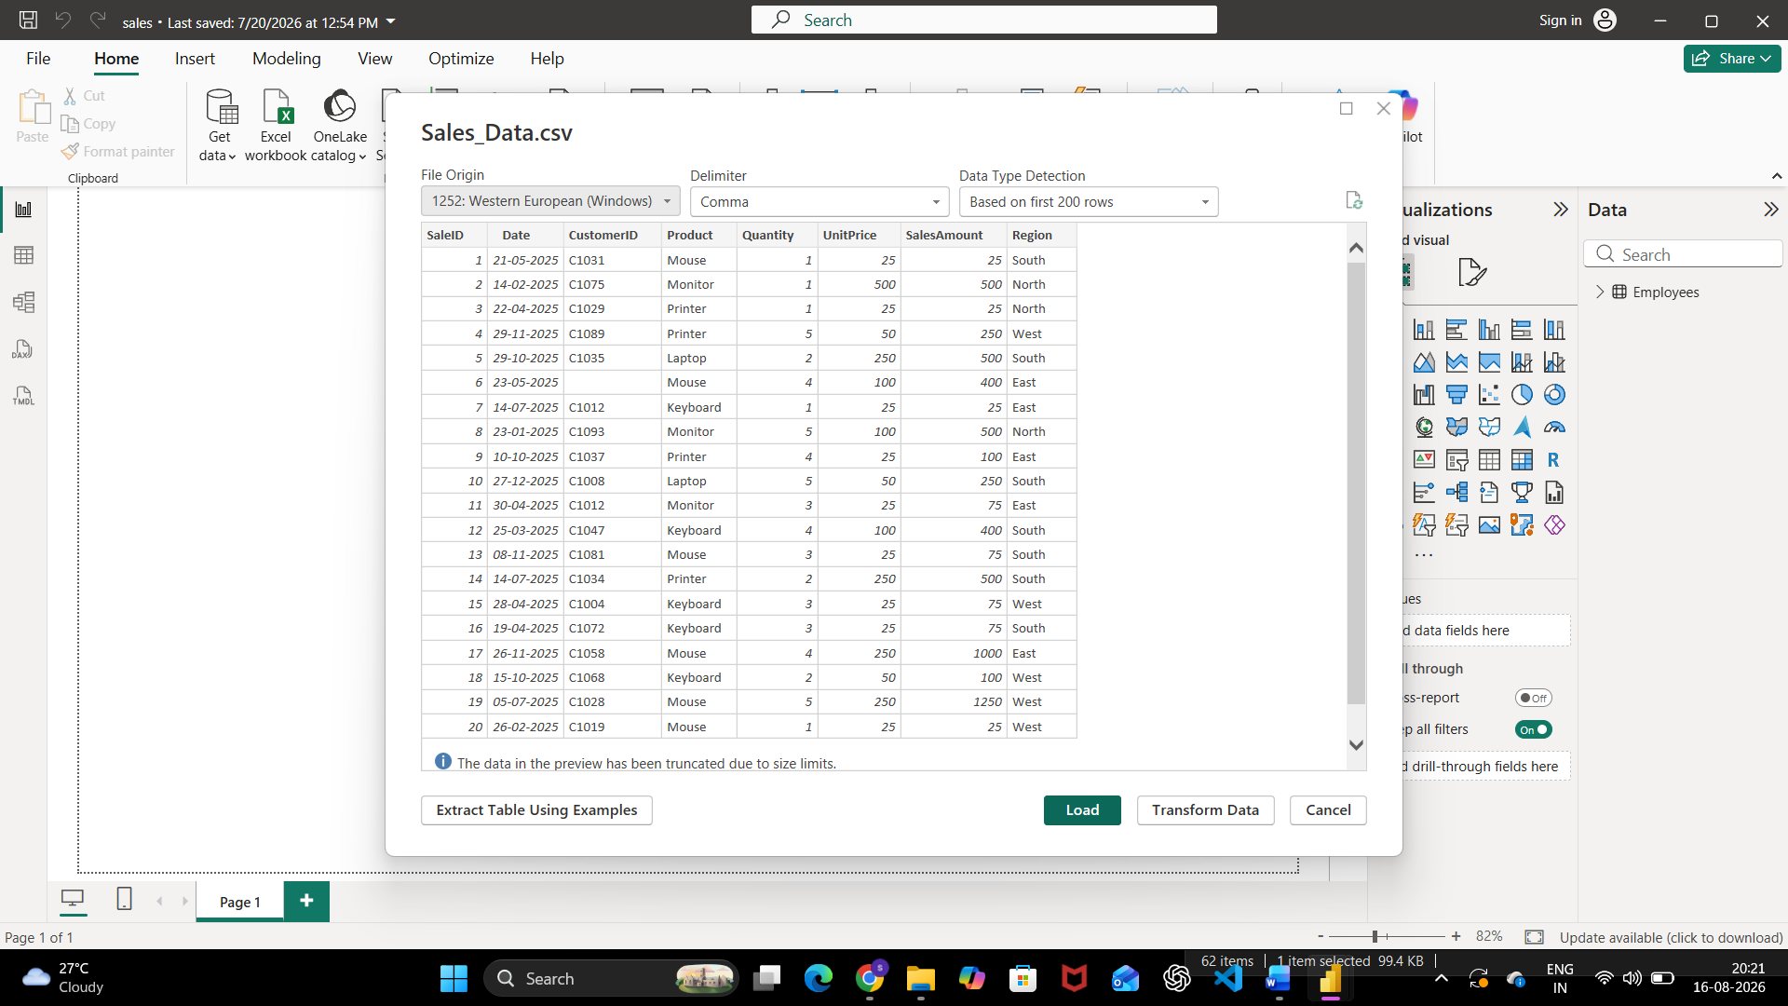
Fig. 1 — Get Data preview of Sales_Data.csv (Text/CSV connector)
Step 2: Import the Excel file.
Home > Get Data > Excel Workbook → Browse to Employee_DB.xlsx → Select the “Employees” sheet → Load
The Navigator window lists the sheets available inside Employee_DB.xlsx. The “Employees” sheet is selected, showing a preview with 6 columns — EmployeeID, Name, Department, Region, Salary, and JoiningDate.
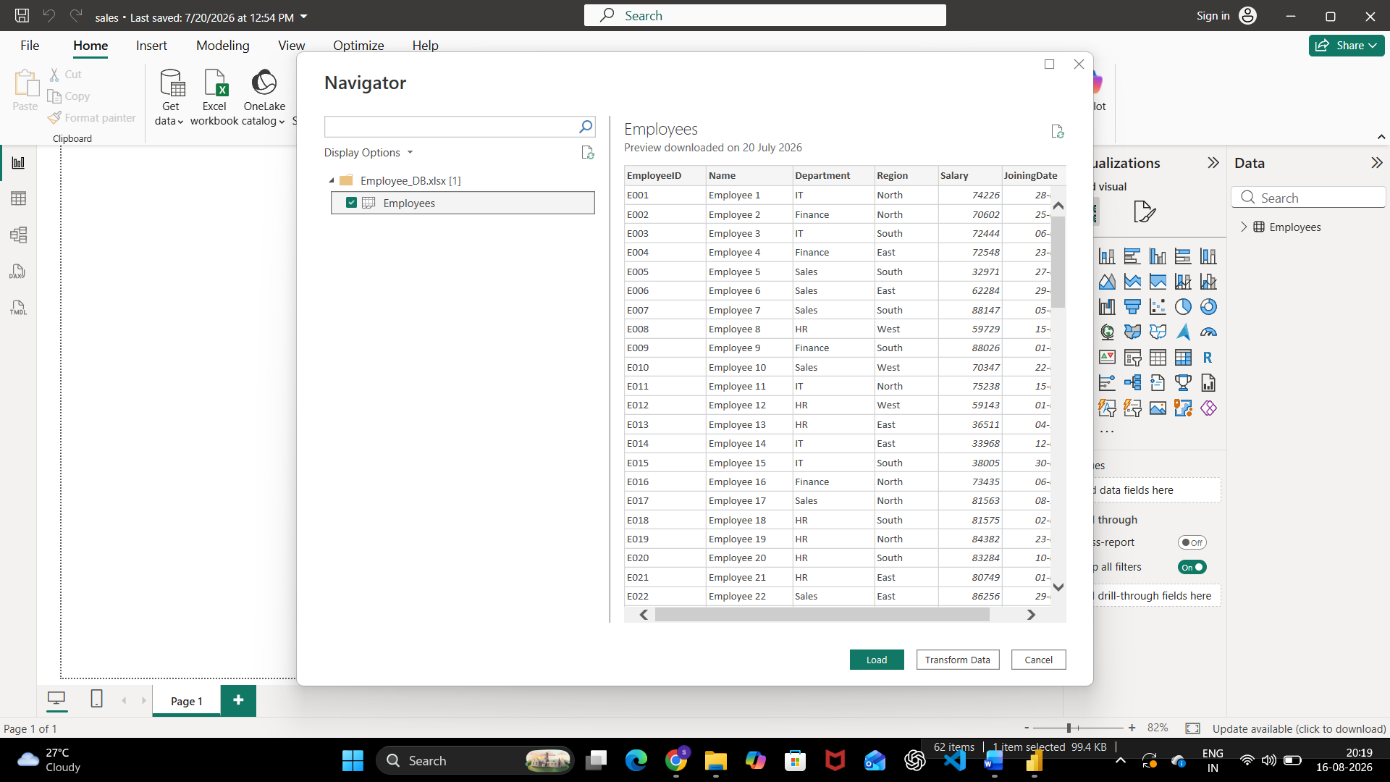
Fig. 2 — Navigator preview of Employee_DB.xlsx → Employees sheet
After loading, both Sales_Data and Employees appear as queries in the Data pane, confirming both heterogeneous sources were acquired successfully.

Part B: Data Profiling in Power Query Editor
Step 4: Open Power Query Editor.
Home > Transform Data
Power Query Editor opens with both queries — Employees and Sales_Data — listed in the Queries pane on the left. The Home ribbon exposes the transform, combine, and data-source management commands used to shape the data before loading it into the model.
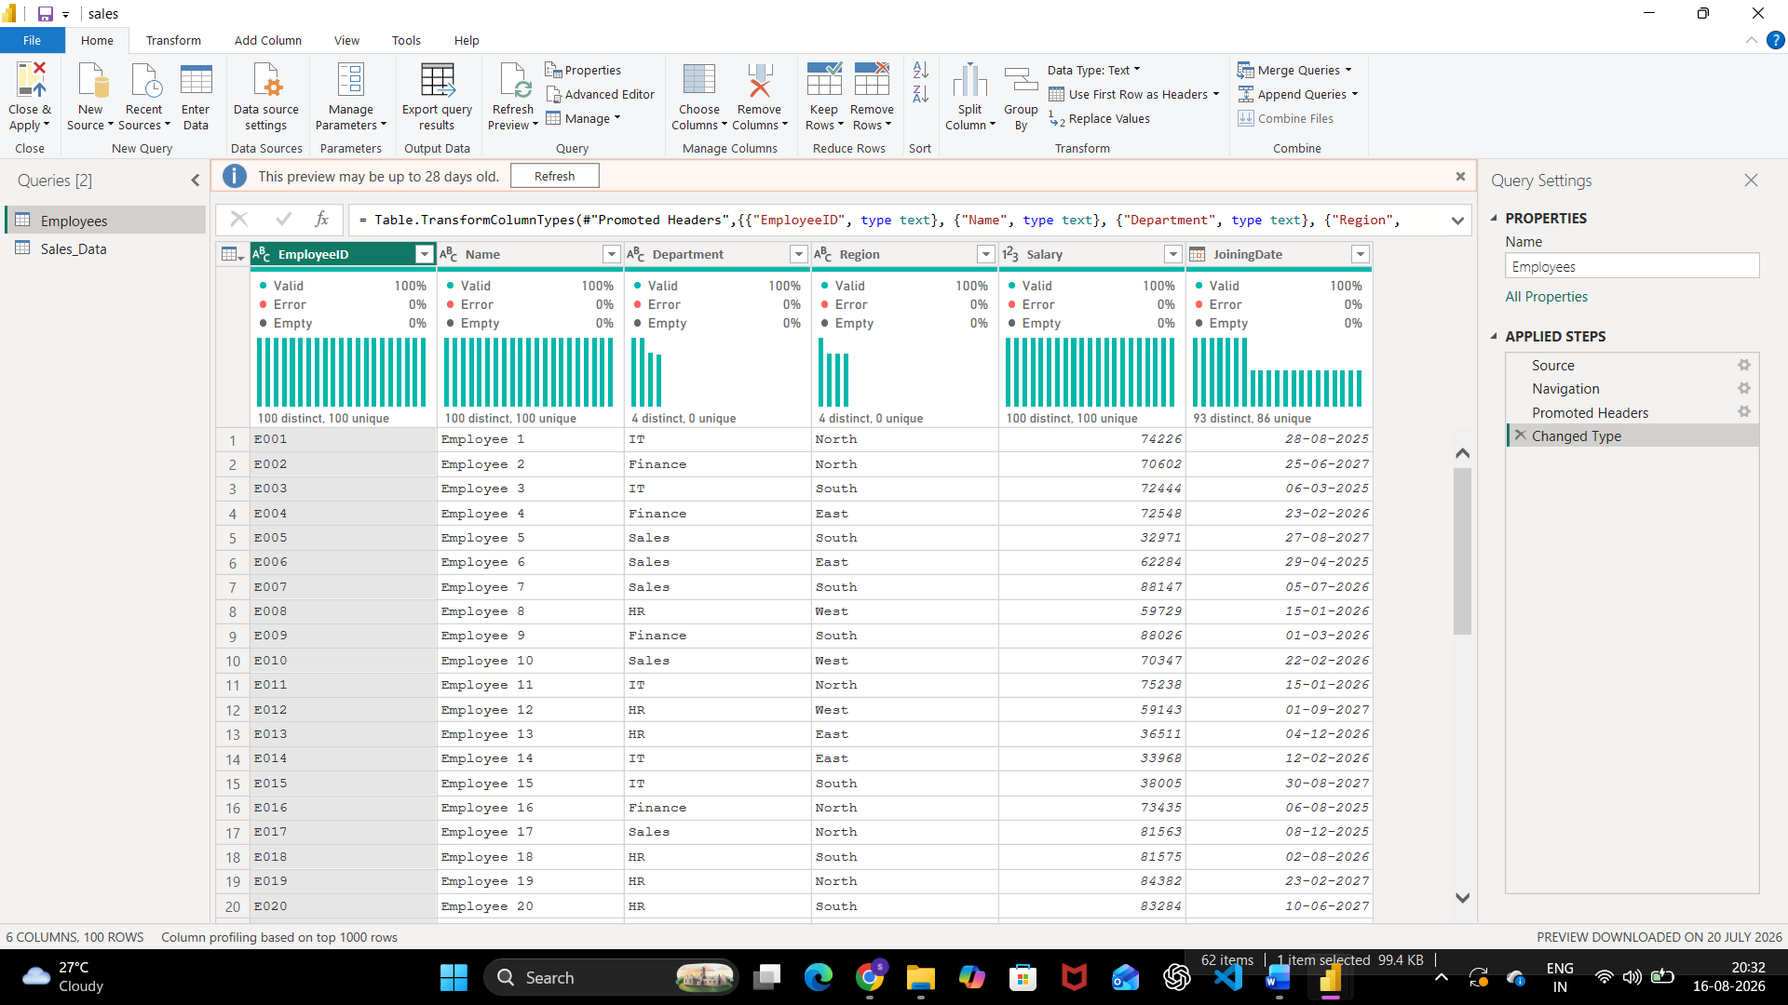
Fig. 3 — Power Query Editor, Home tab, with the Employees query open
Step 5: Enable data profiling features.
View tab > tick: Column Quality
View tab > tick: Column Distribution
View tab > tick: Column Profile
With all three options ticked on the View tab, the data preview grid displays a Column Quality bar (Valid / Error / Empty %) and a Column Distribution histogram above every column. Selecting the EmployeeID column additionally populates the Column Statistics and Value Distribution panes at the bottom of the window.
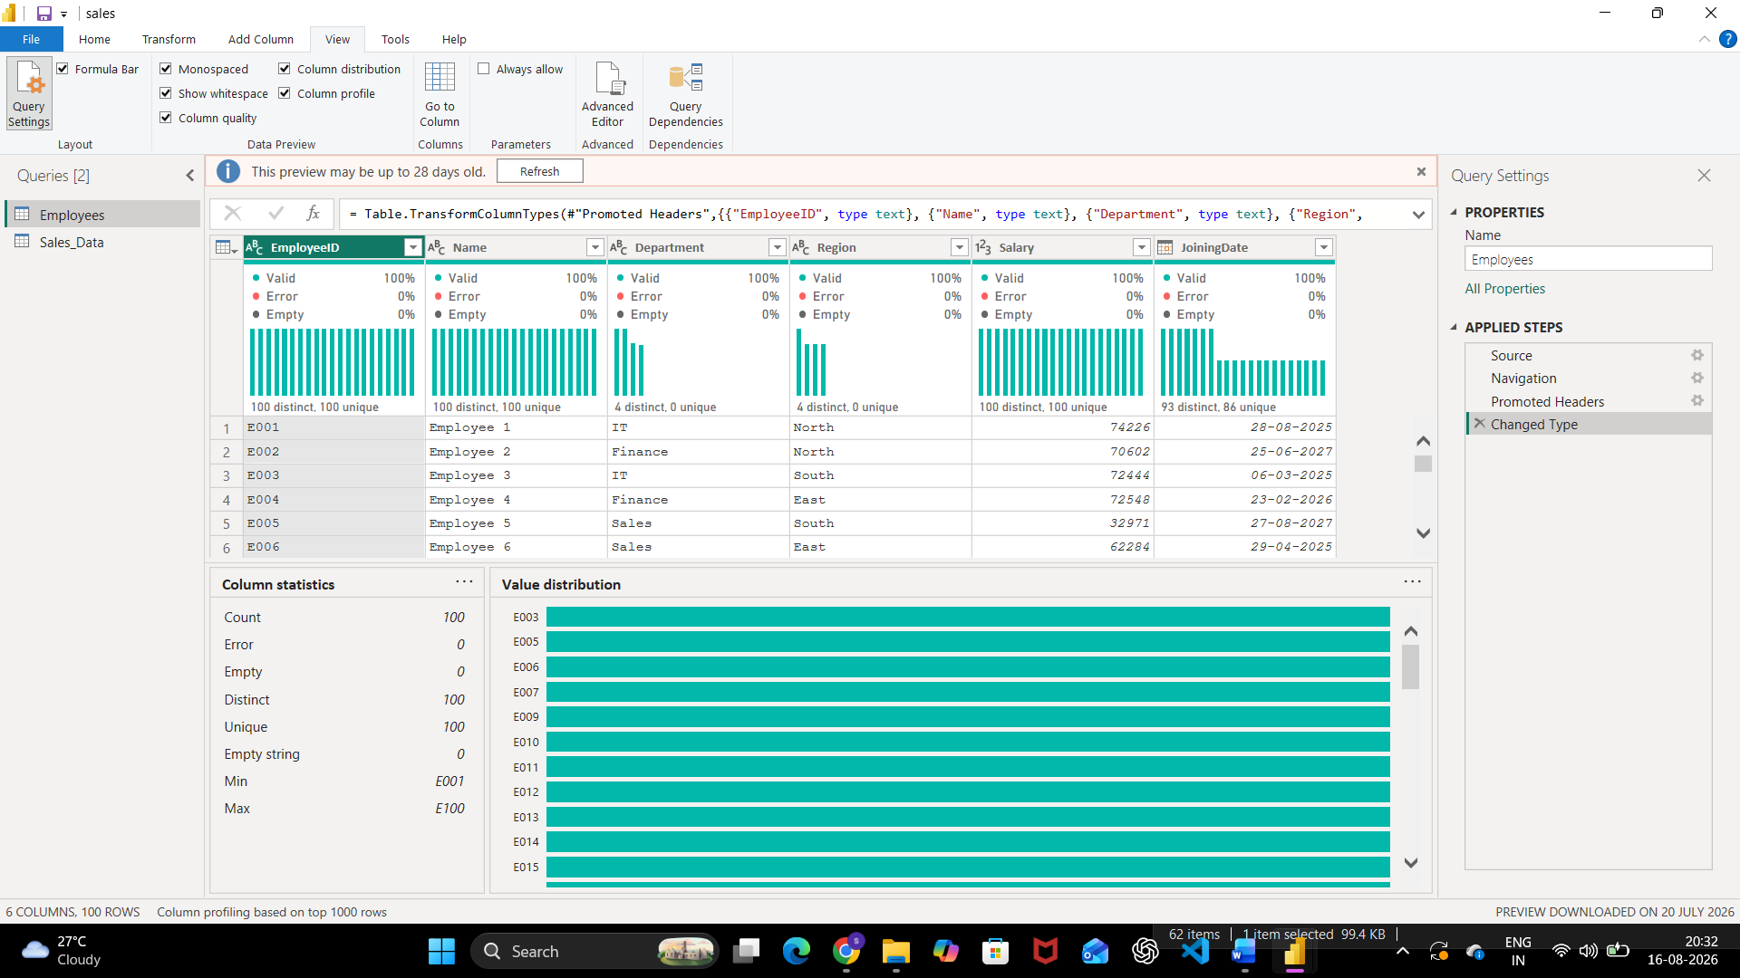
Fig. 4 — Column Quality, Column Distribution and Column Profile enabled for the Employees table
Step 6: Record profiling observations.
Observations recorded for the Employees table (100 rows, 6 columns) using Column Quality, Column Distribution, and Column Profile:
- EmployeeID (Text): 100% valid, 0% empty, 100 distinct / 100 unique — Min E001, Max E100 — fully unique key
- Name (Text): 100% valid, 0% empty, 100 distinct / 100 unique — one name per employee, no blanks
- Department (Text): 100% valid, 0% empty, 4 distinct / 0 unique — only 4 categories (IT, Finance, Sales, HR), low cardinality as expected
- Region (Text): 100% valid, 0% empty, 4 distinct / 0 unique — only 4 categories (North, South, East, West), low cardinality as expected
- Salary (Whole number): 100% valid, 0% empty, 100 distinct / 100 unique — no nulls or errors detected in preview
- JoiningDate (Date): 100% valid, 0% empty, 93 distinct / 86 unique — only 93 of 100 dates are distinct, so 7 duplicate joining dates are present
For the Sales_Data table, the CSV preview (Fig. 1) shows a blank CustomerID value in row 6 — flagged and carried forward into the data-quality findings below.

Part C: Identify and Document Data Quality Issues
Step 7: Data quality issues identified from the profiling results.
- Missing value — CustomerID is blank for SaleID 6 (Sales_Data → CustomerID). Dimension affected: Completeness. Remediation: trace the transaction back to the source system; impute or flag the record for exclusion until the customer ID is confirmed.
- Future-dated records — JoiningDate values such as 25-06-2027 and 27-08-2027 lie beyond the current reporting period (Employees → JoiningDate). Dimension affected: Timeliness / Validity. Remediation: apply a date-range validation rule in Power Query (JoiningDate ≤ today) and re-verify the source-system export.
- Duplicate joining dates — only 93 distinct values across 100 rows, 86 unique (Employees → JoiningDate). Dimension affected: Uniqueness. Remediation: cross-check the duplicate dates against HR records to confirm they are coincidental and not a data-entry or load error.

Result
Data from two heterogeneous sources — a CSV file (Sales_Data.csv) and an Excel workbook (Employee_DB.xlsx) — was successfully acquired and imported into Microsoft Power BI Desktop. Data profiling was performed using the Power Query Editor's built-in tools — Column Quality, Column Distribution, and Column Profile. Key data quality dimensions including completeness, uniqueness, and timeliness were assessed, and three data quality issues (a missing CustomerID, future-dated JoiningDate values, and duplicate JoiningDate entries) were identified and documented for remediation prior to analysis.

Learning Outcomes
After completing this experiment, students will be able to:
- Explain the concept of Business Intelligence, its key components, and the role of data acquisition in a BI pipeline.
- Describe different data source types and the methods used to connect and import them into Power BI.
- Connect to multiple heterogeneous data sources and successfully import datasets using Power BI's Get Data feature.
- Apply data profiling techniques in Power Query Editor to assess data quality dimensions across real-world datasets.
- Interpret profiling statistics to identify data quality issues and propose suitable remediation strategies.

