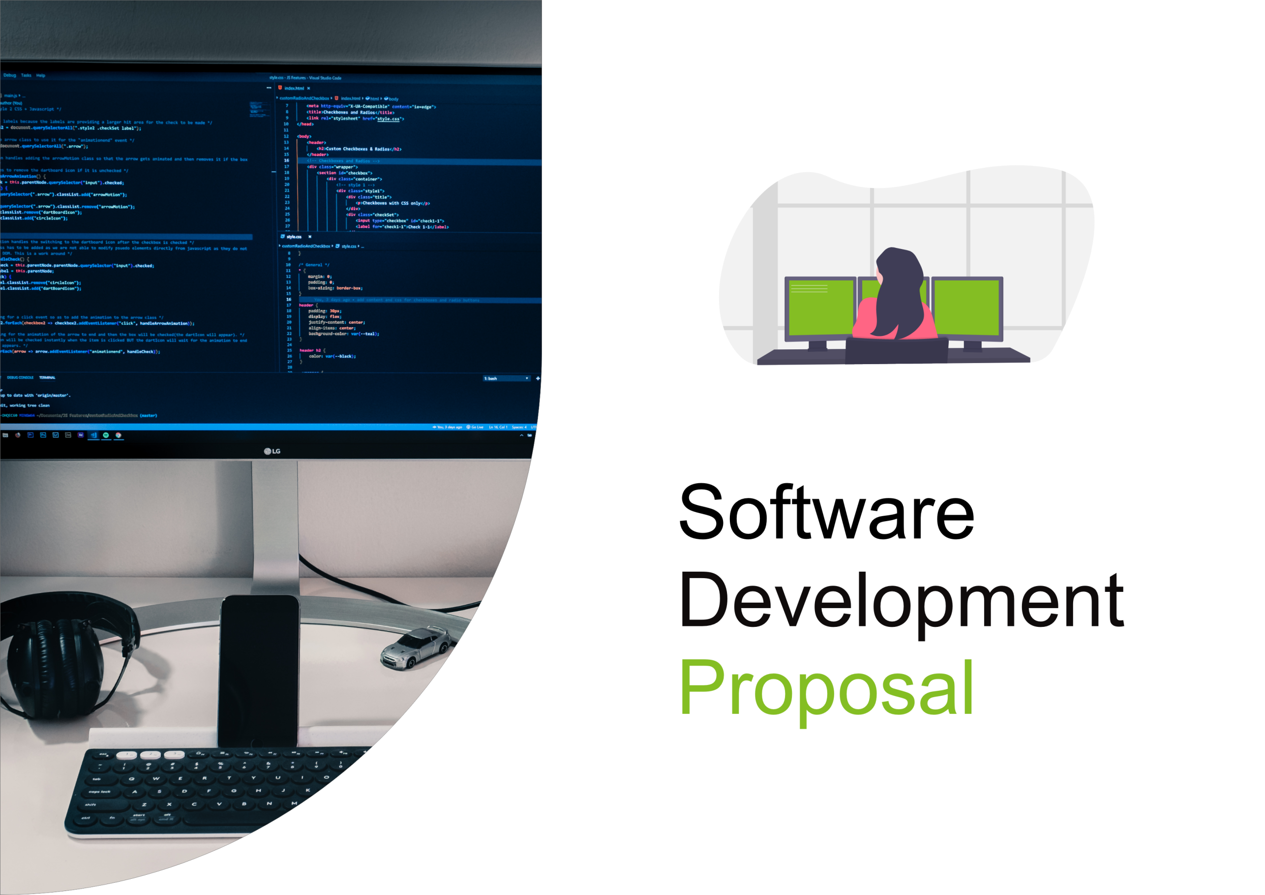

1. Overview

*Deloitte is most famous for being one of the “big four” accounting companies, we provide audit & assurance,*

*consulting, risk and financial advisory, risk management, tax, and related services to our clients. Building robust*

*software solutions is one of the services that we offer. Our team of experts in the software development field has*

*helped hundreds of Deloitte’s clients on thousands of projects.*

*Please, find enclosed in this document our Software Development Proposal for Daikibo’s Real-time Telemetry*

*Dashboard.*

2. Scope

*Here are the main functionalities of the project:*

*● A private dashboard with health status of the 9 telemtry-enabled machines in each of Daikibo's 4 factories.*

*● Access to the page happens only within client's Intranet.*

*● Authentication is synced to internal authentication server (i.e users don't need to create an account).*

*● The dashboard consists of a single page, listing the current statuses of all monitored devices.*

*● The view is collapsible/expandable at a factory level, as well as device level (showing history of statuses)*

*You can refer to the wireframe image located on the next page for a visual reference. Please note this is not the final*

*design, and it’s just a mock-up visual representation of the functionality.*

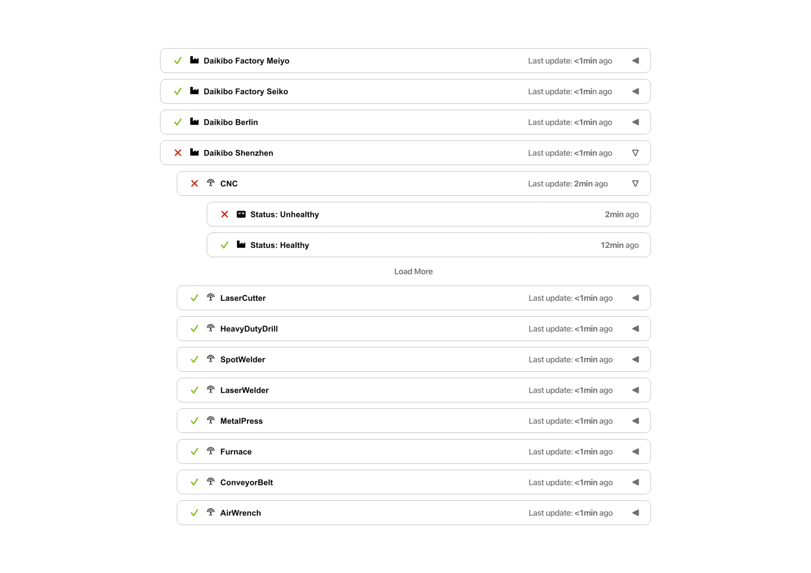

3. Estimate

*The total number of man-hours needed for this project is 150 hours.*

|  |  |  |  |  |
| --- | --- | --- | --- | --- |
| *Design* | *Development* | *Testing* | *Integration* | *Total* |
| *20* | *70* | *20* | *40* | *120* |

*We are going to form an internal team of 3 software engineers and 1 graphic designer.*

*NB: We will require the help of at least 1 IT engineer from Daikibo to hand off the finished product and help us with*

*access to authentication and telemetry databases/servers.*

4. Timeline

1. [1st of June 2023] Design starts

2. [4th of June 2023] Design is circulated to Daikibo for feedback

3. [6th of June 2023] Design is finalized and Development starts

4. [19th of June 2023] Development is done and v1 of the product is demonstrated to Daikibo

5. [21th of June 2023] Development is finalized and Testing starts

6. [25th of June 2023] Testing is done and Integration starts

7. [2nd of July 2023] Testing is done and Integration is completed

5. Support

*This proposal’s main focus is the development of the project, but when we are done and the product is successfully*

*deployed within Daikibo’s infrastructure – we are going to remain available for continuous support.*

*You can submit support tickets through our internal support system. The estimate of work described earlier doesn’t*

*cover the continuous support we provide and any future bug fixes, updates and improvements will be invoiced*

*separately.*