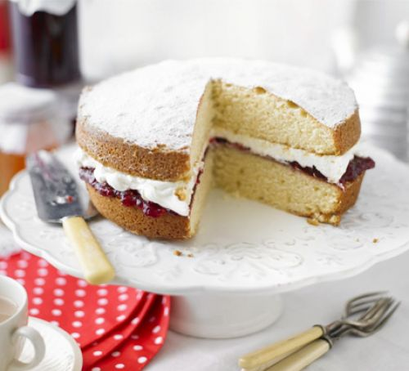Victoria sponge

PREP: 20 MINS COOK: 20 MINS

CUTS INTO 8-10 SLICES

The classic Victoria sandwich is always a teatime winner, every bite brings a taste of nostalgia

## Nutrition: per serving

* kcal 599
* fat 40g
* saturates 23g
* carbs 56g
* sugars 38g
* fibre 1g
* protein 6g
* salt 0.35g

## Ingredients

* 200g unsalted butter, softened, plus extra for greasing
* 200g caster sugar
* 1 tsp vanilla extract
* 4 medium eggs
* 200g self-raising flour, plus extra for dusting
* about 6 tbsp raspberry
* jam
* 250ml double cream, whipped
* icing sugar, for dusting

## Method

1. Heat oven to 190C/170C fan/gas 5. Grease and flour 2 x 20cm sandwich tins. Place the butter, sugar and vanilla extract into a bowl and beat well to a creamy consistency. Slowly beat in the eggs, one by one, then fold in the flour and mix well.
2. Divide the mix between the cake tins, place into the oven and bake for about 20 mins until risen and golden brown. The cakes should spring back when gently pushed in the middle. When ready, remove from the oven and allow to cool for 5 mins in the tin, before turning out onto a wire rack and cooling completely.
3. Spread the jam onto one cake and top with the cream. Sandwich the cakes together and dust with icing sugar.