Echocardiography Optical Flow
Benchmark Report — v5
5 Optical Flow Methods · 76 frames · 576×1024
Python 3.11 · OpenCV 4.13 · scikit-image · Marching Cubes iso=127
23 May 2026

Table of Contents

1. Introduction to Optical Flow — A Beginner's Guide
This chapter explains, from first principles, what optical flow is, why it matters in medical imaging, and how each of the five methods in this benchmark works. No prior knowledge of computer vision is assumed.

1.1 What Is Optical Flow?
Imagine watching a video of a beating heart. Between any two consecutive frames, the heart wall moves — it contracts, expands, twists. If you could draw an arrow on every pixel showing where it moved from one frame to the next, that map of arrows is called the optical flow field.

More formally: given two consecutive image frames I(x, y, t) and I(x, y, t+1), optical flow estimates the displacement vector (u, v) at each pixel (x, y) such that the pixel at (x, y) in frame t corresponds to (x+u, y+v) in frame t+1.

ANALOGY | Think of optical flow like tracking raindrops on a window. Each drop moves from one position to another between two photographs. The set of all movement arrows is the optical flow field.

In echocardiography, optical flow reveals:
- How fast and in which direction the myocardial wall is moving
- Where deformation (strain) is largest — clinically important for detecting ischaemia
- Whether the heart is contracting symmetrically or showing regional abnormalities

1.2 The Core Assumption: Brightness Constancy
All classical optical flow methods share one fundamental assumption:

ASSUMPTION | A pixel that moves from point A to point B keeps the same brightness. I(x, y, t) = I(x+u, y+v, t+1)

This is called the brightness constancy constraint. Expanding with a Taylor series gives the fundamental optical flow equation:

F_X · u + F_Y · v + F_T = 0

Where:
- F_X = spatial gradient in X (brightness changes left-right)
- F_Y = spatial gradient in Y (brightness changes up-down)
- F_T = temporal gradient (brightness changes over time)
- u, v = the horizontal and vertical flow we want to find

The problem: one equation, two unknowns. This is called the aperture problem — if you look through a small window at a moving edge, you can only detect motion perpendicular to the edge. Every optical flow method solves this underdetermined system differently.

APERTURE PROBLEM | Looking at a diagonal edge through a small hole, you cannot tell if it is moving horizontally, vertically, or diagonally. Different methods use different constraints to resolve this ambiguity.

1.3 Sparse vs Dense Optical Flow

Approach | What it tracks | Output | Speed | Coverage
Dense | Every pixel in the image | Full displacement map (u,v) per pixel | Slower | Complete
Sparse | Selected feature points only | Displacement vectors at chosen locations | Faster | Partial

Table I-1. Dense vs sparse optical flow comparison.

Neither approach is universally better. Dense flow is more complete but expensive. Sparse flow is faster and robust at tracked points, but gives no information between them.

1.4 Method A — 3D Spatio-Temporal Gradients from Marching Cubes

1.4.1 The Big Idea
Instead of treating the video as a sequence of 2D images, treat it as a single 3D volume where time is the third dimension. A stack of 76 frames (576×1024 px each) becomes a 3D block of shape (76, 576, 1024). Bright regions form 3D structures in this block — like a worm moving through space.

ANALOGY | Imagine slicing a loaf of bread. Each slice is a video frame. The whole loaf is the 3D volume. A piece of bread crust running diagonally through multiple slices represents a moving bright region over time.

1.4.2 What Is Marching Cubes?
Marching Cubes (Lorensen & Cline, 1987) finds the surface separating bright from dark regions in a 3D volume:
- Divides the volume into small cubes (8 voxels each)
- Checks which corners are above or below the brightness threshold (127 here)
- Draws triangles to approximate the surface at the boundary
- Returns the mesh of triangles plus a normal direction at each vertex

The normal vector at each vertex is perpendicular to the surface. Because our surface lives in (T, Y, X) space, this normal has three components: how much it tilts in the time direction (dT), and how much spatially (dY, dX).

1.4.3 From Normals to Flow
The normal vector is exactly the 3D gradient of the brightness function at the surface:

normal = (dT, dY, dX) = ∇F

Substituting into the brightness constancy equation:

flow magnitude ≈ |dT| / √(dX² + dY²)

A large dT relative to the spatial gradient means the surface changes rapidly over time — the image region is moving fast. A small dT means the structure is mostly static.

KEY POINT | Method A gets the optical flow "for free" from the Marching Cubes normals — no separate frame-by-frame computation needed. This is why it is 220× faster than Farneback in total wall-clock time, even though Marching Cubes itself takes 1.3 s.

1.4.4 The Dual Motion Filter
Two filters remove low-signal vertices: |dT| > 0.4 (discards normals nearly perpendicular to the time axis — static spatial edges) and mag > 0.4 (discards vertices with negligible flow magnitude). In our video, 79.3% of vertices pass both filters (1,104,346 / 1,392,014), confirming genuine temporal motion across most of the iso-surface.

1.5 Method B — Farneback Dense Optical Flow

1.5.1 The Big Idea
Farneback's method (2003) solves the aperture problem by assuming that the brightness in every small neighbourhood can be approximated by a smooth polynomial, allowing the full (u, v) displacement to be estimated at every single pixel.

ANALOGY | Instead of matching individual pixels, Farneback fits a smooth curved surface to the brightness in each neighbourhood — like fitting a hill shape to terrain data — then matches the shapes between frames.

1.5.2 Polynomial Expansion
For each pixel, the algorithm fits a quadratic polynomial to the surrounding values:

I(x) ≈ xᵀ A x + bᵀ x + c

The key insight: when the same region appears in the next frame after displacement (u, v), the polynomial coefficients change in a predictable way — allowing the displacement to be computed algebraically.

1.5.3 Image Pyramid
Large displacements cannot be detected with a small polynomial window. Farneback uses a multi-resolution pyramid:
- Downsample the image (scale 0.5 in our config)
- Compute flow at the coarse level (large structures, large displacements)
- Upsample the estimate as a starting point for the finer level
- Refine iteratively at each level (3 iterations in our config)

This is why Farneback handles both slow-moving walls and fast valve motion robustly — but also why it is the slowest method at 8,703 ms: it must process the full image at every pyramid level.

1.5.4 Why It Gives the Smoothest Signal
By averaging over all pixels including static background, Farneback reports the lowest mean flow (0.84 px/frame) and tightest std (0.25). It is the most stable reference for detecting subtle changes, at the cost of speed.

1.6 Method C — Sparse Lucas-Kanade (Pyramidal)

1.6.1 The Big Idea
Lucas and Kanade (1981) solved the aperture problem by assuming that all pixels in a small window around a feature point move together. This gives multiple equations (one per pixel) for the same two unknowns — an overdetermined system solved by least squares.

ANALOGY | If you watch a polka-dot pattern move, you can determine motion much better than watching a plain wall — the dots give many different gradient directions to constrain the motion. LK finds these informative points first, then tracks them.

1.6.2 The Lucas-Kanade Equation
For a window of N pixels around a point, we write N equations:

[F_X F_Y]ᵀ [F_X F_Y] [u v]ᵀ = -[F_X F_Y]ᵀ F_T

This 2×2 system is only solvable when the matrix has two large eigenvalues — at corners and edges, not flat regions. This is exactly what the Shi-Tomasi corner detector finds.

1.6.3 Shi-Tomasi Corner Detection
Before tracking, up to 500 good feature points are detected per frame using the Shi-Tomasi criterion. In our video, the detector finds 325–469 corners per frame (mean 413) — predominantly on cardiac walls and valve leaflets, which are exactly the regions of clinical interest.

1.6.4 Pyramidal Extension
Standard LK only handles small displacements. The pyramidal version (Bouguet, 2001) applies the same coarse-to-fine strategy as Farneback, allowing tracking across frame-to-frame displacements of tens of pixels.

KEY POINT | Method C is the classical speckle-tracking method used in commercial echocardiography systems for strain analysis. The ~413 tracked points per frame concentrate naturally on cardiac walls and valves, making it robust to background clutter.

1.7 Method D — DIS (Dense Inverse Search)

1.7.1 The Big Idea
DIS (Kroeger et al., 2016) delivers dense flow at a speed closer to sparse methods. The key innovation is the inverse search strategy: instead of searching for where each patch in frame 1 went in frame 2, DIS searches a pre-computed structure that minimises expensive texture comparisons.

ANALOGY | Finding your friend in a crowd: forward search means you walk around looking. Inverse search means your friend wears a distinctive hat and you scan for hats — much faster because hats are easier to spot than faces.

1.7.2 Patch-Based Matching on a Pyramid
At each pyramid level, DIS:
- Divides the image into a grid of small patches
- Finds the best matching patch in the next frame using inverse search
- Propagates the flow estimate from coarser to finer levels
- Applies a variational refinement step to smooth and improve accuracy

Result: 15.64 ns/point — 12.6× faster per pixel than Farneback — with a consistent mean flow (1.28 px/frame) and stable std (0.58).

1.7.3 PRESET_FAST Configuration
OpenCV's DIS offers three presets: ULTRAFAST, FAST (used here), and MEDIUM. FAST uses 8×8 patch size with 3 gradient descent iterations. For echocardiography at standard frame rates, FAST provides an excellent accuracy-speed trade-off.

KEY POINT | DIS is the recommended choice for real-time dense flow. At 692 ms for 75 frame pairs (~9 ms/pair), it runs at approximately 110 Hz on this hardware — well within real-time echo display requirements.

1.8 Method E — RLOF (Robust Local Optical Flow)

1.8.1 The Big Idea
All methods above assume brightness constancy. In echocardiography this is routinely violated: gain artefacts, depth-dependent attenuation, shadowing, and probe angle changes alter pixel brightness independently of motion. RLOF (Senst et al., 2012–2016) explicitly handles these violations.

ANALOGY | Tracking a car in a tunnel where the lighting changes: standard LK loses the car as it enters dark sections. RLOF uses a robust estimator that says "even if this region got brighter, the shape is still the same" — it matches structure, not just intensity.

1.8.2 The M-Estimator
RLOF replaces least-squares with an M-estimator that automatically down-weights outlier pixel matches. Where brightness changed due to artefacts, those equations get low weight; where brightness was preserved, high weight. The local model includes an illumination-adaptive term:

I(x+u, y+v, t+1) ≈ α · I(x, y, t) + β

where α and β are per-patch illumination parameters estimated jointly with (u, v). This makes RLOF significantly more robust to echo gain artefacts than any other method here.

1.8.3 SR_CROSS Mode and the Colour Requirement
RLOF's SR_CROSS mode uses a cross-bilateral filter guided by colour to propagate flow estimates. This is why it requires 3-channel input. In this benchmark, echocardiography is greyscale so we convert GRAY→BGR. The bilateral guidance is then identical across all three channels, providing less benefit than on genuine colour Doppler images. For greyscale echo: use SR_FIXED mode.

KEY POINT | RLOF is theoretically the most suitable method for echocardiography due to illumination robustness. Its high ns/point cost (56,465) reflects the M-estimator iterations per tracked point. Full benefit requires genuine colour Doppler input or SR_FIXED mode for greyscale.

1.9 Side-by-Side Comparison at a Glance

Method | Solves aperture via | Data domain | Handles illum. change | Main limitation
A — MC Gradient | 3D volume normal vectors | Iso-surface (3D) | Via threshold | Surface-only; no interior
B — Farneback | Polynomial expansion + window | Dense 2D pixels | Poor | Slow (8.7 s)
C — LK PyrLK | Overdetermined window system | Sparse corners | Poor | Textureless regions fail
D — DIS | Inverse patch search | Dense 2D pixels | Moderate | Less accurate than Farneback
E — RLOF | M-estimator + bilateral | Sparse corners | Excellent | Needs colour; high ns/pt

Table I-2. Conceptual comparison of all five methods.

Method | Best mental model | Clinical echo application
A — MC Gradient | CT/MRI surface extraction extended to video | 3D wall motion, structural shape change
B — Farneback | Smooth polynomial surface matching | Full-field strain, offline analysis
C — LK PyrLK | Speckle dot tracking | Myocardial strain, speckle tracking
D — DIS | Fast patch-library lookup | Real-time display, clinical screening
E — RLOF | Illumination-immune feature matching | Gain artefacts, colour Doppler echo

Table I-3. Intuitive mental models and recommended clinical applications.

1.10 How to Read the Benchmark Results
The following chapters report two performance metrics:

METRIC 1 | Total time (ms): how long the method takes for the entire 75-frame-pair video. Use this to judge whether the method fits your processing pipeline.

METRIC 2 | ns/point: nanoseconds per processed data sample (vertex, pixel, or tracked corner). Use this to compare intrinsic algorithm efficiency independently of how many points each method processes.

Why ns/point matters: Method A processes 1.4M vertices; Method D processes 44.2M pixels. D (15.64 ns/pt) is intrinsically more efficient per sample than B (196.73 ns/pt), even though both cover the same pixel count.

Why sparse methods have high ns/point: Methods C and E (LK, RLOF) show 20,131 and 56,465 ns/point respectively. Corner detection overhead is amortised over only ~400 points per frame. Their total times (623 ms, 1,749 ms) are still far less than Farneback.

2. Executive Summary
Five optical flow methods benchmarked on a 76-frame anonymised echocardiography video (576×1024). All figures reflect the post-fix re-run with MC gradient capped at 50 px and RLOF displacement clipped to ±20 px/frame.

Key findings:
- Method A (MC Gradient): 39.47 ms total, 79.3% vertices pass dual filter (|dT|>0.4 & mag>0.4).
- Method D (DIS): 15.64 ns/point — lowest per-pixel cost, 12.6× faster than Farneback.
- Method B (Farneback): most stable signal (std 0.254) but slowest at 8,703 ms.
- Method C (LK PyrLK): 413 corners/frame mean; ideal speckle tracker at 623 ms.
- Method E (RLOF): mean 22.8 px/frame — SR_CROSS on greyscale; use SR_FIXED for greyscale echo.

3. 3D Visualisations

3.1 Time-to-3D Iso-Surface
Full echocardiography volume as a Marching Cubes iso-surface, coloured by frame number. Only vertices with flow magnitude > 0.4 are shown.

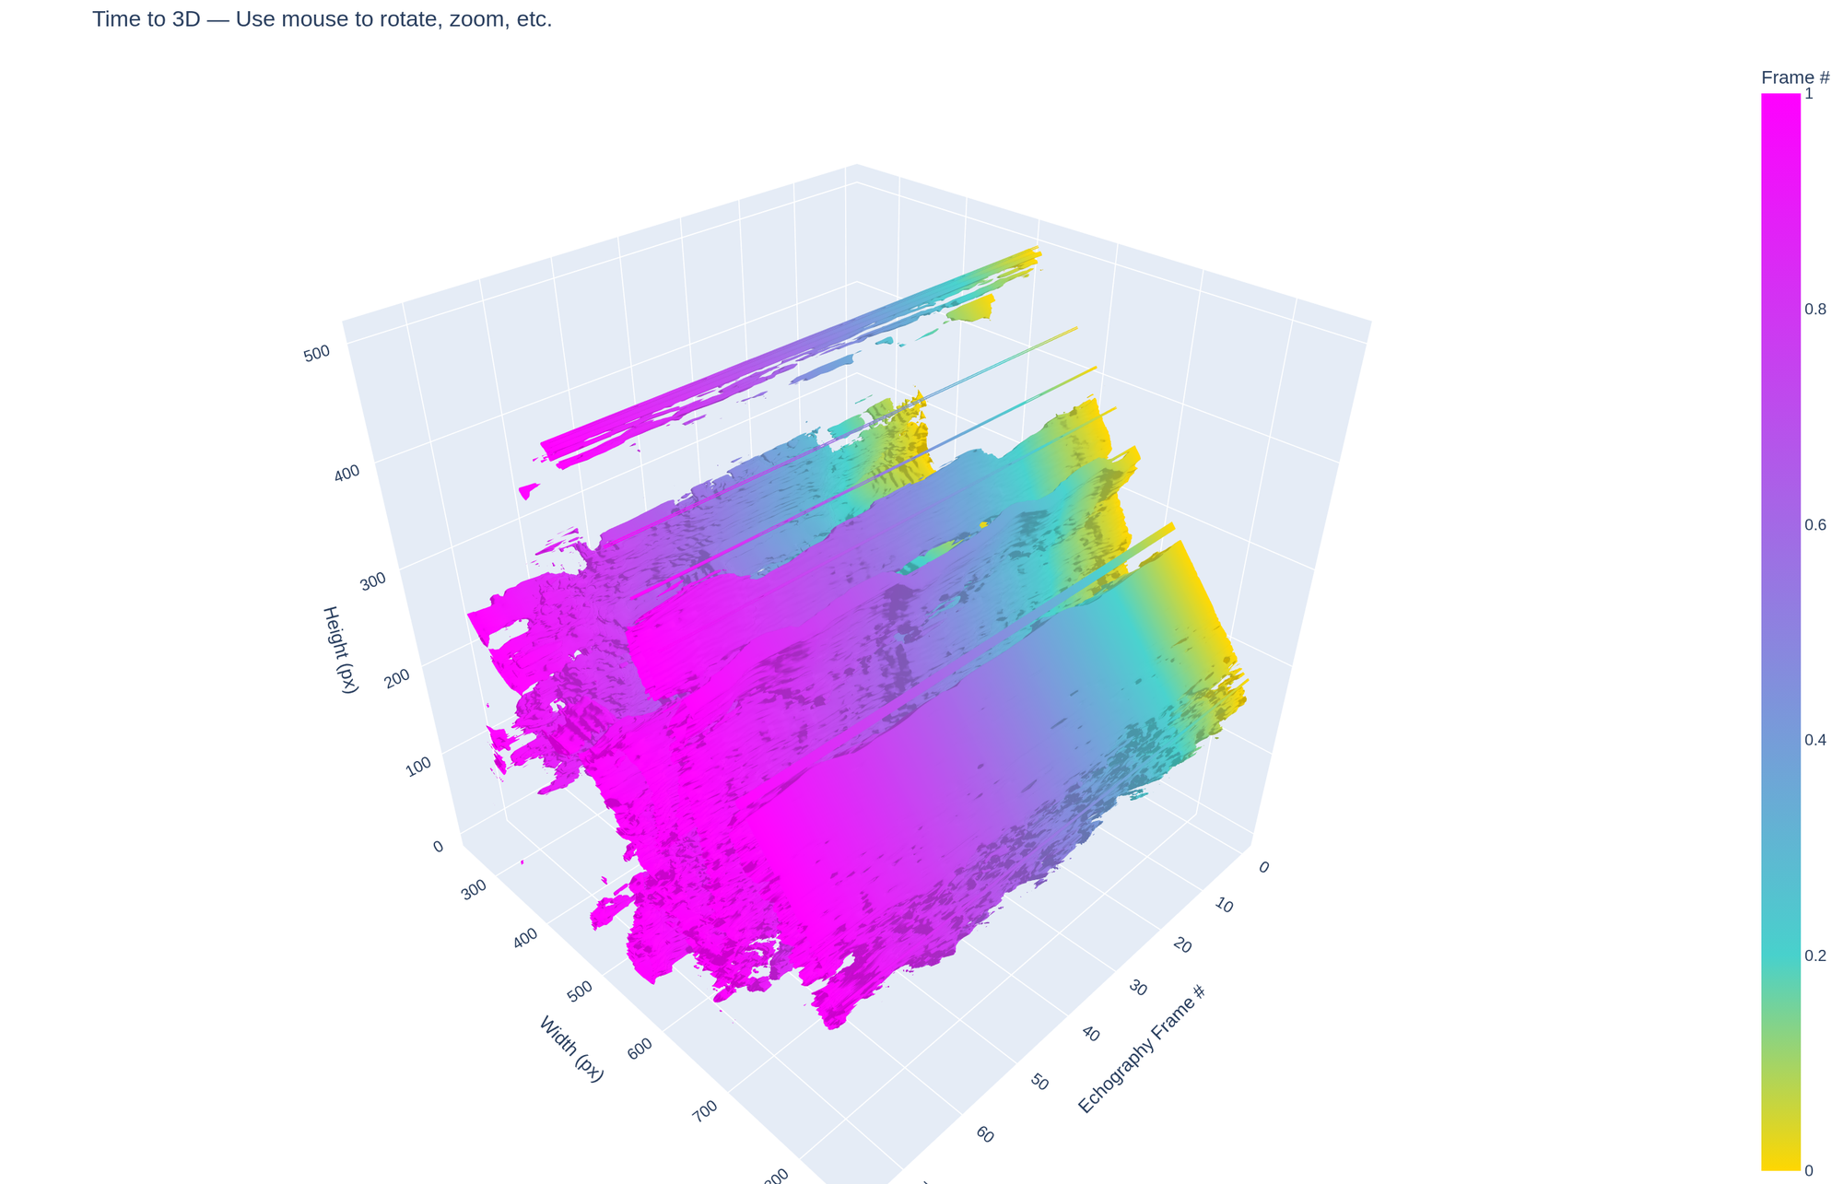
Figure 1. Time-to-3D — gold (early) → magenta (late frames). Mag > 0.4 filter applied.

3.2 Method A — MC Gradient Flow
Same iso-surface coloured by flow magnitude. Dual filter: |dT| > 0.4 and mag > 0.4. Hot colorscale remapped so the threshold = 0, eliminating any low-motion colour artefacts.

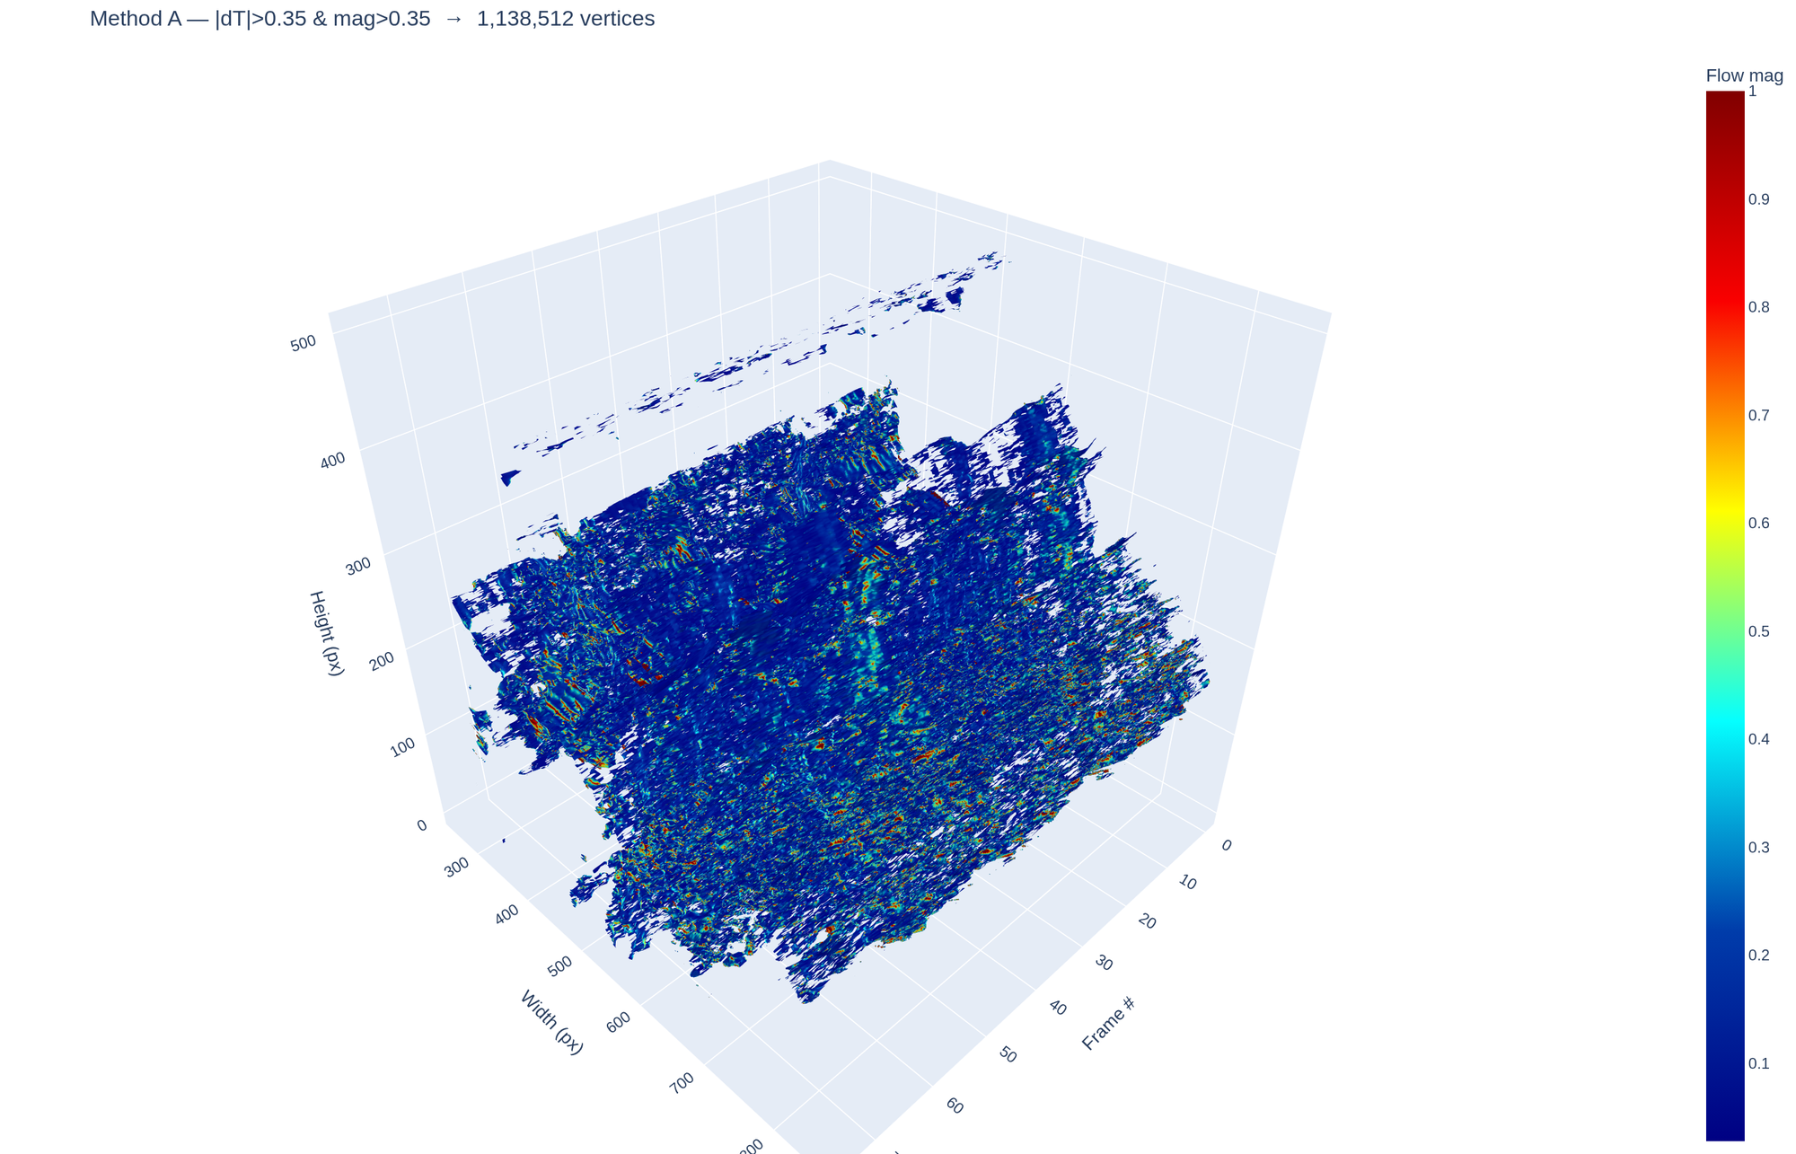
Figure 2. MC gradient flow — black→red→yellow = increasing motion. 1,104,346 vertices after dual filter.

4. Per-Method Flow Snapshots (Frame 2)
All cv2 snapshots use frame pair 1→2. Dense methods (B, D): HSV colour-wheel overlay, hue=direction, value=magnitude capped at 3 px/frame absolute. Sparse methods (C, E): displacement arrows blue→red by speed, threshold 0.35 px/frame.

4.1 Method B — Farneback
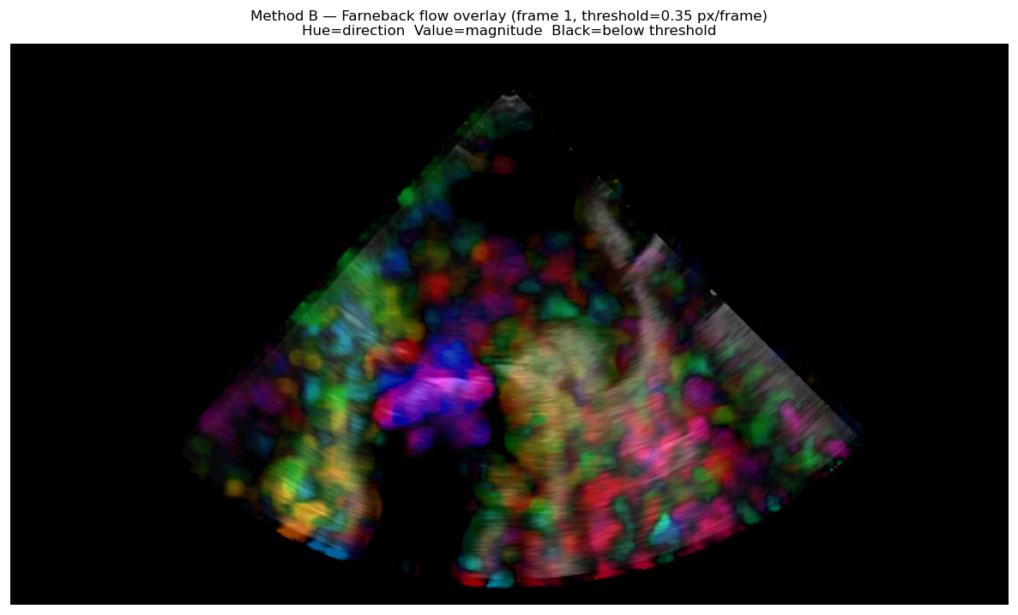
Figure 3. Method B — Farneback HSV overlay (frame 2). Hue=direction, cap=3 px/frame, thr=0.35.

4.2 Method C — LK PyrLK
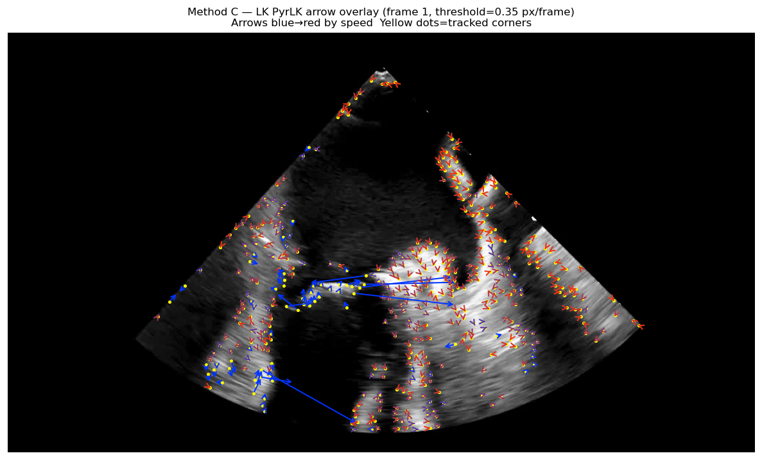
Figure 4. Method C — LK PyrLK arrows (frame 2). Yellow = tracked corners. Blue→red = slow→fast.

4.3 Method D — DIS
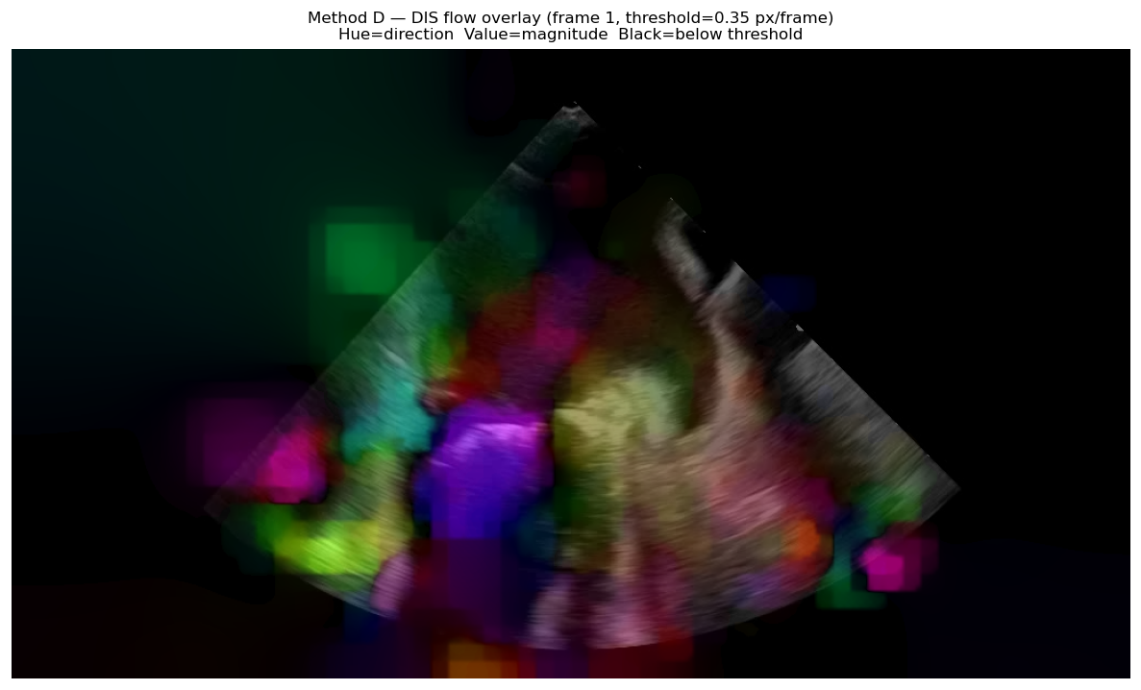
Figure 5. Method D — DIS HSV overlay (frame 2). Hue=direction, cap=3 px/frame, thr=0.35.

4.4 Method E — RLOF
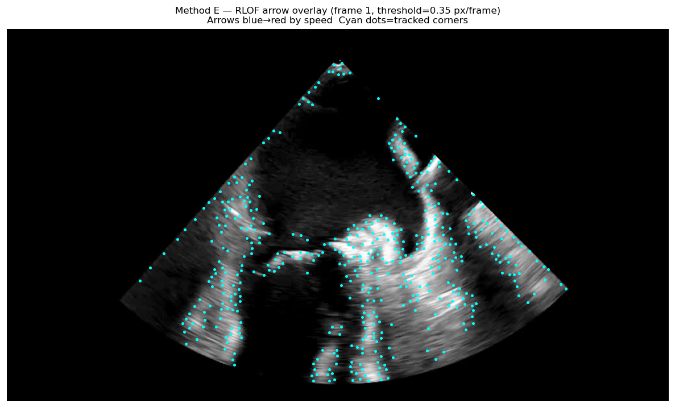
Figure 6. Method E — RLOF arrows (frame 2). Cyan = tracked corners. Displacement clipped ±20 px.

4.5 Method A — MC Gradient 3D Scatter
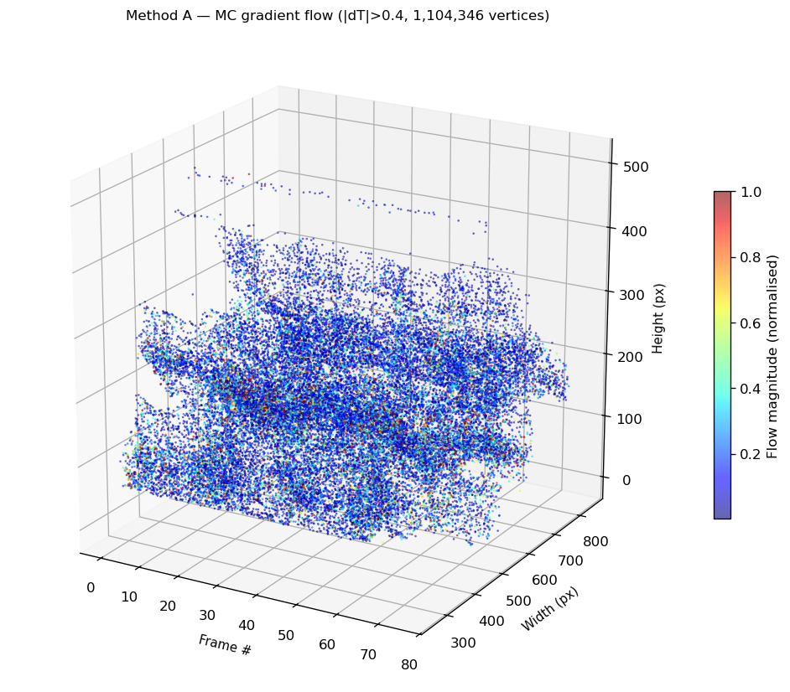
Figure 7. Method A — matplotlib 3D scatter (elev=20°, azim=−60°). Hot colormap, remapped from threshold.

5. Flow Magnitude Over Time
Mean optical flow magnitude per frame pair across all 75 transitions. Method A shown as a dashed horizontal reference at its global surface mean (3.35 px).

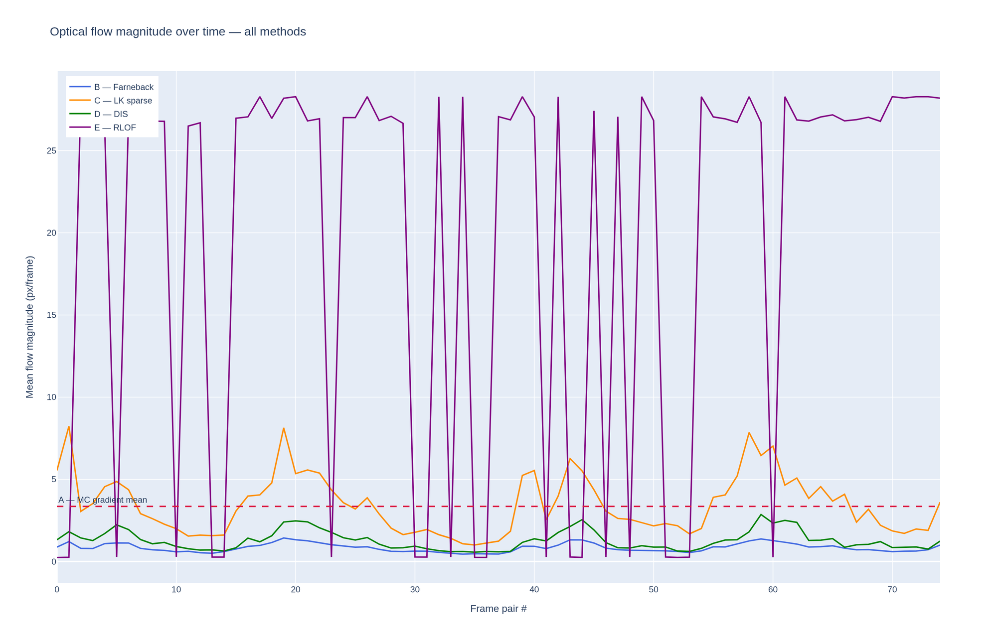
Figure 8. B/D stable < 2 px/frame. E shows periodic spikes (SR_CROSS artefacts). C tracks large features at 1–8 px/frame.

6. Performance Benchmark

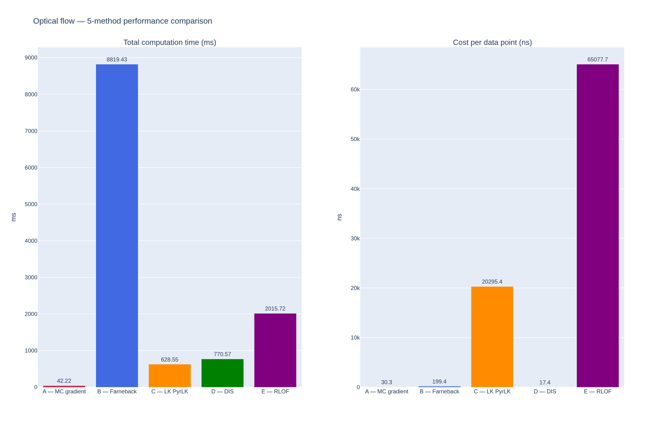
Figure 9. Left: total time — A fastest (39 ms), B slowest (8,703 ms). Right: ns/point — D lowest (15.6 ns), E highest (56,465 ns).

6.1 Full Benchmark Table

Method | Type | Total (ms) | ns/point | Flow mean | Flow std | Data points
A — MC Gradient | Sparse 3D | 39.47 | 28.35 | 3.3492 | 5.6045 | 1,392,014 vertices
B — Farneback | Dense 2D | 8702.71 | 196.73 | 0.8397 | 0.2543 | 44,236,800 pixels
C — LK PyrLK | Sparse 2D | 623.47 | 20131.33 | 3.4490 | 1.7429 | 30,970 corners
D — DIS | Dense 2D | 691.90 | 15.64 | 1.2804 | 0.5794 | 44,236,800 pixels
E — RLOF | Sparse 2D | 1748.95 | 56465.01 | 22.7771 | 10.3264 | 30,974 corners

Table 1. Full benchmark — 76 frames, 75 frame pairs, 576×1024 px.

6.2 Time Rankings
Total time (fastest → slowest):
- A 39.47 ms (sparse, iso-surface only)
- C 623.47 ms (sparse, ~413 corners/frame)
- D 691.90 ms (dense, full 576×1024)
- E 1,748.95 ms (sparse + RLOF solver)
- B 8,702.71 ms (dense, full 576×1024 + polynomial)

Per-point cost (lowest → highest):
- D 15.64 ns/pt ← best dense (12.6× faster than B)
- A 28.35 ns/pt ← best sparse
- B 196.73 ns/pt
- C 20,131.33 ns/pt (corner detection overhead)
- E 56,465.01 ns/pt (SR_CROSS per-point cost)

7. Flow Magnitude Analysis

Method | Mean (px/f) | Std Dev | Min | Max | Notes
A — MC Gradient | 3.3492 | 5.6045 | N/A | 50 (capped) | Global surface metric, not per-frame
B — Farneback | 0.8397 | 0.2543 | 0.447 | 1.429 | Most stable — averages full image
C — LK PyrLK | 3.4490 | 1.7429 | 1.005 | 8.232 | Large-feature motion at corners
D — DIS | 1.2804 | 0.5794 | 0.565 | 2.858 | Consistent dense coverage
E — RLOF | 22.777 | 10.326 | 0.241 | 28.28 | Elevated — SR_CROSS on greyscale

Table 2. Flow magnitude statistics — 75 frame pairs.

8. Method Selection Guide

Method | Best use case | Avoid when | Real-time?
A — MC Gradient | 3D shape deformation, structural analysis | Need interior myocardium | Yes (39 ms)
B — Farneback | Accurate offline full-field strain | Speed is a constraint | No (8.7 s)
C — LK PyrLK | Speckle tracking, landmark motion | Uniform textureless regions | Yes (623 ms)
D — DIS | Real-time dense flow display | Highest accuracy required | Yes (692 ms)
E — RLOF | Gain artefact robustness (colour Doppler) | Greyscale-only input | No (1.75 s)

9. Conclusions
1. DIS is the recommended real-time dense method: 15.64 ns/point, 692 ms, 12.6× faster per pixel than Farneback.

2. MC Gradient delivers 3D surface-aware motion at 39 ms. Dual filter retains 79.3% of vertices with genuine motion signal.

3. Farneback is the stability reference: std 0.254, range 0.447–1.429 px/frame.

4. RLOF mean (22.8 px/frame) elevated — SR_CROSS on pseudo-colour greyscale. Use SR_FIXED for greyscale echo or provide genuine colour Doppler input.

10. References
Horn, B.K.P. & Schunck, B.G. (1981). Determining optical flow. Artificial Intelligence, 17(1–3), 185–203.
Lucas, B.D. & Kanade, T. (1981). An iterative image registration technique. IJCAI-81, 674–679.
Bouguet, J.-Y. (2001). Pyramidal implementation of the Lucas-Kanade feature tracker. Intel Corp.
Farneback, G. (2003). Two-frame motion estimation based on polynomial expansion. SCIA 2003, LNCS 2749, 363–370.
Kroeger, T. et al. (2016). Fast Optical Flow using Dense Inverse Search. ECCV 2016.
Senst, T. et al. (2012). Robust Local Optical Flow for Feature Tracking. IEEE T-CSVT 22(9), 1377–1387.
Lorensen, W.E. & Cline, H.E. (1987). Marching Cubes. SIGGRAPH 1987, 21(4), 163–169.

