History Behind GLOSA
The demand for an International Auxiliary Language (IAL) goes back to classical times, but there was no serious attempt to devise one until the 17th century.
Many great names have been associated with the IAL movement such as Francis Bacon (1561-1626), English statesman, philosopher and essayist, or the German philosopher and mathematician Gottfried Wilhelm Leibniz (1646-1716).
The following pages give a brief survey of the chief historical events which have led up to the almost predestined birth of Glosa and how it has progressed.

Published by Glosa Education Organisation (GEO), Registered charity number 298237
© Wendy Ashby and Rainer Asenkerschbaumer 2006 Glosa Education Organisation
P.O.Box 18, Richmond, Surrey, TW9 2GE, www.glosa.org

C. 800 B.C.
Probably the time when Homer, the great early poet of Greece, lived. Homer is being credited with authorship of the world literature’s earliest epics, Iliad and Odyssey.

750 B.C.
The rise of Classical Latin and subsequent development of Vulgar Latin, the Latin of ordinary people, who discarded unnecessary grammatical complexities. Vulgar Latin gave rise to the Romance Languages, for example: French, Italian, Spanish, Portuguese, Rumanian. The original simplified Vulgar Latin continued as an international language throughout Europe.

C. 2000 years ago
Some clever Indian hit upon the idea of distinguishing position in the counting frame, which led quickly to the numbers. He used a dot to indicate nothing as we know now as nought. This Hindu number language led quickly to a revolution in the art of calculation. It led almost immediately to fractions.

C. 500 A.D.
Indian mathematicians could solve problems which had baffled the greatest scholars of antiquity. These numbers eventually reached Baghdad c. 800 A.D. which was at that time the worlds’ greatest city of civilisation. In Baghdad Greek science and geometry met the Muslim world which was now equipped with an arithmetic much better than that of the Greeks.

1000 A.D.
The Roman Empire came under Muslim rule. Spain in particular was now occupied by Muslim culture and especially enjoyed the benefits of Muslim learning. In its universities students could study the geometry, astronomy, trigonometry of Greece and the arithmetic of India.

1400
Italian plutocracy encouraged links with Constantinople, and Byzantine refugees brought many Greek manuscripts.
Merchants of France, Italy, Germany and Britain were using the new numerals to their great advantage. Many attempts were being continually made in some places such as Britain to prevent the spread of these numbers.

1440
Printing with movable type started in Germany, so Greek texts now were available throughout Europe.

C. 1500
The advance of science was hindered in Britain by the refusal of the governing classes of those days to allow the use of the marvellous Hindu numbers 0, 1, 2, 3, 4, 5, 6, 7, 8, 9. They were first grudgingly permitted in 1500 whilst the Hindus were already developing Algebra.
Classical Latin becomes Scientific Latin, with much simplification.

1662
The Royal Society of Science was founded and immediately encouraged the search for an international language to replace Latin, which had been destroyed by the Reformation. Scientists all over Europe were losing contact with one another.
On the continent Leibniz tried to improve the situation by devising a universal language based on logic. He also saw that all the flexions of Latin simply make the language unnecessarily complicated; and he advocated their removal and replacement by particles, a process already taking place in Vulgar Latin.

1668
Bishop John Wilkins (1614-1672) brought out “The Real Character”, an IAL with Chinese overtones. Leibniz pointed out that complex Latin grammar was totally unnecessary and Vulgar Latin particles were much better.
John Amos Comenius (1592-1671) understood that only through education would the nations of the world confederate. He reasoned most un- scientifically educated people are frightened of change. He stated: “Xenophobia belongs to the tribal mentality”. And he understood that only education opens the minds to the beauties and wonders of the Cosmos.
Only then will the nations of the world confederate.
So Comenius proposed all children should be educated in the local native language together with Latin, which will ensure the essential expansion of intellect and spirit. He very much favoured the teaching of Latin through the study of the local environment, of town, country and nature. He was the first person to draw pictures of ordinary things and activities in the teaching of Latin. Comenius, together with Bishop John Wilkins (a founder of The Royal Society), tried to represent the whole of the Cosmos as a branching tree of ideas. But the task was too complex for their then state of knowledge; and their energies got diverted into simpler dictionaries and encyclopedias.Wilkins tried to develop a taxonomic system but failed.

1735
Carl Linnaeus (1707-1778) devised Botanical Latin, an artificial, international language derived from simplified Latin and ancient Greek. The reason was to worldwide standardise the names of any existing and newly discovered plants by using this language worldwide for their description.
Botanical Latin is progressive: A myriad of new terms are being continuously added, and classical words have been given sometimes entirely new meanings to suit botanists. Simultaneously with this enrichment by coinage from Latin and Greek came a great simplification of grammar.

1852
Peter Mark Roget (1779-1869) published his now famous Thesaurus. He was a member of many scientific and cultural organisations, and was secretary to The Royal Society for 22 years. He had a wide international outlook and was always interested in the precise use of language, but had little interest for literature. He was a doctor of medicine by profession. His great interest was in taxonomy. He was greatly influenced by Wilkins by the application of taxonomy to the development of language in general.
Speaking about Wilkins he wrote “…The probable outcome of such a language would be its immediate acceptance by every civilized nation, and so will be realised the great aim of all lovers of mankind – the establishment of a universal language.” The combination of Rogets’ interests in the precise use of words, his international outlook and interest in classification all combined to bring about the publication in 1852 of the World Thesaurus, which enjoyed an immediate success.
Roget’s Thesaurus classified everything then known about the Cosmos under about 1000 headwords; and it is these 1000 ideas which are adopted by the “Glosa 1000 Central Vocabulary” enabling it to deal with every kind of theme.

1905
The Italian mathematician Professor Giuseppe Peano published a dictionary of Latin without inflexions (Latino Sine Flexione). He used this language at scientific meetings, starting with conventional Latin, then gradually omitting conventional grammatical devices. However, he made no attempt to work out a minimum vocabulary as the language was intended only for European scientists who, being well grounded in Western languages, felt no need for a reduced vocabulary. However, he like Leibniz, cut out all grammar.

1932
Charles Kay Ogden and I.A. Richards published “Basic English” where Basic is an acronym for ‘British American Scientific Commercial English’.
They reduced the vocabulary to only 850 words, but the price of this economy was a more complex grammar and a host of idioms, easy for English speakers but difficult for those who did not know English. Basic English however, had some useful ideas on word economy.

1943
Professor Lancelot Hogben (1895 – 1975) published “Interglossa” sub- titled: “A draft of an auxiliary for a democratic world order, being an attempt to apply semantic principles to language design”, published by Pelican Books in London. Hogben agreed that inflexions are totally unnecessary and time wasting, and pointed out that since Peano scientists now draw their international terminology exclusively from Classical Greek; and that these same Greek words quickly enter the vernacular words such as: ARTHRI-tis (joint-pain), CHLORO-PHYLL (green-leaf), HYPO-GLOSSA-l (under-tongue), HYDRO-GEN (water-maker), CHIRO-POD-y (hand-foot), LEUK-AEMIA (white- blood), POLY-TECHNI-c (many-skills). Hogben listed 880 classical words and roots which easily suffice for any kind of good conversation.
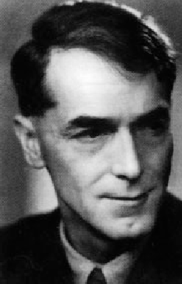
Hogben devised Interglossa while fire-watching on the roof of Aberdeen University during the last war. It failed to get the attention it deserved because:
- Britain was in some social turmoil at the time, people’s attention was otherwise engaged and paper was restricted, so only a few copies of the book were produced.
- Hogben was so certain of its immediate success that he wrote the book purely for teachers of languages and linguists. He was, however, disappointed that so few people took interest in promoting the language and consequently he became re-involved with other linguistic, mathematical and scientific researches.

Lancelot Hogben
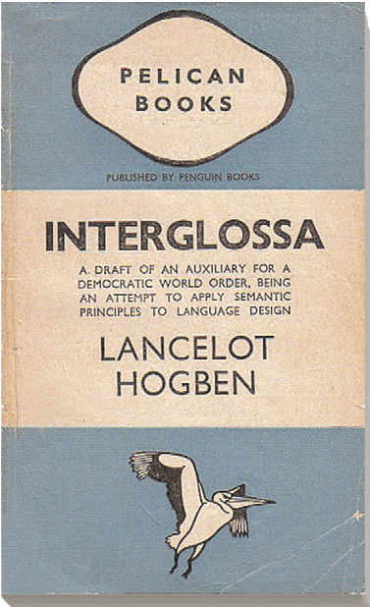
Hogben was a biologist, linguist and a well known scientific researcher with many original papers to his credit. He was Fellow of the Royal Society,Vice Chancellor of the University of Guyana and Hon. Sen. Fellow in Linguistics in Birmingham University (1961-1964). Other books written by Hogben include: Mathematics in the Making, Mathematics for the Million, The Mother Tongue,The Vocabulary of Science, Science for the Citizen.Professor Hogben and his groundbreaking publication He was also general editor of “The Interglossa, published 1943Loom of Language” which was re- issued in paperback by Merlin Press, London 1987. For further details about Hogben see “Lancelot Hogben Scientific Humanist – An unauthorised autobiography” edited by Adrian and Anne Hogben, published by Merlin Press, London, 1998.

C. 1960
The idea might have been lost as surely have many other original ideas, had not Ron Clark, many years later, come across one of the rare copies of the Pelican “Interglossa” in a second-hand book shop. He was immediately enthralled by the beautiful simplicity of the language. Ron Clark had a similar education background to Hogben. He had studied chemistry, biology, science and technology as well as the classical languages at University and was fluent in French, Russian and German. He got in touch with Professor Hogben who, after several discussions, was delighted to give him his encouragement to develop the idea – and so was Glosa born.

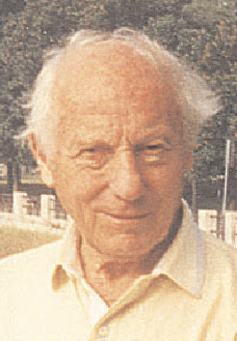
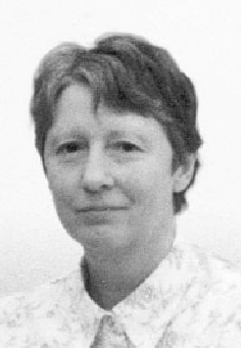
1972
Drawing 1: Ron Clark and Wendy Ashby, founders of GLOSA

Another great step forward occurred when Ron Clark was joined by Wendy Ashby. She, too, immediately recognised the enormous potential of the language.
Hogben suggested they do a lot of translation of many topics to test the language and to introduce any changes they thought fit. Ron discussed these changes with Hogben; by this time Hogben was not in the best of health and communications were via telephone. Hogben died in 1975.
A few further and trivial changes were introduced after this date, and as Hogben was no longer available to approve these modifications, they considered it better to re-name the language to GLOSA (the Greek for tongue, language). The single “S” emphasises that the language is now fully phonetic. Hogben and Clark had previously agreed that the IAL must eventually become phonetic; in the early days it was promoted non- phonetically so that the words would be immediately recognised by English speakers. Now the Greek CH, TH and PH in Glosa are spelt K, T and F.

1978
Published 1100 word-list on glossy A3 card in English – Glosa and Français – Glosa.
Designed the Glosa logo.
Publicised Glosa in local newspapers, on radio and television.
Started a small study and conversation Glosa group among friends in Christchurch, Dorset.
It was then evident that more Glosa publications would be needed for future students and teachers of the language.

1981
Published Tetra-lingual Dictionary, listing 5000 Greek and Latin roots which occur in the scientific and European vocabularies into English-French and German.
Published 2200 English – Glosa and Glosa – English Dictionary. Launched the newsletter Plu Glosa Nota (PGN).
Held the first Glosa weekly meetings in Hampstead in NW London. People of mixed nationalities and linguistic backgrounds attended. As a result, it was confirmed that the ordinary person can master the important mechanics of Glosa within one hour and then can read and write accurately on any theme with the aid of a dictionary. Fluency is gained by practice of speaking, reading and writing in Glosa.
Penfriends started exchanging letters and cassettes in Glosa.

1982
Published 500 word-list as an A4 leaflet.
Published 1800 word Dictionary in English – Glosa and Glosa – English. Published 3000 word German list into Glosa 1000 Central Vocabulary.

1983
Published Glosa 1000 – English Vocabulary as an A4 leaflet. Published 2000 French words into Glosa 1000.
Published 2000 Spanish words into Glosa 1000.
Published Glosa 6000, the very popular English dictionary.
Published Basic Dictionary English – Glosa and Glosa – English, 2nd enlarged and revised edition.
Published Sporta-Glosa 1000, a word-puzzle book with various kinds of word games, some with picture clues and others with word clues.

1984
Published Glosa 5000 Advanced Dictionary. This book lists 5000 of the lesser known Greek and Latin words and roots occurring in scientific and technical terminology.
Published Glosa 1000 Dictionary with etymological mnemo-technic notes. It includes vocabulary of the 5000 most frequently used English words into Glosa 1000 Central Vocabulary.
Published Glosa 1000 – French on one A4 page. Published Glosa 1000 – German on one A4 page.

1985
Published Glosa 6000 Dictionary, 2nd enlarged and revised edition. Published 18 Steps To Fluency in Euro-Glosa, a work book for teachers and students of Glosa who like to work systematically through exercises.

1986
Devised Tako-Glosa, a quick writing system, in which all Glosa 1000 words can be abbreviated to 1, 2 or 3 letters and symbols, all can be typed on an ordinary computer keyboard, typewriter or by pen. Ron Clark and Professor Hogben first discussed about this idea in the late 1960s. Ron first introduced Tako-Glosa in Plu Glosa Nota number 24. Further additions were given in PGN 26, and 27.
Glosa is reviewed in the book The Artificial Language Movement by Dr. Andrew Large, published by Basil Blackwell, Oxford, U.K. This book gives an interesting history of the International Language Movement. Five pages are dedicated to Glosa, including one page from Glosa 1000 – English Vocabulary and an excerpt of an article from Plu Glosa Nota.

1987 (January-May)
Held a series of weekly Glosa meetings in Richmond- upon-Thames.
Published Basic Dictionary, 3rd revised edition.
Glosa gets brief mention in the Cambridge Encyclopedia of Language, by David Crystal.
Glosa Education Organisation (GEO) gets charity status, Reg. No. 298237. GEO aims to:
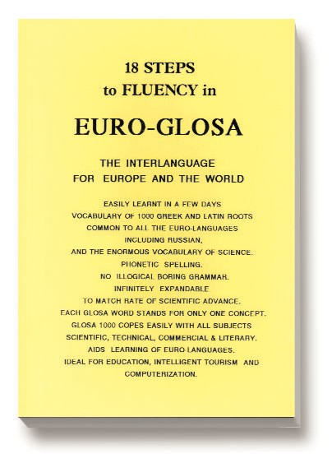
Illustration 1: Euro-Glosa, a 112-page booklet with numerous illustrations
- Promote the teaching of Glosa as a second language in schools worldwide.
- Provide information about Glosa for the general public and educationalists.

1989
Published 18 Steps to Fluency in Euro- Glosa, 2nd revised edition.
Promoted Glosa and the Glosa Education Organisation in the three-day London Language Show in the Barbican Exhibition Centre.
Promoted Glosa and GEO at a five-day Global Partnership Exhibition, Westminster, London. Promoted Glosa and GEO in the three-day Eco- Fair in Richmond Adult College.
Promoted Glosa and GEO in a weekend “One World Fair” in Christchurch Dorset.
Some Glosa members came along to help out on the stands; also several Glosa members met for the first time and more importantly, many people heard about the charity, about the Glosa language and were able to see the various Glosa publications and ask questions.

1990
Published Introducing Euro-Glosa book and audio cassette for studying Glosa.
Published first issue of Eduka-Glosa, a GEO journal. Eduka-Glosa offers a forum for teachers and students of Glosa to exchange ideas and information about the language. It enables them to link with other schools all over the world with the aim of exchanging letters and visits. Eduka-Glosa emphasises that apart from being an IAL, Glosa makes a valuable contribution to general education, giving meaning to the thousands of scientific and technical terms that students have to get quickly acquainted with; it also eases the acquisition of the Euro Vocabularies.
Promoted Glosa at The London Language Show in The Barbican Exhibition Centre.
Promoted Glosa at Global Partnership ’90 in Westminster.

1991
Glosa Education Organisation acquired IBM Desk Top Publishing System, bought with funds raised by an appeal launched and run mainly by Ms Evelyn Jerrard. More professional looking Glosa publications could now be produced and updated.
1992 Launch of an international publicity campaign as a result of an article by Mr George Turnbull in Language Matters, magazine of the Associated Examining Board in Guildford, Surrey. Other long articles about Glosa appeared in six national newspapers in Britain. Interviews on about fifty regional, national and international radio stations followed, furthermore numerous television interviews and newspaper articles in many countries in Europe, Asia, Africa, Australia and USA. Several Glosa members helped with these interviews including a penfriend in USA – he was telephoned during a live broadcast and spoke in Glosa with Wendy Ashby and then was interviewed by the presenter. Also Michael Elliott, member of the European Parliament for London-West, appeared on some radio and television interviews. Michael Elliott MEP started helping to promote Glosa in Brussels.
Wendy Ashby and Ron Clark were invited to the Awards Ceremony of The Royal Anniversary Challenge at the Royal Festival Hall, London. They collected a Bronze Certificate on behalf of Glosa Education Organisation, in
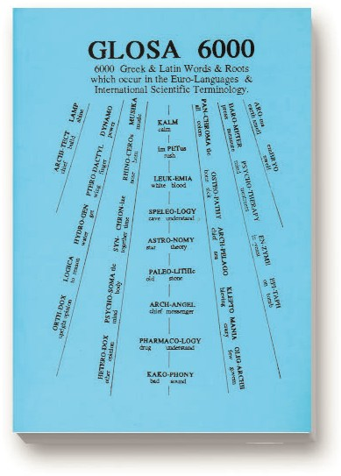
Illustration 2: Glosa 6000 with sample text both in English and Glosa
recognition of the completion of a project of long term benefit to the nation. Published English – Glosa 1000 Classified, a small booklet listing Glosa 1000 into 16 useful categories.
Published English – Glosa 1000, listing 2000 most useful English words into Glosa 1000.
Published Glosa 6000, sub-titled 6000 Greek and Latin Words and Roots which occur in the Euro- Languages and International Scientific Terminology. 3rd enlarged and revised edition, 132 pages.
The publication contains an introduction to Glosa, mechanics of Glosa, examples of parallel phrases and text in Glosa and English. It also contains three vocabularies:
- 2000 English words into Glosa 1000.
- Glosa 1000 – English Vocabulary.
- Glosa 6000 – English Vocabulary.
This dictionary gives the meanings of Greek and Latin roots used in medicine, biology, plant and animal names, etc. Suitable for educationalists, students, linguists and for teachers and students of Glosa.
Published Glosa Summary, an 8-page booklet which was used as a basis for talks given in Secondary Schools.
Published A Sample Talk to accompany the Glosa summary. Suitable for teachers. Contains frequently asked questions and answers about Glosa. Published 18 Steps To Fluency in Euro-Glosa, 3rd. enlarged and revised edition, 108 pages.
Each step has sentences in parallel text showing how to use the Glosa mechanics. Many exercises for translation practice from Glosa into English and vice versa. Samples of informal letters and useful phrases around a theme. Informative illustrations are scattered throughout the book. Two vocabularies are provided: Glosa 1000 Central Vocabulary – English; and 2000 most useful English words into Glosa 1000.
Later in the year George Turnbull wrote and published a follow-up article about Glosa in the autumn issue of Language Matters, magazine of the Associated Examining Board.
Published Français – Glosa 1000 Dictionary Published Deutsch – Glosa 1000 Dictionary Published Español – Glosa 1000 Dictionary

1993 (March – December)
Held a series of fortnightly meetings in Richmond-upon-Thames.
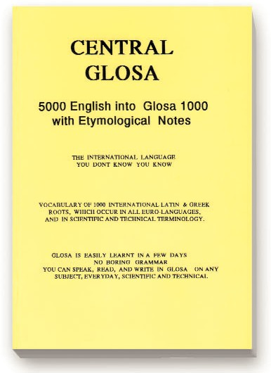
Illustration 3: Publication showing links between Glosa words and relevant Greek / Latin roots
Schools in USA, Uganda and Tanzania started to teach Glosa. There are several local Glosa Study Groups and centres in these countries, also in Taiwan, Mainland China and Kenya.
Published Glosa Summary in German.
Published Central Glosa – 5000 English into Glosa 1000 with Etymological
Notes. This new publication contains 3 dictionaries:
- The main dictionary translates 5000 most useful English words into the Glosa 1000 Central Vocabulary.
- Glosa 1000 – English Dictionary with etymological hints with each Glosa word.
- A selection of words from Glosa 1000 with more detailed etymology. This book is suitable for beginners, advanced students and teachers of Glosa. Wendy Ashby was invited to speak about Glosa in the EEC building, Brussels. Several newspaper articles and radio interviews followed as a result.
Published Glosa 1000-Chinese Dictionary. Wendy Ashby was invited to publicise Glosa and GEO in a three-day Educational Convention in Atlanta
Georgia USA, to visit 10-12 year old students who learn Glosa in school, and to speak with teachers and school board members who are interested in adding Glosa to their school curriculum next term.

1994
Published Glosa Summary in Spanish.
Glosa article on front cover of Language Matters – a magazine linking education and industry, published by Associated Examining Board, Guildford, Surrey.
Articles about Glosa in several national and regional newspapers and in The European. Interviews on several regional television and radio programmes. Published inexpensive Glosa – English and English – Glosa booklets for use in the classroom with a teacher. Many of these booklets were posted to schools overseas, especially to Africa and USA where Glosa is taught daily and demand for Glosa publications is growing.
Launched first edition of Sko-Glosa, a new publication by and for younger students of Glosa.
Articles about Glosa in international magazines including Dictionaries, New Scientist, European Matters, Geographical Magazine.
Television programme about Glosa – the language for Europe, was broadcast during the European elections week.
Inaugural meeting of Eastern Uganda Glosa group.
Later in the year a national one-day Glosa seminar in Uganda for teachers of Glosa. Onen Smith spoke to student teachers of Glosa.
Published Sko-Glosa number 2.
Article published in the Autumn 1994 issue of Language Matters. Articles in national newspapers in several African and European countries. Also enquiries following brief items about Glosa on French radio and USA television.

1995
Continued with promoting Glosa locally and internationally. Published Sko-Glosa number 3.
Following several requests for information about Tako-Glosa (see 1986 entry), Ron Clark modified and re-introduced this speed-writing system in Plu Glosa Nota number 64 and later in number 73.
Set up e-mail address for Glosa Education Organisation. This encouraged many e- mails between GEO HQ, Glosa teachers and students in UK as well as overseas. Glosa featured in a forty minute television documentary about languages on TV in UK with both Wendy Ashby and Ron Clark appearing as studio guests. Promoted Glosa and GEO at Global Partnership Exhibition in Oxford.
Promoted Glosa at Global Partnership ’95 in the Barbican, London. Promoted Glosa and GEO at a two-day Futures Educational exhibition in Richmond College.

1996
Glosa Education Organisation now has a web site on the Internet, set up by Paul Bartlett in USA. It includes vocabularies and other useful items for studying and teaching Glosa.
Published Glosa 1000 English – Swahili dictionary, compiled by teachers in East Africa.
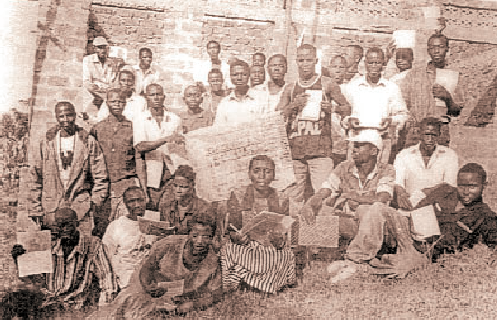
Banobi Herbert and other Glosa teachers in Uganda sent proposals about the new Glosa Gorilla Tourist and Education Centre to be built alongside a national Gorilla reserve in Uganda.
Drawing 2: Glosa students and teachers in Uganda in frontof the Glosa Gorilla Tourist and Education Centre, RUGGOTEC
Published inexpensive Glosa 1000-Swahili booklets and sent many to teachers and students of Glosa in Uganda, Kenya and Tanzania.
Promoted Glosa at a Charities Fair in York House, Twickenham. Also item about Glosa Education Organisation in the local newspaper.
Promoted Glosa at a one-day peace event in Christchurch, Dorset.
Promoted Glosa publications at Zimbabwe International Book Fair.
Promoted Glosa at Global Partnership ’96 in the Barbican Exhibition Centre, London.
Promoted Glosa at Higher Education and Training Exhibition, a two-day event in the Business Design Centre, Islington, London.
Interview with Wendy Ashby on the Big Breakfast programme of Channel 4 Television.

1997
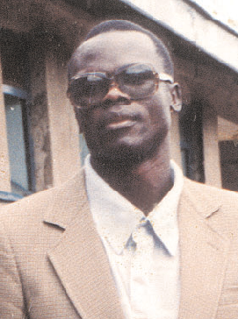
Glosa article in local newspaper.
Drawing 3: Onen R. Smith,main promoter of Glosa in East Africa
Sadly the main East African Glosa promoter Onen R. Smith suddenly died. Herbert Banobi kindly offered to take his place to be the main promoter in Uganda, being supported by several Glosa teachers and supporters in his region.
Building work with RUGGOTEC (Rukungiri Glosa Mountain Gorilla Tourism and Educational Centre) in Uganda continued to progress. Tourists were now invited to visit the centre.
Herbert Banobi, Director of RUGGOTEC, represented Glosa Educational Organisation in the IUPIP (International University of Peoples’ Institutions for Peace) in Rovereto, Italy. He was there for three weeks and Wendy Ashby and Ron Clark joined him there for some of the time. He did a splendid job promoting Glosa during his visit, and works hard promoting Glosa in Uganda.
Information on the Glosa Internet site continues to grow.

1998
Wendy Ashby and Ron Clark visited Glosa friends in France. Promoted Glosa at a Charities Fair and Exhibition in Twickenham. This one-
day event was organised by CVS Richmond and sponsored by local businesses.
Brief mentions about Glosa and GEO in local newspaper and entries in various educational directories.

1999
Most activity this year was via exchanging e-mails with supporters in UK and overseas. Also members kindly offered their time and expertise helping to update existing web pages and compiling new ones. Teachers and students of Glosa are now able to download vocabularies and other Glosa information by computer; consequently, requests to the main address in Richmond for books and other printed matter declined.
Ron Clark (now in his late 80’s) was unwell this past year; also he moved into a new flat. His health seemed to be gradually improving. He bought a new computer and hoped to be more active again together with Wendy Ashby once the system was set up.
Teaching of Glosa on a larger scale began in RUGGOTEC, Uganda.
An autobiography of Professor Lancelot Hogben was published by Merlin Press (see 1943 entry), stimulating new interest in Glosa.

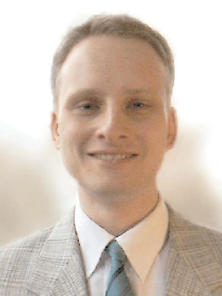
2000
Drawing 4: Marcel Springer, leading contributor to set up the Glosa web site

Ron Clark died very suddenly this year. It was a great shock to everybody who knew him. At the same time the health of the mother of Wendy Ashby suddenly deteriorated and she needed constant care. Most Glosa books and papers were put into storage and apart from general administration there was a break in Glosa promotion
from Richmond. Many Glosa supporters in different countries remained in contact with each other and kept interest for Glosa going. Many personal letters arrived from around the world during this sad time and they gave much encouragement to continue the Glosa work.
Marcel Springer started a new web site for GEO.

2001
After various discussions it was agreed to continue with GEO and resume Glosa activities.
2 new trustees of GEO were welcomed, Rainer and Sabine Asenkerschbaumer, joining the existing trustees Wendy Ashby and Hilarie Bowman, and offering their support and expertise to aid with the next stage of promotion.
Published Plu Glosa Nota number 84. The chief article was entitled: “The Two Marvellous Men of Glosa” (in Glosa: “Bi sti mira-andro de Glosa”). It gave information about the lives and work of the two principle people in compiling and promoting Glosa – Professor Lancelot Hogben and Ron Clark. Both men had very similar background in all-round education, both were very interested in biology, science and technology (especially for the future), linguistics, etymology and mathematics. Both were excellent teachers and had a simple, clear, quick and interesting method of teaching these subjects. And both were very committed to aiding international understanding and world peace.
Wendy Ashby accepted an invitation to talk about Glosa and then lead a discussion at the Richmond branch of University of the Third Age. The members were fascinated by Glosa as both a means of international communication and for its educational value.
Published Plu Glosa Nota number 85 which included news and photograph of Glosa teachers and students from RUGGOTEC in Uganda.
Published Plu Glosa Nota number 86. This included more information about Glosa on the Internet and a brief English – Glosa 1000 word-list to demonstrate that Glosa is also able to translate modern computer terms.
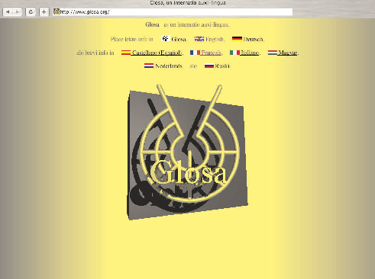
With much input from Marcel Springer and help from other Glosa enthusiasts www.glosa.org web site continued to grow and become more active. Texts
Drawing 5: The multi-lingual web site of Glosa, meanwhile published in 9 different languages

are now available in several European languages.

2002
Published Plu Glosa Nota number 87 including news of further additions to the Glosa Internet site, Glosa vocabularies, translations, letters and replies. Main activities this year were e- mails and additions to the Glosa web pages such as new vocabularies, singing, photographs and translations.

2003
Published Plu Glosa Nota number 88 containing articles about Tako-Glosa, a short story, poetry, vocabularies and word games. The main article featured “Qo Akti?”, a video- arts project compiled by Mathilde ter Heijne, a Dutch artist living in Germany. The video is about the life of the French philosopher Simone Weil. The voices of this presentation were recorded in Glosa and spoken by
Wendy Ashby and Sabine & Rainer Asenkerschbaumer. The first showing of this film was in June and July in Galerie Martina Detterer in Frankfurt, Germany. From there the film went on tour to be shown in other art galeries in Germany and abroad. Parts of this film can be viewed on the Glosa web site.

2004
Glosa information again continued to increase on the Internet. Texts and information are now available in Russian, German, English, Hungarian, French, Spanish, Italian and Chinese. The demand for much more Glosa literature on this site increased again, as well as requests in hardcopy.
Published Plu Glosa Nota number 89. The newsletter included information of a new international web site called The Future Global Language, where people are invited to place their vote to choose the best candidate for a global language, be it an IAL or a national language.
Details were also given about TRASNA, a new on-line biography of Irish literature. It was established by the Centre for Translation and Textual Studies (CTTS) in Dublin University. GEO was invited to contribute by providing four short stories and which were
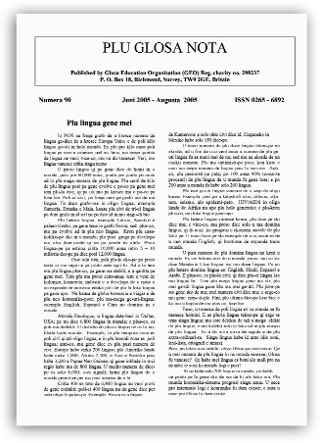
translated into Glosa from the originals by the Irish author Oscar Wilde.
Drawing 6: The Glosa newsletter PGN, launched more than 20 years ago
Titles chosen were:
The Sphinx Without a Secret, The Model Millionaire, The Selfish Giant and The Happy Prince.

2005
Published Plu Glosa Nota number 90. This included the usual mix of technical and linguistic articles and the puzzle page, also brief vocabularies and some translations with parallel text in English, French and Latin.

2006
Published updated version of History Behind Glosa which is available in booklet form or on the
Glosa web site.

Future Plans
To continue publicising Glosa locally and internationally, and to communicate with many more teachers, students and supporters of Glosa world wide.
To encourage and assist with international links between Glosa study groups, schools and teachers.
To update several GEO leaflets and books.
To continue adding information to the Glosa web site.
To publish a poetry book in Glosa. Over the years there has been a varied selection of poetry in Glosa. Ron Clark translated many items which have been published in Glosa books and in “PGN” and these will be included in this first Glosa poetry book. The book will include Glosa translations of poems, prose and songs from various countries, and poems originally written in Glosa.


The Logo
The Glosa symbol represents the Global web or network of electronic communications, telephones, fax, radio, television, computer, Internet, satellites, etc. These marvels are frustrated by 6000+ languages in the world.
The nodes represent the various communications devices; the inner circle the Central Glosa 1000 Vocabulary; the second circle Glosa 6000 Intermediate Vocabulary; and the outer circle stands for the much larger Mega Glosa Vocabulary – embracing all the Greek and Latin words and roots which occur in the chief European vocabularies and in international scientific and technical terminology and via science and medicine. These same roots are penetrating all languages of the world.
The symbol remains open at the top, showing that Glosa must always be open to new ideas. The two antennae probe space. The radii represent the numerous educational spin-offs.
In the centre is the Greek letter psy standing for the human psyche controlling but not controlled.

Summing Up
The following all led to the birth of Glosa almost as if it were predestined.
- The most universal vocabulary most familiar to all the world’s people is the vocabulary of science, which is made up of Latin and exclusively of Greek roots.
- An advanced degree of science and medicine is necessary as well as a world media for broadcasting them over the whole earth. We have that.
- We couldn’t have an advanced science without having first a highly developed mathematics; and this did not exist until the Hindus invented named, ordered numerals and nought (about 2000 years ago).
- These numbers had to be applied by an already mathematically thinking people, the Greeks.
- Such a language must have the simplest of grammars, if any; and the way for this was paved by Leibniz and Karl Linnaeus, the developer of Botanical Latin who showed that all the complex Latin flexions could be replaced by far easier mobile particles – little words of two or three letters.
- The reduced practical vocabulary of Glosa 1000 could not come into existence before Comenius tried applying taxonomy to classifying vocabularies. Then this was developed by Roget who produced his Thesaurus in 1852.
- All of the above fortunate developments had to be recognized by a scientist who was also a linguist, the late professor Lancelot Hogben who combined them into the international auxiliary language called Interglossa in 1943.
- Nobody attempted to help propagate his idea before Ron Clark and Wendy Ashby continued to develop it with Hogbens approval just before he died in 1975.
- The many tribes of people are slowly beginning to come together and co- operate in such groups as the United Nations and the European Union. These, together with the revolutionary Internet, will find the essential common world language Glosa is ready and waiting.

