Chapter 2 — Shipping to It
Series: Home-Lab Education · Phase 16 (Docker Swarm) Built and verified: August 13, 2026 on the three-manager cluster from Chapter 1 Versions at time of writing: Docker 29.7.2 · Compose file format 3.8 · private GitLab registry on :5050 Read this before: Chapter 3 (a pipeline that deploys), Chapter 4 (state) Read this after: Chapter 1 — the cluster, quorum, and what swarm init created

What this chapter covers
A four-service application — frontend, backend, PostgreSQL, Redis — deployed from a private registry onto the cluster, reachable through the routing mesh. The application itself is incidental. What transfers is everything that sat between “I have a compose file” and “it is serving traffic”:
- why a compose file is not a stack file, and which half of it Swarm silently ignores
- how a registry credential actually reaches a node — and the confident wrong answer
- why docker stack deploy exiting 0 means almost nothing
- why “it’s converged” is a harder question than counting replicas
- how a frontend build dictated our network topology
Every command here was run. Where our first explanation of a failure was wrong, the chapter says so, because the wrong explanation is the one you are likely to arrive at too.

1. A stack file is not a compose file
They use the same syntax. They are read by different things, and each ignores parts of the other.
 | docker compose up | docker stack deploy
Scope | One host | The whole cluster
Reads deploy: | Ignores it | This is where all the important settings live
Reads depends_on: | Honours it | 🚨 Silently ignores it
Reads build: | Builds the image | Ignores it — images must already exist in a registry
restart: | Honoured | Ignored; use deploy.restart_policy
Scaling | --scale flag | deploy.replicas, reconciled continuously
The dangerous entries are the ones that are ignored rather than rejected. A compose file full of depends_on deploys onto Swarm without a single warning, and then your backend starts before the database exists. Nothing in the output mentions it. You find out from the application’s logs, if the application is kind enough to say so.
Why depends_on cannot work here, conceptually. On one host, “start B after A” is a meaningful instruction because there is one scheduler and one machine. In a cluster, A might be starting on a different node, or be rescheduled mid-deploy, or be temporarily down while its node is drained. There is no moment at which “A has started” is a stable global fact. So the responsibility moves into the application: services must tolerate their dependencies being absent and retry. This is not Swarm being primitive — Kubernetes takes the same position, which is why readiness probes and init containers exist rather than a depends_on field.
Our stack file lives in this repository, not in the application’s
manifests/capricorn.stack.yml was written here and the application’s own repository was never touched. That was a hard rule for the phase, and the reasoning generalises: the lab is a consumer of the application’s images, not a contributor to it. Editing the app’s repository to make a lab work is how experiments become someone else’s maintenance burden, and how lab-only credentials end up in a production compose file.

2. The secret must exist before the deploy
printf '<password>' | docker secret create pg_password -
Our stack declares the secret as external: true, meaning “this must already exist; I will not create it”. The deploy fails immediately and clearly if it doesn’t, which is the desired behaviour — the alternative is a database that starts and then refuses every connection for a reason you have to go digging for.
Note printf, not echo. echo appends a newline and the newline becomes part of the secret. The resulting authentication failures are entirely invisible: the password looks right everywhere you can inspect it, and the file on disk is one byte longer than you think.
Secrets are delivered as files, and the general problem that creates
A Swarm secret appears inside the container as a file at /run/secrets/<name>. It is mounted from an in-memory filesystem, never written to the container’s disk, and never appears in docker inspect or the service spec — which is exactly why you use them instead of environment variables.
⭐ But almost no application wants a file. Ours wanted a single DATABASE_URL with the password embedded in the middle of a connection string. That mismatch — secret-as-file versus config-as-string — is generic. It recurs with Kubernetes secrets, Vault, and every cloud secrets manager, and it is the point where teams give up and go back to a plaintext environment variable.
The resolution is to compose the value at container start:
command:
- sh
- -c
- 'export DATABASE_URL="postgresql://user:$$(cat /run/secrets/pg_password)@postgres:5432/db"; exec uvicorn app.main:app --host 0.0.0.0 --port 8000'
Two details in that line are not decoration:
- $$ and not $. Compose interpolates $ itself before the container ever sees the string. A single $ means Compose tries to expand $(cat ...) at deploy time, on your workstation.
- 🚨 exec is load-bearing. Without it the shell stays as PID 1 and your application is a child process. PID 1 receives SIGTERM on a rolling update; a plain sh does not forward it. So the application never learns it is being shut down, Swarm waits out its grace period, and then SIGKILLs it. Every update degrades into a ten-second stall and an ungraceful kill, and it will look like a slow application rather than a missing keyword.
Similarly, the PostgreSQL image supports POSTGRES_PASSWORD_FILE, but it is mutually exclusive with POSTGRES_PASSWORD — and that variable was baked into the image. Setting POSTGRES_PASSWORD: "" explicitly is what lets the _FILE path win.
⭐ That baked-in variable is worth pausing on as a general lesson: a credential compiled into an image layer cannot be removed by editing a file. Anyone who can pull the image has it, including any read-only registry token you hand out for deployments. Rotation at the source is the only remedy, and “we fixed the Dockerfile” fixes nothing about the images already published.

3. How a registry credential reaches a node
This is the most valuable section in the chapter, because the intuitive answer is wrong and the failure it produces is genuinely confusing.
docker login gitlab.gothamtechnologies.com:5050 -u <deploy-token-user>
That writes a credential to ~/.docker/config.json on the machine you ran it on. Now deploy the stack without the registry-auth flag and watch what happens:
capricorn_frontend.1 docker-swarm-1 Shutdown Rejected "access forbidden"
capricorn_frontend.1 docker-swarm-2 Shutdown Rejected "access forbidden"
capricorn_frontend.1 docker-swarm-3 Shutdown Rejected "access forbidden"
🚨 The wrong explanation — the one we reached for first
“The manager has credentials, the workers don’t.” It is plausible, it fits a partial reading of the symptoms, and it is false. Look again at that output: the frontend was rejected on docker-swarm-1 too — the very node holding a working credential, where docker pull succeeds by hand.
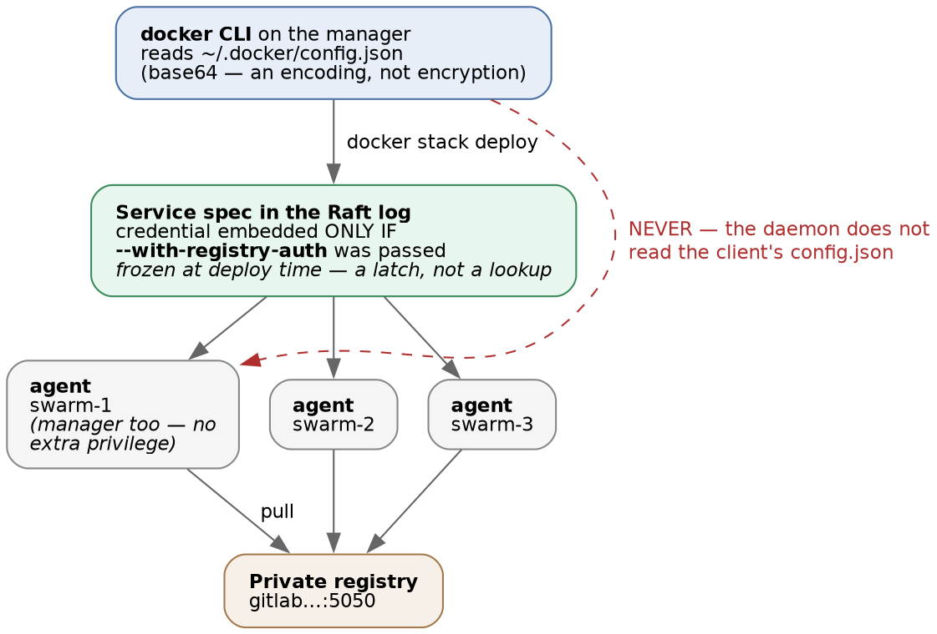
Figure 1 — how a registry credential reaches a node, and where it does not
⭐ A node’s daemon does not read the CLI’s config.json when it runs a task. Only the client does. The agent authenticates solely with a credential embedded in the service spec, which is what --with-registry-auth puts there:
docker stack deploy -c capricorn.stack.yml --with-registry-auth capricorn
Two consequences follow, and both are the kind of thing that costs an afternoon:
- A manager has no more pull privilege than a worker. The node you deploy from is not special.
- Being able to docker pull an image by hand on a host tells you nothing about whether a task can pull it on that same host. It is the most natural diagnostic step available and it tests a different code path than the one that is failing.
Our own debugging manufactured the confusing symptom
Two of the four services appeared to work on the manager. They did not have credentials — their images were already in that node’s local image cache, from the docker pull commands we had just run while investigating. A task whose image is already local never contacts the registry, so it cannot be refused.
The frontend was the only service we had never pulled by hand, so it was the only one that failed honestly — and it therefore looked like the odd one out, as though the problem were specific to it.
⭐ The methodological lesson, which is bigger than Swarm: the commands you run to investigate a failure change the state of the thing you are investigating. A pull warms a cache. A restart clears a bad connection. A docker exec creates the file whose absence was the bug. When a test depends on a cold start, it has to run before you go poking, or from a restored snapshot afterwards.
The retry budget is visible, and it runs out
There were exactly three Rejected rows per task slot. That is restart_policy.max_attempts: 3 being consumed. After the third refusal, Swarm stops trying — permanently.
This is why the failure was stable rather than transient. docker stack deploy had exited 0 half a minute earlier, the retries quietly exhausted themselves, and the service sat at zero replicas indefinitely with nothing surfaced anywhere you would normally look.
⚠️ The delayed failure mode — recorded, not yet verified
The credential is stored in the service spec, in the Raft log. It is a latch, not a live lookup.
So when the token expires, tasks that are rescheduled after that date should fail to pull, while nothing has changed and every configuration file still reads correctly. The trigger is a node restarting or a task moving — weeks after the actual cause. Redeploying refreshes it.
⚠️ We have not tested this. It follows from the mechanism and is written down as a claim to falsify, not as something to teach as fact.
Lab vs PROD — one long-lived token, used by a human and stored in a spec. In the lab: a single registry deploy token valid for over a year, created by hand, sitting in ~/.docker/config.json and copied into every service spec. Why it’s acceptable here: one operator, one cluster, read-only scope on a lab registry. In production: short-lived workload-scoped credentials — federated identity for the CI job, nothing static on disk, pull credentials issued per deployment. If you carry the habit: one leaked token grants registry access for a year, and revoking it does not fail loudly — it breaks the next task reschedule, silently, whenever that happens to occur. ⚠️ Unverified prescription: standard practice as we understand it; not tested here.
Lab vs PROD — docker login stores credentials in recoverable form. In the lab: the token sits in ~/.docker/config.json as base64, which is an encoding and not encryption — reversible with no key, in one command. Docker prints a warning saying so. Why it’s acceptable here: lab-only token, read-only scope. In production: a credential helper backed by the OS keystore, so the token never exists on disk in recoverable form. If you carry the habit: any process running as that user, any backup, and every VM snapshot contains a working registry credential. ⭐ The tool told us it had just done something substandard and the near-universal response is to scroll past it — that is the real lesson here, and “it looks like an opaque blob” is why people assume it is safe.

4. deploy exits 0 long before anything works
$ docker stack deploy -c capricorn.stack.yml --with-registry-auth capricorn
Updating service capricorn_frontend (id: sowosja0k0pw…)
...
$ echo $?
0
docker stack deploy returns success as soon as the manager has accepted your desired state — not when anything is running, and possibly forever before, if the image cannot be pulled. In the failure above, it exited 0 while the frontend had zero replicas and was already out of retries.
A deployment job that stops at that exit code reports green while your application is down. This is the single most common defect in a hand-written deploy pipeline, and it is why scripts/deploy_swarm.sh polls.
Counting replicas is not enough either
Our first convergence check compared running replicas to desired replicas. That is insufficient, in two ways, and both are worth understanding because the check looks obviously correct.
First, order: start-first. This setting brings the replacement task up before retiring the old one, precisely so there is no gap in capacity. Which means running/desired can read 3/3 continuously through an entire rolling replacement. A deploy that swapped every container for a broken image can satisfy a count-only check on the very first poll.
Second, and worse — failure_action: rollback. When a rollout fails, Swarm restores the previous version, and the service settles back at full replicas. A count-only check sees 3/3 and reports a successful deployment. 🚨 The truth is the opposite: your new code was rejected and the cluster is running the old code. That is the most misleading green a deploy job can produce, and it is what a correctly-configured service is designed to do.
The fix is to ask Swarm, which tracks this properly:
docker service inspect <svc> --format '{{.UpdateStatus.State}}'
# updating | completed | rollback_started | rollback_completed | (empty, if never updated)
Treat rollback_* as a hard failure, not a success. ⚠️ Recorded as untested: UpdateStatus appears to be a latch that persists until the next update begins, which would mean a stale rollback_completed could fail a cluster that is actually healthy. Chapter 5 settles it.
The blast radius of a deploy is neither “everything” nor “nothing”
Re-deploying with the auth flag added recreated three services and left Redis completely untouched — its task ran for thirty minutes across two subsequent deploys with no restart at all.
⭐ --with-registry-auth attaches a credential only for images whose registry requires one. So it changed the spec of the three services on the private registry and did nothing to the public redis:7.2.4-alpine. PostgreSQL was working correctly and got bounced anyway, purely because it shares a registry with the services that were broken.
Nothing in the command you type tells you which services are in scope. And a third run, with an unchanged file, recreated nothing at all — which is the declarative model working exactly as designed.
The rule is: a service is recreated when its spec changes. The hard part is that “spec” includes things you did not write in the file — resolved image digests, embedded credentials, and anything else Swarm computes on your behalf.
Tags are resolved to digests, once
capricorn_backend …/backend:latest@sha256:fac031dd827c3f1c78d6732d925ae6888ee65b821c08218dd4b1ea7…
capricorn_redis redis:7.2.4-alpine@sha256:c8bb255c3559b3e458766db810aa7b3c7af1235b204cfdb304e79…
Swarm resolves each tag to a digest when it accepts the spec and stores that. Services therefore do not follow a moving tag the way docker compose pull does.
This cuts both ways, and both matter:
- Good: your deployment is reproducible. A rebuild of :latest cannot silently change what is running underneath you.
- 🚨 Surprising: “I pushed a fix and production is still running the old code” is a Swarm classic. Redeploying the same tag may legitimately do nothing at all.
Even the deliberately-pinned redis:7.2.4-alpine got a digest recorded. A tag — however specific it looks — is a mutable pointer that whoever controls the registry can move. The digest is the image.

5. The routing mesh — any node answers, task or not
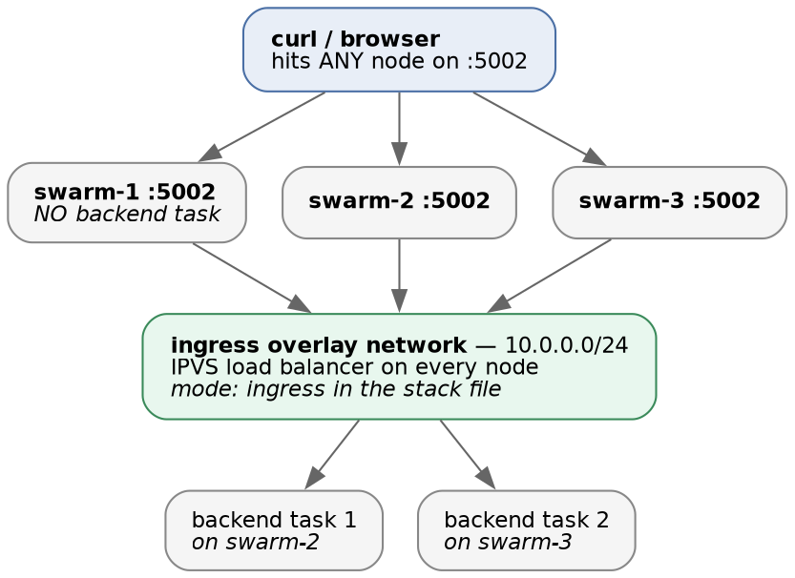
Figure 2 — the routing mesh
With mode: ingress on a published port, every node in the cluster listens on that port, whether or not it is running a task for that service. A request arriving at a node with no local task is load-balanced across the nodes that do have one.
Verified directly: the backend runs two replicas, on nodes 2 and 3, and curl against node 1 on :5002 answers correctly.
The operational payoff is that you can put any node — or all of them — behind a load balancer and stop caring where tasks are scheduled. The catch worth knowing: a node answering on a published port is not evidence that the node is healthy, only that the cluster is. A naive health check that hits one node’s port will pass while that node runs nothing at all.
Lab vs PROD — published over plain HTTP with nothing in front. In the lab: the application is published directly on :5001 and :5002, no reverse proxy, no TLS. Why it’s acceptable here: the lab’s subject is the routing mesh, and a proxy in front of it would hide the very behaviour being studied. In production: TLS terminated at an ingress proxy, and the application’s own ports never published to any network a user can reach. If you carry the habit: session cookies and every API payload cross the network in cleartext. ⚠️ Note how this decision actually arrived — see §6. It was not chosen on merit; it fell out of how an image was built, which is the more insidious way a production environment ends up without TLS.

6. When a frontend build dictates your network topology
The backend is published on 5002. That was not a free choice, and the reason is instructive.
The frontend resolves its API base in the browser, at runtime:
- a build-time VITE_API_URL, if one was compiled in — not set in this image
- page served over HTTPS → same origin, and a proxy routes /api
- page served over HTTP → http://<current-hostname>:5002
We serve plain HTTP, so branch three applies and :5002 is compiled into the JavaScript bundle. Publish the backend on any other port and every API call in the UI breaks — while curl against the backend keeps working perfectly, so it presents as a frontend bug.
🚨 The general lesson: VITE_* variables — and their equivalents in every other frontend build tool — are substituted at BUILD time. Setting one in a stack file, a .env, or a service spec does absolutely nothing; the value is already inside the bundle. Configuration that feels like runtime configuration, but isn’t, is a category of bug that produces no error message at all — just an application quietly talking to the wrong address.
⭐ And note the direction of causation, which is the part worth carrying: the image dictated the network topology, not the reverse. A decision made months earlier in someone’s Dockerfile constrained what we were permitted to do with ports and, by extension, kept us on HTTP.

7. Commands to know by heart
# secrets - printf, never echo
printf '<value>' | docker secret create <name> -
docker secret ls
# deploying
docker stack deploy -c <file>.yml --with-registry-auth <stack>
docker stack ls
docker stack services <stack> # replica counts
docker stack ps <stack> # TASK history - includes failed attempts
docker stack ps <stack> --no-trunc # the useful half of an error is past the truncation
docker stack rm <stack>
# the questions that actually tell you if a deploy worked
docker service inspect <svc> --format '{{.UpdateStatus.State}}'
docker service inspect <svc> --format '{{.Spec.TaskTemplate.ContainerSpec.Image}}' # the digest
docker service logs <svc> --tail 50
# proving the routing mesh
curl -s http://<any-node>:5002/health
docker stack ps is the one to reach for first. docker service ls shows only current state; stack ps shows task history, including the rejected attempts — which is where the actual error message lives, and the only reason we could disprove the “managers have credentials” theory.

8. Glossary
Term | Meaning
Stack | A named group of services deployed from one compose-syntax file
Service | Desired state for one component: image, replica count, update policy
Task | One container plus its state. A replica of a service. Has a history
Rejected | A task the node refused to start — usually an image it could not pull
--with-registry-auth | Embeds the client’s registry credential into the service spec so agents can pull
Routing mesh | Every node listens on a published port and load-balances to wherever tasks run
mode: ingress | Port publishing via the routing mesh. Contrast mode: host, which binds only where a task runs
Overlay network | A virtual network spanning nodes, so containers on different hosts share a subnet
Digest | sha256:… — the immutable identity of an image. What Swarm actually stores
UpdateStatus | Swarm’s own record of how the last rollout went. The honest convergence signal
order: start-first | Start the replacement before stopping the old task. Why replica counts mislead
failure_action: rollback | On a failed rollout, restore the previous version — and full replica count
Convergence | Reality matching desired state. Not the same as the deploy command exiting 0

9. Check yourself
- Your compose file has depends_on. You docker stack deploy it. What does Swarm do about it, and why can’t it do otherwise? (§1)
- docker pull works by hand on the manager, but tasks are Rejected with access forbidden on that same node. Explain. (§3)
- Why does docker pull-ing an image to diagnose a failure make the diagnosis harder? (§3)
- A deploy job runs docker stack deploy and reports success. Name two distinct situations where the application is broken anyway. (§3, §4)
- Your service shows 3/3 replicas after a deploy. Why is that not evidence the deploy worked — and what do you check instead? (§4)
- You add a flag to fix one broken service and three others restart, but a fourth doesn’t. What determines which? (§4)
- You push a rebuilt :latest and redeploy. Nothing changes. Why, and is that a bug? (§4)
- curl http://node1:5002/health succeeds. What does that prove about node 1? (§5)
- The UI’s API calls all fail but curl against the backend works fine. Where do you look? (§6)
- Why is printf used to create a secret rather than echo, and how would the mistake present? (§2)
- A colleague removes a hardcoded password from a Dockerfile and commits the fix. Is the credential now safe? (§2)
- What does exec in a container’s sh -c command have to do with rolling updates? (§2)

