Rancher on K3s · Chapter 1 — What Rancher Is, and Why It Gets Its Own Cluster
Series: Home-Lab Education · Phase 20 (Rancher on K3s) Built and verified: October 27, 2026 on VM 187 vm-k3s-rancher-1 (192.168.1.187); outputs re-captured read-only at 23:25 EDT the same night Versions at time of writing: Rancher 2.15.2 (community) · K3s v1.35.9+k3s1 · Traefik 3.7.13 · cert-manager v1.21.3 · Fleet 0.16.2 · Helm v3.22.1 Read this after: nothing · before: Chapter 2
🤖 DECLARATION — read this before you trust anything below. Every command in this track was executed on VM 187, and every output quoted is real — recorded during the build on October 27, 2026 or re-captured read-only from the running system the same night. But the whole track was run by the AI, not by Andrew, at his explicit instruction. The track’s rule is “only document what you actually ran”, so these chapters are one step weaker than a hands-on track: the commands are verified; the operator judgement was not earned at a keyboard. The purpose, in Andrew’s words: “learn enough to know how it works.”

What this chapter covers
Most confusion about Rancher comes from one wrong picture: that it is a kind of Kubernetes, or something that sits underneath Kubernetes. It is neither. Rancher is an application that runs on a Kubernetes cluster, installed with Helm like any other, and its job is to manage clusters — usually other ones.
This chapter builds the right picture before Chapter 2 installs anything:
- what Rancher is, and where it keeps its data (the answer is surprising)
- the management cluster versus downstream clusters, and why this lab has only the first
- why Rancher gets a cluster of its own instead of living inside one it manages
- everything Rancher installed besides itself — about twenty pods before a single app
- how Rancher’s vocabulary (projects, apps, workspaces) maps onto plain Kubernetes objects
- why the community edition commits you to upgrading every minor release
Nothing in this chapter changes the system. It is all inspection.

1. Rancher is a Deployment
Here is Rancher, running:
sudo kubectl get deploy -n cattle-system
NAME READY UP-TO-DATE AVAILABLE AGE
rancher 1/1 1 1 63m
rancher-webhook 1/1 1 1 60m
system-upgrade-controller 1/1 1 1 60m
One Deployment, one pod, image rancher/rancher:v2.15.2. It was installed by helm install from a chart, it is reached through an ordinary Ingress, and Kubernetes restarts it if it dies. Everything you know about running an application on Kubernetes applies to Rancher itself.
Where Rancher keeps its data
There is no Rancher database. Ask the cluster how many object types it knows about:
sudo kubectl get crd --no-headers | wc -l
sudo kubectl get crd --no-headers | awk '{print $1}' | sed 's/^[^.]*\.//' | sort | uniq -c | sort -rn | head
153
32 management.cattle.io
15 hub.traefik.io
14 fleet.cattle.io
12 rke-machine.cattle.io
10 traefik.io
10 monitoring.coreos.com
10 gateway.networking.k8s.io
8 cluster.x-k8s.io
6 rke.cattle.io
6 rke-machine-config.cattle.io
Rancher stores everything as Kubernetes custom resources — users, clusters, projects, settings, role bindings — in the API of the cluster it runs on. The management.cattle.io group alone adds 32 types. A Rancher user is a real object you can kubectl get:
sudo kubectl get users.management.cattle.io -o custom-columns=NAME:.metadata.name,USER:.username,DISPLAY:.displayName
NAME USER DISPLAY
u-b4qkhsnliz <none> System account for Cluster local
u-mo773yttt4 <none> <none>
user-4zgmb admin Default Admin
⭐ The consequence is the most important operational fact about Rancher: Rancher’s database is the cluster it runs on. On K3s with one server, that is a SQLite file:
sudo ls /var/lib/rancher/k3s/server/db/
state.db
state.db-shm
state.db-wal
Lose that cluster and you lose Rancher’s entire configuration — every user, permission and registered cluster. Backing up Rancher means backing up that cluster’s state; there is no separate database to dump. (Rancher ships a rancher-backup operator for exactly this. ⚠️ It is not installed here and was not tested — this VM is rebuildable from scripts, which is its backup plan.)

2. The manager and the managed
Rancher’s documentation uses three terms that this whole track depends on:
Term | Meaning | In this lab
Rancher server (Rancher Manager) | The application from §1 | deploy/rancher in cattle-system
Management cluster — named local | The cluster Rancher is installed on. Rancher always registers it, under the name local | The single K3s node on VM 187
Downstream cluster | Any other cluster Rancher manages — imported, provisioned by Rancher, or a cloud service such as EKS | None. Deliberately
sudo kubectl get clusters.management.cattle.io
sudo kubectl get clusters.provisioning.cattle.io -A
NAME AGE
local 62m
NAMESPACE NAME VERSION CLUSTER NAME AGE KUBECONFIG READY
fleet-local local local 62m local-kubeconfig true
Rancher’s real job is the downstream clusters. In an enterprise, the management cluster runs Rancher and nothing else, and every cluster that runs applications is downstream of it. Each downstream cluster runs a cattle-cluster-agent that opens a connection outward to the Rancher server, so Rancher does not need to be able to reach the cluster’s API directly. ⚠️ That agent model is recited from Rancher’s documentation, not run here — there is no downstream cluster in this lab to observe it on.
What this lab can show is the special case. List the pods in cattle-system and there is no agent at all:
rancher-6f7f6f6977-lp9th 1/1 Running 0 31m
rancher-webhook-7f55849f6c-pvdhl 1/1 Running 2 (34m ago) 60m
system-upgrade-controller-6f588b757b-wm9rx 1/1 Running 2 (34m ago) 60m
Rancher manages local by talking to the API it is already inside; an agent would be dialling itself.
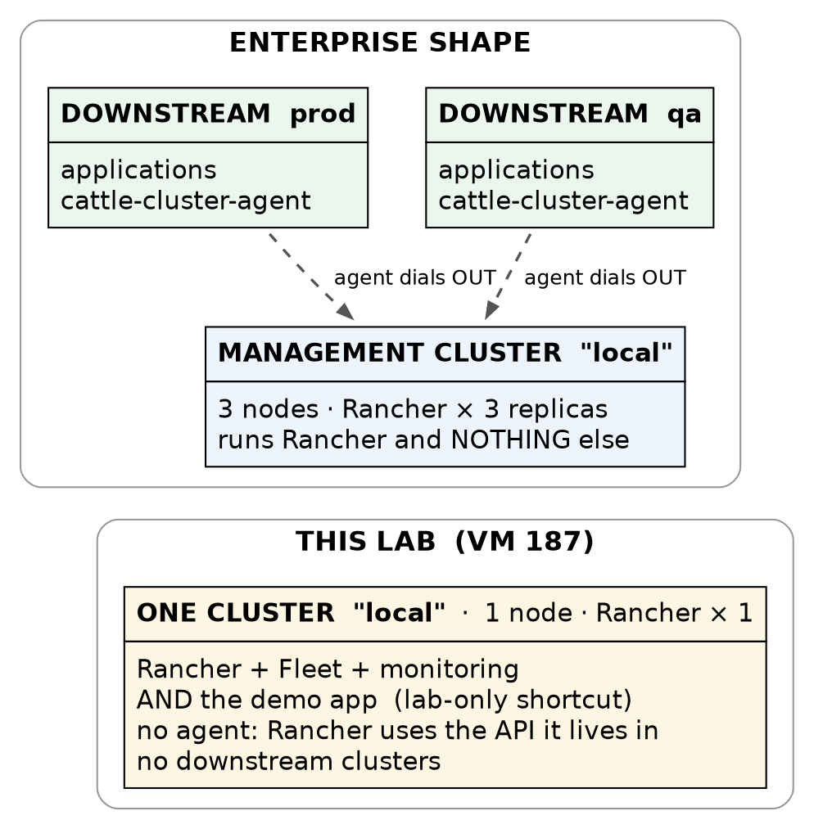
Figure 1 — the enterprise shape and this lab’s shape
Why the CKA cluster is not downstream of this Rancher. Importing a cluster installs Rancher’s agent, its admission webhook and cluster-admin bindings into that cluster. The five-node CKA cluster exists for troubleshooting drills, and Rancher’s components would become part of every symptom. So Rancher manages only itself here, and the local cluster is the test-drive target.

3. Why Rancher gets a cluster of its own
There are four places you could put Rancher. Three of them are wrong for a reason worth remembering:
Option | Why not
The single-container Docker install (docker run rancher/rancher) | Documented for development and test only. There is no upgrade path except migrating to a real install via backup and restore
A systemd service or a Proxmox LXC container | Not a supported install at all. Rancher expects to be a Kubernetes workload; its own state lives in a Kubernetes API
Inside a cluster it manages | If that cluster fails, the tool you would fix it with fails too
✅ Helm, onto a Kubernetes cluster that runs only Rancher | The supported production shape, and what this lab builds — scaled down to one node
The third row is the principle. Rancher holds cluster-admin credentials to every cluster it manages. That makes it the most privileged thing in the estate, and it belongs in its own blast radius: its own cluster, its own upgrade schedule, its own access rules. Mixing it with workloads means any workload compromise is one step from everything.

4. What Rancher installed besides itself
The Rancher chart installs one Deployment. Within minutes of it starting, Rancher had installed six more Helm releases of its own — and helm list shows them alongside the ones you installed:
sudo -E env KUBECONFIG=/etc/rancher/k3s/k3s.yaml helm list -A
NAME NAMESPACE CHART APP VERSION
cert-manager cert-manager cert-manager-v1.21.3 v1.21.3
fleet cattle-fleet-system fleet-110.0.2+up0.16.2 0.16.2
fleet-agent-local cattle-fleet-local-system fleet-agent-local-v0.0.0+s-a686…
fleet-crd cattle-fleet-system fleet-crd-110.0.2+up0.16.2 0.16.2
hello-lab-fleet-hello-lab hello-lab hello-lab-fleet-hello-lab-v0.0.0+git-0682a5dc00f4
rancher cattle-system rancher-2.15.2 v2.15.2
rancher-monitoring cattle-monitoring-system rancher-monitoring-110.0.2+up80.9.1-rancher.22
rancher-monitoring-crd cattle-monitoring-system rancher-monitoring-crd-110.0.2+up80.9.1-rancher.22
rancher-turtles cattle-turtles-system rancher-turtles-110.0.2+up0.27.2 0.27.2
rancher-webhook cattle-system rancher-webhook-110.0.3+up0.11.3 0.11.3
system-upgrade-controller cattle-system system-upgrade-controller-110.0.0 v0.20.1
traefik kube-system traefik-40.1.5+up40.1.0 v3.7.1
traefik-crd kube-system traefik-crd-40.1.5+up40.1.0 v3.7.1
(Columns trimmed for width. The full output also shows revision, update time and status — every release deployed.)
Only four of those were installed deliberately: cert-manager, rancher, and the two rancher-monitoring charts (Chapter 3). K3s installed both traefik releases. Fleet installed hello-lab-fleet-hello-lab (Chapter 4). Rancher installed the other six:
Component | What it is for | Matters here?
rancher-webhook | An admission webhook: the API server asks it to validate changes to Rancher’s own objects. 30 of its 35 rules are failurePolicy: Fail, so if it is down, edits to Rancher resources are refused | Yes — it is in every Rancher write path
fleet + fleet-agent-local | Fleet, Rancher’s GitOps engine: a controller, a gitjob that watches Git, and an agent that applies changes | Yes — Chapter 4 is built on it
system-upgrade-controller | Upgrades K3s/RKE2 on a cluster from Rancher’s UI | 🚨 Yes, as a hazard — see the warning below
rancher-turtles + capi-controller-manager | Cluster API: the machinery Rancher uses to provision new clusters | Dormant — nothing is provisioned here
🚨 system-upgrade-controller is a way around your version pin. K3s here is pinned to v1.35.9 and is not managed by apt, so a routine OS update can never upgrade it. But the Rancher UI can upgrade the local cluster’s K3s through this controller — one click, outside every process that is meant to control that change. Upgrades of the management cluster are a deliberate, tested procedure, never a casual click.
The finished system runs 29 pods (31 listed — two are K3s’s completed Traefik install jobs), three of them application pods, and the node uses about a quarter of its memory:
sudo kubectl top node
NAME CPU(cores) CPU(%) MEMORY(bytes) MEMORY(%)
vm-k3s-rancher-1 505m 8% 6437Mi 26%
The Rancher pod alone was using 863 MiB; Prometheus (Chapter 3) slightly more. Budget memory for Rancher’s companions, not just Rancher — the documented requirements describe the server, not the ecosystem it installs.
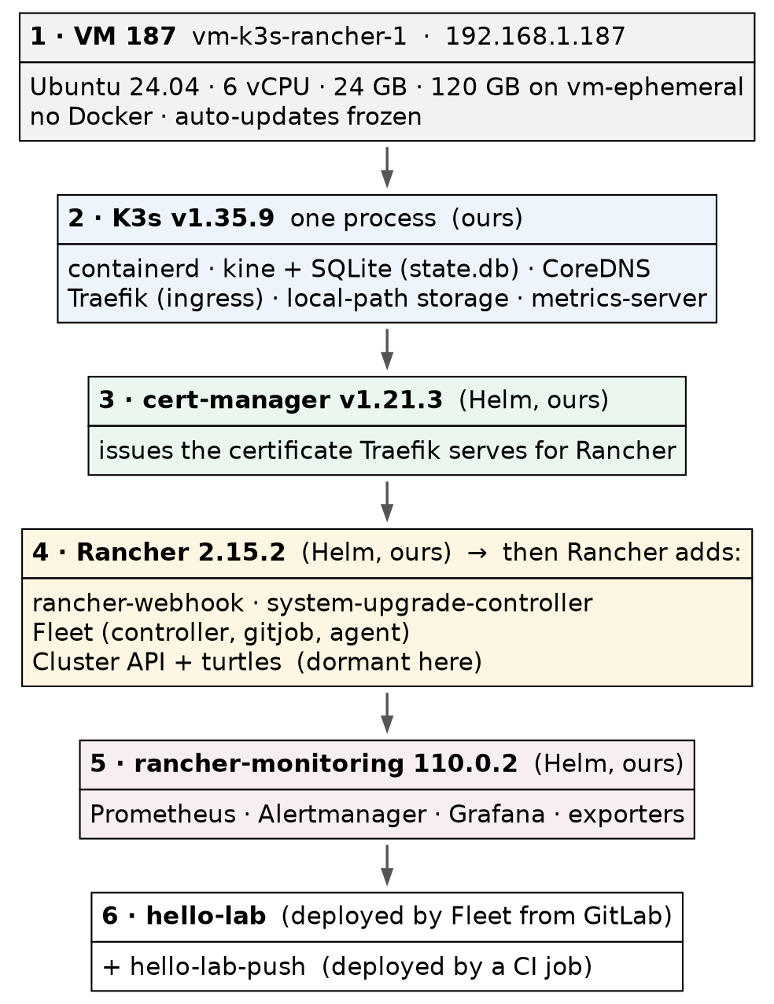
Figure 2 — what runs on VM 187, by layer

5. Rancher’s vocabulary, mapped to Kubernetes
Rancher’s UI introduces words that sound like new concepts. Almost all of them are a Kubernetes object with a Rancher label on it, and knowing which one is what lets you debug Rancher with kubectl when the UI is unhelpful (Chapter 5 shows when that happens).
Rancher says | What it actually is | Evidence on this cluster
Cluster | A clusters.management.cattle.io object, plus a provisioning twin in a Fleet workspace | local, shown in §2
Project | A group of namespaces that share permissions and quotas — a Rancher-only idea; Kubernetes has no such object | p-dshwt = System, p-xblrj = Default
Namespace | A plain namespace, labelled with the project it belongs to | hello-lab, cattle-system, …
App (Apps menu) | A Helm release, mirrored as an apps.catalog.cattle.io object | 13 of them — the same 13 helm list shows
Repository (chart catalogue) | A clusterrepos.catalog.cattle.io — a Git or HTTP source of Helm charts | rancher-charts (branch release-v2.15), rancher-partner-charts, rancher-rke2-charts
Fleet workspace | A namespace that holds GitOps definitions. fleet-local targets the local cluster only; fleet-default targets downstream clusters | Our GitRepo lives in fleet-local
sudo kubectl get projects.management.cattle.io -n local \
-o custom-columns=NAME:.metadata.name,DISPLAY:.spec.displayName
NAME DISPLAY
p-dshwt System
p-xblrj Default
This is also why a fresh Rancher creates a dozen namespaces you did not ask for. local is the cluster’s own management namespace, p-dshwt and p-xblrj back the two projects, and user-4zgmb belongs to the admin user. The names look random because they are generated IDs; the display names live inside the objects.

6. Why K3s, and why one node
K3s is a Kubernetes distribution packaged as a single binary running a single process:
ps -C k3s-server -o pid,rss,etime,cmd --no-headers
19911 1588840 25:20 /usr/local/bin/k3s server
That one process (about 1.5 GB resident here) is the API server, scheduler, controller manager, kubelet and container runtime supervisor at once. K3s also bundles the pieces a bare cluster lacks:
Bundled | Role | Seen in
containerd | The container runtime — no Docker on this VM | CONTAINER-RUNTIME containerd://2.2.7-k3s1
Traefik | The ingress controller. Rancher’s docs: on K3s you do not install one | Chapter 2
CoreDNS | Cluster DNS | kube-system
local-path-provisioner | A default StorageClass that carves volumes out of the node’s disk | Chapter 3 (Prometheus)
metrics-server | What makes kubectl top work | §4 above
kine + SQLite | Stands in for etcd on a single server — the state.db from §1 | —
The choices behind this build, briefly:
- K3s rather than the CKA track’s kubeadm. The CKA cluster exists to practise building Kubernetes by hand. This track is about Rancher, so the cluster underneath should be the least interesting part. K3s and RKE2 are SUSE’s own distributions and the ones Rancher’s install guide leads with (⚠️ recited from the docs; the two were not compared here).
- v1.35. Rancher 2.15.2’s support matrix certifies K3s 1.34–1.36 for the management cluster, and 1.35 is the CKA cluster’s minor, so what you learn transfers.
- One node. A production management cluster runs three, with three Rancher replicas. One node teaches everything except high availability — and is honest about that below.

7. Community Rancher means upgrading every minor
This lab runs community Rancher, not SUSE’s paid Rancher Prime. The difference that matters operationally is not features; it is the patch policy:
Under SUSE’s release policy (in force since August 2024, and checked when this build was planned on October 27, 2026), community users receive patch releases only for the newest minor version. Once 2.16.0 ships, further 2.15.x patches go to Prime customers only.
On community Rancher, staying patched means upgrading every minor release — roughly every few months, and each one may require a K3s upgrade to stay inside the support matrix, and a matching version of every Rancher-packaged chart (Chapter 3’s monitoring chart is tied to 2.15). The upgrade procedure is therefore not an occasional task. ⚠️ It has not been run here yet: 2.15.2 was still the newest community release on October 27, 2026, so the upgrade drill (D6) waits for 2.16.

Where this lab differs from production
Here | In production | Why it matters
One node, one Rancher replica | Three nodes, three replicas | Losing the node loses the management plane until the VM is back. Scale and availability — a table row, not a callout
SQLite (kine) | Embedded etcd across three servers | Same reason: single-server shortcut
No backup operator; rebuildable from scripts | rancher-backup to off-cluster storage | Rancher’s config is the cluster state (§1)
Applications run on the local cluster | Applications run on downstream clusters only | See below — this one is wrong at any scale
Lab vs PROD — applications on Rancher’s own cluster. In the lab: the demo app and its GitOps pipeline run on local, the cluster Rancher itself lives on. Why it’s acceptable here: the purpose is to see Rancher manage something, and a separate downstream cluster was declined to keep the CKA cluster clean (§2); nothing here holds data that matters. In production: Rancher’s documentation says the management cluster should run Rancher and nothing else; workloads go on downstream clusters. If you carry the habit: an application compromise lands in the cluster that holds cluster-admin to every other cluster, and an application’s resource spike competes with the tool you need to diagnose it.

Commands to know by heart
Question | Command
Is Rancher running? | kubectl get deploy -n cattle-system rancher
Does the server answer? | curl -sk https://<rancher-host>/ping → pong
Which clusters does Rancher know about? | kubectl get clusters.management.cattle.io
What did Rancher install? | helm list -A (on K3s, with KUBECONFIG set — Chapter 2)
Which projects exist, by display name? | kubectl get projects.management.cattle.io -n local -o custom-columns=NAME:.metadata.name,DISPLAY:.spec.displayName
What Rancher-specific types exist? | kubectl get crd \| grep cattle.io
How much memory is the stack using? | kubectl top node · kubectl top pods -A --sort-by=memory

Glossary
Rancher server / Rancher Manager — the Rancher application itself: a Deployment in cattle-system.
management cluster (local) — the cluster Rancher is installed on. Rancher always registers it as local.
downstream cluster — any other cluster Rancher manages: imported, provisioned by Rancher, or a hosted service.
cattle-cluster-agent — the agent in each downstream cluster that connects outward to the Rancher server. “Cattle” is Rancher’s historical name for its own components; it prefixes most of its namespaces.
custom resource (CRD) — a new object type added to the Kubernetes API. Rancher keeps all of its state in custom resources.
admission webhook — a service the API server consults before accepting a change. rancher-webhook validates Rancher’s objects.
project — Rancher’s grouping of namespaces for shared permissions; not a Kubernetes concept.
Fleet — Rancher’s built-in GitOps engine. Workspace — the namespace a Fleet definition lives in, which decides which clusters it targets.
K3s — a single-binary Kubernetes distribution with containerd, Traefik, CoreDNS, local-path storage and metrics-server built in.
kine — the layer that lets K3s store cluster state in SQLite instead of etcd.
Rancher Prime — SUSE’s paid edition. Same software; longer patch support.

Check yourself
Answer these out loud. Section references, not answers.
- Someone says “we run our apps on Rancher”. What is the precise version of that sentence? (§1, §2)
- Where is Rancher’s list of users stored, and what has to be backed up to keep it? (§1)
- Why does the local cluster have no cattle-cluster-agent? (§2)
- Give the one-sentence reason Rancher should not run inside a cluster it manages. (§3)
- helm list -A shows thirteen releases and you installed four. Where did the others come from? (§4)
- Why is system-upgrade-controller a risk to a pinned K3s version? (§4)
- In the UI you see a project called Default. How would you find it with kubectl? (§5)
- What does K3s use instead of etcd on one server, and where is it on disk? (§1, §6)
- Why does running community Rancher make the upgrade procedure a regular task? (§7)
- Name the one shortcut in this lab that would be wrong even on a large cluster, and its consequence. (Where this lab differs)

