Rancher on K3s · Chapter 2 — Installing It: K3s, Helm, cert-manager, Rancher
Series: Home-Lab Education · Phase 20 (Rancher on K3s) Built and verified: October 27, 2026, 22:10–22:25 EDT on VM 187 vm-k3s-rancher-1 (192.168.1.187); verification outputs re-captured read-only at 23:25–23:35 the same night Versions at time of writing: K3s v1.35.9+k3s1 · Traefik 3.7.13 · Helm v3.22.1 · cert-manager v1.21.3 · Rancher 2.15.2 Scripts: proxmox/build-scripts/rancher-k3s/ — 3-k3s.sh, 4-rancher.sh (run on the VM as root) · values file in manifests/rancher-values.yaml Read this after: Chapter 1 · before: Chapter 3
🤖 DECLARATION — read this before you trust anything below. Every command in this chapter was executed on VM 187 and every output quoted is real. But it was run by the AI, not by Andrew, at his explicit instruction — so the commands are verified, and the operator judgement behind them was not earned at a keyboard. Chapter 1 explains the rule this declaration exists to honour.

What this chapter covers
The install is four layers, each depending on the one before. The order is the lesson: every step that went wrong in someone’s first Rancher install is a step done out of order, or a layer assumed to be there that was not.
The steps below are the sequence that worked, each followed by how to confirm it took effect — checked from somewhere other than the tool that made the change. The tripping points are at the step where you could still act on them.
The build was scripted, and every script was re-run until it reported 0 changes. The commands shown are the ones inside those scripts, so you can read either.

The order, and why
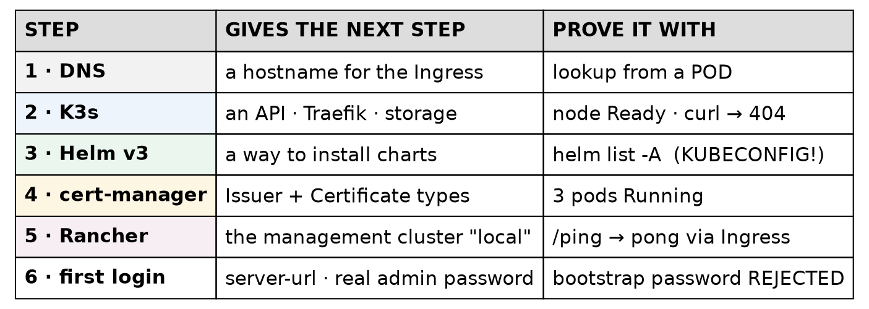
Figure 3 — what each layer needs from the one below
Layer | Needs | Because
DNS name | nothing | The Rancher chart needs a hostname for its Ingress; there is no IP-only install
K3s | a VM | Everything else is a Kubernetes workload
Helm | a cluster to talk to | Rancher, cert-manager and monitoring are all Helm charts
cert-manager | Helm + cluster | It issues the certificate Rancher’s Ingress serves (Step 7)
Rancher | all of the above | Its chart creates cert-manager objects; with no cert-manager, they have nothing to act on
Rancher’s chart does not install cert-manager for you. It assumes it, the same way it assumes an ingress controller — which K3s provides and a bare kubeadm cluster does not.

Step 0 — The VM (assumed)
Routine lab plumbing, already proven many times: VM 187 cloned from template 9000, sized to 6 vCPU, 24 GB RAM, 120 GB disk on vm-ephemeral, personalised with 2-personalize.sh --freeze-updates, added to the lab’s refresh.sh for OS patching, snapshot r01-os-ready.
Two choices in that step are about this build:
- No Docker. K3s brings its own containerd; a second runtime would add a second set of iptables rules and nothing else. So the VM was built with the Kubernetes-node personaliser, not the lab’s Docker-host script.
- vm-ephemeral, no backup job. The lab’s placement rule is one question: can this project rebuild it? Yes — from the scripts in this chapter — so it goes on the unmirrored pool.

Step 1 — A name that pods can resolve
The Rancher chart needs a hostname. Two public Route53 A records were created, both pointing at the VM:
Name | Points at | For
rancher.gothamtechnologies.com | 192.168.1.187 | the Rancher UI and API
hello-rancher.gothamtechnologies.com | 192.168.1.187 | the demo app (Chapter 4)
A private address in public DNS is existing lab practice — gitlab.gothamtechnologies.com already resolves publicly to 192.168.1.181. It reveals an internal address and nothing more, and it means every machine, and every pod, resolves the name with no special configuration.
⚠️ Why not just /etc/hosts? Because pods do not read the node’s /etc/hosts. A pod asks CoreDNS (nameserver 10.43.0.10 below), and CoreDNS forwards upstream. A name that exists only in a hosts file works from your shell and fails from inside the cluster — which is where Rancher’s own components need it.
Confirm — from the node and from inside a pod:
getent hosts rancher.gothamtechnologies.com
sudo kubectl exec -n hello-lab deploy/hello-lab -- \
python -c "import socket; print(socket.gethostbyname('rancher.gothamtechnologies.com'))"
sudo kubectl exec -n hello-lab deploy/hello-lab -- cat /etc/resolv.conf
192.168.1.187 rancher.gothamtechnologies.com
192.168.1.187
search hello-lab.svc.cluster.local svc.cluster.local cluster.local myfiosgateway.com
nameserver 10.43.0.10
options ndots:5
(The pod check needs a running pod, so on a fresh build it comes after Step 2. It is shown here because it belongs to this step’s question.)

Step 2 — K3s, pinned, from a file you can read
2a. Write the configuration before installing
K3s reads /etc/rancher/k3s/config.yaml at start. Writing it first means the cluster is created right, rather than created and then reconfigured:
sudo cat /etc/rancher/k3s/config.yaml
write-kubeconfig-mode: "0600"
node-ip: 192.168.1.187
tls-san:
- "rancher.gothamtechnologies.com"
- "192.168.1.187"
- "vm-k3s-rancher-1"
Key | What it does | Why it matters
write-kubeconfig-mode: "0600" | The admin kubeconfig K3s writes is readable by root only | 🚨 That file is cluster-admin. An earlier lab track used 644 and made it world-readable
node-ip | Pins the address the node advertises | One NIC here, but it removes a guess
tls-san | Extra names written into the API server’s certificate | A client connecting by any name not in the certificate gets a TLS error
The CIDRs were left at their defaults — pods 10.42.0.0/16, services 10.43.0.0/16 — after checking that neither overlaps the lab network 192.168.1.0/24. ⚠️ At work, check against the corporate ranges: a default CIDR is a guess about someone else’s network, and 10.x is where corporate networks live.
2b. Install from a pinned installer, saved to a file
K3S_VERSION="v1.35.9+k3s1"
curl -fsSL -o /root/k3s-install-${K3S_VERSION}.sh \
"https://raw.githubusercontent.com/k3s-io/k3s/v1.35.9%2Bk3s1/install.sh"
INSTALL_K3S_VERSION="$K3S_VERSION" sh /root/k3s-install-${K3S_VERSION}.sh server
Three deliberate differences from the one-liner on K3s’s home page:
- Never curl … | sh. The installer is saved, so it can be read and its checksum recorded, and what ran is what is on disk afterwards.
- The installer comes from the pinned tag, not from get.k3s.io. The script and the binary are the same release.
- INSTALL_K3S_VERSION pins the binary. K3s is not managed by apt, so routine OS patching can never upgrade it. Upgrades are a deliberate act: change the version, re-run.
2c. Confirm
sudo kubectl get node -o wide
sudo kubectl get pods -n kube-system
NAME STATUS ROLES AGE VERSION INTERNAL-IP EXTERNAL-IP OS-IMAGE KERNEL-VERSION CONTAINER-RUNTIME
vm-k3s-rancher-1 Ready control-plane 73m v1.35.9+k3s1 192.168.1.187 <none> Ubuntu 24.04.5 LTS 6.8.0-147-generic containerd://2.2.7-k3s1
NAME READY STATUS RESTARTS AGE
coredns-b644fd95b-fczl9 1/1 Running 2 (41m ago) 73m
helm-install-traefik-bjjs7 0/1 Completed 2 73m
helm-install-traefik-crd-svcwn 0/1 Completed 0 73m
local-path-provisioner-d9d8769b6-v5f8s 1/1 Running 2 (41m ago) 73m
metrics-server-7f4b6d9bd7-gd4pq 1/1 Running 2 (41m ago) 73m
svclb-traefik-b40a9fc0-927hh 2/2 Running 4 (41m ago) 72m
traefik-5869c87968-wm585 1/1 Running 2 (41m ago) 72m
(Captured after two reboot drills, hence the restart counts of 2.)
Read three things in that output:
- helm-install-traefik is a Completed job with 2 restarts. K3s installs Traefik by running Helm inside the cluster, through its own Helm controller. On first boot the job raced the CRDs it needed and retried. Completed with restarts is normal here; it is not a crash to chase.
- svclb-traefik is K3s’s built-in load balancer. Traefik’s Service is type LoadBalancer, and on a bare-metal cluster nothing would ever give it an address. K3s runs a small pod that binds ports 80 and 443 on the node, so the Service gets the node’s own IP as its external address:
- NAME TYPE CLUSTER-IP EXTERNAL-IP PORT(S) AGE
traefik LoadBalancer 10.43.132.182 192.168.1.187 80:31808/TCP,443:31191/TCP 65m
- No application pods, and nothing Pending. A fresh cluster with something Pending has a scheduling or storage problem before you have added anything.
Then test the ingress from outside Kubernetes: curl http://192.168.1.187/ returns 404. A 404 from Traefik is success: the controller is answering, and nothing has asked it to route anything yet.
⚠️ Read the running image, not the chart’s label. helm list reports Traefik’s app version as v3.7.1; the running image is rancher/mirrored-library-traefik:3.7.13. K3s’s packaging sets the image itself. When a version matters, ask the Deployment what it is running: kubectl get deploy -n kube-system traefik -o jsonpath='{.spec.template.spec.containers[0].image}'.
⛔ The kubeconfig stays on the VM. All of this is run over SSH, on the node. Copying /etc/rancher/k3s/k3s.yaml to the workstation would put a second cluster-admin context next to the CKA cluster’s, and one wrong context is a drill command run against the wrong cluster.

Step 3 — Helm v3, and the sudo trap
HELM_VERSION="v3.22.1"
curl -fsSLo helm.tgz "https://get.helm.sh/helm-${HELM_VERSION}-linux-amd64.tar.gz"
curl -fsSLo helm.sha "https://get.helm.sh/helm-${HELM_VERSION}-linux-amd64.tar.gz.sha256sum"
[ "$(sha256sum helm.tgz | cut -d' ' -f1)" = "$(cut -d' ' -f1 helm.sha)" ] && echo verified
tar -xzf helm.tgz && sudo install -m 0755 linux-amd64/helm /usr/local/bin/helm
Why v3 when Helm 4 exists: Rancher’s install documentation assumes Helm 3, and its version-requirements page defines only a v3 rule. When a vendor documents one major version, use that one for their product.
🚨 The trap you will hit the first time you use it. kubectl on K3s is a wrapper that knows where the admin kubeconfig lives. Helm is not, and sudo drops your environment:
sudo helm list -n cattle-system
Error: Kubernetes cluster unreachable: Get "http://localhost:8080/version": dial tcp [::1]:8080: connect: connection refused
localhost:8080 means “I found no kubeconfig at all” — it is Kubernetes clients’ last-resort default, not a sign that the API server is down. Point Helm at the file explicitly:
sudo -E env KUBECONFIG=/etc/rancher/k3s/k3s.yaml helm list -A
The build scripts run as root and export KUBECONFIG=/etc/rancher/k3s/k3s.yaml at the top for this reason.
Confirm: helm version --short → v3.22.1+gd6c1a0e.

Step 4 — cert-manager
helm repo add jetstack https://charts.jetstack.io
helm upgrade --install cert-manager jetstack/cert-manager --version v1.21.3 \
-n cert-manager --create-namespace --set crds.enabled=true --wait --timeout 10m
- crds.enabled=true installs cert-manager’s custom resource types (Issuer, Certificate, …) with the chart. Rancher’s chart creates an Issuer, and without the CRD the cluster does not know that type exists.
- --wait matters more than it looks. cert-manager runs its own admission webhook; an install that returns before the webhook is ready can make the next install fail with an error about a webhook it cannot reach. ⚠️ A well-known failure, not hit here — --wait is what prevented it.
- upgrade --install is the idempotent form: it installs if absent and does nothing if already at that version. Re-running the script is safe.
Confirm:
sudo kubectl get pods -n cert-manager
NAME READY STATUS RESTARTS AGE
cert-manager-7b64759498-dxnlw 1/1 Running 2 (41m ago) 70m
cert-manager-cainjector-5d85cc9c99-lt4l4 1/1 Running 2 (41m ago) 70m
cert-manager-webhook-674b6c7468-r5ltq 1/1 Running 2 (41m ago) 70m
Three pods: the controller, the CA injector, and the webhook.

Step 5 — Rancher
5a. The values file is part of the system
# Rancher Helm values for vm-k3s-rancher-1 (Phase 20). Upgrades MUST reuse these.
# bootstrapPassword is deliberately absent — it is passed from a root-only file at install time
hostname: rancher.gothamtechnologies.com
replicas: 1
ingress:
tls:
source: rancher
Value | Why
hostname | The Ingress host, and the name Rancher will tell agents to dial
replicas: 1 | The chart defaults to 3 — sized for a three-node management cluster
ingress.tls.source: rancher | Rancher generates its own CA and cert-manager issues the certificate from it (Step 7). The alternatives are letsEncrypt and secret (bring your own)
⭐ Keep this file, in version control. Rancher’s docs say it plainly: upgrades need the same options. A helm upgrade without the original values silently reverts every setting to the chart default — here that would mean three replicas and a different certificate source. The file is in the repo; the only thing missing from it is the password, by design.
5b. Install, keeping the password out of sight
helm repo add rancher-latest https://releases.rancher.com/server-charts/latest
# first install only: the bootstrap password goes in a temporary values file, mode 600
printf 'bootstrapPassword: "%s"\n' "$BOOTSTRAP_PASSWORD" > "$BS"
helm upgrade --install rancher rancher-latest/rancher --version 2.15.2 \
-n cattle-system --create-namespace -f rancher-values.yaml -f "$BS"
rm -f "$BS"
The password goes in a file, not --set, because command-line arguments are visible to every user on the machine in the process list. $BOOTSTRAP_PASSWORD is read from a root-only file that is deleted once the install is done.
5c. Confirm — from outside the cluster
sudo kubectl -n cattle-system rollout status deploy/rancher
curl -sk https://rancher.gothamtechnologies.com/ping; echo
deployment "rancher" successfully rolled out
pong
/ping answering pong through the Ingress is the real test: it proves DNS, Traefik, the certificate, the Service and the pod in one request. rollout status alone proves only the last of those.

Step 6 — First login: settings, and retiring the bootstrap password
A fresh Rancher waits for someone to open the UI, accept the terms and set the server URL. The script does the same through Rancher’s own objects — settings are Kubernetes resources, as Chapter 1 showed:
kubectl patch settings.management.cattle.io server-url --type merge \
-p '{"value":"https://rancher.gothamtechnologies.com"}'
kubectl patch settings.management.cattle.io first-login --type merge -p '{"value":"false"}'
server-url matters more than it looks: it is the address Rancher gives every downstream agent to dial back to. ⚠️ Changing it after downstream clusters are registered is documented as disruptive — recited, not tested; there are no downstream clusters here.
🚨 Tripping point — a setting that does not exist. The script also tried to set telemetry-opt, a setting that appears in older Rancher guides. On 2.15.2:
Error from server (NotFound): settings.management.cattle.io "telemetry-opt" not found
Settings come and go between Rancher versions, and a script written from an older guide stops dead. The fix was to check that a setting exists before patching it, and skip it with a warning if not. List what your version actually has with kubectl get settings.management.cattle.io.
The bootstrap password must stop working. The script logs in with it once, through Rancher’s API, and changes the admin password to the real one. Then it proves both halves: the new password logs in, and the bootstrap value is rejected. Until the second half is true, anyone who saw the install command can log in as admin.
Confirm — the management cluster is up:
sudo kubectl get clusters.management.cattle.io local \
-o jsonpath='{.status.conditions[?(@.type=="Ready")].status}'; echo
sudo kubectl get settings.management.cattle.io first-login eula-agreed \
-o custom-columns=NAME:.metadata.name,VALUE:.value
True
NAME VALUE
first-login false
eula-agreed 2026-10-28T02:22:58.000Z
local Ready=True is what the UI shows as Active. Snapshot r02-rancher-up.

Step 7 — Follow the certificate
The browser warns when it opens https://rancher.gothamtechnologies.com. It is worth knowing exactly why, because the warning is about trust, not about a broken certificate. With ingress.tls.source: rancher, four objects form a chain:
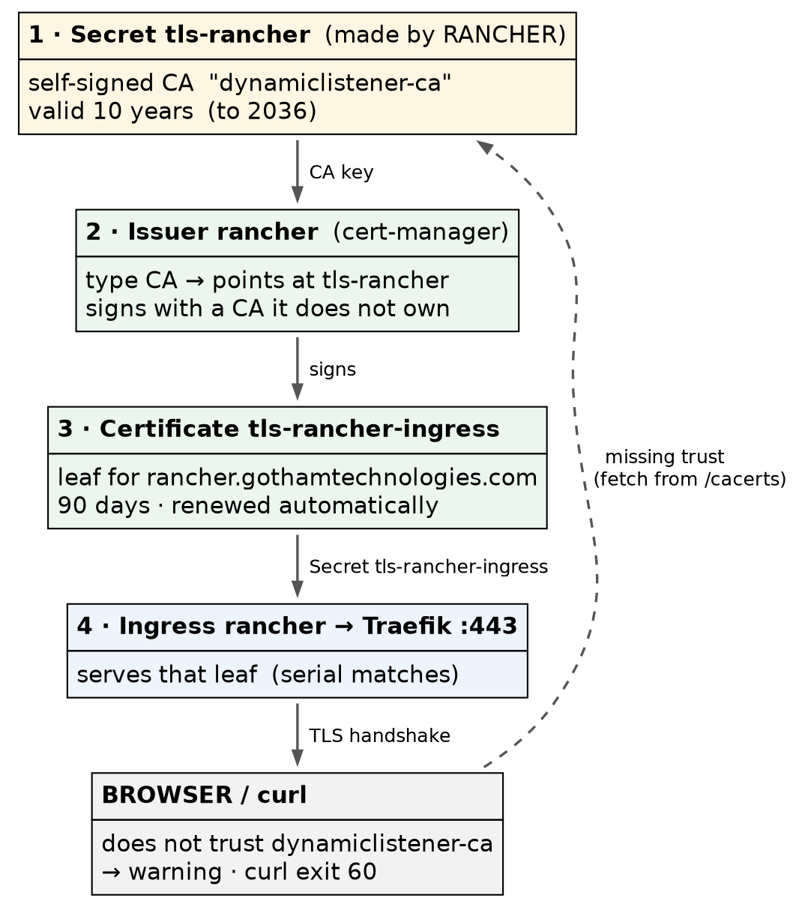
Figure 4 — the certificate chain behind Rancher’s Ingress
1. Rancher generates its own CA and stores it in the Secret tls-rancher:
sudo kubectl get secret -n cattle-system tls-rancher -o jsonpath='{.data.tls\.crt}' \
| base64 -d | openssl x509 -noout -subject -issuer -dates
subject=O = dynamiclistener-org, CN = dynamiclistener-ca@1793154155
issuer=O = dynamiclistener-org, CN = dynamiclistener-ca@1793154155
notBefore=Oct 28 01:22:35 2026 GMT
notAfter=Oct 25 01:22:35 2036 GMT
Subject equals issuer: a self-signed CA, valid for ten years. (dynamiclistener is the TLS library Rancher and K3s share; the name is not a misconfiguration.)
2. cert-manager’s Issuer points at that CA — it does not own one of its own:
$ kubectl get issuer -n cattle-system rancher -o jsonpath='{.spec}'
{"ca":{"secretName":"tls-rancher"}}
3. A Certificate asks for a leaf for the hostname, and the Ingress names the Secret it produces:
$ kubectl get certificate -n cattle-system tls-rancher-ingress -o jsonpath='{.spec}'
{"dnsNames":["rancher.gothamtechnologies.com"],"issuerRef":{"group":"cert-manager.io","kind":"Issuer","name":"rancher"},"secretName":"tls-rancher-ingress","usages":["digital signature","key encipherment"]}
$ kubectl get ingress -n cattle-system rancher -o jsonpath='{.spec.tls}'
[{"hosts":["rancher.gothamtechnologies.com"],"secretName":"tls-rancher-ingress"}]
4. Traefik serves that leaf. Prove it by comparing serial numbers — the certificate on the wire against the one in the Secret:
echo | openssl s_client -connect rancher.gothamtechnologies.com:443 \
-servername rancher.gothamtechnologies.com 2>/dev/null | openssl x509 -noout -serial -ext subjectAltName
serial=25B9DC7AC20E2BF790DC76CD7439720AA7CBD2E6
X509v3 Subject Alternative Name: critical
DNS:rancher.gothamtechnologies.com
Same serial as tls-rancher-ingress. The leaf is valid for 90 days (Oct 28, 2026 → Jan 26, 2027), and cert-manager renews it automatically, signed by the same ten-year CA.
So why the warning? No browser trusts dynamiclistener-ca. Give a client that CA and the error disappears:
curl -s -o /dev/null -w '%{http_code} %{ssl_verify_result}\n' https://rancher.gothamtechnologies.com/ping; echo exit=$?
curl -s -o /dev/null -w '%{http_code}\n' \
--cacert <(sudo kubectl get secret -n cattle-system tls-rancher -o jsonpath='{.data.tls\.crt}' | base64 -d) \
https://rancher.gothamtechnologies.com/ping
curl -sk https://rancher.gothamtechnologies.com/cacerts | openssl x509 -noout -subject -issuer
000 20
exit=60
200
subject=O = dynamiclistener-org, CN = dynamiclistener-ca@1793154155
issuer=O = dynamiclistener-org, CN = dynamiclistener-ca@1793154155
Exit 60 is curl’s “peer certificate cannot be authenticated”, and verify result 20 is OpenSSL’s “unable to get local issuer certificate” — no trusted CA. Hand curl the CA from tls-rancher and the same request returns 200. Rancher also publishes that CA at /cacerts, which is how a client that is not on the cluster can obtain it. ⚠️ Fetching it with -k, as the last command does, trusts whatever answered — fine for a demonstration, wrong as the way to establish trust; verify the CA out of band.
Lab vs PROD — a self-signed CA, and clicking through the warning. In the lab: Rancher’s UI is served under a CA that Rancher generated itself, so every browser warns and every visit starts with “proceed anyway”. Why it’s acceptable here: one administrator, on a home network, where the name and address are known; the alternative (Let’s Encrypt) needs the server reachable from the internet. In production: the certificate comes from the organisation’s CA or a public one (ingress.tls.source: secret or letsEncrypt), and the browser shows no warning at all. ⚠️ Recited from Rancher’s documentation; only rancher was tested here. If you carry the habit: clicking through a certificate warning becomes reflex, and the one day the warning means someone is intercepting the admin login — to the tool that holds cluster-admin everywhere — you click through that one too.

Step 8 — Prove it is re-runnable
Each script has a --check mode that reports without changing anything. Run against the finished system:
sudo bash 4-rancher.sh --check
━━━ HELM v3.22.1
ok helm v3.22.1
━━━ CERT-MANAGER v1.21.3
ok cert-manager v1.21.3 deployed
━━━ RANCHER 2.15.2
ok rancher 2.15.2 deployed
━━━ WAIT FOR RANCHER
deployment "rancher" successfully rolled out
ok deploy/rancher rolled out (1 available)
ok https://rancher.gothamtechnologies.com/ping -> pong
━━━ FIRST-LOGIN SETTINGS
ok setting server-url = https://rancher.gothamtechnologies.com
ok setting eula-agreed = 2026-10-28T02:22:58.000Z
ok setting first-login = false
━━━ VERIFY THE local CLUSTER
ok management cluster 'local' Ready=True (Active in the UI)
0 change(s) made. Re-run to confirm it reports 0.
(Abridged: the repository, pod-list and per-namespace lines are omitted.)
0 changes on a re-run is the test of an install script. A script that reports changes on a system it already built is either not idempotent or is fighting something else that changes the same thing — and either is a problem you want to know about now, not during an outage.

Where this lab differs from production
Here | In production | Why it matters
One node, replicas: 1 | Three nodes, three replicas | Availability — a table row (Chapter 1)
Rancher-generated CA | Organisation or public CA | Callout in Step 7
Public DNS record with a private address | Internal DNS, or the same pattern by policy | Discloses one internal address; acceptable here
Install scripts run as root on the node, kubeconfig on the node | The same, or a bastion with audited access | Kept deliberately — it is the safe pattern, not a shortcut

Commands to know by heart
Question | Command
Is the node up, and what is it running? | kubectl get node -o wide
Did K3s’s bundled components start? | kubectl get pods -n kube-system (Completed helm-install-* jobs are normal)
Why does sudo helm say localhost:8080? | It found no kubeconfig: sudo -E env KUBECONFIG=/etc/rancher/k3s/k3s.yaml helm …
Is Rancher up, end to end? | curl -sk https://<host>/ping → pong
What image is actually running? | kubectl get deploy -n <ns> <name> -o jsonpath='{.spec.template.spec.containers[0].image}'
Which certificate is on the wire? | openssl s_client -connect <host>:443 -servername <host> \| openssl x509 -noout -serial -issuer
What is Rancher’s CA? | curl -sk https://<host>/cacerts
Which settings does this Rancher version have? | kubectl get settings.management.cattle.io
Is the management cluster Active? | kubectl get clusters.management.cattle.io local -o jsonpath='{.status.conditions[?(@.type=="Ready")].status}'

Glossary
tls-san — Subject Alternative Names: extra names and addresses written into the API server’s certificate, so clients can connect by any of them.
ServiceLB (svclb-*) — K3s’s built-in load balancer: it gives a LoadBalancer Service the node’s IP by binding the ports on the node.
K3s Helm controller — the component inside K3s that installs bundled charts (Traefik) by running Helm jobs in the cluster. ⚠️ Changing Traefik’s settings on K3s is done with a HelmChartConfig object rather than helm upgrade — standard K3s practice, not exercised here.
idempotent — safe to run again: a second run changes nothing. helm upgrade --install is the idempotent form of helm install.
bootstrap password — the one-time admin password set at install. It must be replaced and then rejected.
server-url — the address Rancher gives agents to dial back to.
CA issuer — a cert-manager Issuer that signs certificates with a CA stored in a Secret. It renews leaves; it does not own or rotate the CA.
leaf certificate — the certificate for one hostname, signed by a CA. Here: tls-rancher-ingress, 90 days.
/cacerts — Rancher’s endpoint publishing its CA certificate.

Check yourself
Answer these out loud. Section references, not answers.
- Why must cert-manager be installed before Rancher, and what fails if it is not? (The order, Step 4)
- A name resolves on the node but Rancher’s pods cannot reach it. What is the likely cause? (Step 1)
- What does tls-san protect you from, and when would you discover you had left a name out? (Step 2a)
- helm-install-traefik shows 2 restarts. Do you investigate? (Step 2c)
- curl http://<node>/ returns 404 before Rancher is installed. Good or bad? (Step 2c)
- sudo helm list reports localhost:8080 … connection refused. Is the API server down? (Step 3)
- Why is the Rancher values file kept in version control, and what happens on an upgrade without it? (Step 5a)
- Why is /ping a better test than rollout status? (Step 5c)
- Which two things must be true about passwords before Step 6 is finished? (Step 6)
- The browser warns about Rancher’s certificate. Name the four objects in the chain and say which one the browser is objecting to. (Step 7)
- What does it mean when a script’s --check reports a change on a finished system? (Step 8)

