Rancher on K3s · Chapter 3 — Seeing It: rancher-monitoring
Series: Home-Lab Education · Phase 20 (Rancher on K3s) Built and verified: October 27, 2026, 22:26–22:30 EDT on VM 187 vm-k3s-rancher-1 (192.168.1.187); outputs re-captured read-only at 23:35–23:45 the same night Versions at time of writing: rancher-monitoring 110.0.2+up80.9.1-rancher.22 (Prometheus Operator v0.87.1 · Grafana 12.3.1) · Rancher 2.15.2 · K3s v1.35.9+k3s1 Script: proxmox/build-scripts/rancher-k3s/5-monitoring.sh · values in manifests/monitoring-values.yaml Read this after: Chapter 2 · before: Chapter 4
🤖 DECLARATION — read this before you trust anything below. Every command in this chapter was executed on VM 187 and every output quoted is real. But it was run by the AI, not by Andrew, at his explicit instruction — so the commands are verified, and the operator judgement behind them was not earned at a keyboard. ⚠️ The Grafana dashboards were not opened in a browser; everything here was verified through Prometheus’s own API.

What this chapter covers
Rancher has a Monitoring menu, and installing it is one Helm chart. What that chart actually deploys — and what it quietly does not do — is the subject of this chapter:
- what rancher-monitoring is, and why it is two charts
- how to choose its version (Rancher decides, not you)
- why K3s needs special settings to be monitored at all
- 🚨 why the retention limit is the only thing stopping Prometheus filling the disk — the volume’s size is not
- how a five-minute-old error kept being served after Grafana had recovered
- why the alerting pipeline, as installed, tells nobody anything

1. What rancher-monitoring is
It is the community kube-prometheus-stack — Prometheus, Alertmanager, Grafana and the exporters — repackaged by Rancher with Rancher’s images and Rancher’s defaults. The chart says so in its own metadata:
sudo kubectl get apps.catalog.cattle.io -n cattle-monitoring-system rancher-monitoring \
-o jsonpath='{.spec.chart.metadata.annotations}' | tr ',' '\n' \
| grep -E 'rancher-version|kube-version|upstream|display-name|certified'
"catalog.cattle.io/certified":"rancher"
"catalog.cattle.io/display-name":"Monitoring"
"catalog.cattle.io/kube-version":"\u003e= 1.34.0-0 \u003c 1.37.0-0"
"catalog.cattle.io/rancher-version":"\u003e= 2.15.0-0 \u003c 2.16.0-0"
"catalog.cattle.io/upstream-version":"80.9.1"}
(\u003e and \u003c are > and <, escaped by JSON.) The version string itself encodes the same thing: 110.0.2+up80.9.1-rancher.22 reads as Rancher’s chart line 110, built on upstream 80.9.1.
It is built on the operator pattern. You do not configure Prometheus by editing its config file; you create Kubernetes objects and an operator turns them into config:
Object | Meaning | Count here
Prometheus | “run a Prometheus with these settings” | 1
ServiceMonitor | what to scrape, found by Service labels | 13
PrometheusRule | alerting and recording rules | 31
Alertmanager | “run an Alertmanager” (its routing lives in a Secret) | 1
And the pods that result, as the install script’s --check mode lists them:
alertmanager-rancher-monitoring-alertmanager-0 2/2 Running
prometheus-rancher-monitoring-prometheus-0 3/3 Running
pushprox-k3s-server-client-c6kgg 1/1 Running
pushprox-k3s-server-proxy-cfd8ddbc7-hqlv2 1/1 Running
rancher-monitoring-grafana-7ff7db6cd-4cmmf 3/3 Running
rancher-monitoring-kube-state-metrics-c8f675d4c-r644m 1/1 Running
rancher-monitoring-operator-6969495657-bt9vk 1/1 Running
rancher-monitoring-prometheus-adapter-776b98d674-h8lgf 1/1 Running
rancher-monitoring-prometheus-node-exporter-qbm44 1/1 Running
ok all cattle-monitoring-system pods Running
pvc prometheus-rancher-monitoring-prometheus-db-prometheus-rancher-monitoring-prometheus-0 Bound 20Gi local-path
ok Prometheus retention: 7d 15GiB
ok Prometheus targets: 15 targets; none down
Pod | Job
operator | Watches the objects above and writes Prometheus and Alertmanager configuration
prometheus-…-0 | Scrapes and stores metrics; evaluates rules
alertmanager-…-0 | Receives firing alerts and routes them to people (§6)
grafana | Dashboards — three containers, one of which is the proxy in §5
node-exporter | Node metrics: CPU, memory, disk, network
kube-state-metrics | Object metrics: how many replicas are ready, rather than how much CPU
prometheus-adapter | Serves Prometheus data through the Kubernetes metrics API
pushprox-… | Reaches K3s’s control plane (§3)
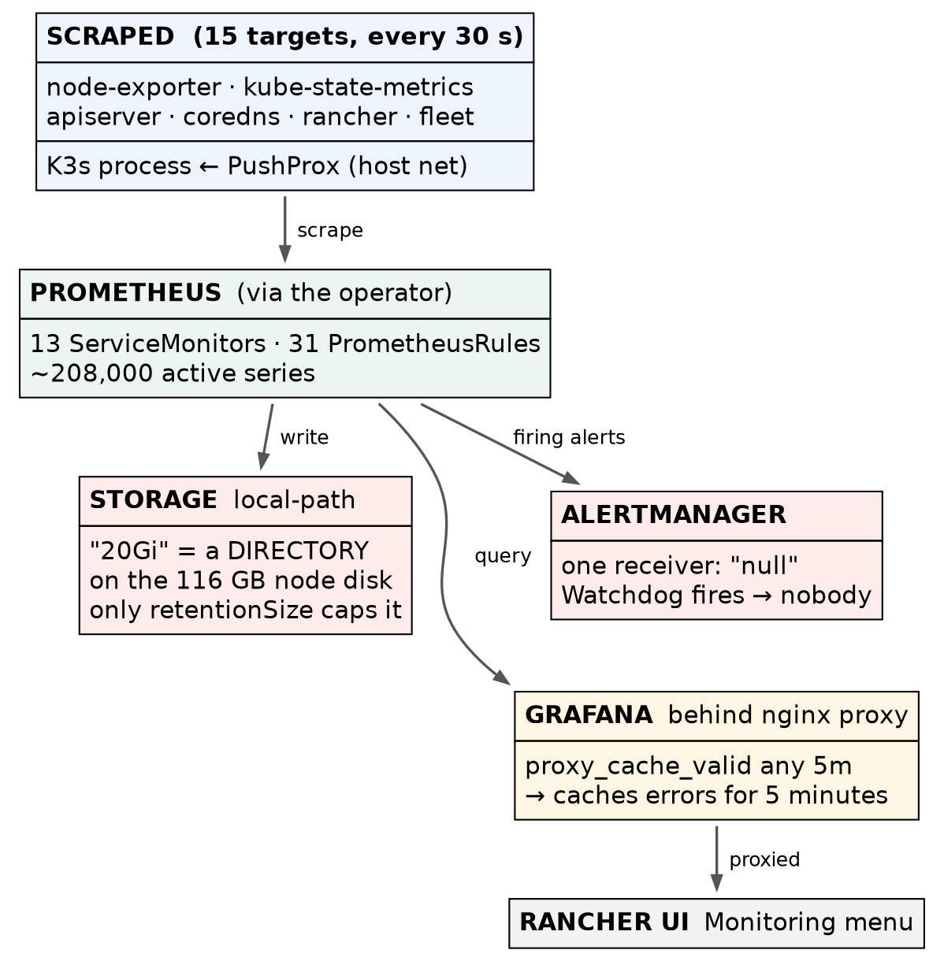
Figure 5 — how metrics flow, and where the two surprises sit

2. Install the CRDs, then the chart — at the version Rancher allows
2a. Choose the version from the annotation, not from “latest”
The rancher-version annotation above is a constraint: this chart works with Rancher 2.15.x only. Chart line 110 belongs to Rancher 2.15; Rancher 2.16 will need chart line 111. ⭐ Upgrading Rancher means upgrading every Rancher-packaged chart with it — this is part of why Chapter 1 called the upgrade a regular procedure rather than an event.
2b. Two charts, in order
helm repo add rancher-charts https://charts.rancher.io
helm upgrade --install rancher-monitoring-crd rancher-charts/rancher-monitoring-crd \
--version 110.0.2+up80.9.1-rancher.22 -n cattle-monitoring-system --create-namespace --wait --timeout 15m
helm upgrade --install rancher-monitoring rancher-charts/rancher-monitoring \
--version 110.0.2+up80.9.1-rancher.22 -n cattle-monitoring-system \
-f monitoring-values.yaml --wait --timeout 15m
The custom resource types come in their own chart so that their lifecycle is separate from the workloads’: Helm treats CRDs cautiously (deleting one deletes every object of that type), and splitting them out lets the main chart be removed or reinstalled without touching the definitions. ⚠️ That rationale is the general Helm practice, recited; what was run here is the two installs, in that order.

3. K3s needs its own monitoring settings
On a kubeadm cluster, the scheduler and controller manager are separate pods, each with a metrics endpoint Prometheus can scrape. On K3s they are all inside the one k3s server process (Chapter 1, §6), with their metrics bound to the node’s localhost — where a pod cannot reach them.
The values file handles both halves of that:
k3sServer:
enabled: true # deploy PushProx to reach the K3s process
kubeControllerManager:
jobNameOverride: k3s-server # the dashboards' queries look for this job name instead
kubeScheduler:
jobNameOverride: k3s-server
kubeProxy:
jobNameOverride: k3s-server
PushProx is the trick. A client runs on the node’s own network and connects outward to a proxy inside the cluster; Prometheus scrapes through the proxy, and the client fetches from localhost on its behalf:
sudo kubectl get ds -n cattle-monitoring-system pushprox-k3s-server-client \
-o jsonpath='{.spec.template.spec.hostNetwork} {.spec.template.spec.containers[0].args}'
true ["--fqdn=$(HOST_IP)","--proxy-url=$(PROXY_URL)","--allow-port=10250","--use-localhost","--insecure-skip-verify","--token-path=/var/run/secrets/kubernetes.io/serviceaccount/token"]
hostNetwork: true and --use-localhost are the two halves. The jobNameOverride lines matter just as much: without them the targets are scraped, but the dashboards query job names that do not exist, and the control-plane panels sit empty with no error. ⚠️ That failure is inferred from how the dashboards select data; it was not provoked here.
Confirm — every target up, from Prometheus’s own API:
sudo kubectl exec -n cattle-monitoring-system prometheus-rancher-monitoring-prometheus-0 -c prometheus -- \
wget -qO- 'http://localhost:9090/api/v1/targets?state=active' | python3 -c '…count by job and health…'
1 up apiserver
1 up coredns
3 up k3s-server
1 up kube-state-metrics
1 up monitoring-fleet-controller
1 up monitoring-gitjob
1 up node-exporter
1 up rancher
1 up rancher-monitoring-alertmanager
1 up rancher-monitoring-grafana
1 up rancher-monitoring-operator
2 up rancher-monitoring-prometheus
(The Python one-liner that counts targets by job is abbreviated here; the full command is in COMMANDS.md.)
15 targets, none down, three of them k3s-server through PushProx. ⭐ Check the targets page, not a dashboard tile: a dashboard with no data looks identical whether the target is down, the job name is wrong, or nothing has happened yet. The targets API says which.

4. Retention — and the size limit that is not a limit
4a. What was set, and why
prometheus:
prometheusSpec:
retention: 7d
retentionSize: 15GiB
storageSpec:
volumeClaimTemplate:
spec:
storageClassName: local-path
resources:
requests:
storage: 20Gi
The reason is the storage underneath. The VM’s disk sits on a thin-provisioned ZFS pool shared by many VMs, and a thin pool that fills stalls every VM on it at once. Prometheus, left alone, grows until something stops it. So retention was set explicitly — by age (7 days) and by size (15 GiB), whichever comes first.
4b. 🚨 The 20 Gi on the volume claim enforces nothing
The volume claim asks for 20 Gi, and Kubernetes reports it bound at 20 Gi. Now ask the filesystem:
sudo kubectl exec -n cattle-monitoring-system prometheus-rancher-monitoring-prometheus-0 -c prometheus -- \
df -h /prometheus | tail -1
sudo kubectl get pv -o custom-columns=NAME:.metadata.name,CAP:.spec.capacity.storage,PATH:.spec.hostPath.path,LPATH:.spec.local.path,NODE:.spec.nodeAffinity.required.nodeSelectorTerms[0].matchExpressions[0].values[0]
sudo sh -c 'du -sh /var/lib/rancher/k3s/storage/*'
/dev/sda1 115.2G 12.8G 102.4G 11% /prometheus
NAME CAP PATH LPATH NODE
pvc-8c511a4c-1b0c-4188-bf29-d840c51850f8 20Gi <none> /var/lib/rancher/k3s/storage/pvc-8c511a4c-…_cattle-monitoring-… vm-k3s-rancher-1
94M /var/lib/rancher/k3s/storage/pvc-8c511a4c-…_cattle-monitoring-…
(The long directory names are truncated with … and the column padding shortened to match.)
Prometheus sees the node’s entire 115 GB root disk. local-path does not create a 20 GB volume; it creates a directory on the node’s disk and labels it 20 Gi. Nothing enforces the label.
So the guard that actually protects the disk is retentionSize: 15GiB — Prometheus deleting its own oldest data when it passes that size. If that setting were missing, the “20Gi” would not save you; Prometheus would grow until the VM’s 120 GB disk was full. (Found while writing this chapter, not during the build — the plan had assumed the claim size was a second line of defence.)
Confirm the setting the operator actually applied — read it from the Prometheus object, not the values file:
sudo kubectl get prometheus -n cattle-monitoring-system rancher-monitoring-prometheus \
-o jsonpath='{.spec.retention} {.spec.retentionSize} {.spec.scrapeInterval}'; echo
7d 15GiB 30s
Measured growth so far: 44.3 MB at 22:59, 75.9 MB at 23:24 — about 208,000 active series, scraped every 30 seconds. Early growth includes the write-ahead log and is not a rate to extrapolate. ⚠️ Whether retentionSize is honoured has not been tested yet: that is drill D5, due after 24 hours of data (Chapter 5).

5. Reaching Grafana — and the five-minute ghost
Grafana’s pod has three containers:
grafana-sc-dashboard rancher/appco-k8s-sidecar:2.1.2-1.10
grafana rancher/appco-grafana:12.3.1-1.12
grafana-proxy rancher/mirrored-library-nginx:1.31.3-alpine
The sidecar loads dashboards from ConfigMaps. grafana-proxy is an nginx that sits in front of Grafana so it can be served through Rancher’s UI, and it caches what it serves:
sudo kubectl get cm -n cattle-monitoring-system grafana-nginx-proxy-config -o jsonpath='{.data}' \
| tr ',' '\n' | grep -o -E 'proxy_cache[a-z_]*[^;]*;' | sort -u
proxy_cache my_zone;
proxy_cache_bypass $http_cache_control;
proxy_cache_path /var/cache/nginx/cache levels=1:2 keys_zone=my_zone:100m inactive=1d max_size=10g;
proxy_cache_valid 200 302 1d;
proxy_cache_valid 301 30d;
proxy_cache_valid any 5m;
🚨 proxy_cache_valid any 5m caches errors too. Immediately after the install, Prometheus reported the Grafana target down with HTTP 502 for about five minutes — although Grafana itself had finished starting. While Grafana was still coming up, the proxy got no good answer from it and returned a 502 — and with any 5m, the proxy cached that 502 and served it for five minutes. It then cleared by itself, with no change made.
⭐ The lesson is general: a cache in front of a service can keep reporting a failure after the failure is over. When something “stays broken” for a suspiciously round number of minutes, look for a cache before you start restarting things. Asking the backend directly — past the proxy — tells you which. The same proxy, with the same settings, sits in front of Prometheus.

6. Alerts that go nowhere
Prometheus evaluates 31 rule sets and can fire alerts. Alertmanager’s job is to route them to a person. Look at where it routes them (structure only — this file can hold credentials):
sudo kubectl get secret -n cattle-monitoring-system alertmanager-rancher-monitoring-alertmanager \
-o jsonpath='{.data.alertmanager\.yaml}' | base64 -d | grep -nE 'receiver|name:|_configs|route'
26:receivers:
27:- name: "null"
28:route:
33: receiver: "null"
35: routes:
38: receiver: "null"
One receiver, named "null", on every route. And what is firing right now, from Prometheus’s alerts API (the same wget … | python3 pattern as the targets check, against /api/v1/alerts):
1 alerts; [('Watchdog', 'firing')]
Watchdog is the alert that is designed to fire forever — its only purpose is to prove that alerts reach someone. Here it is delivered to "null". The whole pipeline works up to the last step, and the last step is a black hole.
Lab vs PROD — monitoring with no alert route. In the lab: rancher-monitoring is installed with its default Alertmanager configuration, whose only receiver is "null"; rules evaluate and alerts fire, and nobody is told. Why it’s acceptable here: one person, looking at the system directly; the purpose is to see the stack, not to be paged by it. In production: receivers (email, chat, a pager) are configured — through AlertmanagerConfig objects or the chart’s values — and Watchdog is wired to a dead-man’s switch that alerts when it stops arriving. ⚠️ Recited practice; no receiver was configured or tested here. If you carry the habit: a green Monitoring menu becomes evidence that someone would be told, and the first real outage is discovered by a user.

7. What monitoring costs
sudo kubectl top pods -A --sort-by=memory | head -5
NAMESPACE NAME CPU(cores) MEMORY(bytes)
cattle-monitoring-system prometheus-rancher-monitoring-prometheus-0 50m 884Mi
cattle-system rancher-6f7f6f6977-lp9th 19m 863Mi
cattle-monitoring-system rancher-monitoring-prometheus-adapter-776b98d674-h8lgf 2m 501Mi
cattle-monitoring-system rancher-monitoring-grafana-7ff7db6cd-4cmmf 11m 313Mi
The monitoring stack uses more memory than Rancher itself — about 1.7 GiB for Prometheus, its adapter and Grafana against Rancher’s 0.85 GiB — on a cluster that runs one demo app. Prometheus’s memory grows with the number of active series (here ~208,000), not with the number of apps. Size the management cluster for its monitoring, not just for Rancher.

Where this lab differs from production
Here | In production | Why it matters
Alertmanager receiver "null" | Real receivers + a dead-man’s switch on Watchdog | Callout in §6
Prometheus on local-path — a directory on one node’s disk, no backup | Network or replicated storage; long-term metrics shipped off the cluster | Metrics lost with the node. Acceptable for a lab; a table row, because losing metrics is rarely the incident
Size held by retentionSize alone (§4b) | The same setting, plus storage that enforces a quota | Both should exist; here only one does
7 days of retention | Longer, or tiered | Scale

Commands to know by heart
Question | Command
Which monitoring chart versions fit this Rancher? | the catalog.cattle.io/rancher-version annotation
Are all targets up? | Prometheus API …/api/v1/targets?state=active (or the Targets page)
What retention is really applied? | kubectl get prometheus -n cattle-monitoring-system -o jsonpath='{.items[0].spec.retention} {.items[0].spec.retentionSize}'
How big is the data really? | kubectl exec … prometheus-…-0 -c prometheus -- du -sh /prometheus
Is the volume’s size enforced? | df -h inside the pod, against the claim’s size
Where do alerts go? | the receiver lines of the Alertmanager Secret
What is firing? | Prometheus API …/api/v1/alerts
Is something cached? | the proxy’s proxy_cache_valid lines; then ask the backend directly

Glossary
kube-prometheus-stack — the community Helm chart bundling Prometheus, Alertmanager, Grafana and the exporters. rancher-monitoring is Rancher’s packaging of it.
operator — a controller that turns custom objects into running configuration. The Prometheus Operator reads ServiceMonitor and PrometheusRule objects.
ServiceMonitor — an object saying “scrape the Services with these labels, on this port”.
target — one endpoint Prometheus scrapes. up or down per target.
PushProx — a client on the node’s network that fetches metrics on Prometheus’s behalf, for endpoints a pod cannot reach.
retention / retentionSize — how long, and how much, Prometheus keeps before deleting its oldest data.
local-path — K3s’s default storage class: a directory on the node’s disk. Its size field is a label, not a quota.
receiver — an Alertmanager destination (email, chat, pager). "null" discards.
Watchdog — an alert that always fires, to prove that alert delivery works.

Check yourself
Answer these out loud. Section references, not answers.
- What is rancher-monitoring, in one sentence, and what does +up80.9.1 in its version mean? (§1)
- You upgrade Rancher to 2.16. What happens to the monitoring chart? (§2a)
- Why does K3s need PushProx when a kubeadm cluster does not? (§3)
- The control-plane dashboards are empty but every target is up. What do you suspect? (§3)
- Why is the targets API a better check than a Grafana panel? (§3)
- The claim says 20 Gi. What actually stops Prometheus filling the disk, and how would you prove it? (§4b)
- Grafana showed a 502 for exactly five minutes and then recovered without anyone touching it. Explain. (§5)
- Everything in Monitoring is green and an outage happens. Who is told? Why? (§6)
- Which uses more memory here, Rancher or its monitoring — and what drives Prometheus’s memory? (§7)

