Rancher on K3s · Chapter 4 — Shipping to It: GitOps with Fleet, and the Push Model
Series: Home-Lab Education · Phase 20 (Rancher on K3s) Built and verified: October 27, 2026, 22:30–22:50 EDT on VM 187 vm-k3s-rancher-1 (192.168.1.187) and GitLab project production/rancher-k3s; outputs re-captured read-only at 23:24–23:50 the same night Versions at time of writing: Fleet (bundled with Rancher 2.15.2) · K3s v1.35.9+k3s1 · GitLab CI images docker:27, alpine:3.22 · kubectl v1.35.9 in the push job Script: proxmox/build-scripts/rancher-k3s/6-gitops.sh · manifests in manifests/ (fleet-gitrepo.yaml, push-rbac.yaml, apps-repo/) Read this after: Chapter 3 · before: Chapter 5
🤖 DECLARATION — read this before you trust anything below. Every command in this chapter was executed on VM 187 or in GitLab CI, and every output quoted is real. But it was run by the AI, not by Andrew, at his explicit instruction — so the commands are verified, and the operator judgement behind them was not earned at a keyboard. The pipeline timings are quoted from the build record; the pipeline’s own job logs are not reproduced here.

What this chapter covers
A cluster with nothing on it teaches nothing. This chapter wires the lab so that a commit to GitLab becomes a running pod without anyone typing kubectl, and it does it twice, two different ways, so they can be compared:
- the pull model — Fleet, inside the cluster, watches a Git repository and applies what it finds
- the push model — a CI job, outside the cluster, holds a cluster credential and applies changes itself
- 🚨 who holds which credential in each model — the real difference between them
- how a node is allowed to pull images from a private registry (K3s has its own file for this)
- what Fleet turns a folder of YAML into, object by object
- why Fleet’s status can say NotReady about an app that is perfectly healthy
- how long a change takes, from git push to serving: 36–42 seconds

1. Two ways to ship
Both models start the same way: a developer commits, CI builds an image and pushes it to a registry. They differ in the last step — who changes the cluster.
 | Pull model (Fleet) | Push model (deploy_push job)
Who connects to whom | the cluster reaches out to GitLab | the CI runner reaches into the cluster’s API
What CI holds | no cluster credential at all | a token that can change the cluster
What the cluster holds | a read-only Git token, a read-only registry token | nothing extra
What “deployed” means | whatever is in Git, continuously re-applied | whatever the last job applied
How you roll back | git revert | re-run an older job, or kubectl by hand
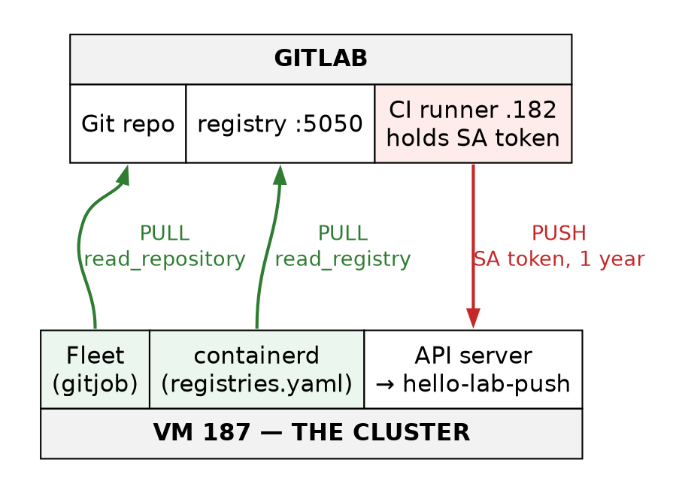
Figure 1 — Pull versus push: which direction each connection goes, and which credential it carries. In the pull model only read-only tokens exist, and they live in the cluster. In the push model the credential that can change the cluster lives on the CI runner.
⭐ The reason the industry moved towards pull is in the second row. In the pull model, stealing everything GitLab holds does not give you the cluster; an attacker would have to get a malicious commit merged to main, which is a reviewed, logged, revertible event. In the push model, whoever can read the runner’s credential can change the cluster directly. ⚠️ That framing is general GitOps practice, recited; what was built here is one of each, side by side, on the same app.

2. The apps repository
Everything that ships lives in one GitLab project, production/rancher-k3s, laid out so that source, deployment manifests and the push-model copy are separate folders:
.gitlab-ci.yml build → bump → (manual) deploy_push
hello-lab/ app.py, Dockerfile the source — CI builds this
fleet/hello-lab/ fleet.yaml, kustomization.yaml,
deployment.yaml, service.yaml, ingress.yaml what Fleet applies
push/hello-lab-push/ kustomization.yaml the push-model copy (no Ingress, 1 replica)
README.md
(Condensed from git ls-files. One stray file, hello-lab/__pycache__/app.cpython-314.pyc, was committed by accident; it is harmless because the Dockerfile copies only app.py.)
hello-lab is deliberately tiny: a Python HTTP server that answers with the commit it was built from, so every curl tells you exactly which version is serving:
curl -s http://hello-rancher.gothamtechnologies.com/
{"app": "hello-lab", "version": "3a2687e8", "delivered_by": "fleet", "pod": "hello-lab-66b58bbb5f-px6d8", "namespace": "hello-lab"}
The Deployment is written the way a production one should be: non-root (runAsUser: 65534), read-only root filesystem, all Linux capabilities dropped, readiness and liveness probes on /healthz, a 64 Mi memory limit. See deployment.yaml.

Step 1 — Let the node pull from the private registry
What it gives you: pods on this node can pull images from gitlab.gothamtechnologies.com:5050.
The obvious move is wrong. On a Docker host you would log in with docker login or edit /etc/docker/daemon.json. K3s does not use Docker — it runs its own containerd and reads its registry settings from /etc/rancher/k3s/registries.yaml, and nothing else. Without that file, the first deploy fails as ImagePullBackOff with an error that looks like a network or DNS fault.
What 6-gitops.sh writes there (the template from the script — the credential values come from a root-only file, never from Git):
mirrors:
"gitlab.gothamtechnologies.com:5050":
endpoint:
- "http://gitlab.gothamtechnologies.com:5050"
configs:
"gitlab.gothamtechnologies.com:5050":
auth:
username: "$PULL_USER"
password: "$PULL_TOKEN"
Two halves. mirrors says how to reach the registry — here, over plain HTTP. configs says how to log in — a GitLab deploy token with only the read_registry scope.
🚨 Tripping point — the file is read only when K3s starts. Writing it changes nothing until systemctl restart k3s. The script restarts K3s itself when it changes the file. Running containers survive a K3s restart (⚠️ K3s’s documented behaviour, recited — not isolated in a test here), but an edit without a restart is silently ignored.
Confirm — structure only. This file holds a credential, so show its keys, never its values:
sudo grep -oE "^ *[a-z]+:|\"http://[^\"]*\"" /etc/rancher/k3s/registries.yaml
sudo stat -c '%a %U %n' /etc/rancher/k3s/registries.yaml
mirrors:
endpoint:
"http://gitlab.gothamtechnologies.com:5050"
configs:
auth:
username:
password:
600 root /etc/rancher/k3s/registries.yaml
Notice what this credential is attached to: the node, not a namespace. Every pod on this node, in any namespace, can pull from that registry with it. On one node running one app that is fine; it is also why a real cluster usually uses per-namespace imagePullSecrets instead. ⚠️ Recited practice; only the node-wide form was built here.
Lab vs PROD — plaintext transport for credentials. In the lab: the node pulls images over plain HTTP (http://…:5050), and Fleet fetches Git over plain HTTP too (Step 3) — each sending a deploy token in every request. Why it’s acceptable here: the traffic crosses one flat home LAN that Andrew controls end to end, the tokens are read-only, and the lab’s GitLab is served over HTTP. In production: registry and Git are served over TLS, and the cluster trusts their CA; a credential never crosses the network in cleartext. If you carry the habit: anyone who can capture traffic on the path collects the tokens, and the http:// endpoint in registries.yaml becomes a copy-paste default for the next cluster. ⚠️ The production practice is recited; the HTTP behaviour is verified.

Step 2 — CI: build the image, then bump the tag in Git
What it gives you: every commit to hello-lab/ produces an image tagged with its commit, and a second commit that tells Fleet to deploy it.
The pipeline has three stages: build, bump, deploy. The first two run automatically, and only when something under hello-lab/ changed:
.app_changed: &app_changed
- if: $CI_COMMIT_BRANCH == $CI_DEFAULT_BRANCH
changes: [hello-lab/**/*]
build:
stage: build
image: docker:27
rules: *app_changed
script:
- echo "$CI_REGISTRY_PASSWORD" | docker login -u "$CI_REGISTRY_USER" --password-stdin "$CI_REGISTRY"
- docker build --pull --build-arg GIT_SHA="$CI_COMMIT_SHORT_SHA" -t "$IMAGE:$CI_COMMIT_SHORT_SHA" hello-lab
- docker push "$IMAGE:$CI_COMMIT_SHORT_SHA"
(Excerpt — tags: lines removed; full file in manifests/apps-repo/gitlab-ci.yml.)
The image tag is the commit hash, never latest. That is what makes the next job possible: the tag in Git names exactly one image, so the Git history is the deployment history.
The bump job is the bridge between CI and Fleet. It clones the repo, rewrites one line, and commits:
bump:
stage: bump
needs: [build]
resource_group: fleet-bump
variables:
GIT_STRATEGY: none
script:
- git clone -q "http://oauth2:<BUMP_TOKEN>@${CI_SERVER_HOST}/${CI_PROJECT_PATH}.git" repo && cd repo
- LATEST=$(git log -1 --format=%H -- hello-lab)
- if [ "$LATEST" != "$CI_COMMIT_SHA" ]; then echo "main has a newer hello-lab commit ($LATEST); skipping"; exit 0; fi
- |
sed -i -E "s|^( *newTag:).*|\1 ${CI_COMMIT_SHORT_SHA} # written by the CI bump job — do not edit by hand|" fleet/hello-lab/kustomization.yaml
- git diff --quiet && { echo "tag already ${CI_COMMIT_SHORT_SHA}"; exit 0; }
- 'git commit -qam "deploy: hello-lab ${CI_COMMIT_SHORT_SHA} [skip ci]"'
- git push -q origin HEAD:"$CI_DEFAULT_BRANCH" || { git pull -q --rebase origin "$CI_DEFAULT_BRANCH" && git push -q origin HEAD:"$CI_DEFAULT_BRANCH"; }
(Excerpt — the apk add git and git config lines are removed. The real job writes ${BUMP_TOKEN} where this shows <BUMP_TOKEN>; the placeholder form keeps this repository’s GitHub push guard, which blocks any URL with an inline credential, from mistaking it for a real token.)
Each line exists for a reason:
- [skip ci] in the message — without it, the bump commit would trigger another pipeline, which would bump again, forever.
- resource_group: fleet-bump — only one bump runs at a time, so two quick commits cannot race to write the same line.
- The LATEST check — if a newer app commit is already on main, this older job steps aside rather than rolling the tag backwards.
- The push retry — if main moved while the job ran, rebase once and push again.
The history shows the pattern — every app commit followed by a bot commit:
git log --format='%h %an %s' -10
0682a5d fiberoptix Revert "D2: replicas 3 while Rancher is scaled to 0"
c83b005 fiberoptix Revert "D3: deliberately broken manifest (replicas: three)"
58d445a fiberoptix D3: deliberately broken manifest (replicas: three)
b778273 fiberoptix D2: replicas 3 while Rancher is scaled to 0
65f94cd ci-tag-bump deploy: hello-lab 3a2687e8 [skip ci]
3a2687e fiberoptix hello-lab: exit on SIGTERM (PID 1 has no default handler)
b65f936 ci-tag-bump deploy: hello-lab 5b687bd9 [skip ci]
5b687bd fiberoptix hello-lab: report delivery path (fleet vs push)
bea279c ci-tag-bump deploy: hello-lab fd227698 [skip ci]
fd22769 fiberoptix hello-lab app, Fleet manifests, CI (build/bump/push-model)
(The four newest commits are Chapter 5’s drills.)
🚨 Tripping point — two YAML traps, caught before the first push. The pipeline file was parsed locally before it was committed, and two lines did not mean what they looked like:
- - git commit -qam "deploy: hello-lab …" written unquoted is not a string. The : inside it makes YAML read the line as a mapping (key git commit -qam "deploy), and GitLab rejects the job. Fix: wrap the whole command in single quotes, as above.
- The sed line contains # written by…. In a plain YAML scalar, space-then-# starts a comment, so everything after it would have been silently dropped from the command. Fix: the - | block scalar, where # is just a character.
⭐ The general lesson: parse CI YAML before you push it (python3 -c 'import yaml; …', or GitLab’s CI Lint). Both of these would have produced a pipeline that looked plausible and did something else.
🚨 Tripping point — pull before you commit. Because the bump job pushes to main after every build, your local clone is behind after every deploy. In the first end-to-end test the local push was rejected because main had moved, and the stopwatch waited 304 seconds for a deploy that had never started. Not a system fault — an operator one. The re-run took 36 seconds.

Step 3 — Fleet: point it at the repository
What it gives you: the cluster watches fleet/hello-lab on main and keeps the cluster matching it.
Fleet came with Rancher (Chapter 1, §4). Wiring it to a repository is one object, a GitRepo, plus a Secret holding a read-only deploy token:
apiVersion: fleet.cattle.io/v1alpha1
kind: GitRepo
metadata:
name: hello-lab
namespace: fleet-local
spec:
repo: http://gitlab.gothamtechnologies.com/production/rancher-k3s.git
branch: main
paths:
- fleet/hello-lab
clientSecretName: gitlab-rancher-k3s-read
pollingInterval: 15s
- namespace: fleet-local — Fleet’s workspace for Rancher’s own cluster. GitRepos in fleet-local deploy to the local cluster; downstream clusters are targeted from fleet-default (⚠️ that half is recited — there are no downstream clusters here).
- paths — only this folder. The source code and the push-model copy are invisible to Fleet.
- pollingInterval: 15s — how often Fleet asks GitLab “has main moved?”. Short for the lab, to make timings visible.
The Secret’s shape — type and key names only:
sudo kubectl get secret -n fleet-local gitlab-rancher-k3s-read \
-o go-template="{{.type}}{{range \$k,\$v := .data}} {{\$k}}{{end}}{{\"\n\"}}"
kubernetes.io/basic-auth password username
Fleet over a plain-HTTP Git URL with a basic-auth Secret works; the build plan had listed it as unverified, and it fetched on the first poll.
Inside the repository folder, two small files tell Fleet how to render it:
# fleet.yaml
defaultNamespace: hello-lab
kustomize:
dir: .
# kustomization.yaml (excerpt)
images:
- name: hello-lab
newName: gitlab.gothamtechnologies.com:5050/production/rancher-k3s/hello-lab
newTag: 3a2687e8 # written by the CI bump job — do not edit by hand
The Deployment says only image: hello-lab; Kustomize’s images: block rewrites that to the full registry path and tag. The bump job edits exactly one line in the whole repository — newTag.
What Fleet turns a folder into
This is the part worth slowing down for. Fleet does not apply YAML directly. It passes it through a chain of objects, each owned by a different Fleet component:
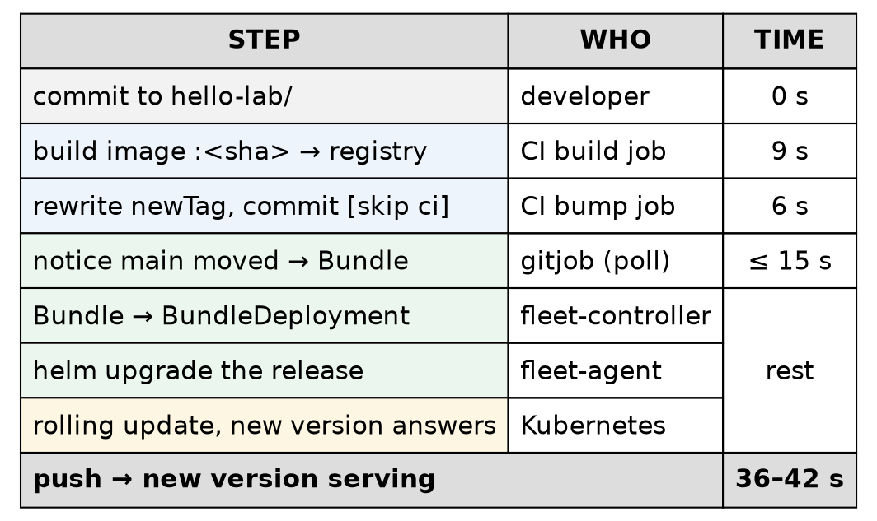
Figure 2 — The delivery path, with measured timings: from a commit in GitLab, through CI and the bump commit, to Fleet’s chain of objects and a rolling update. Total: 36–42 seconds. Which Fleet component does which step is from Fleet’s design (recited); the times are measured.
Confirm — each link in the chain:
sudo kubectl get gitrepo -n fleet-local -o wide
sudo kubectl get bundles -n fleet-local
sudo kubectl get bundledeployments -A
sudo kubectl get clusters.fleet.cattle.io -A
NAME REPO COMMIT BUNDLEDEPLOYMENTS-READY STATUS
hello-lab http://gitlab.gothamtechnologies.com/production/rancher-k3s.git 0682a5dc00f48922fa927e88b5bd2c21d255e273 1/1
NAME BUNDLEDEPLOYMENTS-READY STATUS
fleet-agent-local 1/1
hello-lab-fleet-hello-lab 1/1
NAMESPACE NAME DEPLOYED MONITORED STATUS
cluster-fleet-local-local-1a3d67d0a899 fleet-agent-local True True
cluster-fleet-local-local-1a3d67d0a899 hello-lab-fleet-hello-lab True True
NAMESPACE NAME BUNDLES-READY LAST-SEEN STATUS
fleet-local local 2/2 2026-10-28T03:21:01Z
Read it top to bottom:
- GitRepo hello-lab — has fetched commit 0682a5dc…, the current main.
- Bundle hello-lab-fleet-hello-lab — the rendered contents of one path, named GitRepo name + path. ⭐ A Bundle is “what to deploy”, independent of where.
- BundleDeployment — one per Bundle per target cluster, in a namespace belonging to that cluster. Here there is one cluster, so one each.
- Cluster local — Fleet’s record of the target, with 2 of 2 bundles ready.
The second Bundle, fleet-agent-local, is Fleet deploying its own agent through the same mechanism.
And the last link — the agent installs each BundleDeployment as a Helm release:
sudo -E env KUBECONFIG=/etc/rancher/k3s/k3s.yaml helm list -A | grep -E "NAME|hello"
NAME NAMESPACE REVISION UPDATED STATUS CHART
hello-lab-fleet-hello-lab hello-lab 21 2026-10-28 02:57:40.709117945 +0000 UTC deployed hello-lab-fleet-hello-lab-v0.0.0+git-0682a5dc00f4
(Column padding trimmed; the empty APP VERSION column is removed.)
The repository contains no Helm chart, yet there is a Helm release, revision 21, whose chart version is the Git commit. Fleet wrapped the Kustomize output in a generated chart, so the app gets Helm’s release history. The Deployment carries the marks of it:
{"app":"hello-lab","app.kubernetes.io/managed-by":"Helm","objectset.rio.cattle.io/hash":"a4294e0dc46b25bf1dffd8a5885af2b08124aac2"}
hello-lab-fleet-hello-lab
(Labels, then the meta.helm.sh/release-name annotation, of deploy/hello-lab.)
🚨 Consequence: do not helm upgrade or kubectl edit that release by hand. The next commit Fleet applies overwrites your change, and until then the cluster no longer matches Git — the one thing GitOps promises. Change Git. ⚠️ Recited, not tested here: Fleet reports hand-made drift as Modified, and reverts it on its own only if the GitRepo sets correctDrift, which this one does not.
The components behind the chain are separate Deployments, none of them Rancher itself:
NAME READY UP-TO-DATE AVAILABLE AGE
fleet-controller 1/1 1 1 61m
gitjob 1/1 1 1 61m
helmops 1/1 1 1 61m
NAME READY UP-TO-DATE AVAILABLE AGE
fleet-agent 1/1 1 1 60m
(kubectl get deploy in cattle-fleet-system, then cattle-fleet-local-system.) ⚠️ Their division of labour is from Fleet’s design, recited: gitjob polls Git and produces Bundles; fleet-controller turns Bundles into BundleDeployments for each target cluster; fleet-agent runs on the target and does the Helm install; helmops handles Helm-chart sources and is not used by this repository. What was verified is the consequence: because these are their own Deployments, GitOps kept delivering with Rancher scaled to zero (Chapter 5, drill D2).
Confirm — Fleet’s own view:
sudo kubectl get gitrepo -n fleet-local hello-lab -o jsonpath='{range .status.conditions[*]}{.type}={.status}{"\n"}{end}'
Ready=True
GitPolling=True
Reconciling=False
Stalled=False
Accepted=True

Step 4 — Ship a change, and time it
What it gives you: proof that the whole path works, and a number for how long it takes.
The measured path, from the build record: commit to hello-lab/ → build 9 s → bump 6 s → bump commit lands on main → Fleet’s next poll (up to 15 s) → Helm upgrade → rolling update → the new version answering. Push to new version serving: 36–42 seconds, across the runs timed.
How “serving” was decided: curl in a loop until the version field equals the new commit. Not the pipeline’s green tick, and not Fleet’s status — the app’s own answer, from outside the cluster.
🚨 Tripping point — Fleet’s status can lag a finished rollout
After one deploy, Fleet reported the app NotReady, “[progressing] Updated: 1/2”, for about four minutes — while the Deployment was already 2/2 with NewReplicaSetAvailable, and curl returned the new version. The agent had evaluated status once, mid-rollout, and did not look again until it restarted.
⭐ So a Fleet “NotReady” is a question, not an answer. Before acting on it, ask the Deployment itself:
sudo kubectl -n hello-lab rollout status deploy/hello-lab
If that says successfully rolled out and the app answers with the right version, the rollout is done and Fleet’s status will catch up. ⚠️ The four-minute lag was observed once; how often it happens was not measured.
Rolling back is a commit
Because Git is the desired state, a rollback is git revert of the bump commit, pushed like any other change. Fleet sees main move and rolls back to the older tag, which the node usually still has cached. The two Revert commits at the top of the history above are exactly that, from Chapter 5’s drills; the broken-manifest revert recovered in 21 seconds.

Step 5 — Container hygiene: exit when asked
What it gives you: rollouts that take seconds, not 30 extra each — and reboots that do not hang.
When Kubernetes replaces a pod, it sends the container SIGTERM and waits up to terminationGracePeriodSeconds (here the default, 30) before killing it:
gitlab.gothamtechnologies.com:5050/production/rancher-k3s/hello-lab:3a2687e8 30 {"rollingUpdate":{"maxSurge":"25%","maxUnavailable":"25%"},"type":"RollingUpdate"}
(Image, grace period and strategy of deploy/hello-lab.)
The first version of hello-lab ignored SIGTERM. Not through a bug in the code: a process running as PID 1 gets no default action for SIGTERM — the kernel will not kill it on the program’s behalf, and Python installs no handler. So every old pod sat out the full 30 seconds and was then killed. The fix is three lines:
if __name__ == "__main__":
# As PID 1, Python gets no default SIGTERM action; without this every rollout waits the full
# 30 s terminationGracePeriod before the kubelet SIGKILLs the old pod.
signal.signal(signal.SIGTERM, lambda *_: sys.exit(0))
HTTPServer(("", PORT), Handler).serve_forever()
The cost turned out to be bigger than slow rollouts. In the reboot drill, the push-model copy was still running the old image, and that one container stretched the VM’s shutdown to 87 seconds; once it was redeployed with the fix, shutdown took 4 (Chapter 5, drill D1). ⭐ For every image you ship: check that PID 1 handles SIGTERM, or run it under a small init such as tini. ⚠️ tini is recited, not used here.

Step 6 — The push model, for comparison
What it gives you: the same app deployed the old way, from CI, so the two models can be compared on the same cluster.
6a. An identity that can do very little
The push job needs a cluster identity. It gets a ServiceAccount confined to one namespace, hello-lab-push — never hello-lab, which belongs to Fleet:
kind: Role
metadata:
name: gitlab-deployer
namespace: hello-lab-push
rules:
- apiGroups: ["apps"]
resources: ["deployments"]
verbs: ["get", "list", "watch", "create", "update", "patch"]
- apiGroups: ["apps"]
resources: ["replicasets"]
verbs: ["get", "list", "watch"]
- apiGroups: [""]
resources: ["services"]
verbs: ["get", "list", "watch", "create", "update", "patch"]
- apiGroups: [""]
resources: ["pods"]
verbs: ["get", "list", "watch"]
(Excerpt of push-rbac.yaml; the Namespace, ServiceAccount and RoleBinding are in the same file.) A Role, not a ClusterRole: its power ends at the namespace boundary. No delete, no Secrets, no Ingress.
Confirm — ask the API server what the identity can do, by impersonating it:
sudo kubectl auth can-i --list --as=system:serviceaccount:hello-lab-push:gitlab-deployer \
-n hello-lab-push | head -12
sudo kubectl auth can-i get secrets -n hello-lab-push \
--as=system:serviceaccount:hello-lab-push:gitlab-deployer
sudo kubectl auth can-i create deployments -n hello-lab \
--as=system:serviceaccount:hello-lab-push:gitlab-deployer
Resources Non-Resource URLs Resource Names Verbs
selfsubjectreviews.authentication.k8s.io [] [] [create]
selfsubjectaccessreviews.authorization.k8s.io [] [] [create]
selfsubjectrulesreviews.authorization.k8s.io [] [] [create]
services [] [] [get list watch create update patch]
deployments.apps [] [] [get list watch create update patch]
pods [] [] [get list watch]
replicasets.apps [] [] [get list watch]
[/.well-known/openid-configuration/] [] [get]
[/.well-known/openid-configuration] [] [get]
[/api/*] [] [get]
[/api] [] [get]
no
no
Exactly the Role, plus the self-review permissions every identity gets. It cannot read Secrets, and it cannot touch Fleet’s namespace.
🚨 Tripping point — can-i says “no” with exit code 1. The script’s first version tested kubectl auth can-i … | grep -q no under set -o pipefail; on a correct “no”, can-i exits 1, the pipeline failed, and the script printed two false alarms claiming the account could read Secrets. Read the answer, not the exit status:
cani() { KUBECONFIG=/root/push-kubeconfig.yaml kubectl auth can-i "$@" 2>/dev/null || true; }
[ "$(cani get secrets -n hello-lab-push)" = no ] && ok "cannot read secrets in hello-lab-push" || warn "SA can read secrets"
6b. A token, and where it lives
6-gitops.sh --push-kubeconfig mints a token for that ServiceAccount and wraps it in a kubeconfig:
TOKEN=$(kubectl create token gitlab-deployer -n hello-lab-push --duration=8760h)
--duration=8760h is one year (it expires 2027-10-28). The kubeconfig was uploaded to GitLab as a protected file variable, PUSH_KUBECONFIG, and then shredded on the VM. Note what the cluster keeps:
sudo kubectl get secrets -n hello-lab-push
No resources found in hello-lab-push namespace.
A token from kubectl create token is signed, not stored — the cluster holds no copy, so there is nothing in the cluster to delete. It stays valid until it expires, unless the ServiceAccount itself is deleted. ⚠️ That revocation behaviour is from the Kubernetes documentation, recited; it was not tested here.
6c. The job
The manual deploy_push job downloads a pinned kubectl (checking its SHA-256), points it at the kubeconfig, renders the push copy, sets the image tag and applies:
- export KUBECONFIG="$PUSH_KUBECONFIG"
- kubectl auth whoami
- |
kubectl kustomize push/hello-lab-push \
| sed -E "s#(image: .*/hello-lab):.*#\1:${CI_COMMIT_SHORT_SHA}#" \
| kubectl apply -f -
- kubectl -n hello-lab-push rollout status deploy/hello-lab --timeout=180s
(Excerpt.) The push copy reuses the Fleet manifests through Kustomize and patches them — namespace hello-lab-push, no Ingress (so it never competes for the hello-rancher hostname), one replica.
The job was run from GitLab during the build — first as job 1041, and again after drill D1 (Chapter 5) with the fixed image. Confirm — what it left behind:
sudo kubectl get deploy -n hello-lab-push
sudo kubectl get deploy -n hello-lab-push hello-lab -o jsonpath="{.spec.template.spec.containers[0].image}{\"\n\"}"
NAME READY UP-TO-DATE AVAILABLE AGE
hello-lab 1/1 1 1 47m
gitlab.gothamtechnologies.com:5050/production/rancher-k3s/hello-lab:3a2687e8
Same image, two namespaces, two delivery mechanisms. The difference is not in what runs, but in who could have changed it.
Lab vs PROD — a cluster credential on a privileged CI runner. In the lab: PUSH_KUBECONFIG is handed to jobs on the GitLab runner at .182, and that runner mounts the host’s Docker socket into its jobs (lab ledger L19). Any job that runs there can reach the Docker daemon, and from there the host and every credential passing through it. Why it’s acceptable here: one person writes every job; the token is confined to one throwaway namespace and cannot read Secrets; it exists to be compared, not relied on. In production: prefer the pull model; where push is unavoidable, use runners that do not share the Docker socket, short-lived credentials issued per job (for example OIDC federation), and protected environments. If you carry the habit: the runner becomes the softest way into every cluster it deploys to, and the namespace-scoped Role is the only thing between a compromised job and production. ⚠️ The production controls are recited; the Role’s limits were verified with can-i.

Where this lab differs from production
Here | In production | Why it matters
Registry and Git over plain HTTP, carrying deploy tokens | TLS everywhere | Callout in Step 1
Push-model token on a runner that mounts the Docker socket | Pull model; or isolated runners with per-job credentials | Callout in Step 6
Registry credential is node-wide (registries.yaml) | Per-namespace imagePullSecrets, or a registry the nodes trust by identity | One credential, every namespace
Apps on Rancher’s own local cluster, via fleet-local | Apps on downstream clusters, via fleet-default | Chapter 1’s callout
pollingInterval: 15s | Longer polling, or a Git webhook to trigger Fleet | Load on GitLab at scale
Bump job commits straight to main | Often a merge request, or a separate config repository | Review of what ships
One-year push token | Hours, or per job | Exposure window

Commands to know by heart
Question | Command
Is Fleet on the latest commit? | kubectl get gitrepo -n fleet-local -o wide
Did it render and deliver? | kubectl get bundles -n fleet-local · kubectl get bundledeployments -A
What did it actually install? | helm list -A (with KUBECONFIG set — Chapter 2)
Fleet says NotReady — is it? | kubectl -n <ns> rollout status deploy/<name>
Which version is serving? | curl the app’s own version endpoint
What can this identity do? | kubectl auth can-i --list -n <ns> --as=system:serviceaccount:<ns>:<sa>
Mint a ServiceAccount token | kubectl create token <sa> -n <ns> --duration=<h>
How does this node log in to the registry? | keys of /etc/rancher/k3s/registries.yaml — never its values
Roll back | git revert <bump commit> and push

Glossary
GitOps — Git holds the desired state, and an agent keeps the cluster matching it.
pull model / push model — whether the cluster fetches changes (pull) or CI sends them (push).
Fleet — Rancher’s GitOps engine; installed with Rancher, but running as its own Deployments.
workspace — a Fleet namespace grouping GitRepos and target clusters. fleet-local = Rancher’s own cluster.
GitRepo — Fleet object: which repository, branch and paths to watch.
Bundle — the rendered contents of one path: what to deploy.
BundleDeployment — one Bundle bound to one target cluster.
registries.yaml — K3s’s registry configuration: endpoints (mirrors) and logins (configs). Read at start only.
deploy token — a GitLab credential scoped to one project and one purpose (read_repository, read_registry).
[skip ci] — a commit-message marker telling GitLab not to run a pipeline for that commit.
ServiceAccount token — a signed credential for a ServiceAccount; from kubectl create token, not stored in the cluster.
PID 1 — the first process in a container. It gets no default signal handling.

Check yourself
Answer these out loud. Section references, not answers.
- In one sentence each: what does GitLab hold in the pull model, and what does it hold in the push model? (§1)
- Why can the bump job’s commit not trigger an endless chain of pipelines? (Step 2)
- Two developers merge app changes a minute apart. What stops the older pipeline rolling the tag backwards? (Step 2)
- A teammate adds docker login to the node and pods still cannot pull. Why, and where does the login belong? (Step 1)
- You edited registries.yaml and nothing changed. What did you forget? (Step 1)
- Name the four Fleet objects between a commit and a running pod, in order. (Step 3)
- There is no Helm chart in the repository. Why does helm list show a release for the app? What happens if you helm upgrade it by hand? (Step 3)
- Fleet says NotReady and curl returns the new version. What do you run, and what do you conclude? (Step 4)
- Every rollout of a new image takes 30 seconds longer than it should. What do you check in the image? (Step 5)
- The push token leaks. What can the holder do, what can they not do, and how do you stop it? (Step 6)

