Rancher on K3s · Chapter 5 — Breaking It: Four Drills
Series: Home-Lab Education · Phase 20 (Rancher on K3s) Drills run: October 27, 2026, about 22:45–23:00 EDT on VM 187 vm-k3s-rancher-1 (192.168.1.187), measured from the workstation .195 Versions at time of writing: K3s v1.35.9+k3s1 · Rancher 2.15.2 · Fleet as bundled · Ubuntu 24.04.5, systemd defaults Script: none — each drill was a one-off command sequence, quoted (abbreviated) below Read this after: Chapter 4 · before: the hand-built cluster that comes next
🤖 DECLARATION — read this before you trust anything below. Every drill in this chapter was executed on VM 187, and every number is measured. But it was run by the AI, not by Andrew, at his explicit instruction — so the outcomes are verified, and the operator judgement behind them was not earned at a keyboard. ⚠️ The drills’ raw terminal output was not kept in full; numbers and error strings are quoted from the build record, and where the record abridges an error string, so does this chapter (…).

What this chapter covers
A system you have only seen working is a system you do not understand yet. Each drill here breaks one thing on purpose and measures what happens, in the same four parts:
- Prediction — written down before the drill ran.
- Run — what was done, as commands.
- Measured — what actually happened, with numbers.
- At 3am — what this teaches you to do when it happens for real.
Drill | What was broken | The lesson in one line
D1 | The whole VM rebooted | One container that ignores SIGTERM costs every reboot 90 seconds
D2 | Rancher scaled to zero | The apps and GitOps do not need Rancher to keep running
D3 | A broken manifest committed to Git | The old version keeps serving; alert on Ready, not Stalled
D4 | The registry password made wrong | Rancher’s summary hides the 401; the pod’s Events do not
D5 | (not yet run) Prometheus disk after 24 h | Is retentionSize really enforced?
D6 | (not yet run) upgrade Rancher | Waits for a newer community release
⚠️ A prediction that came true is still worth recording, and one that did not is worth more: D1’s first run missed its prediction by over a minute, and that miss found a real bug.

How the drills were measured
From outside. Every timing was taken from the workstation .195, polling every 2 seconds, so a number means “a user could have seen it” — not “a log line said so”. The reboot drill’s loop, abbreviated:
T0=$(date +%s); ssh agamache@192.168.1.187 'sudo systemctl reboot'
while [ $(( $(date +%s) - T0 )) -lt 600 ]; do
E=$(( $(date +%s) - T0 ))
[ -z "$SSH" ] && ssh -o ConnectTimeout=2 -o BatchMode=yes agamache@192.168.1.187 true && SSH=$E
[ -z "$HELLO" ] && curl -s --max-time 2 http://hello-rancher.gothamtechnologies.com/ | grep -q '"version"' && HELLO=$E
[ -z "$RANCHER" ] && [ "$(curl -sk --max-time 2 https://rancher.gothamtechnologies.com/ping)" = pong ] && RANCHER=$E
[ -z "$UI" ] && [ "$(curl -sk -o /dev/null -w '%{http_code}' --max-time 3 https://rancher.gothamtechnologies.com/dashboard/)" = 200 ] && UI=$E
...
sleep 2
done
(Abbreviated: the 2>/dev/null redirections and the exit test are removed.)
A poll from outside is the only clock that includes everything — DNS, Traefik, the pod, the network. The availability checks in D2–D4 work the same way: curl the app once a second, count successes and failures.

D1 — Reboot the VM
Prediction: SSH back in about 40 s; the app serving within 90 s; Rancher’s /ping within 3 minutes; nothing needs restarting by hand.
Run: sudo systemctl reboot, then the loop above.
Measured — first run:
 | Predicted | Run 1
SSH | ~40 s | 109 s
App serving | ≤ 90 s | 139 s
Rancher /ping | ≤ 180 s | 151 s
Nothing needed a hand restart — but SSH was 70 seconds late, and SSH does not depend on Kubernetes at all. When the first thing back is late, look at the shutdown, not the startup. The previous boot’s journal:
sudo journalctl -b -1 --no-pager -o short-precise \
| grep -iE "timed out|killing process|stop job|Stopped k3s|Stopping k3s|reached target.*(shutdown|final)|systemd-shutdown|containerd-shim" | tail -15
It contained, abridged in the record: cri-containerd-…scope: Stopping timed out. Killing … (python). Shutdown alone had taken 87 seconds. systemd’s limit is visible directly:
systemctl show -p DefaultTimeoutStopUSec
DefaultTimeoutStopUSec=1min 30s
The cause. One Python container ignored SIGTERM, so systemd waited out its full 90-second limit and then killed it. As Chapter 4 explained, Python running as PID 1 gets no default SIGTERM action. The Fleet copies of hello-lab already ran the fixed image; the culprit was the push-model copy, still on the older image from before the fix, because nobody had re-run its manual job.
The fix: re-run deploy_push, so the push copy gets the image with the handler. Then the drill again:
 | Predicted | Run 1 | Run 2 (after fix)
Shutdown | — | 87 s | 4 s
SSH | ~40 s | 109 s | 27 s
App serving | ≤ 90 s | 139 s | 47 s
Rancher /ping + dashboard | ≤ 180 s | 151 s | 63 s
At 3am:
- ⭐ One badly built container slows the reboot of the whole machine — not just its own pod. On a node with fifty images from fifty teams, one is enough.
- If a node takes about 90 seconds longer than usual to reboot, read the previous boot’s journal for Stopping timed out.
- A manually triggered deploy path drifts: the Fleet copy got the fix automatically, the push copy did not.
- Side finding: right after the first reboot, Fleet showed the app NotReady for about four minutes while it was healthy. That is the status lag from Chapter 4, Step 4 — check rollout status before believing Fleet.

D2 — Scale Rancher to zero
Prediction: the app keeps serving, and Fleet keeps delivering commits, with Rancher gone — because neither runs inside the Rancher pod.
Run (abbreviated):
sudo kubectl -n cattle-system scale deploy/rancher --replicas=0
sudo kubectl -n cattle-system wait --for=delete pod -l app=rancher --timeout=120s
# from .195: 30 requests to the app, one per second
for i in $(seq 1 30); do curl -sf --max-time 2 http://hello-rancher.gothamtechnologies.com/ >/dev/null && OK=$((OK+1)) || FAIL=$((FAIL+1)); sleep 1; done
# commit a real change while Rancher is down: replicas 2 -> 3
sed -i 's/^ replicas: 2$/ replicas: 3/' fleet/hello-lab/deployment.yaml
git commit -qam "D2: replicas 3 while Rancher is scaled to 0" && git push …
# poll readyReplicas until 3; then scale Rancher back to 1 and poll /ping until pong
Measured:
Check | Result
Rancher UI | 503 — Rancher is gone
App, 30 requests during the outage | 30 / 30 OK
Fleet applies the new commit (replicas → 3) | 22 s after the push, Rancher still at 0
Rancher back after scaling to 1 | 34 s to pong
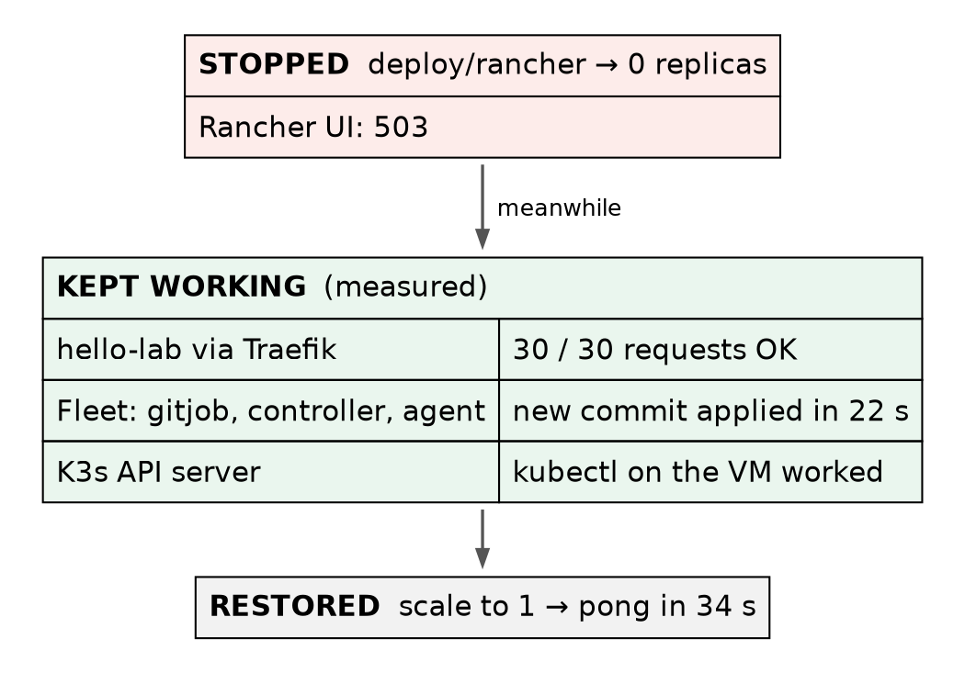
Figure 1 — What keeps running when Rancher is gone. Measured in drill D2: the Rancher UI returns 503, while the app keeps serving and Fleet keeps applying commits, because neither runs inside the Rancher pod.
At 3am:
- ⭐ Rancher down is not an outage of the apps. It is an outage of the management — the UI, the Rancher API, and anything people do through them. Your workloads are run by Kubernetes, not by Rancher (Chapter 1, §2).
- GitOps keeps working because Fleet’s controllers are their own Deployments (Chapter 4, Step 3). So a fix can still ship through Git while the Rancher UI is down.
- What you lose is the convenience layer. kubectl on the cluster still works — which is why the cluster’s own kubeconfig must stay reachable, on the VM, independent of Rancher.
- ⚠️ Not tested here: a downstream cluster with Rancher down. There is none in this lab. The same principle is expected to hold — its agent loses its connection to the manager while its workloads keep running — but that is recited, not measured.

D3 — Commit a broken manifest
Prediction: Fleet shows an error naming the problem; the old version keeps serving; git revert recovers.
Run: a manifest that is valid YAML but invalid Kubernetes — a number written as a word:
sed -i 's/^ replicas: 3$/ replicas: three/' fleet/hello-lab/deployment.yaml
git commit -qam "D3: deliberately broken manifest (replicas: three)" && git push …
sleep 30
sudo kubectl get gitrepo -n fleet-local hello-lab -o jsonpath="{range .status.conditions[*]}{.type}={.status} {.message}{\"\n\"}{end}"
sudo kubectl get bundle -n fleet-local hello-lab-fleet-hello-lab -o jsonpath="{range .status.conditions[*]}{.type}={.status} {.message}{\"\n\"}{end}"
sudo kubectl get deploy -n hello-lab hello-lab
# from .195: 15 requests, one per second
(Abbreviated: output truncation with cut removed.)
Measured:
Check | Result
Fleet’s state | ErrApplied, carrying the API server’s own error, abridged in the record as .spec.replicas: expected numeric … got string
The Deployment | still 3/3, on the last good spec
App, 15 requests while broken | 15 / 15 OK
GitRepo condition Stalled | False — throughout
Recovery after git revert | Ready in 21 s
Notice why the old version kept serving. Fleet rendered the manifest and handed it to the API server, which rejected it, so nothing about the running Deployment was ever changed. A bad commit of this kind fails closed.
The surprise: Stalled stayed False the whole time. The word sounds like exactly the condition to alert on, and it would never have fired. Ready went False, with the error in its message.
🚨 Tripping point — reverting more than one commit. After the first revert (of D3), the plan was to revert D2 with git revert HEAD~1. But after a revert, HEAD~1 is the commit you just reverted, not the one before it: the command targeted the D3 commit again and stopped on a conflict. A diagnostic command then re-applied the broken commit locally. Neither was pushed; the fix was git reset to the good commit, then git revert b778273 — by hash. You can see the final result at the top of the history in Chapter 4, Step 2.
At 3am:
- ⭐ Alert on the GitRepo’s Ready condition, not on Stalled.
- A rejected manifest leaves the running version alone. You have time; read Fleet’s error, which is the API server’s error, and fix Git.
- Revert by hash, never by relative position, when more than one commit is involved.
- ⚠️ This was a manifest the API server rejects. A manifest that is accepted but wrong — a bad image tag, a broken config — gets rolled out, and protection then depends on readiness probes and the rolling-update strategy. That case was not drilled here.

D4 — Break the registry credential
Prediction: a new pod goes to ImagePullBackOff with a 401; the surviving pod keeps serving; restoring the credential recovers.
Run (abbreviated — the backup of the good file and the restore are shown as comments):
# backup: sudo install -m 600 /etc/rancher/k3s/registries.yaml /root/registries.yaml.good
sudo sed -i -E "s/(password: \").{4}/\1XXXX/" /etc/rancher/k3s/registries.yaml # spoil 4 characters
sudo systemctl restart k3s # registries.yaml is read only at start (Chapter 4)
P=$(sudo kubectl get pods -n hello-lab -o name | head -1)
sudo kubectl delete -n hello-lab $P --wait=false
sudo crictl rmi "$IMG" # remove the cached image, or the node never needs the password
🚨 The step that makes the drill honest: crictl rmi. The node already had the image cached. A replacement pod would have started from the cache and the broken credential would never have been used. That is also the real-world trap: a credential can be wrong for weeks, unnoticed, until a node needs an image it has never pulled — a new node, a new tag, a cleaned cache.
Measured:
Check | Result
New pod | ImagePullBackOff
The pod’s Events | abridged in the record: failed to fetch oauth token: … GET http://gitlab…/jwt/auth?… 401 Unauthorized
App, 15 requests during | 15 / 15 OK — the surviving pod served
Rancher’s view of the same pod | state imagePullBackOff, message “containers with unready status”, error: false, transitioning: true
Recovery after restoring the file + K3s restart | Running in 16 s, no pod deleted by hand
(Rancher’s view was read from its own API — the “Steve” API the dashboard renders from — not from a screenshot of the UI.)
Read the error carefully. 401 Unauthorized came from GitLab’s token endpoint (/jwt/auth). So DNS worked, the network worked, the registry answered and sent the client to log in — and the login was refused. Every layer below the credential is ruled out by that one line.
Rancher’s summary did not paint it as an error. error: false, transitioning: true — the pod looks like it is on its way somewhere. The 401 appears only in the pod’s Events.
The recovery is still visible in the cluster’s event log, read-only, about 25 minutes later:
sudo kubectl get events -n hello-lab --sort-by=.lastTimestamp | tail -5
26m Warning Failed pod/hello-lab-66b58bbb5f-kk2sj Error: ImagePullBackOff
25m Normal Pulling pod/hello-lab-66b58bbb5f-kk2sj Pulling image "gitlab.gothamtechnologies.com:5050/production/rancher-k3s/hello-lab:3a2687e8"
25m Normal Pulled pod/hello-lab-66b58bbb5f-kk2sj Successfully pulled image "gitlab.gothamtechnologies.com:5050/production/rancher-k3s/hello-lab:3a2687e8" in 589ms (589ms including waiting). Image size: 16944113 bytes.
25m Normal Created pod/hello-lab-66b58bbb5f-kk2sj Container created
25m Normal Started pod/hello-lab-66b58bbb5f-kk2sj Container started
Kubernetes kept retrying the pull on its own back-off schedule; once K3s restarted with the good credential, the next retry succeeded.
At 3am:
- ⭐ For ImagePullBackOff, go straight to kubectl describe pod or the Events tab. The summary tells you that it failed; the Events tell you why.
- 401 from a token endpoint = the credential. Timeouts or “no such host” = network or DNS. Read which one it is before changing anything.
- On K3s, a fixed registries.yaml needs a K3s restart, and then patience — no pods need deleting.
- Clearing a node’s image cache is how you test a credential. It is also how a hidden bad credential surfaces in production.

D5 and D6 — not yet run
D5 — is retentionSize enforced? Chapter 3 showed that retentionSize: 15GiB is the only thing stopping Prometheus filling the node’s disk. Baseline at 22:59 on October 27: 44.3 MB on disk, ~207,000 active series. Due after 24 hours of data (October 28, 23:00 or later), re-measured with:
sudo kubectl exec -n cattle-monitoring-system prometheus-rancher-monitoring-prometheus-0 -c prometheus -- du -sh /prometheus
A day of data is unlikely to reach 15 GiB, so D5 mainly checks the growth rate; it does not prove the cap. Proving the cap means waiting for it, or temporarily setting a much smaller retentionSize and watching old blocks go.
D6 — upgrade Rancher. Rancher 2.15.2 was still the newest community release when this was written. When a newer one exists, the drill is: the same rancher-values.yaml, helm upgrade to the new version, and the matching rancher-monitoring chart line (Chapter 3, §2a). It is the procedure Chapter 1, §7 said community users are pushed into regularly.

Where this lab differs from production
Here | In production | Why it matters
Drills run once each, by the AI, at a quiet time | Game days, repeated, by the people on call | Judgement comes from repetition, and from people
One node — a reboot takes everything down | Several nodes, drained one at a time | D1’s numbers are the whole-site outage here, and a single-node event at work
Rancher at 0 for under a minute, no downstream clusters | Rancher outages measured in hours, with downstream agents disconnected | D2 proves the principle, not the long-outage behaviour
Availability measured by curl from one workstation | Synthetic checks from several places, with alerting | Chapter 3: alerts here go to "null"

Commands to know by heart
Question | Command
Why was the last shutdown slow? | journalctl -b -1 \| grep -i "timed out"
What is systemd’s stop limit? | systemctl show -p DefaultTimeoutStopUSec
Take Rancher away (drill) | kubectl -n cattle-system scale deploy/rancher --replicas=0
Is Fleet really failing? | the GitRepo’s Ready condition and its message (not Stalled)
Why won’t the image pull? | kubectl describe pod <pod> → Events · kubectl get events -n <ns> --sort-by=.lastTimestamp
What images does this node have cached? | sudo crictl images
Force a real pull (drill) | sudo crictl rmi <image>, then delete the pod
Measure from outside | a curl loop from another machine, counting successes

Glossary
drill — breaking something on purpose, with a written prediction, to learn how it fails.
DefaultTimeoutStopSec — how long systemd waits for a unit to stop before it kills it. 90 s by default.
ErrApplied — Fleet’s state when the API server rejected what Fleet tried to apply.
Ready / Stalled — GitRepo conditions. Only Ready reflected the failure in D3.
ImagePullBackOff — the kubelet failed to pull an image and is retrying with growing delays.
token endpoint — the URL a registry sends clients to for a login token; for GitLab, /jwt/auth.
Steve API — Rancher’s Kubernetes proxy API, which the dashboard reads; it adds summary fields such as state, error and transitioning.
crictl — the command-line client for the node’s container runtime (containerd); it sees images and containers below Kubernetes.

Check yourself
Answer these out loud. Section references, not answers.
- SSH came back 70 seconds late after a reboot. Why did that point at the shutdown? What did you read to confirm it? (D1)
- Why did the push-model copy still have the bug when the Fleet copy did not? (D1)
- Rancher is down. Name what still works, and how you would ship an urgent fix. (D2)
- You are writing the alert for “GitOps is failing”. Which condition, and why not the obvious one? (D3)
- Why did the broken manifest not take the app down? What kind of bad commit would? (D3)
- You need to undo the last two commits. Why is git revert HEAD~1 after the first revert wrong? (D3)
- Why was crictl rmi necessary in D4, and what does that tell you about a real bad credential? (D4)
- An image pull fails with a 401 from /jwt/auth. What has that ruled out? (D4)
- Rancher’s pod view shows error: false. Where do you look instead? (D4)
- What exactly will D5 prove after 24 hours, and what will it not prove? (D5)

