Docker Swarm · Chapter 4 — State: What the Cluster Will Not Carry For You
Series: Home-Lab Education · Phase 16 (Docker Swarm) Built and verified: August 18, 2026 on the three-manager cluster from Chapter 1 Versions at time of writing: Docker 29.7.2 · redis:7.2.4-alpine · PostgreSQL 16 in a private image Read this before: Chapter 5 (breaking it on purpose), Chapter 6 (false greens) Read this after: Chapter 2 — the stack file, secrets-as-files, and what convergence means

What this chapter covers
Swarm schedules processes well. It does not move state, and it will not tell you when it has separated one from the other. Everything here was produced by moving a running database to a node that had never held its data, and by rotating a password the way a real operator would:
- why a named volume is cluster-wide in your manifest and node-scoped in reality
- how state becomes stranded rather than lost, and why that is the harder incident
- why the moment your data was most durable can be the moment it became unreachable
- why rotating a secret rotates the client and never the server
- how a database can be seeded by a race between your own application’s workers
The lesson that ties them together: Swarm’s job ends at “a container is running somewhere”; every question about which bytes that container can see is yours. Each section below is a signal that stayed green while something important was wrong.

1. A named volume is a promise about a name, not about data
Our Redis service is about as careful as a small service gets:
redis:
image: redis:7.2.4-alpine
command: ["redis-server", "--appendonly", "yes"]
volumes:
- redis_data_swarm:/data
--appendonly yes turns on the append-only file, so every write is journalled to disk rather than trusted to a periodic snapshot. That is the durable choice, and it is real: with two keys written, the volume contained an appendonlydir with a base RDB, an incremental AOF and a manifest.
Then we added a placement constraint to force the service onto a different node — the same thing the scheduler does on its own when a node drains, reboots, or runs out of memory:
docker service update --constraint-add 'node.hostname==docker-swarm-3' \
--detach=false capricorn_redis
Nine seconds later:
verify: Service capricorn_redis converged
What we asked | What it said
docker service ls | 1/1
docker service inspect … UpdateStatus | completed
docker service ps | Running 5 seconds ago, no error
redis-cli DBSIZE | 🚨 0
redis-cli GET c3:canary | 🚨 empty
The orchestrator was not lying. A container from that image is running on that network with that volume name mounted at /data, which is exactly what we asked for. Everything the service definition promised was delivered.
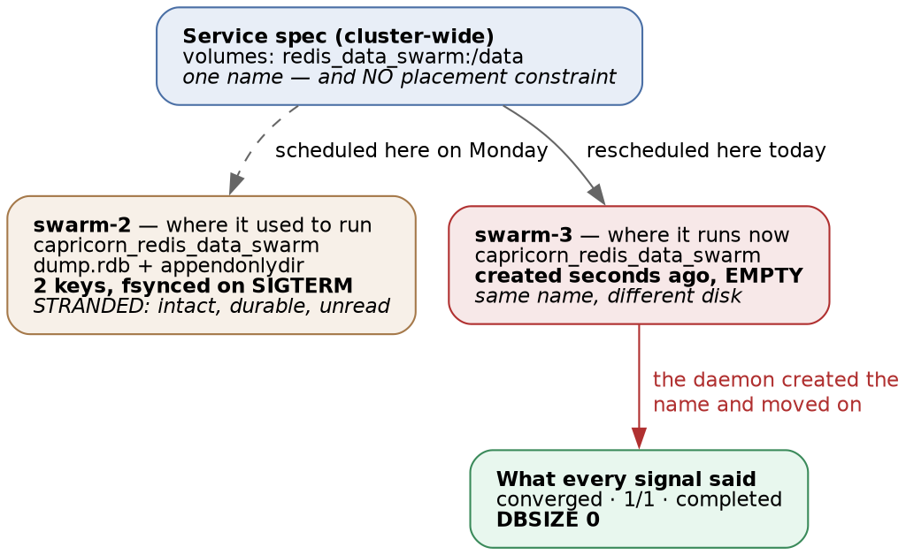
Figure 1 — the same volume name on two nodes: one holding the data, one freshly created and empty
The part that surprises people: Docker created a second volume with the same name
docker volume inspect capricorn_redis_data_swarm --format '{{.CreatedAt}}'
# 2026-08-18T19:06:56-04:00 ← on the NEW node, seconds old and empty
There is no cluster-wide volume registry behind a local-driver volume. redis_data_swarm is a name, resolved independently by the Docker daemon on whichever node the task lands on, and if that name does not exist there, the daemon creates it empty and proceeds. Two nodes then hold the same volume name with different contents, and docker volume ls on either one looks completely normal.
⭐ This is the single most transferable idea in the chapter. Everything else about Swarm is cluster-scoped — service names, secrets, overlay networks, DNS. Volumes are the exception, and they are the one thing that holds data. The mental model that gets people into trouble is assuming the volume follows the service, because every other noun does.
The data was not destroyed. It was stranded.
Moving the constraint back to the original node returned both keys, byte for byte:
DBSIZE after moving back: 2
GET c3:canary: [written-before-reschedule-2026-08-18]
On disk, on the original node, the old data had been sitting there the whole time:
/var/lib/docker/volumes/capricorn_redis_data_swarm/_data/
dump.rdb 155 bytes 19:06
🚨 Look at that timestamp. 19:06 is the moment the old task shut down — Redis caught SIGTERM, flushed its dataset to disk, and exited cleanly. The data was never more durable than at the instant it became unreachable.
⭐ Durability and availability are independent properties, and the drill makes the distinction physical. A backup regime proves the first one. Nothing in this failure would have been prevented by a better backup, and nothing in it would have been detected by verifying that backups are valid. The bytes were perfect, fsynced, and addressed to a machine nobody was querying.
At 3am this presents as data loss and is really an addressing problem. The instinct it punishes is the good one: you check the application, see an empty dataset, and start looking for what deleted your data. Nothing deleted it. The first question is not “what happened to the data”, it is “which node am I talking to, and which node was I talking to yesterday”.
# The one command that resolves the ambiguity in seconds:
docker service ps <service> --filter desired-state=running --format '{{.Node}}'
Which is why the database is pinned, and Redis deliberately is not
Service | Volume exists on | Placement constraint
postgres | swarm-1 only | ✅ node.hostname == docker-swarm-1
redis | swarm-2 only | none — left free on purpose, so this drill could happen
The pin is why C3 could only be run against Redis. Postgres cannot be rescheduled, so it cannot be separated from its data — and the manifest states the cost of that in the same breath as the benefit:
placement:
constraints:
- node.hostname == docker-swarm-1 # trades availability for durability:
# postgres dies with docker-swarm-1
⭐ That comment is the whole lesson in one line, and it is why the pin is a decision rather than a precaution. A pinned database is less available than an unpinned one — if that node is gone, the service is down, full stop. What you buy is that it can never come up wrong. Two honest options exist, and they are different sizes:
Fix | What it buys | What it costs
Pin with a placement constraint | The service can only ever run where its data is | If that node is down, the service is down — you have chosen consistency over availability, deliberately
Replicated / networked storage (NFS, Ceph, a cloud volume) | The data follows the task | Real operational surface: a storage system to run, and its failure modes become yours
🚨 What you must not do is leave it unpinned and believe you have redundancy. An unpinned stateful service on a three-node cluster looks more available than a pinned one and is strictly more dangerous, because the failure mode is silent instead of loud. A pinned service that refuses to start tells you the truth immediately; an unpinned one comes up empty and reports success.
Lab vs PROD — node-local volumes for stateful services. In the lab: both stateful services use local-driver named volumes on a single node. Postgres is pinned there; Redis is deliberately left free so that this chapter’s drill could be run. Why it’s acceptable here: the pin makes the database immovable and therefore honest, the Redis dataset is a regenerable cache, and all three VMs are snapshotted. In production: stateful services get replicated or networked storage, or a hard pin plus a written plan for that node’s failure — and either way it is a recorded decision rather than whatever the scheduler chose. If you carry the habit: one reschedule serves an empty database while every dashboard stays green. The data is intact on a node nobody is looking at, so the incident presents as data loss, the team reaches for a restore, and a restore over the top of a healthy-but-stranded volume is how a recoverable incident becomes an unrecoverable one.
The application never noticed
With Redis wiped to nothing, the frontend served 200, the summary endpoint returned full counts, and the backend’s logs mentioned Redis zero times.
⭐ A cache losing everything is supposed to be survivable, and here it was. But note what that means for detection: the component whose whole job is to be non-critical is also the component whose failure produces no signal. If Redis had held sessions, rate-limit counters, or a job queue, the same silent wipe would have logged users out, reset quotas, or dropped queued work — and the only evidence would have been user complaints. Chapter 6 returns to this: the absence of an error is not evidence of correctness, it is the absence of instrumentation.

2. Secrets are state too — and rotating one rotates only half of it
Swarm secrets are immutable by design: you cannot edit pg_password in place. A real rotation therefore swaps the object underneath an unchanged mount path, which our stack expresses in three lines:
secrets:
pg_password:
name: pg_password_v2 # the CLUSTER object; the container still sees /run/secrets/pg_password
external: true
We deployed that with a genuinely new value and left the database alone — which is not a contrived scenario. It is the everyday one: somebody rotates the credential in the secret store, and the server holding the data is a separate system that nobody remembered was separate.
What happened, in order:
- Pre-flight checks passed — the secret exists.
- All four services converged. 2/2, 3/3, 1/1, 1/1.
- Image digests resolved and were reported.
- The smoke gate failed: SMOKE FAILED: /api/v1/banking/categories returned 500.
The two logs together tell the whole story:
backend asyncpg.exceptions.InvalidPasswordError: password authentication failed for user "capricorn"
postgres FATAL: password authentication failed for user "capricorn"
Why the server kept the old password
The PostgreSQL image reads POSTGRES_PASSWORD_FILE only when it runs initdb — that is, only when the data directory is empty. Our volume already contained a database, so the entrypoint skipped initialisation entirely and the password stored inside PostgreSQL’s own catalog was never touched.
⭐ So the secret is the client’s copy of a credential whose authority lives in the data directory. The rotation succeeded perfectly and made the two disagree.
 | Where the value lives | What the rotation did
Client (the app) | /run/secrets/pg_password, re-read at container start | Updated
Server (Postgres) | The pg_authid catalog, inside the volume | Untouched
The actual rotation needs both halves, and the order matters:
# 1. change it in the server FIRST (the app's old secret keeps working)
ALTER USER capricorn WITH PASSWORD '<new>';
# 2. then create the new secret and redeploy the client
Do it in the other order and you have an outage between the two steps. Do only step 2 and you have what we just built.
🚨 The pre-flight guard cannot see this class of failure, and neither can any orchestrator
Chapter 2’s deploy script guards against a missing secret, and Chapter 5’s Drill B proves that guard fires. This is the neighbouring failure and the guard is blind to it:
 | Secret absent | Secret present but wrong
Pre-flight | ✅ Refuses to deploy | Passes
Task states | (never gets there) | All Running
UpdateStatus | (never gets there) | completed
Caught by | The guard | 🎯 Only something that transacts
⭐ A wrong secret is delivered successfully. Every orchestrator-level signal is entitled to be green, because from Swarm’s point of view nothing failed: it mounted the file it was told to mount. No amount of better orchestration can detect this. Only a request that reaches the database can.
⚠️ A second-order trap we walked into while building the drill. With name: in play, the stack key is pg_password while the cluster object is pg_password_v2. A pre-flight that greps the stack file for secret keys therefore verifies the existence of an object the deploy will not use — a check that passes for the wrong reason. If you write such a guard, resolve name: first or check what the deployed service spec actually references.
🚨 And while we were in there: localhost is not authenticated
Two probes of the same fact disagreed — the rotated password appeared to work from inside the container while the backend was being rejected over the network. The discriminator was to try a deliberately wrong password:
PGPASSWORD=total-garbage-xyz psql -h 127.0.0.1 -U capricorn -d capricorn_lab -tAc 'select 1'
# 1 ← it worked
psql -h 127.0.0.1 -U capricorn -d capricorn_lab -tAc 'select current_user'
# capricorn ← no password at all, also fine
The reason is in the image’s pg_hba.conf, and it is the default for PostgreSQL images rather than anything unusual about ours:
local all all trust
host all all 127.0.0.1/32 trust
host all all ::1/128 trust
host all all all scram-sha-256
Only the last line — the one covering connections from other containers — checks a password. Anyone who can get a shell in that container is already inside the database as its owner. On Swarm that means anyone in the docker group on that node, who can also read /run/secrets/pg_password directly with docker exec. Rotating the password changes neither of those facts.
Lab vs PROD — trust on loopback, and docker group as a database credential. In the lab: the Postgres image’s default pg_hba.conf trusts all loopback connections, and every lab operator is in the docker group on all three nodes. Why it’s acceptable here: an isolated home network, a single operator, and lab-only data. In production: scram-sha-256 on every line including loopback, and membership of the docker group treated as equivalent to root on that host — because it is. If you carry the habit: host access silently becomes data access. Your password rotation, your secrets manager and your database audit log are all bypassed by one docker exec, and nothing in the configuration you do review will show it. This is also why “the database only listens on localhost” is a weaker statement than it sounds: on a container host, localhost is a shared address space.

3. Your application’s startup is state management, whether you designed it that way or not
The last piece of state in this stack is not stored by Swarm at all. Our backend seeds a demo dataset on startup if the database looks empty — a pattern found in nearly every application that ships with a “just bring it up” story.
Run one worker and it is flawless: 682 rows, every table populated, one clean log line.
Run the production configuration — 2 replicas × 4 uvicorn workers — against a fresh database and the log fills with:
Failed to import demo data, using minimal bootstrap:
… UniqueViolationError … duplicate key value violates unique constraint "categories_pkey"
✅ Bootstrap complete: {… 'total': 682}
Eight workers, no coordination, one shared database. The mechanism is worth understanding in general form because the shape recurs everywhere:
- Each worker checks “does data exist?” — all eight see empty, all eight proceed.
- The seeding routine clears leftovers and commits that clear before inserting.
- That commit publishes an empty state, so a worker that was about to be saved by the guard now passes it too.
- Workers insert rows with explicit primary keys; the losers collide and fail.
- Each loser catches the error and falls back to a minimal path — then logs success.
⭐ The defect is step 2, and it is a general rule about guarded initialisation: a guard that reads committed state is worthless if the guarded routine commits an intermediate state. The window it opens is not a microsecond; it is however long the import takes.
🚨 The consequence that matters more than the collision: if a container restarts between that commit and the final one, the database is left committed-empty — the delete has landed and the insert never will. A crash during seeding is a data-loss event rather than a retry.
The correct shape is one transaction and one lock:
SELECT pg_advisory_lock(hashtext('app_bootstrap')); -- the other workers wait here
-- clear + insert + release, committed exactly once
The advisory lock makes it correct at any worker count; the single transaction makes a failure recoverable rather than destructive. Neither depends on Swarm.
⭐ Why this belongs in a Swarm chapter at all. depends_on does not exist here (Chapter 2), so ordering moved into the application — and anything the application does at startup now happens concurrently, N replicas × M workers at a time, on a schedule you do not control. Swarm did not create this bug. It made a single-worker assumption load-bearing and then scaled it out. The same is true of a Kubernetes Deployment, an ECS service, and a Compose file with --workers 4.
The fingerprint to grep for across your own environments is the fallback message. If a log line says the application fell back to a degraded initialisation, that database was seeded by whichever worker lost a race, and nobody was told. Ours logged ✅ Bootstrap complete immediately afterwards — which is Chapter 6’s subject.

4. Commands to know by heart
# WHERE is this service actually running right now?
docker service ps <svc> --filter desired-state=running --format '{{.Node}}'
# Which nodes hold a volume with this name? (run per node - there is no cluster view)
docker volume ls --filter name=<stem>
docker volume inspect <vol> --format '{{.CreatedAt}} {{.Mountpoint}}'
# Is this volume's content real, or a fresh empty one the daemon just made?
docker volume inspect <vol> --format '{{.CreatedAt}}' # seconds old = the task was rescheduled
# Read what a container actually received (works for any secret - see the Lab vs PROD note)
docker exec <cid> cat /run/secrets/<name>
# Does the SERVER agree with the secret? (from OUTSIDE the container - loopback is trusted)
docker service logs <db-svc> --tail 40 | grep -i 'authentication failed'
# Pin a stateful service to its data, deliberately and visibly
docker service update --constraint-add 'node.hostname==<node>' --detach=false <svc>
docker service inspect <svc> --format '{{.Spec.TaskTemplate.Placement.Constraints}}'
The full ledger of investigative commands for this track, indexed by the question each one answers, is COMMANDS.md.

5. Glossary
Term | Meaning
Named volume (local driver) | A directory managed by the Docker daemon on one node. The name is resolved node-locally; identical names on different nodes are unrelated storage.
Stranded state | Data that is intact and durable but on a node nothing is currently reading. Distinct from data loss, and frequently mistaken for it.
AOF (append-only file) | Redis’ journal of every write, replayed at start-up. A durability mechanism; not an availability or portability mechanism.
initdb | PostgreSQL’s one-time cluster initialisation. Reads POSTGRES_PASSWORD_FILE; runs only on an empty data directory, which is why it ignores later rotations.
pg_hba.conf | PostgreSQL’s host-based auth rules, matched top-down. Default container images trust loopback.
Advisory lock | An application-level lock held in the database (pg_advisory_lock), used to serialise work across processes that share only that database.
Guarded initialisation | “Do this only if it hasn’t been done.” Safe only if the guard and the work are in one transaction.

6. Check yourself
Answer out loud; the section is given rather than the answer.
- A service is 1/1, UpdateStatus is completed, and its database is empty. What are the first two commands you run, and what would each one rule out? (§1)
- Why is “stranded” a more dangerous diagnosis than “lost”, given what an operator’s instinct is? (§1)
- Redis had --appendonly yes and still came up empty. What exactly did the AOF guarantee, and what did it never claim to? (§1)
- You rotate a database password in your secret store and redeploy. The deploy is green and the app is broken. Which half of the credential changed, and what is the correct ordering of the two steps? (§2)
- Why can no improvement to the orchestrator detect a present-but-wrong secret? (§2)
- Your database “only listens on localhost”. Why is that a weaker statement on a container host than on a VM? (§2)
- A guard checks whether data exists before seeding. Under what circumstance does that guard actively cause a corruption it was written to prevent? (§3)
- Which of this chapter’s four failures would a valid, tested backup have prevented? (§1, §2, §3)

