Docker Swarm · Chapter 5 — Breaking It On Purpose
Series: Home-Lab Education · Phase 16 (Docker Swarm) Built and verified: August 13 and 18, 2026 on the three-manager cluster from Chapter 1 Versions at time of writing: Docker 29.7.2 · Compose file format 3.8 Read this before: Chapter 6 — why so many of these signals were green Read this after: Chapter 2 (shipping to it), Chapter 4 (state)

What this chapter covers
Ten failures — eight provoked deliberately, two that arrived on their own — each with a prediction written down before the command was run, where there was a command to run at all. The predictions matter more than the outcomes: a prediction that survives contact taught you nothing, and the ones that were wrong are where the real material came from.
Drill | What we broke | Prediction held?
A | Database scaled to zero under a running app | ⚠️ Partly — the app was worse than predicted
B | Secret deleted before deploy | ✅ Yes
C | Concurrent workers seeding one database | ⚠️ Partly — the mechanism was different
C6a | Image tag that cannot be pulled | ✅ Yes, all four predictions
C6b | Image that pulls and runs but is the wrong application | ✅ Yes — and it is the worst result in the track
C3 | Stateful service moved to a node with no data | ✅ Yes, and worse than predicted (Chapter 4)
C5 | Raft quorum reduced to 1 of 3 | ❌ One prediction refuted
D | Secret rotated without touching the database | ✅ Yes (Chapter 4)
— | Unplanned: three replicas silently lost to a reboot | 🚨 Not predicted at all — the best finding
— | Unplanned: :latest moved underneath a redeploy | 🚨 Not predicted; it corrupted a drill
Every command was run against the real cluster with the real application on it. Where our first explanation was wrong, this chapter gives the wrong one first, because it is the one you will reach for too.

1. Two ways to ship a broken image, and only one of them is caught
This is the drill that Chapter 2 promised would settle whether Swarm’s rollback machinery is worth trusting. The answer is yes — for exactly one of the two failure modes, and the other one is more common.
C6a — a tag that cannot be pulled
We deployed a variant of the stack with the frontend’s tag replaced by :does-not-exist-c6. Four predictions, all confirmed:
Prediction | Outcome
The site keeps serving throughout | ✅ :5001 → 200 before, during, and after
One failed task is enough to trigger rollback | ✅ One Rejected task on slot 3
UpdateStatus goes to rollback_started; the deploy script fails | ✅ Script exited 1 in 1.3 seconds
It settles at 3/3 on the old digest | ✅ 🎯
The task list is the clearest evidence of how order: start-first protects you:
capricorn_frontend.3 Accepted less than a second ago
\_ capricorn_frontend.3 Rejected "failed to resolve reference …:does-not-exist-c6: not found"
\_ capricorn_frontend.3 Running 26 minutes ago ← the OLD task, never stopped
Swarm tried to start the new task before stopping the old one, the new one never reached Running, so the old one was never asked to stop. Users saw nothing. That behaviour is a direct consequence of two settings, and neither is a default:
update_config:
order: start-first # default is stop-first: it would have taken a replica down FIRST
failure_action: rollback # default is pause: it would have stopped mid-rollout and waited
⚠️ With the defaults, this same deploy would have removed one of three replicas, failed to replace it, and then paused — leaving the service permanently at 2/3 with no further action, no rollback, and a deploy command that has already exited.
🎯 The finding: a rejected deploy is indistinguishable from a good one by replica count
$ docker service ls --filter name=capricorn_frontend
NAME REPLICAS IMAGE
capricorn_frontend 3/3 …/frontend:latest
That is the output after a deploy that was rejected and rolled back. 3/3. The right image reference. Nothing anywhere in that line records that the last thing you asked for was refused.
⭐ So “count the replicas” is not a deploy check — it is a steady-state check, and it cannot distinguish “your change is live” from “your change was rejected and the previous version was restored”. Both are healthy clusters. Only one of them is running your code. The distinguishing signal is the one field that speaks about the update rather than the service:
docker service inspect <svc> \
--format '{{if .UpdateStatus}}{{.UpdateStatus.State}}{{else}}<absent>{{end}}'
Value | Meaning
<absent> | The service has never been updated since creation. Not an error — the field does not exist yet.
updating | In flight.
completed | The update you asked for is live.
rollback_started / rollback_completed | 🚨 Your deploy was refused. The old version is serving.
⚠️ The <absent> case is the trap for tooling. A template like {{.UpdateStatus.State}} does not return empty on a never-updated service; it errors. A check that treats that error as “unknown, keep going” is fine; one that treats it as “no rollback, so we’re good” is fine too — but a check that crashes on a freshly created service will be discovered at the worst possible time.
⚠️ One caveat we could not close. rollback_completed persists until the next update, so a stale value can fail a deploy of a cluster that is actually healthy. Our script compares against the state observed before deploying rather than trusting the field absolutely.
An unresolvable tag also silently disables digest pinning
Swarm printed this, unprompted, and then deployed anyway:
image …:does-not-exist-c6 could not be accessed on a registry to record its digest. Each node will access … independently, possibly leading to different nodes running different versions of the image.
⭐ Digest pinning is best-effort. When the manager can reach the registry it resolves the tag to a digest and every node runs identical bytes. When it cannot, it degrades to per-node resolution and reduces the guarantee to a warning in scrollback. A registry outage during a deploy does not just delay you — it can strip the mechanism that keeps your cluster homogeneous.
C6b — an image that starts perfectly and is the wrong application
This one was designed in advance. Our stack file has a deliberate omissions block, written five days before the drill, stating the hypothesis in full:
# DELIBERATE OMISSIONS - DO NOT "FIX" THESE
# * No healthcheck: blocks are absent on purpose so trap C6 can show that update_config /
# rollback_config cannot detect a container that starts, stays up, and serves garbage.
# Healthchecks get ADDED after C6 has been felt, not before.
⭐ Worth noticing as a practice, separately from the result: the prediction was written into the artefact, next to the omission that makes it testable. A comment saying do not fix this, and here is what it will demonstrate is the difference between a gap and an experiment — and it survives the months between writing the manifest and running the drill.
We pointed the frontend at nginx:alpine. It pulls. It starts. It answers 200.
==> waiting for convergence (timeout 300s)
all services converged
==> smoke gate: is it ready for business? (timeout 90s)
/api/v1/banking/categories -> 200, body matched
/api/v1/data/summary -> total=682 rows
==> done
UpdateStatus: completed. EXIT=0. 3/3. And the users are looking at this:
<title>Welcome to nginx!</title>
A grep -ci capricorn on the served page returned 0. The entire user-facing application was gone and every single signal was green, including the gate we built specifically to catch false greens.
🚨 Two independent lessons, and they are the most important pair in the track:
(1) Swarm’s rollback is driven by task failure, not by correctness. There is nothing here for rollback to react to — the container is running, so the task succeeded. The only way to give Swarm an opinion about correctness is a healthcheck, at which point the wrong image fails its check, the task is marked unhealthy, and the rollback machinery from C6a works again:
healthcheck:
test: ["CMD", "wget", "-qO-", "http://localhost/some-path-only-OUR-app-serves"]
interval: 10s
retries: 3
start_period: 30s
⭐ A healthcheck that only proves “something is listening on port 80” would have passed here too. The check has to test something only your application would answer.
(2) A gate only defends the endpoint it actually calls. Our smoke gate polls the backend, because it was written after a drill in which the backend was the liar. It has no opinion about the frontend, and so a total frontend failure passed it in 200-shaped silence.
⭐ The generalisation is uncomfortable and worth sitting with: verification does not compose. A healthy dependency tells you nothing about its consumer. Our gate proved the database was reachable and correct through the backend — which is genuinely valuable, and was completely irrelevant to what had broken. Every published port needs its own check, and each check must assert something specific to the thing behind it.
Lab vs PROD — no healthcheck on the application images. In the lab: none of the four services defines healthcheck, so Swarm’s only failure signal is “did the process exit”. Why it’s acceptable here: we are studying orchestrator behaviour, and running without checks is exactly what exposed C6b. In production: every service carries a healthcheck that exercises the thing the service exists to do — and it is treated as part of the deliverable, not deployment configuration. If you carry the habit: any image that starts becomes a successful deploy. Rollback is disarmed precisely in the wrong-but-running case, which is the one no human notices, and you will find out from a customer.
Also unplanned: :latest moved underneath a redeploy
Midway through the drills a redeploy produced a different backend digest than the run 40 minutes earlier. Nobody had asked for an upgrade. Someone had pushed to the same mutable tag.
⭐ This corrupted a drill in progress — we were comparing behaviour between two runs and the binary changed between them. The reason to record resolved digests on every deploy is not audit tidiness; it is so that you can tell a behaviour change from a code change. Without that line in the log we would have attributed a new symptom to our own configuration.

2. Quorum: the cluster stops managing itself and keeps serving
Chapter 1 derived the rule — a Raft cluster of N managers needs floor(N/2)+1 to commit, so three managers tolerate one loss. This drill spends the tolerance and then oversteps it.
We stopped the Docker daemon on the leader and one other node, leaving one follower alone:
sudo systemctl stop docker.socket docker.service # on the leader
sudo systemctl stop docker.socket docker.service # and on a second manager
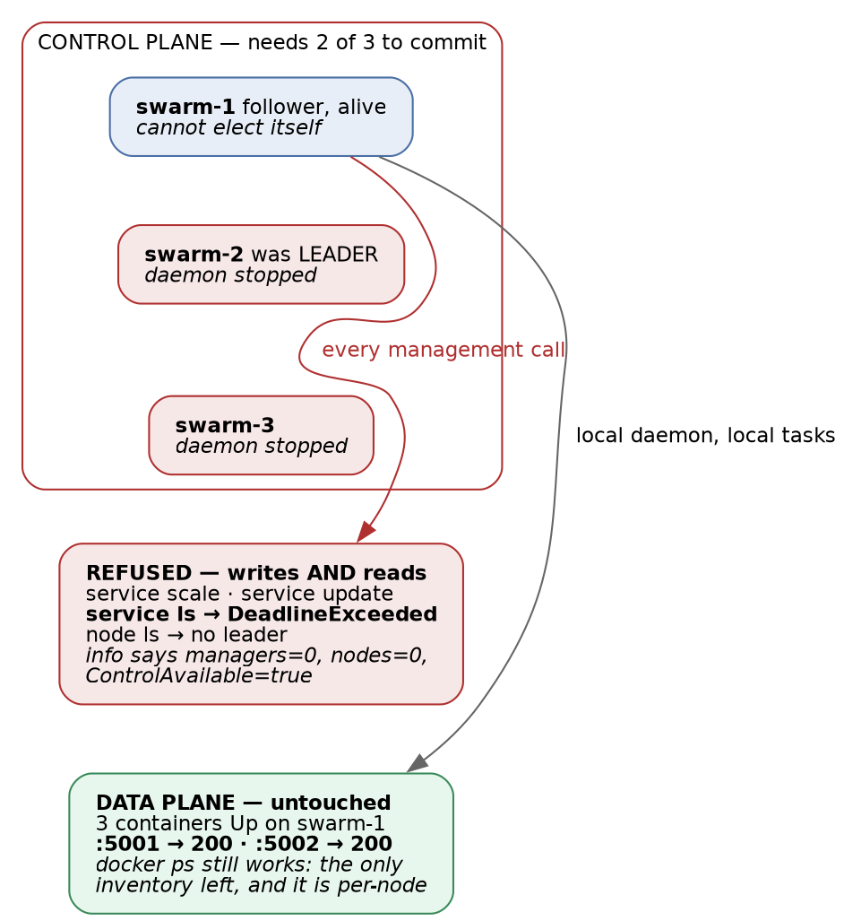
Figure 1 — quorum loss separates the control plane from the data plane: management refuses even reads, while the application keeps serving
From the survivor:
Command | Result
docker service scale capricorn_frontend=4 | The swarm does not have a leader… Make sure more than half of the managers are online
docker service update --label-add … | same refusal
docker service ls — a read | 🚨 rpc error: code = DeadlineExceeded
docker node ls | The swarm does not have a leader
docker ps | ✅ three containers Up
curl :5001 and :5002/api/v1/… | ✅ 200, with real data
The application was completely unaffected. Its containers were already running, the local daemon was healthy, and the database happened to be on the surviving node. 100 % of the workload, 0 % of the orchestration.
❌ The refuted prediction: reads need the leader too
We predicted docker service ls would still answer from the local Raft store, and reasoned that this would be dangerous — an operator seeing a normal service list would conclude the cluster was fine.
Wrong. Reads fail with DeadlineExceeded. Swarm will not serve a possibly-stale answer from a follower; it insists on the leader and times out instead.
⭐ Correct for consistency, and it inverts the operational consequence. You do not get a misleading answer — you get no answer at all, which means total loss of cluster visibility while the workload is untouched. During a real quorum loss, docker ps on each node individually is the only inventory you have, and it is per-node, so you must visit all of them. Practise that before you need it.
🚨 And the one genuinely misleading display
docker info --format '{{.Swarm.Managers}} {{.Swarm.Nodes}} {{.Swarm.ControlAvailable}}'
# 0 0 true
managers=0 nodes=0 — which reads as “this cluster is empty” at exactly the moment you can least afford to misread something. And ControlAvailable is still true, because that field means “this node was configured as a manager”, not “management works”. Monitoring that asks “am I a manager with control available?” answers yes while every management operation is failing.
The refused writes really were refused
Worth verifying rather than trusting the error message, because “the command failed” and “the change did not happen” are different claims. After recovery:
frontend replicas in spec: 3 ← the scale=4 never landed
backend labels: [] ← the label-add never landed
⭐ Raft refused to commit, and refused honestly. That is the property that makes a quorum-based control plane trustworthy: an operation either commits to a majority or does not exist. The alternative — a cluster that accepts writes without quorum — is one that silently diverges and then has to pick a winner.
Recovery, and where the danger actually is
Starting both daemons restored quorum within a minute. Leadership moved to the surviving node — the second time in this phase that we observed leadership is not sticky. Every service returned to full strength and the smoke gate passed.
🚨 The instinct this drill exists to correct. A cluster with no leader is not “down”; it is serving traffic with the steering wheel disconnected, and every symptom you can see from the CLI screams outage. The reflex is to restart Docker on the node that still works, or to reboot it, or to run docker swarm init --force-new-cluster. All three of those convert a fully-serving application into a real outage. The correct action is boring: bring a manager back. Quorum is arithmetic — nothing else fixes it, and nothing needs to.
Lab vs PROD — three managers that are also the only workers. In the lab: all three nodes are managers and all three run application tasks. Why it’s acceptable here: three VMs is the minimum that can demonstrate quorum at all, and co-locating is what makes a three-node lab useful. In production: managers are dedicated and typically five of them, so you tolerate two failures and retain quorum during a rolling upgrade of the control plane. If you carry the habit: one node reboot puts you one failure from losing quorum, and because manager work and application work share the same CPU and disk, a workload spike can make a manager slow enough to be considered failed — an application problem escalating into a control-plane problem.

3. 🚨 The unplanned one: three replicas that a reboot took away silently
Nothing in the plan produced this. We rebooted all three nodes as routine maintenance, came back, and the cluster looked fine. It was not.
capricorn_backend 1/2 ← should be 2
capricorn_frontend 2/3 ← should be 3
The task history explained it, and the explanation is a single word in the manifest:
restart_policy:
condition: on-failure # ← this
A reboot sends SIGTERM. The containers shut down cleanly, exiting 0. Swarm recorded them as Complete, not Failed — and on-failure means restart when the task fails. A clean exit is not a failure, so the tasks were never restarted. The replicas simply stopped existing.
Task state | Exit | on-failure restarts it? | any restarts it?
Failed | non-zero | ✅ | ✅
Complete | 0 | 🚨 No | ✅
🚨 And the database came back only by luck. Postgres had the same on-failure policy. Its container did not exit cleanly — it vanished, so the task was recorded as Failed, so it was replaced. Had it shut down as gracefully as the others, the database would simply not have come back, and the same reboot would have been an outage instead of a capacity loss. The policy was equally wrong for all four services; only the manner of dying differed.
The discriminator, when a service is under-replicated for no visible reason:
docker service ps <svc> --format '{{.CurrentState}}' | sort | uniq -c
docker service inspect <svc> --format '{{.Spec.TaskTemplate.RestartPolicy.Condition}}'
⭐ Complete in the list is the whole diagnosis. It looks benign — it is even a success word — and it is the fingerprint of a replica that will never come back.
Why this is the most valuable finding in the phase: every other failure here was provoked. This one was produced by the most ordinary operation in infrastructure, it degraded capacity rather than availability, and it announced itself nowhere. The service was serving. Nothing alerted. Capacity had quietly fallen by a third and the only evidence was a number nobody was reading.
The fix is one word — condition: any — and the reasoning generalises: in a cluster, “the process exited cleanly” is not a reason to stop running the service. You asked for three replicas. The desired state does not care why there are two.
The drill that later confirmed the fix, by accident
The quorum drill in §2 stopped Docker daemons, which SIGTERMs their containers — the identical mechanism that ate replicas here. Under condition: any, every service returned to full strength.
⭐ Same failure input, opposite outcome, one variable changed. That is a controlled experiment we did not plan, and it is stronger evidence than the original fix had. It is also a lesson about drills in general: a later drill can validate an earlier fix for free, if you record the earlier one precisely enough to recognise the repeat.
Lab vs PROD — on-failure on long-running services. In the lab: the first manifest used condition: on-failure with max_attempts: 3, copied from habit. Why it’s acceptable here: it was not — this was simply a mistake, and it is in the chapter because finding it was worth more than the drills we had planned. In production: condition: any for anything that should always be running; on-failure belongs to batch jobs where completion is meaningful. If you carry the habit: capacity erodes silently across every maintenance window. Each reboot costs replicas, the service never goes down, and you discover the shortfall during a traffic peak — the one moment the missing capacity matters and the one moment you cannot safely investigate.

4. The other four, in brief
Full predictions, outputs and analysis for these are in the phase record; each has its own home in the other chapters.
Drill | One-line finding | Where
A — database scaled to zero | The app retried 15 times, gave up, and logged Application startup complete with no database. Six of seven signals said healthy. | Chapter 6
B — secret deleted | The pre-flight guard refused the deploy immediately and clearly. The one drill where a guard did its job. | Chapter 2
C — concurrent seeding | Eight workers raced to seed one database; a committed intermediate state made the guard useless. | Chapter 4 §3
D — rotate the secret only | Converged green, then failed the smoke gate: the client’s copy rotated, the server’s did not. | Chapter 4 §2

5. How to run a drill so that it means something
Five of the runs in this phase produced confident, plausible, void results. That is a high enough rate to be a subject rather than an embarrassment, and the causes were always the same shape.
What went wrong | The rule it produced
A variant stack file was generated, then the default one was deployed | 🚨 Assert your preconditions; do not print them. The deploy script printed the file it was using. Nobody read it.
docker volume rm failed, with stderr suppressed, so the “empty database” was not empty | ⭐ Never suppress stderr on a step the experiment depends on.
Two probes of one fact disagreed; one was testing a missing database, not a wrong password | ⭐ When two probes disagree, at least one measures something else. Find out which before concluding.
cmd && echo WORKS \|\| echo FAILED reported an auth failure that was really a typo’d database name | ⭐ Never let a probe report a cause it did not distinguish. Print the real error.
A command intended for a cluster node ran on the workstation, because a shared mount made both look identical | ⭐ Have the script verify where it is — ours calls docker node ls first and would have refused.
⭐ The thread through all five: a successful-looking run is the most dangerous possible outcome of a badly instrumented experiment, because it is indistinguishable from a real result and it goes into your notes as one. This is the same failure mode the whole chapter is about — a green signal that means nothing — with the experimenter in the role of the orchestrator.
Write the prediction down first. It is the cheapest instrument available and it is the only one that detects the failure where you learn nothing because you had no expectation to violate. Our C5 prediction was wrong, and that refutation is one of the most useful facts in this track — it would not exist if we had not committed to a guess.

6. Commands to know by heart
# Did my deploy actually take, or was it rejected and rolled back?
docker service inspect <svc> \
--format '{{if .UpdateStatus}}{{.UpdateStatus.State}}: {{.UpdateStatus.Message}}{{else}}<absent>{{end}}'
# What is REALLY running (digest, not tag)?
docker service inspect <svc> --format '{{.Spec.TaskTemplate.ContainerSpec.Image}}'
# Why is this service under-replicated? (Complete = a clean exit that was never restarted)
docker service ps <svc> --format '{{.CurrentState}}' | sort | uniq -c
docker service inspect <svc> --format '{{.Spec.TaskTemplate.RestartPolicy.Condition}}'
# Why was a task refused? (--no-trunc or the reason is cut off)
docker service ps <svc> --no-trunc --format '{{.Name}}\t{{.CurrentState}}\t{{.Error}}'
# Quorum check, and the one that still answers when quorum is gone
docker node ls # needs the leader
docker info --format '{{.Swarm.Managers}}/{{.Swarm.Nodes}}'
docker ps # per-node, and the ONLY inventory during quorum loss
# After any maintenance: did everything come back to full strength?
docker service ls --format '{{.Name}}\t{{.Replicas}}'

7. Glossary
Term | Meaning
UpdateStatus | Service field describing the most recent update rather than the service. Absent until the first update. The only signal that distinguishes a live change from a rolled-back one.
start-first / stop-first | Whether a rolling update starts the replacement before stopping the incumbent. stop-first is the default and takes capacity down first.
failure_action | What a failed rolling update does: pause (default), continue, or rollback.
Complete vs Failed | Task terminal states for exit 0 and non-zero respectively. on-failure restarts only the latter.
Quorum | The floor(N/2)+1 managers Raft needs to commit. Below it: no writes, no reads, workload unaffected.
ControlAvailable | “This node is configured as a manager.” Not “management is working.”
Void run | An experiment whose result cannot be trusted because a precondition was not asserted. Dangerous mainly when it looks like a success.

8. Check yourself
- docker service ls shows 3/3 and the tag you expected. Name two completely different situations that produce that output, and the single command that separates them. (§1)
- Why does a healthcheck restore Swarm’s ability to roll back, and what property must the check have to be worth anything? (§1)
- With stop-first and failure_action: pause — the defaults — what state does an unpullable image leave a three-replica service in, and for how long? (§1)
- Quorum is lost. docker service ls times out and the application is serving. What are you not going to do, and why is each of those three instincts harmful? (§2)
- Why is a control plane that refuses reads without a leader easier to operate than one that serves stale reads? (§2)
- A service shows 2/3 after a reboot and nothing is in a failed state. What single word in the manifest explains it, and what does Complete mean in the task list? (§3)
- Which drill accidentally validated the fix from §3, and why was it a fair test? (§3)
- You run a drill and it works exactly as predicted, first time. What should you check before writing it down? (§5)

