Docker Swarm · Chapter 6 — False Greens: Why “Converged” Is Not “Working”
Series: Home-Lab Education · Phase 16 (Docker Swarm) Built and verified: August 13–18, 2026 on the three-manager cluster from Chapter 1 Versions at time of writing: Docker 29.7.2 · Compose file format 3.8 Read this before: nothing — this is the chapter the others were building toward Read this after: Chapters 2, 4 and 5 — the deploys, the state, and the drills

What this chapter covers
This chapter was not planned. It exists because the same phenomenon appeared in every failure drill, in the tooling we wrote to catch it, and in five of our own experiments:
a system reports success for a question it was never asked.
Nothing here is a bug in Docker. Every green signal in this chapter was honest about its own contract. The error was ours each time: reading a lower layer’s truthful answer as though it settled a higher layer’s question. That mistake is the most common cause of a long outage that “monitoring didn’t catch”, and it is completely learnable.

1. The drill that started it: six of seven signals said healthy
We scaled the database to zero replicas while the application was running and healthy, expecting the backend to crash-loop. It did not. It retried its connection fifteen times over about 75 seconds, gave up, and logged:
Failed to import demo data, using minimal bootstrap: … Name or service not known
INFO: Application startup complete.
“Application startup complete.” With no database in the cluster at all.
Here is every signal an operator would reasonably consult, with what it said:
# | Signal | Said | Truthful about
1 | docker service ls | 2/2 | Two containers exist
2 | docker service ps | Running, no errors | The tasks are up
3 | UpdateStatus | completed | The last update finished
4 | docker stack deploy exit code | 0 | The manager accepted the spec
5 | Container Status | Up 36 seconds | The process is alive
6 | The app’s own startup log | startup complete | Its startup code path finished
7 | 🎯 A request that reads the database | HTTP 500 | 🎯 Whether it works
⭐ Six green, one red, and only the red one was asking a useful question. Notice that none of the six is wrong. 2/2 is a true statement about replica count. Running is a true statement about the task. The exit code truthfully reports that the manager accepted the desired state. Every one of them answers a question you did not mean to ask.
Why the application did this, and why it will happen to you
The retry loop is good engineering. Chapter 2 explains why depends_on cannot exist in a cluster: there is no moment at which “the database has started” is a stable global fact, so services must tolerate absent dependencies and retry. Our application does exactly what the platform requires.
The defect is the last step. Having exhausted its retries, it caught the exception and continued to serve — announcing success rather than refusing to start.
⭐ The general rule, and it applies to anything you write: an application that cannot do its job must fail loudly at start-up, not serve errors quietly. The choice looks like resilience versus brittleness and is really about who finds out. Refuse to start, and your orchestrator sees a failed task, stops the rollout, and rolls back — the machinery in Chapter 5 all works. Start anyway, and the orchestrator has nothing to react to, so discovery is deferred to a user.
⚠️ And notice the dependency failure did not look like a connection error. With the service scaled to zero it disappeared from Swarm’s internal DNS, so the symptom was Name or service not known — a name resolution failure. In Swarm, “my dependency has no replicas” and “I have a DNS problem” produce the same message, and the first is far more likely.

2. A taxonomy of the false greens we produced
Every one of these was observed on the real cluster:
# | The lie | What was actually wrong | Chapter
1 | Running + startup complete | No database existed | 6 §1
2 | completed + EXIT=0 + smoke gate passed | The entire frontend was replaced by nginx’s welcome page | 5 §1
3 | 1/1 + converged | Redis dataset was empty; its data was stranded on another node | 4 §1
4 | 3/3 on the expected tag | The deploy had been rejected and rolled back | 5 §1
5 | Nothing at all — no alert, no error | Capacity had silently fallen to 2/3 and 1/2 after a reboot | 5 §3
6 | ✅ Bootstrap complete | Three of four workers had failed and fallen back to a degraded path | 4 §3
7 | managers=0 nodes=0 with ControlAvailable=true | Quorum was lost; the field means “configured as a manager” | 5 §2
8 | A drill that “worked” | The wrong stack file was deployed; the result was void | 5 §5
⭐ Read down the “actually wrong” column: a missing database, a missing UI, a missing dataset, a refused change, missing capacity, a corrupted import, a dead control plane, and a fabricated measurement. There is no category of failure in this phase that did not present as green somewhere.
The structural reason: each layer honestly reports its own contract
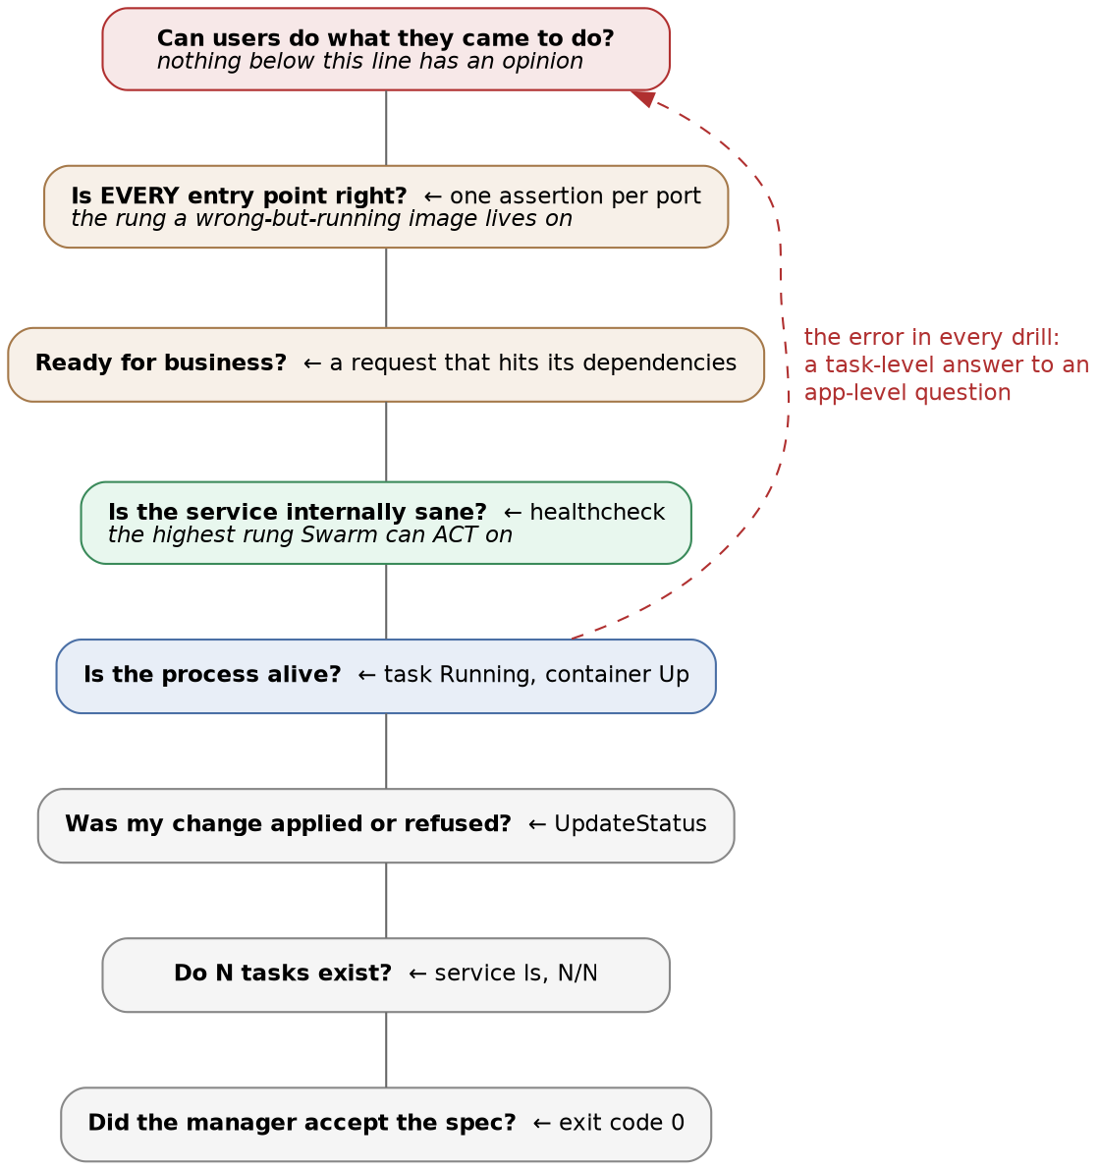
Figure 1 — the ladder of questions: each signal answers only its own rung, and Swarm’s contract ends well below the one you care about
Swarm’s contract is “a container matching this spec is running somewhere”. It fulfils that contract with real rigour, which is why it is trustworthy — and it is why it can never answer the question at the top. There is no configuration that makes a lower rung report on a higher one.
⭐ So the discipline is not “distrust the orchestrator”. It is: know which rung each signal sits on, and never accept an answer from a rung below the question. Almost every incident in this phase was an instance of one specific version of that error — accepting a task-level signal as an answer to an application-level question. Running is rung four. “Is it working?” is rung seven.

3. The instrument we built, and its measured blind spot
After Drill A, deploy_swarm.sh gained a smoke gate: after convergence, poll an endpoint that cannot succeed unless the dependency chain works, and fail the deploy if it does not.
# after convergence, before declaring success:
# 1. call an endpoint that must touch the database
# 2. require the expected content, not just a 200
# 3. require a row count the schema alone cannot produce
==> smoke gate: is it ready for business? (timeout 90s)
/api/v1/banking/categories -> 200, body matched
/api/v1/data/summary -> total=682 rows
It works. It is the only thing that caught the secret rotation in Chapter 4 §2 — a deploy where all four services converged, digests resolved, and every task was Running:
SMOKE FAILED: /api/v1/banking/categories returned 500
body: {"detail":"Internal server error"}
The stack CONVERGED and is still broken - which is the whole reason this gate exists.
Three design decisions that turned out to be load-bearing
A 200 is not enough — check the body. An error page, a login redirect and a proxy’s default page are all 200. C6b is the proof: nginx’s welcome page is a perfectly valid 200.
Count rows, and pick a threshold the schema alone cannot reach. Our first version required at least one row, which is nearly useless: the database’s own initialisation scripts insert reference data, so “more than zero rows” is true of a database that has never seen the application. We raised it to 100 after measuring what the application’s degraded fallback path actually writes: about one row. A threshold is only a discriminator if it sits between the two states you are distinguishing — so measure the failure mode before choosing the number.
Retry with a timeout, and report the code you actually got. An early version printed HTTP 000000, because a failed curl was being invoked twice and its “no response” sentinel concatenated. A gate that reports a nonsense code trains you to ignore it.
🚨 And the gate passed the worst failure in the track
C6b replaced the frontend with nginx:alpine. The gate printed 200, body matched and total=682 rows while every user saw Welcome to nginx!
Because the gate polls the backend. It was written when the backend was the liar, so that is what it watches. It never had an opinion about the frontend, and its silence was indistinguishable from approval.
⭐ The lesson is about verification in general, and it is the one I would keep if I could keep only one from this phase: verification does not compose. Proving that the backend can reach a correct database is genuinely valuable and tells you nothing about the frontend. A healthy dependency is not evidence about its consumer. Every published entry point needs its own assertion, and each assertion must test something only the correct thing behind it would produce.
⚠️ Honest status of our own tooling: the gate covers the backend only. The frontend check is outstanding work, and the more robust fix is a healthcheck on the frontend image itself — which would also re-arm Swarm’s rollback for that failure mode, as Chapter 5 §1 explains. Written here rather than quietly fixed, because a chapter claiming a complete gate would be its own false green.

4. Honest logs, dishonest outcomes
The application’s logging deserves its own section, because it was truthful at every individual step and misleading in aggregate — a pattern worth recognising since it is so much more common than logs that simply lie.
Failed to import demo data, using minimal bootstrap: … UniqueViolationError … ← true
Failed to import demo data, using minimal bootstrap: … UniqueViolationError … ← true
Failed to import demo data, using minimal bootstrap: … UniqueViolationError … ← true
✅ Bootstrap complete: {… 'total': 682} ← true, and misleading
Three workers failed and fell back to a degraded path. A fourth succeeded. The final line reports the fourth worker’s view, at INFO, decorated with a check mark — and it is factually correct. There were 682 rows.
⭐ Three properties made this dangerous, and none of them is “the log was wrong”:
- The failure was logged at a lower severity than the success. The eye goes to the last line.
- The success line describes a different scope — one worker’s outcome — than the failures.
- 🚨 The final state was decided by commit ordering. The full import happened to commit last. Had a degraded worker committed last, the same log would have printed with a fraction of the data.
⭐ The rule this produces: a summary line must describe the outcome of the whole operation, or it must not be phrased as one. “Bootstrap complete” is a claim about the system. The worker was only entitled to say “this worker finished”. And any code path that catches an exception and continues owes the reader an unmissable statement that it did so — because the alternative is a log that reads as success and a system that is degraded.
The practical takeaway is a grep. The fingerprint of this failure is the fallback message. Search your own environments for it; if it appears, that database was initialised by whichever process lost a race, and nobody was told.

5. The same failure, with us in the orchestrator’s role
Five runs in this phase produced confident, plausible, void results — and it is the same phenomenon: a green signal answering a question nobody asked.
The void run | What was actually true
A drill “passed” in 2.3 seconds | The default stack file was deployed; the broken variant was never used
A control experiment ran on an “empty” database | docker volume rm had failed, with stderr suppressed
A password was “rejected” | The probe named a database that does not exist
A password “worked” | Loopback connections are trust — no password was checked
A script ran “on the node” | It ran on the workstation; a shared mount made both look identical
⭐ A successful-looking run is the most dangerous outcome of a badly instrumented experiment, because it is indistinguishable from a real one and it goes into the notes as a finding. Four practices came out of this, and they are cheap:
- 🚨 Assert preconditions; do not print them. Our deploy script printed the file it was deploying, on line three. That is not a control — it is a hope that a human reads carefully at the exact moment they are least likely to.
- ⭐ Never suppress stderr on a step the experiment depends on. 2>/dev/null || echo "already gone" turned a failed deletion into a reassuring message.
- ⭐ Never let a probe report a cause it did not distinguish. cmd && echo WORKS || echo FAILED collapses every failure mode into one label. Print the real error.
- ⭐ When two probes of one fact disagree, at least one is measuring something else. Find out which before concluding. This is how the trust finding surfaced — the contradiction was the evidence.
And write the prediction down before running the command. It is the only instrument that catches the failure where you learn nothing because you had no expectation to violate. Our quorum prediction was wrong, and that refutation is among the most useful facts in this track; it would not exist if we had not committed to a guess we could lose.

6. What to actually do
The ladder, and one instrument per rung
Question | Instrument | Rung it really answers
Did the manager accept my spec? | docker stack deploy exit code | Accepted — not applied
Do N tasks exist? | docker service ls → N/N | Steady state — not “my change is live”
Was my change applied or refused? | UpdateStatus.State | The update itself
Is the process alive? | Task Running, container Up | Liveness only
Is the service internally sane? | healthcheck in the image | 🎯 The only correctness signal Swarm can act on
Is it ready for business? | A request that exercises its dependencies | The application
Is each entry point right? | One assertion per published port | 🎯 The rung C6b lives on
Did capacity survive maintenance? | docker service ls read by something after every window | The thing nobody watches
⭐ The healthcheck row is the highest-leverage one, because it is the only rung where a correctness signal is visible to the orchestrator. Everything below it is liveness; everything above it is your own tooling. A healthcheck converts “wrong but running” into a failed task — and a failed task is something rollback can act on.
The three questions worth asking of any deploy pipeline
- What could be broken and still let this pipeline go green? For our first version the honest answer was: the database, the dataset, the frontend, and the previous version still serving.
- Which of my checks would notice if the thing it watches were replaced by something that merely answers? If the answer is “none”, every check is a liveness check wearing a costume.
- After a reboot, what reads the replica count? If nothing does, capacity is on an honour system.
Lab vs PROD — the deploy script is the only monitoring. In the lab: correctness is checked once, at deploy time, by deploy_swarm.sh. There is no alerting, no dashboard, and nothing watching between deploys. Why it’s acceptable here: the lab is driven by hand, the operator is present for every change, and drills are the point. In production: the same assertions run continuously as synthetic checks, and replica counts are alerted on rather than inspected. If you carry the habit: every failure that begins after a deploy is discovered by a user. Deploy-time verification only proves the system was correct at one instant — and the reboot that silently cost us three replicas happened at no deploy at all, which is precisely why nothing noticed.

7. Commands to know by heart
# The only question that matters, asked of the application itself:
curl -sS -o /tmp/b -w '%{http_code}' http://<host>:<port>/<endpoint-that-reads-the-database>
grep -q '<something only the real answer contains>' /tmp/b && echo REALLY OK
# Was my change applied, or refused and rolled back?
docker service inspect <svc> \
--format '{{if .UpdateStatus}}{{.UpdateStatus.State}}{{else}}<absent>{{end}}'
# What does the application say about itself, as opposed to what Swarm says about it?
docker service logs <svc> --tail 60 | grep -iE 'error|failed|fallback|retry|refus'
# Did capacity survive the last maintenance window?
docker service ls --format '{{.Name}}\t{{.Replicas}}' | awk -F'[\t/]' '$2!=$3'
# Is a dependency actually absent, or is this really DNS? (they look identical)
docker service ls --filter name=<dependency>
The complete ledger for this track, indexed by the question each command answers, is COMMANDS.md.

8. Glossary
Term | Meaning
False green | A truthful success signal reporting on a narrower contract than the question being asked of it.
Convergence | Swarm’s desired-state reconciliation completing. A statement about tasks; no statement about correctness.
Readiness | Whether a service can actually do its job, including dependencies. Swarm has no concept of it; a healthcheck is the closest available.
Smoke gate | A post-deploy assertion that exercises the dependency chain and fails the deploy if it does not hold.
Discriminator | A probe chosen to separate two competing explanations, rather than to confirm the one you prefer.
Void run | An experiment whose preconditions were not asserted. Its danger is proportional to how successful it looks.

9. Check yourself
- Name the six signals that said “healthy” while the application had no database, and state precisely what each one was truthfully reporting. (§1)
- Why is “retry, then start anyway and serve errors” worse than crashing, in terms of who finds out and what the orchestrator can do? (§1)
- On the ladder in §2, which rung does docker service ls occupy, and which rung does “is the site working” occupy? (§2)
- Our smoke gate requires 100 rows rather than 1. What did we have to measure before that number meant anything? (§3)
- The gate passed while the entire frontend was replaced by nginx. State the general principle in one sentence. (§3)
- Four log lines were each individually true and collectively misleading. Which three properties made them dangerous? (§4)
- Which single practice would have prevented all five void runs, and why is printing a precondition not the same as asserting one? (§5)
- For a deploy pipeline you actually maintain: what could be broken today and still let it go green? (§6)

