Table of Contents

Chapter 4 — Provisioning Application State: What Kubernetes Doesn’t Know
Who this chapter is written for. Andrew is interviewing for an SRE / DevOps role on an order management system. The question behind this chapter is a pipeline question: you have a Helm release that deploys three healthy brokers — how does the thing your application actually needs get created, and what happens the second, third and hundredth time the pipeline runs?

Verified facts header
Run on vm-k8-redpanda-1 (192.168.1.186), single-node k3s v1.36.2, Redpanda chart 26.1.9 / v26.1.12, on 3 August 2026. Every command was executed and every output quoted is real.
Thing | Value as tested
Cluster | 3 brokers, Healthy: true, 7 days uptime
Seeding image | docker.redpanda.com/redpandadata/redpanda:v26.1.12 (ships rpk at /usr/bin/rpk and bash)
In-cluster broker address | redpanda.redpanda.svc.cluster.local:9093 (headless, see Ch3 §5a)
Operator installed | No — Helm chart only, so no Topic CRDs
Manifests | manifests/seed-topics.sh (the reconciler) and manifests/seed-topics-job.yaml (the Job that runs it)
Health endpoint | Admin API :9644 — not the Kafka API :9093 (§6c)
Prerequisite reading: Chapter 3 §5 (headless Services and how a client connects) and §2d (why partition count is permanent). This chapter assumes both.

What this chapter covers
- Two control planes, and the boundary between them
- The gap, proved — a “successful” deployment that cannot serve a single request
- Why the broker config file cannot hold topics
- The seeding Job, written the way everyone writes it first
- Making it idempotent
- The readiness race
- Why idempotent still isn’t reconciling
- The operator alternative
- What I’d actually put in a pipeline
- Production gap, commands, glossary, interview questions, self-test

1. Two control planes
Kubernetes deploys the brokers. It has no idea what a topic is.
Decided by Kubernetes / Helm | Decided by Redpanda itself
How many brokers (statefulset.replicas: 3) | Topics
CPU, memory, disk size, StorageClass | Partitions per topic
Networking, listeners, TLS | Replication factor per topic
The broker config file | ACLs, users, quotas, consumer groups
When you run rpk topic create orders -p 6 -r 3, nothing in Kubernetes changes. That command speaks the Kafka admin protocol to a broker, which writes the definition into the controller Raft group — the redpanda/controller/0_0 directory on each broker’s PVC. It is replicated by Raft like any other data.
So in this cluster kubectl get topics returns nothing, because no such object exists.
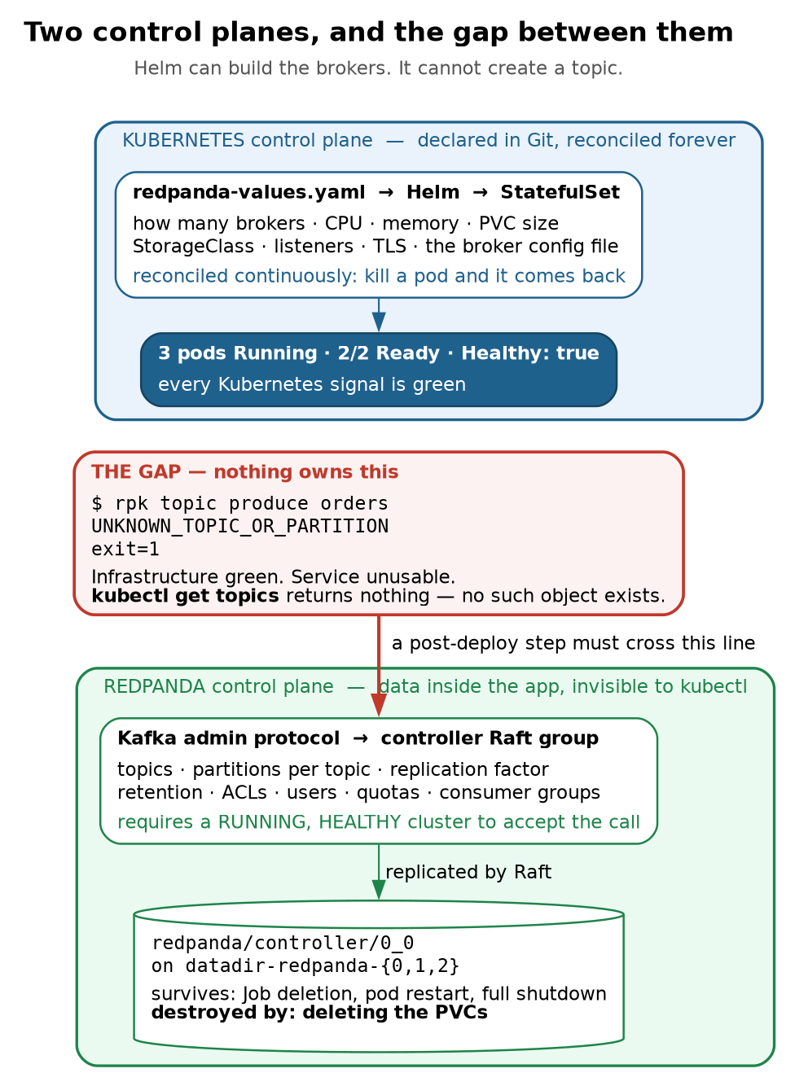
Figure 1 — two control planes, and the gap between them
The same fact, seen from both sides
Rebuild from redpanda-values.yaml and you get three healthy brokers and zero topics. Delete every Kubernetes object used for seeding and the topics survive untouched. Because topic state is not Kubernetes state, helm install + rollout status is not a sufficient deployment gate. It asserts the brokers exist, not that the service can be used.
Two consequences that look contradictory but are the same fact seen from opposite sides:
- Rebuild the cluster from redpanda-values.yaml and you get three healthy brokers and zero topics. Your Helm chart does not describe them.
- Delete every Kubernetes object involved in seeding and your topics survive untouched. We proved this by accident: after kubectl delete job seed-topics, all three topics were still there, and the re-run failed with TOPIC_ALREADY_EXISTS — only possible because they outlived the Job that made them.
The state lives on the volumes:
datadir-redpanda-0 Bound 20Gi
datadir-redpanda-1 Bound 20Gi
datadir-redpanda-2 Bound 20Gi
It survives Job deletion, pod restarts, broker crashes and full cluster shutdown. It does not survive deleting the PVCs — which is exactly why market-ticks had to be recreated after the failed install on 27 July, when recovery required kubectl -n redpanda delete pvc --all. This is also why helm uninstall deliberately leaves StatefulSet PVCs behind (Ch3 §6g).

2. The gap, proved
A deployment where every Kubernetes signal is green and the service cannot serve a request.
rpk cluster config get auto_create_topics_enabled
# false
echo '{"order":"ORD-1","qty":100}' | rpk topic produce orders; echo "exit=$?"
unable to produce record: UNKNOWN_TOPIC_OR_PARTITION: This server does not host this topic-partition.
exit=1
rpk topic consume orders -o :end; echo "exit=$?"
unable to consume topic "orders": UNKNOWN_TOPIC_OR_PARTITION: This server does not host this topic-partition.
exit=1
Both directions fail identically, both exit 1. Meanwhile:
- Helm reports the release deployed
- Every pod is Running
- rpk cluster health says Healthy: true, no nodes down, no leaderless partitions
“Infrastructure green” and “service usable” are different assertions, and only one of them is being monitored. A pipeline that stops at helm install + rollout status will report success on a cluster no application can use. This is the same shape as Chapter 2’s Available=True while a rollout was broken: the signal is true, it just isn’t answering the question you care about.

3. Why the broker config cannot hold topics
The natural first instinct is to put topics in a startup config file. It doesn’t work, and the reason is worth understanding.
Redpanda’s cluster config can be seeded at bootstrap, but it only holds cluster properties:
default_topic_partitions 1
default_topic_replications 3
log_segment_size 134217728
Those are defaults applied to topics created later. There is no field anywhere in the broker config that says “a topic named orders with 6 partitions.” Topics are not configuration — they are data in the controller Raft group, so they can only be created by talking to a running cluster over the admin API. That ordering constraint is what forces everything else in this chapter.
The shortcut, and why to reject it
auto_create_topics_enabled false
Set that to true and topics spring into existence the moment any client produces to a name that doesn’t exist. It removes the seeding problem entirely, and you should still not do it:
- New topics inherit default_topic_partitions, which is 1 here. One partition means no parallelism and, at RF 3, a single leader carrying all traffic.
- A typo silently creates a topic instead of erroring. Produce to oders and you get a working producer writing to a topic nobody will ever consume. With auto-create off you get an immediate, unmissable UNKNOWN_TOPIC_OR_PARTITION.
- Partition count is effectively permanent (Ch3 §2d), so an accidentally auto-created topic is a mistake you cannot cleanly undo once it has data.
Leave it false and seed deliberately. “We disable auto-create and provision topics explicitly” is a good sentence in an interview.

4. The seeding Job, written the way everyone writes it first
Since topics require a running cluster, seeding is a post-deploy step. In Kubernetes that’s a Job. The chart already demonstrates the pattern — redpanda-configuration is a post-install Job that configured cluster properties once the brokers were reachable.
The broker image is a convenient base: it already ships rpk, so no custom image is needed.
command: ["/usr/bin/bash","-c"]
args:
- |
set -euo pipefail
B=redpanda.redpanda.svc.cluster.local:9093
rpk -X brokers=$B topic create orders -p 6 -r 3
rpk -X brokers=$B topic create executions -p 6 -r 3
echo "seeding complete"
Note the broker address is the headless Service name, not a specific broker (Ch3 §5b). Hardcoding redpanda-0… would make seeding fail whenever broker 0 happened to be down, against a cluster that could have served the request from either survivor.
First run against a fresh cluster works perfectly:
TOPIC STATUS
orders OK
TOPIC STATUS
executions OK
seeding complete
Job Complete, exit 0, both topics created. This is why the pattern survives code review.
The second deploy
Nothing changed. Same manifest, re-applied — exactly what a pipeline does on the next release:
NAME READY STATUS RESTARTS AGE
seed-topics-hnqxm 0/1 Error 0 59s
seed-topics-qzz24 0/1 Error 0 90s
seed-topics-w46kq 0/1 Error 0 79s
TOPIC STATUS
orders TOPIC_ALREADY_EXISTS: The topic has already been created
Warning BackoffLimitExceeded job-controller Job has reached the specified backoff limit
rpk topic create is not idempotent. Measured exit codes:
Command | Topic exists | Topic missing
rpk topic create | exit 1 | exit 0
rpk topic describe | exit 0 | exit 1
Three pods, because backoffLimit: 2 means one attempt plus two retries. Then the Job fails permanently. Nothing is actually wrong — the topics are correct, the cluster is healthy, the application works — and the pipeline goes red anyway.
The wait that lies
kubectl -n redpanda wait --for=condition=complete job/seed-topics --timeout=90s; echo "exit=$?"
error: timed out waiting for the condition on jobs/seed-topics
exit=1
The Job was marked Failed after about 34 seconds. The wait sat there for the full 90, then reported a timeout rather than the actual failure.
kubectl wait --for=condition=complete only ever watches for success. On failure it cannot distinguish “still working” from “already dead,” so your pipeline is both slower than necessary and wrong about the cause. Someone reading CI sees “timed out waiting for condition” and starts investigating cluster performance, while the real message — TOPIC_ALREADY_EXISTS — sat in the pod logs the whole time.
Two fixes, and you want both: make the Job idempotent so it stops failing, and make the wait able to observe failure so a genuine problem surfaces fast with the right message.

5. Making it idempotent
The fix follows directly from the exit-code table in §4. rpk topic describe is a clean existence test, so guard the create with it:
if ! rpk topic describe "$name" >/dev/null 2>&1; then
rpk topic create "$name" -p "$want_p" -r "$want_rf"
fi
That is the whole idea, and it is enough to stop the pipeline going red on every redeploy.
The runs below use a throwaway topic called drift-demo rather than orders, so that partition and replication drift can be inflicted deliberately without damaging a topic the later chapters depend on. It is not in the shipped TOPICS array — to follow along, add it:
TOPICS=(
"orders:6:3:retention.ms=604800000"
"executions:6:3:retention.ms=604800000"
"orders-v2:6:3:retention.ms=604800000"
"drift-demo:6:3:retention.ms=604800000" # add this line
)
and then inflict each kind of drift by hand between runs:
# Tier 1 — a config the script can fix in place
rpk topic alter-config drift-demo --set retention.ms=3600000
# Tier 3 — a partition count it cannot. Recreate it wrong on purpose.
rpk topic delete drift-demo && rpk topic create drift-demo -p 2 -r 3
Run against a cluster where the topic is missing, then again with nothing changed:
############ RUN 1: topic missing -> creates it
CREATE drift-demo partitions=6 rf=3
OK: all topics match declared state
exit=0
############ RUN 2: unchanged -> idempotent, no-op
OK drift-demo partitions=6 rf=3
OK: all topics match declared state
exit=0
Same manifest, run twice, exit 0 both times. That is what §4’s version could not do.
5a. Two things worth stealing from the implementation
set -uo pipefail, deliberately without -e. The reflex is set -euo pipefail, but here -e is actively wrong: it aborts on the first problem, so a run with three drifted topics reports one and hides the other two. You then fix it, re-run, and discover the next one — a slow serial reveal during a deploy window. Without -e the script collects every problem in a drift counter, prints them all, and fails once at the end. A checker should report everything it found, not the first thing it found.
No jq. The natural approach is rpk topic describe --format json | jq, but the Redpanda broker image ships rpk and bash and no jq. Rather than build and maintain a custom image just to add a JSON parser, the script parses the table output with awk:
have_p=$(awk '/^PARTITIONS/{print $2}' <<<"$summary")
have_rf=$(awk '/^REPLICAS/{print $2}' <<<"$summary")
Slightly less robust in principle, and zero supply chain in practice. Using the broker’s own image also guarantees the rpk client version always matches the cluster.

6. The readiness race
Idempotency solves the second deploy. It does nothing for the far nastier problem: the seeding step can start before the cluster is able to answer it.
This is not hypothetical here. The chart’s own redpanda-configuration post-install Job hit it on 27 July — one Error pod sitting beside a Complete one. It was recorded at the time as “normal Job backoff, raced broker readiness,” without recognising it as the canonical failure mode of this entire pattern.
6a. Reproducing it deliberately
Scale the brokers to zero, apply the Job into the outage, then bring the cluster back:
kubectl -n redpanda scale sts redpanda --replicas=0
kubectl -n redpanda rollout status sts/redpanda --timeout=120s
kubectl apply -f seed-topics-job.yaml # deploying into a dead cluster
sleep 20
kubectl -n redpanda scale sts redpanda --replicas=3
The naive Job cannot survive this, and the reason is arithmetic rather than bad luck. Its retry budget is backoffLimit: 2 — three pods, with backoff between them, about 32 seconds total. Broker startup took between 21 seconds and roughly 2 minutes depending on image cache. The Job frequently exhausts its entire budget before the cluster has finished starting, and is then marked Failed permanently even though the cluster becomes perfectly healthy moments later.
6b. Pod-Ready is not cluster-ready
The obvious fix is to wait for the broker pods to be Ready. That is not sufficient, and this is the most important measurement in the chapter. Real timestamps from one run:
21:31:21 Job applied 0 brokers running, DNS resolves to nothing
21:31:41 scaled to 3 all 3 pods scheduled
21:32:02 all 3 pods 2/2 Ready <-- a pod-readiness gate would fire HERE
21:32:11 Healthy: true <-- the cluster could actually serve HERE
21:32:18 seeding complete
For nine seconds every Kubernetes signal was green — three pods Running, 2/2 Ready, rollout status reporting success — while the cluster reported:
Healthy: false
Unhealthy reasons: [leaderless_partitions]
All nodes: [0 1 2]
Nodes down: []
Leaderless partitions (11): [kafka/executions/0 kafka/orders/0 kafka/orders/2 ...]
Under-replicated partitions (0): []
All three brokers up and registered, nothing down, and 11 of 18 partitions unable to accept a write. The processes had started and joined the cluster before Raft had elected leaders.
It was 11 and not 18 for a reason worth internalising: each partition is its own independent Raft group (Ch3 §3). They elect independently and finish at different times, so seven had completed and eleven had not. There is no single instant at which “the cluster” becomes ready — only a per-partition process that a cluster-level health check summarises for you.
Note also Under-replicated partitions (0) while 11 partitions were leaderless. With no leader there is nobody to compute under-replication, so the metric reads zero. That is the second time this metric has lied in a way that would matter at 3am — the first was the two-broker quorum drill in Ch3 §9b. Alert on Leaderless. Never on Under-replicated alone.
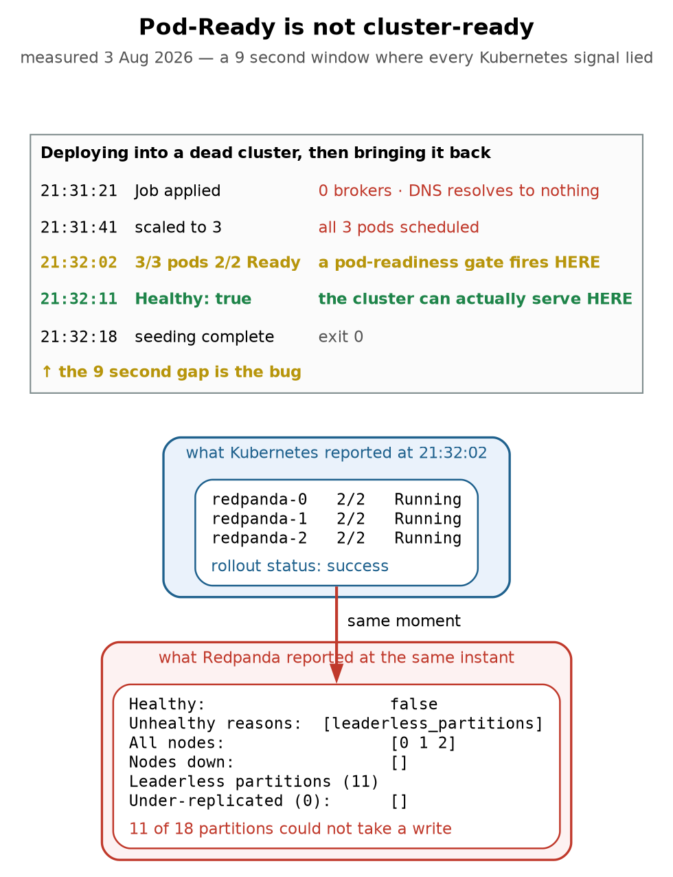
Figure 2 — Pod-Ready is not cluster-ready
Why every simpler gate fails
Wait for DNS? The chart sets publishNotReadyAddresses: true, so the headless Service hands out brokers that are not yet accepting connections. Resolution is not a readiness signal.
Wait for pods Ready? Measured above: 9 seconds early. Each partition is its own Raft group and elects independently — 7 of 18 had finished, 11 had not. There is no instant when “the cluster” becomes ready.
Just sleep? Scheduled→Ready was 21s here and closer to 2 minutes with cold images. sleep 60 would pass today and fail that run; sleep 180 is safe and wastes 3 minutes on every deploy forever.
Poll for Healthy: true. Cost 0s on an already-healthy cluster, 50s here. Self-adjusting, and bounded so a genuinely broken cluster still fails the pipeline.
Alert on Leaderless, never on Under-replicated alone — with no leader there is nobody to compute under-replication, so it read 0 while 11 partitions were dead. Second time this metric lied.
6c. The fix, and the trap inside the fix
Gate on cluster health, in an init container, so the main container does not even start until the cluster can serve:
initContainers:
- name: wait-for-cluster-health
image: docker.redpanda.com/redpandadata/redpanda:v26.1.12
command: ["/usr/bin/bash", "-c"]
args:
- |
A=redpanda-0.redpanda.redpanda.svc.cluster.local:9644
A=$A,redpanda-1.redpanda.redpanda.svc.cluster.local:9644
A=$A,redpanda-2.redpanda.redpanda.svc.cluster.local:9644
for i in $(seq 1 120); do
if rpk -X admin.hosts=$A cluster health 2>/dev/null | grep -qE '^Healthy:[[:space:]]+true'; then
echo "cluster healthy after $(( (i-1)*5 ))s"; exit 0
fi
echo "waiting for cluster health... ${i}/120"
sleep 5
done
echo "ERROR: cluster did not reach Healthy:true within 600s"; exit 1
The trap: the first version of this used -X brokers= and hung for five minutes against a cluster that was demonstrably healthy. rpk cluster health is an Admin API call on :9644. -X brokers= sets the Kafka API (:9093) broker list and is silently ignored by this subcommand, so rpk fell back to its default of 127.0.0.1:9644 — which inside a seeding pod is nothing at all:
unable to request cluster health: Get "http://127.0.0.1:9644/v1/cluster/health_overview":
dial tcp 127.0.0.1:9644: connect: connection refused
It was doubly misleading because testing the same command from inside redpanda-0 worked — there, localhost:9644 really is a broker’s admin API. The lesson generalises well beyond rpk: a health gate that cannot reach its target is indistinguishable from a target that is unhealthy. This one failed closed for entirely the wrong reason, and would have blocked every deploy while pointing the on-call engineer at the cluster instead of at the manifest.
Topic operations use -X brokers= (:9093). Cluster operations use -X admin.hosts= (:9644).
6d. Why the simpler gates don’t work
Gate | Why it fails
Wait for DNS to resolve | The chart sets publishNotReadyAddresses: true, so the headless Service hands out brokers that are not yet accepting connections. Resolution is not a readiness signal.
Wait for pods Ready | Measured 9 seconds too early (§6b).
sleep N | Scheduled→Ready was 21s with warm images and closer to 2 minutes cold. sleep 60 passes today and fails that run; sleep 180 is safe and wastes 3 minutes on every deploy forever.
Poll for Healthy: true | Costs 0s on an already-healthy cluster and took 50s here. Self-adjusting, and bounded so a genuinely broken cluster still fails the pipeline.
Verified both ways — against a healthy cluster the guard is free:
cluster healthy after 0s
OK orders partitions=6 rf=3
OK executions partitions=6 rf=3
OK: all topics match declared state
and through the full outage it absorbed both phases without failing:
waiting for cluster health... 1/120
...
waiting for cluster health... 10/120
cluster healthy after 50s
OK orders partitions=6 rf=3
OK executions partitions=6 rf=3
OK: all topics match declared state
6e. The structural point
The retry moved from the pod level to inside the container, and that is the part worth being able to explain.
The naive Job retried by dying and being recreated, so its patience was governed by backoffLimit — and that single knob controls both “how long will we tolerate a slow dependency” and “how many times do we retry a genuine error.” You cannot raise one without raising the other.
The guard retries in a loop inside one long-lived init container, which decouples the two budgets: a 600-second wait for a slow cluster, with backoffLimit: 2 still governing real failures. A slow start is absorbed patiently; a broken cluster still turns the pipeline red within a bounded time.

7. Idempotent is not reconciling
The §5 guard is re-runnable, which feels like the finish line. It isn’t. It converges on presence, not on correctness — it only ever asks does this topic exist?
Create a topic by hand with the wrong shape — 2 partitions where the manifest declares 6 — and the existence-only guard reports success forever. The pipeline is green. The topic is wrong. Nobody finds out until an ordering bug surfaces in production, and by then the fix is the one thing you cannot safely do (Ch3 §2d).
So the script has to compare shape, not just existence. What it should do about a mismatch depends entirely on the field, which sorts into three tiers.
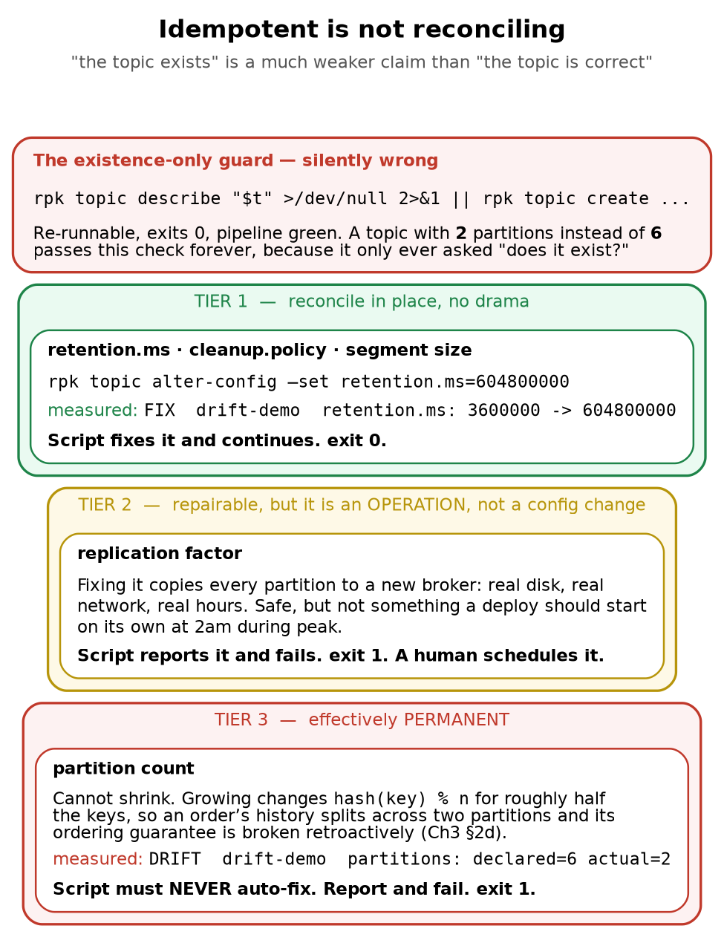
Figure 3 — idempotent is not reconciling
The design rule
A reconciler should fix what is cheap and reversible, and refuse to fix what is expensive or destructive — loudly, with a non-zero exit, naming the field and both values. The failure mode to avoid is not “the script could not fix it.” It is “the script reported success on a cluster that was wrong” — which is exactly what the existence-only guard does, and why a green pipeline is not evidence of a correct topic.
For Tier 3 the only real defence is prevention: auto-create off, partition count reviewed at creation, and sized for growth up front, because it is the one number you can never take back.
7a. Tier 1 — reconcile in place
Retention, cleanup policy, segment size. Cheap, instant, reversible. Just fix them:
############ introduce drift by hand
retention.ms 3600000 DYNAMIC_TOPIC_CONFIG
############ RUN 3: should FIX it in place
OK drift-demo partitions=6 rf=3
FIX drift-demo retention.ms: 3600000 -> 604800000
OK: all topics match declared state
exit=0
retention.ms 604800000 DYNAMIC_TOPIC_CONFIG
Detected, corrected, exit 0, and the follow-up describe confirms it stuck.
Where does 7 days come from, though? retention.ms=604800000 has been sitting in the spec since §5 as if it were self-evident, and for an order journal at a broker-dealer it is worth defending — because two plausible-sounding alternatives are both wrong.
Not cleanup.policy=compact. Compaction keeps the latest record per key and discards the rest, which for orders keyed by order_id means keeping the last event of each order and throwing away its fill history. That destroys the exact thing Chapter 6’s seq check reads, and it does it silently, in the background, weeks after someone set the flag. Compaction is right for a current state topic — the latest position per account — and wrong for an event journal.
Not multi-year retention on broker disk either, even though broker-dealer order records carry regulatory retention measured in years (SEC Rule 17a-4 and the FINRA rules that lean on it). Those obligations also demand things a Kafka topic does not provide — a durable, non-rewriteable format, and the ability to produce specific records on request. The pattern is to treat the topic as the transport and short-term buffer, and to land an immutable copy in archival storage (tiered storage, or a consumer writing to object storage with a retention lock) which is what the regulator actually reads.
So the 7 days is sized against operational need, not legal need: long enough to replay a bad deploy, re-run a day’s positions, or bootstrap a new consumer group from the start of the week, and short enough that the brokers’ local disks are not the system of record. That framing — retention answers “how far back can I replay”, archival answers “what must I be able to produce in five years” — is the answer to give when someone asks why the number is what it is.
7b. Tier 2 — repairable, but it is an operation
Replication factor. Technically fixable, but the fix copies every partition to another broker: real disk, real network, potentially hours. That is a maintenance activity, not something a deploy should silently kick off at 2am during peak trading. Report it, fail, let a human schedule it.
7c. Tier 3 — effectively permanent
Partition count. Cannot shrink. Growing it changes hash(key) % n for roughly half the keys, so an order’s history splits across two partitions and its ordering guarantee is broken retroactively (Ch3 §2d). The script must never, under any circumstances, auto-fix this:
############ RUN 4: should REPORT and FAIL, not silently pass
DRIFT drift-demo partitions: declared=6 actual=2 << NOT AUTO-FIXABLE
FAILED: declared state not reached. See DRIFT lines above.
exit=1
7d. The design rule
Fix what is cheap and reversible. Refuse to fix what is expensive or destructive — loudly, with a non-zero exit, naming the field and both values.
The failure mode to design against is not “the script could not fix it.” It is “the script reported success on a cluster that was wrong.” A green pipeline is evidence that the checks passed, not that the topic is correct — and those are only the same statement if the checks actually compare the thing you care about.
For Tier 3 the only real defence is prevention: auto-create off, partition count reviewed at creation time, and sized for growth up front, because it is the one number you can never take back.

8. The operator alternative
The Redpanda Operator adds custom resources, so a topic becomes an object Kubernetes genuinely knows about:
apiVersion: cluster.redpanda.com/v1alpha2
kind: Topic
metadata:
name: orders
spec:
partitions: 6
replicationFactor: 3
additionalConfig:
retention.ms: "604800000"
What that buys you over a Job:
 | Job | Operator
Runs | Once, at deploy | Continuously reconciles
Drift detected | At deploy time only (§7) | Continuously
Drift corrected | Tier 1 fixed in place; Tier 2/3 reported and the deploy fails (§7) | Tier 1 the same; Tier 2/3 still need a human
Visibility | rpk only | kubectl get topics
Ordering | You handle readiness (§6) | Controller retries until healthy
Cost | One YAML file | Another controller to run, upgrade and monitor
Be precise about that middle pair, because it is the row people wave at to justify an operator and it is not as one-sided as “Job: undetected”. §7 is the section where the Job does detect drift — it fixes retention in place and fails the deploy on partition and replication drift. The real difference is when, not whether: the Job only looks when you deploy, so drift introduced at 11 a.m. on a Tuesday sits undiscovered until the next release. And an operator does not magically fix Tier 3 either — you cannot reduce a partition count by reconciling harder.
The honest trade-off: for a three-broker lab with two topics, the Job is proportionate. For production with many topics across teams, the operator earns its keep — topic definitions become reviewable pull requests instead of somebody’s shell history, and drift gets fixed rather than discovered during an incident.
Same pattern, wider than Redpanda. Schema Registry subjects, OpenSearch index templates, database migrations and Kafka ACLs are all this identical problem: state that lives inside an application, created after the application is running, invisible to Kubernetes. Chapters 5 and 6 hit it again.

9. What I’d actually put in a pipeline
Putting §5 through §7 together, a deploy of this service has four stages, and the interesting design decisions are all about where the gates go and what turns the build red.
1. helm upgrade --install redpanda -f redpanda-values.yaml
gate: kubectl rollout status sts/redpanda
asserts: the brokers exist and their pods are Ready
does NOT assert: the cluster can serve a request
2. seed-topics Job
initContainer: poll Admin API until Healthy: true (bounded, 600s)
container: reconcile declared topics (idempotent + drift-checking)
gate: kubectl wait --for=condition=complete job/seed-topics
asserts: every declared topic exists with the declared shape
3. smoke test
produce one record to each topic and read it back
asserts: the thing the application will actually do, works
4. deploy the application
Points worth being able to defend:
The topic spec is a reviewed artefact, not shell history. The declared list lives in seed-topics.sh in Git, mounted into the Job from a ConfigMap. Changing a partition count is a pull request with a diff, which is the only control that reliably stops Tier 3 mistakes.
kubectl -n redpanda create configmap topic-spec \
--from-file=seed-topics.sh=seed-topics.sh --dry-run=client -o yaml | kubectl apply -f -
Stage 1’s gate is deliberately weak, and that’s fine as long as you know it. rollout status is an infrastructure assertion. Stage 2 and 3 are the service assertions. The mistake is stopping after stage 1 and calling the deploy verified.
Stage 3 exists because stages 1 and 2 can both pass on a broken system. Stage 2 proves the metadata is right; only an actual round-trip proves a client can use it.
ttlSecondsAfterFinished: 3600. Without it, every deploy leaves dead pods behind and kubectl get pods becomes unreadable exactly when you need it during an incident.
Fail red on Tier 2 and Tier 3 drift. Tempting to warn and continue so deploys aren’t blocked by something that “isn’t really broken.” Don’t: a warning in CI output is a warning nobody reads, and these are precisely the two categories that get more expensive the longer they go unnoticed.
9a. The kubectl wait trap, restated
From §4: kubectl wait --for=condition=complete only ever watches for success, so on failure it burns the full timeout and then reports a timeout instead of the actual error. Run both conditions concurrently and take whichever fires first, so a genuine failure surfaces immediately with the right message:
kubectl -n redpanda wait --for=condition=complete job/seed-topics --timeout=600s & ok=$!
( kubectl -n redpanda wait --for=condition=failed job/seed-topics --timeout=600s && exit 1 ) & bad=$!
wait -n $ok $bad; rc=$? # capture IMMEDIATELY -- see below
kubectl -n redpanda logs job/seed-topics --all-containers
kill $ok $bad 2>/dev/null # whichever waiter is still running
exit $rc
Then always print the logs, on success and failure alike — the useful message (TOPIC_ALREADY_EXISTS, or a DRIFT line) is in the pod, not in the wait output.
Two things in that snippet are easy to get wrong, and I got both wrong first.
The exit 1 is inside a subshell, so it exits the subshell, not your script. It does not fail the pipeline. What actually carries the failure is wait -n, which returns the exit status of whichever job finished — and that is a status you have exactly one command to capture. My original version ended the block at wait -n $ok $bad and read correctly in isolation. Then the next sentence says “always print the logs”, and the moment you follow that instruction:
$ bash wait-original.sh; echo "exit = $?"
exit = 0 # the failure is gone; $? now belongs to kubectl logs
A deploy gate that reports success on every failed seed, introduced by adding a log line. Hence rc=$? on the same line, before anything else runs.
The kill matters too: the losing waiter otherwise sits there for the remaining timeout. Harmless in a shell, an accumulating pile of processes in a CI runner that does this on every deploy.
Verified both paths on bash 5.3 — failure returns 1 with the logs printed, success returns 0 immediately rather than waiting out the loser’s timeout.

10. Where this sandbox differs from production
Here | Production
Two topics in a bash array | Many topics across teams; a spec file per service, or an operator with Topic CRDs
Job triggered by kubectl apply | Helm post-install,post-upgrade hook, or an ArgoCD sync wave, so ordering is declared rather than remembered
Topic spec in a ConfigMap built by hand | ConfigMap rendered by the chart from values, so spec and release version together
Script runs once per deploy | Operator reconciles continuously; drift is corrected between deploys, not just discovered at deploy
retention.ms is the only Tier 1 field checked | Also cleanup.policy, min.insync.replicas, max.message.bytes, per-topic compression
No ACLs | Topics created with an owning principal and ACLs, provisioned in the same step
Drift found only when the pipeline runs | A scheduled reconcile job or an alert on spec-vs-actual, so drift is found in minutes, not at the next release
admin.hosts over plaintext | mTLS to the Admin API, credentials from a Secret, never in the manifest
Single node, so “3 brokers” share a failure domain | Real anti-affinity across nodes and zones (Ch3 §6c)
The single biggest gap is the fourth row. Everything in this chapter runs at deploy time, so between deploys the cluster can drift and nothing notices. That is the structural argument for the operator in §8, and it is the honest answer to “why would you ever run a controller for this?”

11. Commands to know by heart
# ---- the boundary: k8s knows nothing about these ----
rpk topic list
rpk topic describe orders
rpk topic create orders -p 6 -r 3 # exit 1 if it already exists
rpk topic describe orders >/dev/null 2>&1 # exit 0 = exists (the idempotency guard)
# ---- cluster-level config (what a bootstrap file CAN set) ----
rpk cluster config get auto_create_topics_enabled
rpk cluster config get default_topic_partitions
# ---- drift: compare shape, not just existence (see §7) ----
rpk topic describe orders # PARTITIONS / REPLICAS summary
rpk topic describe orders -c # per-topic configs, incl. retention.ms
rpk topic alter-config orders --set retention.ms=604800000 # Tier 1 fix
# ---- the two DIFFERENT endpoints (see §6c) ----
rpk -X brokers=redpanda.redpanda.svc.cluster.local:9093 topic list # Kafka API
rpk -X admin.hosts=redpanda-0.redpanda.redpanda.svc.cluster.local:9644 \
cluster health # Admin API
# ---- seeding Jobs ----
kubectl -n redpanda create configmap topic-spec \
--from-file=seed-topics.sh=seed-topics.sh --dry-run=client -o yaml | kubectl apply -f -
kubectl -n redpanda logs job/seed-topics -c wait-for-cluster-health
kubectl -n redpanda logs job/seed-topics -c seed
kubectl -n redpanda get pods -l job-name=seed-topics
kubectl -n redpanda describe job seed-topics | tail -12
kubectl -n redpanda delete job seed-topics --ignore-not-found
# ---- waiting properly (see §4, §9a) ----
kubectl -n redpanda wait --for=condition=complete job/seed-topics --timeout=600s
kubectl -n redpanda wait --for=condition=failed job/seed-topics --timeout=600s
# ---- reproducing the readiness race (see §6a) ----
kubectl -n redpanda scale sts redpanda --replicas=0
kubectl -n redpanda scale sts redpanda --replicas=3
kubectl -n redpanda get pods -l app.kubernetes.io/name=redpanda \
-o jsonpath='{range .items[*]}{.metadata.name}{" ready="}{range .status.conditions[?(@.type=="Ready")]}{.lastTransitionTime}{end}{"\n"}{end}'

12. Glossary
Term | Meaning
Control plane (Kubernetes) | Manages pods, storage, networking. Knows nothing of topics.
Control plane (Redpanda) | The controller Raft group; holds topics, ACLs, cluster config.
Seeding / bootstrapping | Creating application-level state after the application is running.
Idempotent | Re-running produces the same result without error. Converges on presence.
Reconciling | Continuously corrects live state to match declared state. Converges on correctness.
auto.create.topics.enable | Creates topics implicitly on first produce. Off here, deliberately. Redpanda spells it auto_create_topics_enabled — same knob, and this chapter uses both spellings because rpk accepts only the second while every Kafka document you will read uses the first.
retention.ms | How long records survive before deletion. Sized for how far back you can replay, not for regulatory retention — that belongs in archival storage (§7a).
cleanup.policy=compact | Keeps only the latest record per key. Correct for a current-state topic, destructive for an event journal, and it does its damage silently (§7a).
Post-install hook | A Helm-managed Job that runs after the release is applied.
backoffLimit | Retries before a Job is marked Failed. 2 means three pods total.
Operator / CRD | A controller plus custom resource types, making app state a Kubernetes object.
Init container | Runs to completion before the main container starts. Used here as the health gate.
ttlSecondsAfterFinished | Auto-deletes a finished Job so dead pods stop cluttering get pods.
publishNotReadyAddresses | Service setting that puts not-ready pods in DNS. True here, so resolution is not readiness.
Admin API (:9644) | Cluster operations — health, config, broker membership. What cluster health uses.
Kafka API (:9093) | Client and topic operations. What -X brokers= sets, and what cluster health ignores.
Drift | Live state diverging from declared state. Tiered here by whether it is safe to auto-repair.
Fail closed | Refusing to proceed when a check can’t be completed. Safe, but §6c shows it can mislead.

13. Interview questions this material answers
Short, defensible answers. The value is that each one is backed by something measured on this cluster, so the follow-up “have you actually seen that happen?” has a real answer.
“Walk me through deploying a Kafka/Redpanda-backed service.” Four stages (§9): brokers via Helm gated on rollout status; topics via a health-gated, idempotent Job gated on Job completion; a produce/consume smoke test; then the application. The key point is that the first gate only asserts infrastructure — helm install plus rollout status will report success on a cluster that cannot serve a single request, because topics are not Kubernetes objects.
“Your deploy pipeline went red but the service is fine. What happened?” Almost certainly a non-idempotent seeding step. rpk topic create exits 1 with TOPIC_ALREADY_EXISTS, so the Job succeeds on first deploy and fails on every one after. Guard with rpk topic describe, which exits 0 when the topic exists.
“Your seeding job fails intermittently on fresh environments only.” A readiness race. The retry budget (backoffLimit: 2, roughly 32 seconds) is shorter than broker startup (21s to 2 minutes here, depending on image cache), so it exhausts its retries before the dependency is available. Fix with an init container that polls for cluster health, which decouples the wait budget from the failure budget.
“Why not just wait for the pods to be Ready?” Because pod-Ready is not cluster-ready. Measured a 9-second window where all three brokers were 2/2 Ready and 11 of 18 partitions were still leaderless — each partition is its own Raft group and they elect independently. Waiting for DNS is worse still: publishNotReadyAddresses: true means the name resolves to brokers that aren’t accepting connections yet.
“Why not sleep 120?” Because the correct value is unknowable and changes per environment. Startup was 21 seconds here with warm images and near 2 minutes cold. Any fixed sleep is either too short sometimes or wasting minutes on every deploy always. Polling costs zero when the cluster is already healthy.
“What’s the difference between an idempotent script and a reconciling one?” Idempotent converges on presence — safe to re-run, exits 0. Reconciling converges on correctness — it compares live shape against declared shape. An existence-only guard reports success forever on a topic with 2 partitions where 6 were declared, which is how a green pipeline coexists with a wrong cluster.
“You find a topic with the wrong partition count. Fix it.” I don’t, not automatically. Growing a partition count changes hash(key) % n for about half the keys, so an order’s history splits across two partitions and ordering breaks retroactively. Shrinking isn’t possible at all. The correct move is to fail the pipeline loudly and treat it as a migration — typically a new correctly-shaped topic and a controlled cutover. That’s why I sort drift into fix in place / schedule as an operation / never auto-fix.
“What would you alert on for this cluster?” Leaderless partitions and Nodes down. Explicitly not Under-replicated on its own — I’ve watched it read 0 twice while the cluster was badly degraded, because with no leader there’s nobody to compute it.
“Would you use the operator?” Depends on scale and on whether drift between deploys matters. A Job is proportionate for a handful of topics owned by one team. The operator earns its keep when topic definitions belong in pull requests across teams and you need drift corrected continuously rather than discovered at the next release — the honest limitation of everything in this chapter is that it only runs at deploy time.
“Why is auto.create.topics.enable off?” New topics would inherit default_topic_partitions, which is 1 here — no parallelism, one leader carrying everything. Worse, a typo silently creates a working producer writing to a topic nobody consumes, and since partition count is effectively permanent that’s a mistake you can’t cleanly undo. With it off you get an immediate UNKNOWN_TOPIC_OR_PARTITION.

14. Check yourself
- You rebuild the cluster from redpanda-values.yaml. What do you get, and what is missing? (§1)
- Where does a topic definition physically live? What does it survive, and what kills it? (§1)
- Every pod is Running and rpk cluster health is green. Why might the service still be unusable? (§2)
- Why can’t topics go in the broker’s startup config? (§3)
- Give two concrete reasons not to enable auto_create_topics_enabled. (§3)
- Why should a seeding Job dial the headless Service name instead of redpanda-0? (§4, Ch3 §5b)
- rpk topic create on an existing topic — what’s the exit code, and why does that break a pipeline? (§4)
- Which rpk command gives a clean existence test, and what are its exit codes? (§4)
- Your Job failed at 34s but kubectl wait took 90s and reported a timeout. Explain both, and fix it. (§4, §9a)
- Name the one field an idempotent seeding script cannot safely fix. (§7, Ch3 §2d)
- When is an operator worth running, and when is a Job proportionate? (§8)
- Name three non-Redpanda examples of this same provisioning problem. (§8)
- Why is set -e the wrong choice in a drift-checking script? (§5a)
- Why parse rpk table output with awk instead of --format json | jq? (§5a)
- All three broker pods are 2/2 Ready. Name two reasons that doesn’t mean seeding will succeed. (§6b, §6d)
- Why were 11 of 18 partitions leaderless rather than all 18? (§6b, Ch3 §3)
- Under-replicated partitions (0) during a serious outage — why, and what do you alert on instead? (§6b)
- A health gate hangs for 5 minutes against a healthy cluster. What’s the first thing you check? (§6c)
- Which rpk operations use :9093 and which use :9644? What happens if you pass the wrong flag? (§6c)
- Why does moving the retry into an init container help, when the Job already had backoffLimit? (§6e)
- Give an example of Tier 1, Tier 2 and Tier 3 drift, and what a pipeline should do with each. (§7)
- A pipeline is green. What does that prove about your topics, and what does it not? (§7d)
- Why run a produce/consume smoke test when the seeding Job already exited 0? (§9)
- What is the single biggest limitation of the deploy-time approach in this chapter? (§10)

What’s next
- Chapter 5 — consumer groups and rebalancing: who owns which partition, what a rebalance costs, and the difference a SIGTERM makes over a SIGKILL.
- Chapter 6 — the application: the client-side settings (acks, enable.idempotence, partitioner choice) that decide whether the pipeline is correct.
- Chapter 7 — Schema Registry: this same provisioning problem, with subjects instead of topics.

