Table of Contents

Chapter 5 — Consumer Groups, Rebalancing and Delivery Semantics
Who this chapter is written for. Andrew is interviewing for an SRE / DevOps role on an order management system. Chapters 3 and 4 got data into Redpanda and got topics provisioned. This one is about getting data out reliably — how work is divided, what happens when a consumer dies, and why “we process each message exactly once” is the sentence that double-executes trades.

Verified facts header
Run on vm-k8-redpanda-1 (192.168.1.186), single-node k3s v1.36.2, Redpanda v26.1.12, on 3 August 2026. Every command was executed and every number quoted is measured.
Thing | Value as tested
Topic | orders — 6 partitions, RF 3, 1500 records produced across the session
Keys | ORD-1 … ORD-12, equal volume each, so partition load == key count
Group | oms-processor, grown from 1 to 7 members and back down to 5
Assignment strategy | cooperative-sticky (rpk’s default)
Group coordinator | node 2, at __consumer_offsets/7
Offsets topic | __consumer_offsets — 16 partitions, RF 3, cleanup.policy=compact
Session timeout floor | group_min_session_timeout_ms = 6000 (max 300000)
Prerequisite reading: Chapter 3 §2 (topics, partitions, offsets) and §5 (headless Services and how a client connects). Chapter 4 §7c on why partition count is permanent is the punchline of §3 here.

What this chapter covers
- What a consumer group is, and the three rules of assignment
- The parallelism ceiling — and why the idle consumer isn’t useless
- Skew: why one partition gets hammered, and why no broker will fix it
- Lag, and how to read the describe table during an incident
- Rebalancing: what moves, and what it costs
- Graceful death versus hard death — the same failure, two different data outcomes
- Delivery semantics, and why idempotency is yours to own
- Where offsets actually live
- Replay — deliberately reprocessing the past, and what it costs
- Production gaps, commands, glossary, interview questions, self-test

1. What a consumer group is
A consumer group is how several processes share the work of reading one topic without reading the same record twice at the same time. You opt in by passing a group name:
rpk topic consume orders -g oms-processor -o start -f '%p %o %k\n'
Everything interesting follows from three rules.
Rule 1 — a partition has exactly one owner in the group, at any instant. Never two. This is the rule that makes per-partition ordering safe to depend on: if two consumers could interleave work on the same key, the ordering guarantee from Chapter 3 would be worthless the moment you scaled out.
Rule 2 — a consumer may own many partitions. With one member in the group, it owned all six:
MEMBERS 1
TOTAL-LAG 120
TOPIC PARTITION CURRENT-OFFSET LOG-START-OFFSET LOG-END-OFFSET LAG MEMBER-ID CLIENT-ID HOST
orders 0 - 0 0 - rpk-b84e5b00... rpk 10.42.0.1
orders 1 - 0 30 30 rpk-b84e5b00... rpk 10.42.0.1
orders 2 - 0 50 50 rpk-b84e5b00... rpk 10.42.0.1
orders 3 - 0 10 10 rpk-b84e5b00... rpk 10.42.0.1
orders 4 - 0 10 10 rpk-b84e5b00... rpk 10.42.0.1
orders 5 - 0 20 20 rpk-b84e5b00... rpk 10.42.0.1
Two things about that output are worth pausing on, because both cause real mistakes.
It is nine columns, and the ones people forget are in the middle. Any awk you write against this must count past LOG-START-OFFSET, so LAG is $6 and MEMBER-ID is $7 — not $5 and $6, which is what you get if you assume the abbreviated five-column table that appears in a lot of write-ups (including an earlier draft of this one). An index that is off by one here does not error; it silently prints CLIENT-ID, which is the string rpk for every rpk consumer alive, so sort -u | wc -l cheerfully reports one owner no matter what the group is doing. Check the header against your own rpk version before trusting any fixed index.
CURRENT-OFFSET is - everywhere, which means this group has committed nothing yet. This is a snapshot taken before the first commit, so read it as evidence of ownership only. It is not in conflict with §2’s statement that c1 processed those 120 records; processing and committing are different events, and the entire second half of this chapter is about the gap between them.
Rule 3 — assignment counts partitions, not records. Add a second consumer and the six partitions split 3/3. The work does not:
c1 owns p0, p1, p2 -> 0 + 45 + 75 = 120 records (67%)
c2 owns p3, p4, p5 -> 15 + 15 + 30 = 60 records (33%)
(By this point 180 records had been produced in total — the 120 above plus a further 60 while the second consumer was joining. The split is 120/60 of 180, not of the earlier 120.)
Doubling the consumers left one of them doing twice the work of the other, and nothing in the protocol will ever correct that. The group has no idea some partitions are hot.
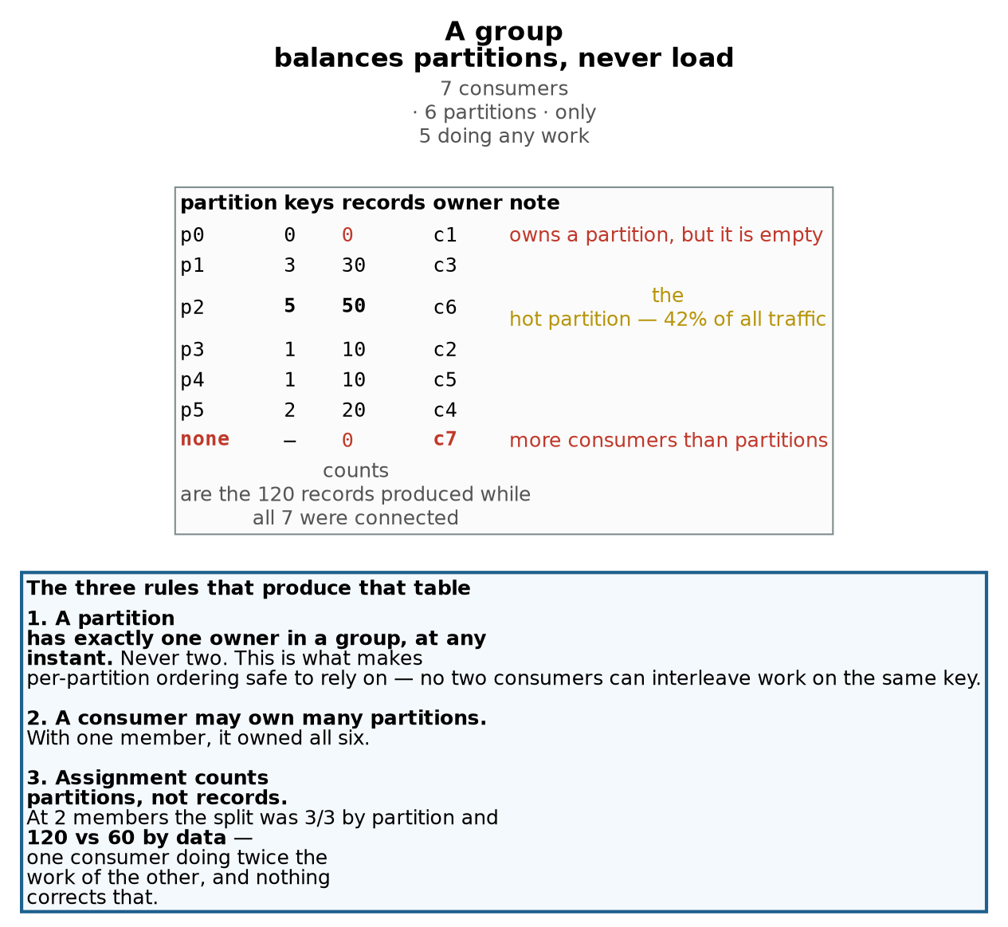
Figure 1 — how partitions are assigned to group members
Partition count is a permanent ceiling on consumer parallelism
Six partitions means at most six consumers can do work. The 7th got no assignment and stayed at zero records while 120 flowed past it.
So your worst-case lag is set by your hottest partition, not by your consumer count. If p2 falls behind you cannot add consumers to help — it already has a dedicated one, and rule 1 forbids a second. The only levers are a faster consumer, a different key, or more partitions — and more partitions rewrites hash(key) % n and breaks ordering retroactively (Ch3 §2d, Ch4 §7c).
But idle is not the same as useless. When the p2 owner was killed, c7 inherited it instantly — already connected, already in the group, no process start. An idle consumer is a warm standby you pay for in steady state. Whether that trade is worth it depends on your consumer’s startup cost.

2. The parallelism ceiling
Six partitions, seven consumers. Measured over 120 records produced while all seven were connected:
c6 -> p2 50 records <-- the hot partition
c3 -> p1 30
c4 -> p5 20
c2 -> p3 10
c5 -> p4 10
c1 -> p0 0 <-- owns a partition, but it has never held a record
c7 -> -- 0 <-- owns nothing: more consumers than partitions
Seven consumers, five doing work. Two distinct flavours of idle, and it’s worth separating them because only one is structural. c7 has no assignment at all — with six partitions, the seventh member is surplus by definition. c1 does have an assignment, but partition 0 is empty, so it is functionally idle too. Note also that c1 was the original consumer that single-handedly processed the first 120 records; rebalancing demoted it to the empty partition with no regard for history.
The number to take away:
Your worst-case lag is set by your hottest partition, not by your consumer count. If p2 falls behind, adding consumers cannot help — it already has a dedicated one, and Rule 1 forbids a second.
Your only levers are a faster consumer, a different key, or more partitions. And more partitions rewrites hash(key) % n, breaking ordering retroactively for roughly half the keys (Ch3 §2d, Ch4 §7c). Partition count is not just a storage decision — it’s your permanent maximum throughput, chosen before you have any data about what that needs to be.
2a. Idle is not the same as useless
That conclusion needs immediate qualification, because the next demo contradicted the obvious reading of it. When the p2 owner was killed, c7 inherited the partition instantly. It was already connected, already authenticated, already a group member — failover needed no process start, no metadata fetch, just an assignment.
So a surplus consumer is a warm standby you pay for in steady state. Whether that’s a good trade depends entirely on how expensive your consumer’s startup is. For a JVM service with a slow warm-up, one idle replica may be excellent value. For a cheap process under a Deployment that Kubernetes will restart in two seconds anyway, it’s waste.

3. Skew: why one partition gets hammered
Twelve order IDs, identical volume each, hashed into six partitions:
p0: (none) 0%
p1: ORD-4, ORD-5, ORD-12 25%
p2: ORD-2, ORD-3, ORD-7, ORD-10, ORD-11 42% <-- five of twelve keys
p3: ORD-8 8%
p4: ORD-1 8%
p5: ORD-6, ORD-9 17%
The natural question is why Redpanda doesn’t notice that p3 is quiet and send some of p2’s traffic there. Two independent reasons, and the second is the important one.
The broker never gets a vote. hash(key) % 6 is computed client-side, in the producer, before the record is sent. By the time it arrives at a broker it is already addressed to partition 2. The broker is a destination, not a router.
And if it could, it must not. Move ORD-2 to p3 to level out disk usage and ORD-2’s history is now split across two partitions, read by two different consumers, with no ordering between them — a cancel could be processed before the order it cancels. That is exactly the damage from Chapter 3’s repartitioning demo, except inflicted silently, mid-flight, by the broker. Redpanda declines to balance your data because balancing it would break the one guarantee you’re paying for.
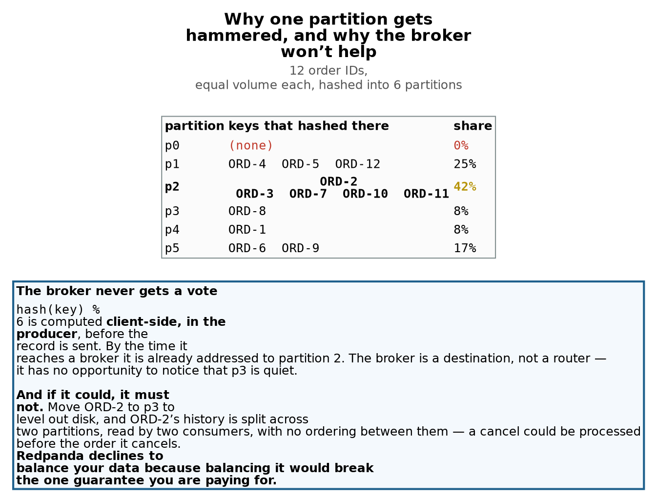
Figure 2 — two problems that look identical
Two different problems that look identical
Small-numbers skew — fixes itself. 12 keys into 6 buckets should average 2 each; random assignment lands like this routinely, for the same reason 12 coin flips rarely give exactly 6 heads. A real OMS has thousands to millions of order IDs and the distribution flattens on its own.
Do not over-learn this particular skew. A genuinely hot single key — unfixable by partitioning. If one client’s account is 40% of volume, no partition count helps: that key must stay on one partition to keep its ordering. The answers are a composite key such as account-shard (spreads load, gives up per-account ordering) or a dedicated topic for that flow. It is a data-modelling decision, not a tuning one.
Not on the list: adding partitions. It does not reliably fix skew — the redistribution can be just as unlucky — and it breaks ordering retroactively for roughly half the keys.
3a. Two problems that look identical
Small-numbers skew fixes itself. Twelve keys into six buckets should average two each; random assignment lands like the table above routinely, for the same reason twelve coin flips rarely give exactly six heads. A real OMS has thousands to millions of distinct order IDs and the distribution flattens on its own. Don’t over-learn this particular skew — it’s an artifact of the demo.
A genuinely hot single key is unfixable by partitioning. If one client’s account ID were 40% of volume, no partition count helps: that key must live on one partition to keep its ordering. The answers are a composite key such as account-shard-3 (spreads the load, gives up per-account ordering, keeps per-order ordering) or a dedicated topic for that flow. It’s a data-modelling decision, not a tuning one, and saying so is the right answer if an interviewer asks how you’d handle a hot partition.
Notably absent from both lists: adding partitions. It doesn’t reliably fix skew — the redistribution can be just as unlucky — and it breaks ordering retroactively.

4. Lag, and how to read the table
LAG is LOG-END-OFFSET minus CURRENT-OFFSET: how far this group’s committed progress trails what has been written. It is the single most important operational metric for a consumer, and in an order management system it is the direct answer to how stale is our view of the book.
Three things about that table that matter at 3am:
Lag is per-partition; TOTAL-LAG is only the sum. Total lag can look healthy while one partition is badly behind. Given the skew above, a stall on p2 would be 42% of your traffic while the other five partitions keep the aggregate looking survivable. Alert on max per-partition lag, not just the total.
A dash is not a zero. Partition 0 shows CURRENT-OFFSET - even when the group is fully caught up. A dash means this group has never committed an offset for this partition, which is very different from having committed offset 0. Nothing ever arrived, so nothing was ever committed. Read it alongside LOG-END-OFFSET to tell “idle partition” apart from “consumer never started.”
Lag falling to zero says nothing about correctness. It means the group committed offsets up to the high-water mark. Whether the consumer actually did anything useful with those records — or crashed after committing — is a separate question that lag cannot answer.

5. Rebalancing
Whenever membership changes — a consumer joins, leaves, or is declared dead — the coordinator reassigns partitions. This is a rebalance, and it happens far more often than people expect: every deploy, every scale event, every pod eviction, every OOM kill.
BALANCER cooperative-sticky is rpk’s default and the modern one. The older eager strategies (range, roundrobin) revoke every assignment from every member and redistribute from scratch — a genuine stop-the-world pause across the whole group. Cooperative rebalancing moves only the partitions that actually need to move, so consumers untouched by the change keep working.
A practical consequence of watching this live: the describe output barely changes. Going from 2 members to 7 changed MEMBERS and the MEMBER-ID column and nothing else, because no new data had arrived. The rebalance moved ownership, not progress. If you’re trying to observe a rebalance, count distinct owners rather than reading offsets:
echo "members: $(rpk group describe oms-processor | awk '/^MEMBERS/{print $2}')"
echo "owners: $(rpk group describe oms-processor | awk 'NF>6 && $1=="orders"{print $7}' | sort -u | wc -l)"
When those two numbers disagree, you have surplus consumers.
Rebalances make the distribution less fair over time, not more. After two consumers died, the group settled at 5 members for 6 partitions with 527953fc owning both p2 and p3 — the hot partition plus another one, on a single consumer. Nothing rebalances for load, so each failure is an opportunity for the assignment to get worse.

6. The same failure, two different data outcomes
This is the demo worth remembering. Partition 2 had four owners over its life:
c1 offsets 0 .. 74 (75 records)
c6 offsets 75 .. 137 (63) <-- killed with SIGTERM
c7 offsets 138 .. 395 (258) <-- killed with SIGKILL
c2 offsets 393 .. 624 (232)
^^^
393, 394, 395 processed TWICE
SIGTERM — graceful. c6 ended at 137, c7 began at 138. The dying consumer committed its final offset and left the group explicitly, so the coordinator reassigned immediately without waiting for any timeout. Zero duplicates, zero gaps.
SIGKILL — what production actually does. c7 had consumed through offset 395, but its last committed offset was 392. It died with no opportunity to commit or to leave the group, so the coordinator could only detect it by missed heartbeats, and c2 correctly resumed from 393:
2 393 ORD-10 2 393 ORD-10
2 394 ORD-11 2 394 ORD-11
2 395 ORD-2 2 395 ORD-2
Three records processed twice — and 75 + 63 + 258 + 232 = 628 processed for 625 records written.
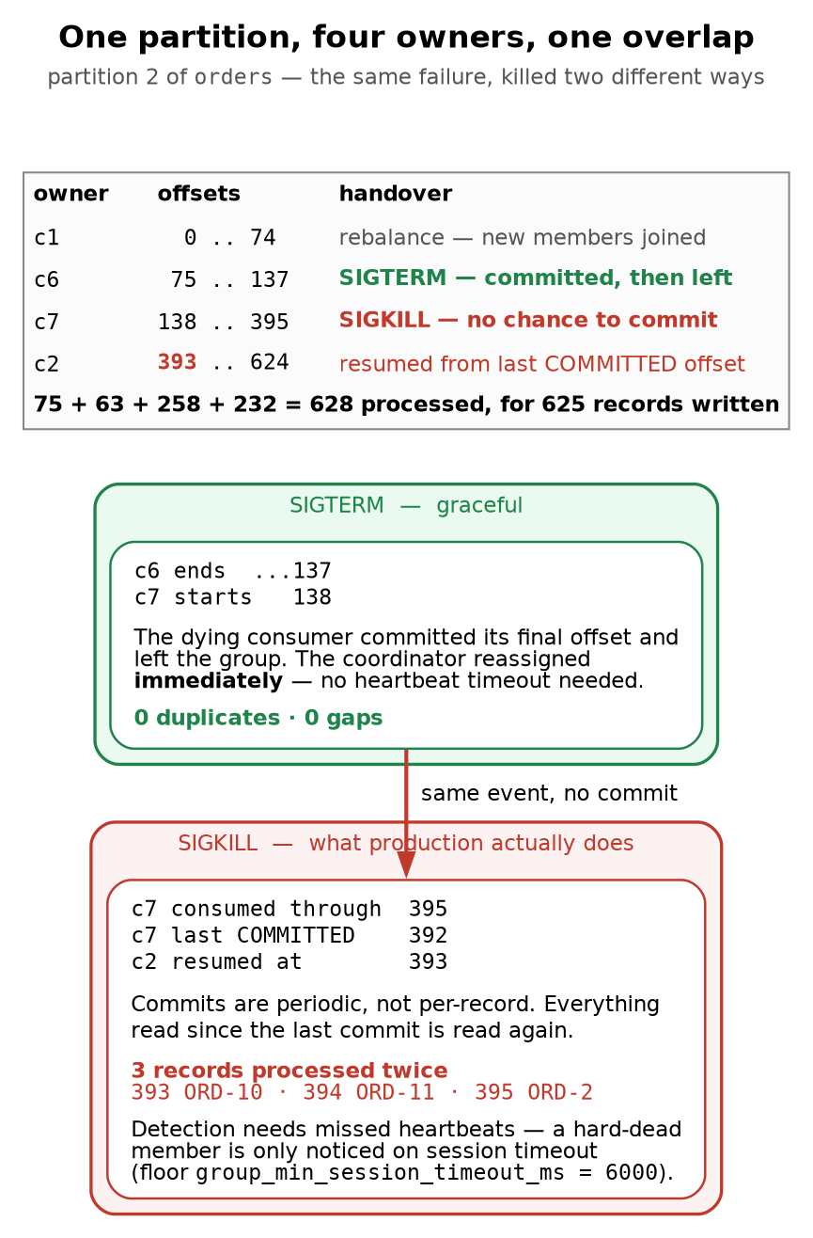
Figure 3 — what a rebalance actually costs
At-least-once is not a setting. It is the default reality.
The duplicate count is throughput × time since last commit. Shortening the commit interval makes duplicates rarer and commit traffic heavier; it never makes them impossible. A consumer committing every 30s on a busy partition replays thousands, not three.
So the fix is not tuning — it is an idempotent consumer. Dedupe on an event ID, make the write conditional on current state, or upsert by order ID instead of appending. “Each message is processed exactly once” is the assumption that double-executes trades.
Exactly-once exists, but is narrower than it sounds: Kafka/Redpanda transactions cover read-process-write loops that stay inside the cluster. The moment the side effect is an external order gateway or a REST call, you are back to at-least-once and idempotency is yours to own.
The mechanism is the gap between consumed and committed. Committing is periodic, not per-record; doing it per record would mean a synchronous round trip for every message. Everything read since the last commit gets read again. That’s not a bug — that’s the definition of at-least-once delivery.
OOM kills, kubectl delete pod --force, node failures and liveness-probe kills (Ch2 §7) are all the SIGKILL case. The graceful path is the exception, not the norm.

7. Delivery semantics
The duplicate count is throughput × time since last commit. That makes it tunable, and the tuning is a straight trade: a short auto.commit.interval means fewer duplicates and more commit traffic; a long one means better throughput and a bigger replay window. You saw three records because rpk commits often. A consumer committing every 30 seconds on a busy partition replays thousands.
Which is why tuning is not the fix. You can make duplicates rarer; you cannot make them impossible. The fix is an idempotent consumer:
- dedupe on an event ID you carry in the record
- make the write conditional on current state (UPDATE ... WHERE status = 'PENDING')
- upsert keyed by order ID rather than appending
“We assume each message is processed exactly once” is the assumption that produces double-executed trades. In an OMS, reprocessing a fill must be safe, not merely unlikely.
Exactly-once exists, but it’s narrower than the name suggests. Kafka/Redpanda transactions give you exactly-once for read-process-write loops that stay inside the cluster — consume from topic A, produce to topic B, commit offsets and output atomically. The moment your side effect leaves the cluster (an order gateway, a REST call, a row in Postgres outside the transaction), you are back to at-least-once and idempotency is your responsibility.

8. Where offsets actually live
Your group’s progress is stored as records in an ordinary Redpanda topic:
NAME __consumer_offsets
INTERNAL true
PARTITIONS 16
REPLICAS 3
cleanup.policy compact
Three consequences worth knowing:
Offsets survive your consumers. During an early test the group showed STATE Empty with MEMBERS 0 after every consumer exited — the group and its committed offsets persisted with nothing running. That’s why a consumer restarting resumes instead of replaying from the beginning, and why -o start did not make a newly joined member re-read history: -o start only decides where to begin when the group has no committed offset for a partition.
One partition of that topic is your coordinator. COORDINATOR-PARTITION __consumer_offsets/7 — the group name hashes to one of the 16 partitions, and the broker leading it coordinates your group. This is why group membership is affected by broker failures: lose the leader of that partition and your group needs a new coordinator before it can rebalance.
cleanup.policy=compact, not delete. Compaction keeps the latest value per key rather than expiring old records by age, and the key here is (group, topic, partition) — so the current offset survives indefinitely while superseded ones are collected. That is exactly the right policy for this data and exactly the wrong one for an order journal, for the same reason: compaction preserves the latest state and discards the history (Ch4 §7a).
It has to be this way, because the alternative is silent. An ordinary topic like orders carries retention.ms=604800000, so its records are deleted after seven days by design. If offsets expired on a timer like that, a consumer group that was idle over a long weekend would come back, find no committed offset, fall through to auto.offset.reset, and replay the topic from the beginning — reprocessing every order it had already handled, with no error anywhere. Compaction is what stops a quiet group from becoming a duplicate storm.

9. Replay: deliberately reprocessing the past
Offsets are just numbers in a topic (§8), which means you can write them. That turns “reprocess yesterday’s fills” from a crisis into a command, and “how would you replay a day of data” is a stock interview question for anyone operating a streaming platform.
rpk group seek <group> --to start # from the beginning of the topic
rpk group seek <group> --to end # skip everything unprocessed
rpk group seek <group> --to 1785801782636 # a specific epoch-millisecond timestamp
rpk group seek <group> --topics orders -to start # one topic only
The group must be empty first. A seek rewrites the committed offsets, and a live member would carry on from its own in-memory position and then commit over the top of your change. So the procedure is always: stop the consumers, confirm the group has no members, seek, restart.
kubectl -n market scale deploy position-keeper --replicas=0
kubectl -n market wait --for=delete pod -l app=position-keeper --timeout=90s
rpk group seek position-keeper --to start
kubectl -n market scale deploy position-keeper --replicas=1
What a replay actually costs
This is worth doing once, because it proves Chapter 6’s central claim from the opposite direction. The state before the replay was a clean, fully reconciled run — 2,000 orders, 8,000 fills, 800,000 shares, both ledgers agreeing exactly. Then the group was seeked to offset 0 and every record in the topic was processed a second time:
before replay after replay
transactional : rows=8000 total=800000 rows=8000 total=800000
gateway : calls=8000 total=800000 calls=16216 total=1621600
The transactional ledger did not move at all. Not by one share. It upserts on (order_id, seq), so reprocessing rewrites rows that already hold the correct value, and the answer is identical whether you process the topic once or a hundred times.
The gateway doubled, because every replayed fill was a fresh non-rollback-able call, and 821,600 shares were “executed” that nobody ordered.
So the rule for replay is the same rule as for crash recovery, which is why it is worth seeing twice: replay is free for idempotent state and catastrophic for external side effects. Before you seek a group in production, the question is not “can I replay” — you always can — it is what else does this consumer touch? If it only writes to a store keyed by a business key, replay is a non-event. If it sends orders, emails, or payments, you must disable the side effect first, or replay into a parallel consumer group writing to a shadow store and compare.
That last technique is worth naming, because it is what people actually do: a shadow replay uses a different group.id on the same topic, so it gets its own offsets and reads every record without disturbing the live group at all (§1, rule 1 applies per group, not across groups).
The staleness number goes strange during a replay, and it should. The consumer reports the age of the events it is handling, and during this replay it read staleness=1116.16s — the records were eighteen minutes old. That is correct and it is the reason to measure event age rather than record lag: an alert on “my view of the book is 18 minutes stale” is meaningful, whereas TOTAL-LAG 10001 needs someone to know how fast this consumer drains before it means anything.
A bug this replay found
The first attempt at the above crash-looped, and the reason is a good one to keep. Seeking a group triggers a rebalance, and a rebalance can revoke your partitions between processing a record and committing its offset. The commit then fails with:
KafkaError{code=_NO_OFFSET,val=-168,str="Commit failed: Local: No offset stored"}
That is not an error condition — it means “there is nothing stored to commit”, the successor will redeliver from the last committed position, and the idempotent write makes that safe. But the consumer treated every exception during commit as fatal, so a routine rebalance became a CrashLoopBackOff in the middle of a recovery operation. Code that is careful about correctness tends to be over-eager about failing, and the place that bites is always the rebalance path, because that is the path you cannot easily test on a single quiet consumer.

10. Where this sandbox differs from production
Here | Production
rpk topic consume as the consumer | A real client library, with explicit commit control and rebalance listeners
Auto-commit on rpk’s default interval | Deliberate commit strategy — usually commit after the side effect succeeds
Duplicates observed and shrugged at | Idempotent handlers, dedupe store, or transactional read-process-write
12 keys | Thousands to millions, so hash skew disappears
Consumers as background shell jobs | A Deployment, so every rollout triggers a rebalance (Ch2)
No lag monitoring | Alert on max per-partition lag and on lag rate of change, not just totals
Group left with surplus members | Replica count matched to partition count deliberately, or a standby chosen on purpose
Session timeouts left at defaults | Tuned against real processing time — too short causes false-dead rebalance storms
No rebalance listener | onPartitionsRevoked commits before losing a partition, shrinking the duplicate window
The biggest gap is the second row. Everything here auto-commits on a timer, which means the consumer can commit a record it has not finished processing. Committing after the side effect succeeds converts a possible lost record into a possible duplicate record — and with an idempotent handler, duplicates are harmless while losses are not.

11. Commands to know by heart
# ---- groups ----
rpk group list
rpk group describe oms-processor
rpk group delete oms-processor # only when Empty
rpk group seek oms-processor --to start # replay; also --to end, --to timestamp
rpk group offset-delete oms-processor -t orders:2
# ---- consuming in a group ----
rpk topic consume orders -g oms-processor -o start -f '%p %o %k\n'
rpk topic consume orders -o :end # one-shot, NO group, does not commit
# ---- the two numbers that reveal surplus consumers ----
# Column indices assume the nine-column table in 1: LAG is $6, MEMBER-ID is $7.
# Check your rpk's header before trusting them -- an off-by-one prints CLIENT-ID,
# which is the same string for every consumer and so always reports one owner.
rpk group describe oms-processor | awk '/^MEMBERS/{print "members:", $2}'
rpk group describe oms-processor | awk 'NF>6 && $1=="orders"{print $7}' | sort -u | wc -l
# ---- who owns what ----
rpk group describe oms-processor | awk 'NF>6 && $1=="orders" {print "p"$2" -> "$7}'
# ---- worst per-partition lag, which is what to alert on ----
rpk group describe oms-processor | awk 'NF>6 && $6 ~ /^[0-9]+$/ {if ($6>m) {m=$6; p=$2}} END{print "max lag", m, "on p"p}'
# ---- where the offsets live ----
rpk topic describe __consumer_offsets

12. Glossary
Term | Meaning
Consumer group | A set of consumers sharing a topic, coordinated so each partition has one owner.
Group coordinator | The broker leading this group’s partition of __consumer_offsets.
Assignment / ownership | Which member reads which partitions. Changes only at a rebalance.
Rebalance | Reassignment triggered by membership change. Cooperative moves only what must move.
cooperative-sticky | Incremental rebalance strategy; the default. Contrast: eager range/roundrobin.
Committed offset | The last position this group durably recorded. What a new owner resumes from.
Lag | LOG-END-OFFSET − CURRENT-OFFSET. Per-partition; TOTAL-LAG is the sum.
Session timeout | How long without a heartbeat before a member is declared dead. Floor 6000 ms here.
At-least-once | The default. Records may be processed more than once; never silently skipped.
At-most-once | Commit before processing. No duplicates, but a crash loses records.
Exactly-once | Transactional read-process-write, inside the cluster only.
Idempotent consumer | Processing the same record twice has the same effect as once. The real fix.
Warm standby | A surplus consumer with no assignment, ready to inherit a partition instantly.

13. Interview questions this material answers
“How do you scale up consumption?” Add consumers to the group, up to the partition count. Past that, extra members get no assignment — I measured a seventh consumer sitting at zero records while 120 flowed through six partitions. Partition count is a permanent ceiling on consumer parallelism, which is why it’s a capacity decision made at topic creation.
“One partition is lagging badly. Add consumers?” No — that partition already has a dedicated owner and a second consumer isn’t permitted to touch it. Worst-case lag is set by the hottest partition, not the consumer count. The real levers are a faster consumer, a different key, or more partitions with the ordering breakage that implies.
“Why doesn’t the broker rebalance data off a hot partition?” It can’t and it shouldn’t. The producer computes hash(key) % n client-side, so the record arrives already addressed. And moving a key would split its history across two partitions read by two consumers with no ordering between them — a cancel could be processed before its order.
“You have a genuinely hot key. Now what?” That’s a data-modelling problem, not a tuning one. Composite key like account-shard-N to spread the load while keeping per-order ordering, or a dedicated topic for that flow. Adding partitions doesn’t reliably help and breaks ordering retroactively.
“A consumer pod gets OOM-killed. What happens to the data?” Duplicates, not loss. It had consumed past its last committed offset, so whoever inherits the partition replays from the commit point — I measured exactly three records reprocessed. A graceful SIGTERM shutdown in the same scenario handed over at exactly the right offset with zero overlap. The difference is entirely whether the process got to commit.
“So how do you prevent duplicates?” You don’t — you make them harmless. Duplicate count is throughput × time since last commit, so tuning the commit interval changes the odds, never the possibility. The consumer must be idempotent: dedupe on event ID, conditional writes, or upsert by order ID. Exactly-once only covers read-process-write loops that stay inside the cluster.
“What do you alert on?” Max per-partition lag rather than total — with skewed keys, one stalled partition carrying 42% of traffic hides inside a healthy-looking aggregate. Plus lag rate of change, and rebalance frequency, since a group rebalancing constantly is usually a session timeout tuned below real processing time.
“What triggers a rebalance, and why should I care?” Any membership change: deploys, scaling, evictions, OOM kills, missed heartbeats. Each one pauses consumption for the partitions that move and, with a hard-dead member, adds a session-timeout delay before it’s even noticed. Cooperative-sticky limits the blast radius to only the partitions that actually move; older eager strategies revoke everything from everyone.
“Where are consumer offsets stored?” In __consumer_offsets, a compacted internal topic — 16 partitions, RF 3 here. The group name hashes to one partition and its leader is the group coordinator. It’s compacted rather than time-expired precisely so committed offsets never age out from under a group.

14. Check yourself
- State the three rules of partition assignment. (§1)
- Two consumers split six partitions 3/3. Why might one still do twice the work? (§1)
- You have 6 partitions and 7 consumers. What does the 7th do? (§2)
- Give an argument for deliberately running a consumer with no assignment. (§2a)
- Why can’t you fix a lagging partition by adding consumers? (§2)
- Who chooses the partition a record goes to, and at what point? (§3)
- Give the ordering argument for why a broker must not rebalance data between partitions. (§3)
- Distinguish small-numbers skew from a genuinely hot key. Different fixes — what are they? (§3a)
- TOTAL-LAG is 40 across six partitions. Why might that still be an incident? (§4)
- CURRENT-OFFSET shows -. What does that mean, and what else do you need to interpret it? (§4)
- You add five consumers and rpk group describe looks unchanged. Did the rebalance happen? (§5)
- What does cooperative-sticky do that range doesn’t? (§5)
- Why does the partition distribution get less fair as consumers die? (§5)
- Same consumer, killed by SIGTERM vs SIGKILL. Describe both data outcomes and explain the gap. (§6)
- Which real-world failures behave like SIGKILL? (§6)
- Duplicate count is a function of what two quantities? (§7)
- Why is shortening the commit interval not a solution to duplicates? (§7)
- Name three ways to make a consumer idempotent. (§7)
- When does exactly-once actually apply, and when does it stop applying? (§7)
- Where are offsets stored, and why is that topic compacted rather than time-expired? (§8)
- Your group has STATE Empty and MEMBERS 0. Are the offsets gone? (§8)
- Why did -o start not make a newly joined consumer replay all history? (§8)
- What is a group coordinator, and how is it chosen? (§8)
- Why is “commit after the side effect succeeds” usually the right default? (§9)

What’s next
- Chapter 6 — the application: producer acks, enable.idempotence, partitioner choice, and a consumer written to be idempotent rather than hoping — where the duplicates measured in this chapter turn into a wrong number a business cares about.
- Chapter 7 — Schema Registry: the Chapter 4 provisioning problem again, with subjects instead of topics, plus what happens to these consumers when the schema changes underneath them.

