Kubernetes (CKA) · Chapter 5 — What a Bare Cluster Cannot Do: Metrics and Storage
Series: Home-Lab Education · Phase 18 (Kubernetes HA + CKA) Built and verified: November 4, 2026 on VMs 201–205 (192.168.1.201–205), every command run by hand on control-1 Versions at time of writing: Kubernetes v1.35.8 · metrics-server v0.9.0 · local-path-provisioner v0.0.37 · Kustomize v5.7.1 (built into kubectl) · busybox 1.38.0 Files: manifests/ch05/metrics-server/ and manifests/ch05/local-path/, committed exactly as applied Read this after: Chapter 4 (the proven cluster) · before: Chapter 6 (traffic in)

What this chapter covers
Chapter 4 ended with a cluster that is highly available, networked and proven — and that still cannot do half of what the exam’s workload tasks assume. Ask it for a node’s CPU and it has no idea. Ask it for a persistent volume and nothing answers. Ask it to route HTTP from outside and nothing is listening.
None of that is a fault. kubeadm builds a control plane and stops, and every one of those gaps is the same gap: something has to be installed that kubeadm does not give you. This chapter closes the first two — metrics and storage. Chapter 6 closes the third.
Each part runs the same three beats, and the first beat is the one worth the most:
- Signature — what the cluster looks like without the component. Recognising absence is Troubleshooting, the exam’s 30% domain.
- Install — the simplest way that is still a real method.
- Proof — an outcome, checked somewhere other than the install’s own output.
⭐ Why the signature comes first. The exam hands you clusters that are already built and equipped, so which component is installed is not what is examined — the objects are, and so is the look of a cluster with a piece missing. A message you have seen in the lab is one you recognise in seconds under a clock.
Where to run this
🚨 On control-1, not on your workstation. The first command of this chapter was run on the workstation by accident and printed:
The connection to the server localhost:8080 was refused - did you specify the right host or port?
That is not an outage. With no kubeconfig, kubectl falls back to localhost:8080, so the message means this machine has no cluster configured. A real API outage names the real server — https://192.168.1.206:6443 here. ⭐ Check where you are before reading what you got — on the exam, that is the task’s ssh line.

Part A — metrics-server
What it is, and the path a request takes
kubectl top does not talk to the kubelets. It asks the API server for the metrics.k8s.io API — and the API server does not serve that API itself. An APIService object registers it with the API server’s aggregation layer: requests for this group go to that Service. metrics-server is the pod behind the Service, and it gets its numbers by scraping every kubelet’s port 10250.
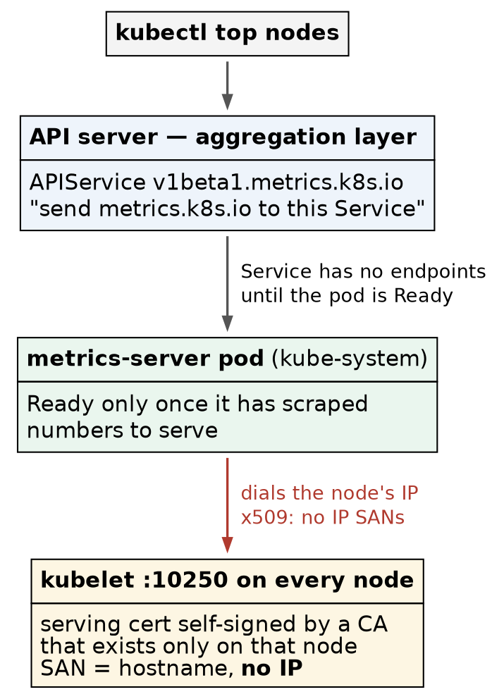
The path a kubectl top request takes, and where it broke
Three hops, and each one fails with a different signature. Read them top to bottom: is the API registered, does its Service have an endpoint, and can the pod reach the kubelets.
⚠️ metrics-server is not monitoring. It keeps a few seconds of CPU and memory, in memory, for the autoscalers and kubectl top — no history, no alerting. Monitoring is a separate stack.
Why Kustomize. The fix below is one flag on an upstream file. Editing the downloaded YAML would work, and would leave a file that no longer matches the release it claims to be. A kustomization.yaml keeps components.yaml byte-identical to upstream — its sha256 checks against the release — and states the change separately, where a reviewer can see it. ⭐ Patching an upstream file without editing it is exactly what Kustomize is for, and it is on the syllabus.
1. Read the signature of “not installed”
kubectl top nodes
kubectl get apiservices | grep metrics
Confirm: error: Metrics API not available, and the grep prints nothing — there is no v1beta1.metrics.k8s.io at all.
2. Install it as shipped — and watch it fail
mkdir -p ~/ch05/metrics-server && cd ~/ch05/metrics-server
curl -sLO https://github.com/kubernetes-sigs/metrics-server/releases/download/v0.9.0/components.yaml
cat > kustomization.yaml <<'EOF'
apiVersion: kustomize.config.k8s.io/v1beta1
kind: Kustomization
resources:
- components.yaml
EOF
kubectl kustomize . | grep '^kind:' # preview: nine objects, nothing applied yet
kubectl apply -k .
⭐ kubectl kustomize . renders without applying. Preview what you are about to create, every time — it is free, and it is the only moment the answer is cheap.
Installing it unpatched is deliberate: it shows the second signature, which is the one people misread.
kubectl -n kube-system get pods -l k8s-app=metrics-server
kubectl get apiservice v1beta1.metrics.k8s.io
kubectl -n kube-system logs deploy/metrics-server | tail -5
kubectl top nodes
What it showed:
Check | Reading | Meaning
Pod | Running, 0/1 | the process is up, but readiness fails: no metrics to serve
APIService | False (MissingEndpoints) | registered, but its Service has no Ready pod behind it
Log | x509: cannot validate certificate for 192.168.1.20x because it doesn't contain any IP SANs | the real cause
kubectl top | error: Metrics API not available | 🚨 the same words as before the install
🚨 That last row is the lesson. Not installed and installed but broken print the identical error. The message never tells you which; the APIService does. Nothing listed means absent; False with a reason means present and failing.
Why the certificate fails. Each kubelet’s serving certificate, /var/lib/kubelet/pki/kubelet.crt, is self-signed by a CA that exists only on that node, and names only the hostname:
sudo openssl x509 -in /var/lib/kubelet/pki/kubelet.crt -noout -subject -issuer -ext subjectAltName
# issuer=CN = vm-k8s-cka-control-1-ca@1789659917
# DNS:vm-k8s-cka-control-1
metrics-server dials the node’s IP (--kubelet-preferred-address-types=InternalIP comes first in its arguments), and a certificate with no IP in its SANs cannot match an IP. Even with the right name, nothing in the cluster trusts the issuing CA.
3. Patch it with Kustomize, not with an editor
cat > kustomization.yaml <<'EOF'
apiVersion: kustomize.config.k8s.io/v1beta1
kind: Kustomization
resources:
- components.yaml
patches:
- target:
kind: Deployment
name: metrics-server
patch: |-
- op: add
path: /spec/template/spec/containers/0/args/-
value: --kubelet-insecure-tls
EOF
kubectl kustomize . | grep -A8 ' args:' # the new flag is the LAST arg
kubectl apply -k .
kubectl -n kube-system rollout status deploy/metrics-server
The patch is a JSON 6902 operation: add to args/-, where - means “append to the end of the list”. It does not need to know how many arguments upstream ships, so it keeps working when the next release adds one.
Confirm — the apply did exactly one thing:
deployment.apps/metrics-server configured
... unchanged (x8)
⭐ One configured and eight unchanged is a diff you can read: the patch touched the Deployment and nothing else. ⚠️ rollout status printed 1 old replicas are pending termination for a while — the broken pod stays until its replacement is Ready, which is a rolling update working as designed.
4. Prove it with numbers
kubectl get apiservice v1beta1.metrics.k8s.io # True
kubectl top nodes
kubectl top pods -A --sort-by=memory | head
Confirm: the APIService reads True, and all five nodes report CPU and memory. Ours, on the idle equipped cluster: control planes at 41–49% memory, workers at 27–34%.
⭐ Read the top of the pod list — it holds a lesson about leader election. The API servers lead the list (430–560 Mi each), and on our cluster control-2’s controller-manager sat near the top while the other two did not appear. control-2 held both the kube-controller-manager and kube-scheduler leases:
kubectl -n kube-system get leases kube-controller-manager kube-scheduler
Three controller-managers run, and only the lease holder does any work; the other two wait. Memory usage is a quick way to see who is active, and the lease is the way to prove it.
Lab vs PROD — metrics-server skipping kubelet certificate verification. In the lab: --kubelet-insecure-tls makes metrics-server accept whatever certificate port 10250 presents. Why it’s acceptable here: five nodes on one isolated LAN, one operator, and the numbers feed only kubectl top and practice autoscalers. In production (recited, not run here): the kubelets request serving certificates signed by the cluster CA (serverTLSBootstrap: true), someone approves those requests, and an automated approver restricted to kubelet serving certificates keeps approving them as they rotate. If you carry the habit: metrics-server cannot tell a kubelet from anything else answering on that address — and those numbers decide how many replicas your autoscalers run. Approve-by-hand without the automation fails the other way: the certificates rotate, and metrics break silently months later.

Part B — storage
The four objects, and who creates each
Object | Scope | Who creates it
PersistentVolumeClaim (PVC) | namespace | you — “I need 1 GiB, read-write, from this class”
PersistentVolume (PV) | cluster | an administrator by hand, or a provisioner on demand
StorageClass | cluster | an administrator — names a provisioner and its rules
provisioner | a running pod | an installed component — the thing that makes PVs
A claim binds to a volume. Without a class and a provisioner, nothing ever makes the volume, so the claim waits forever. ⭐ Static PVs need no provisioner at all — an administrator writes the PV by hand and a matching claim binds to it. That is a separate exercise; this part is about dynamic provisioning.
Why local-path. It is one file, needs no extra disks, and provisions for real: each volume is a directory on the node that runs the pod. It is not a production storage system, and the callouts below say why.
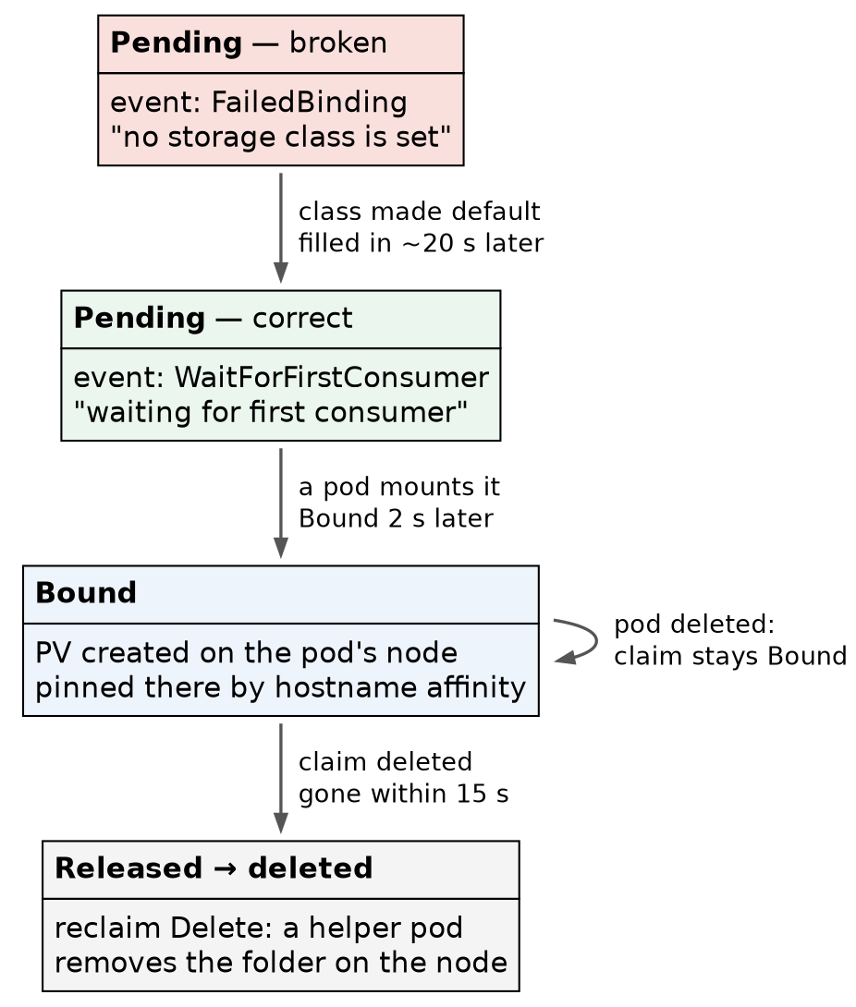
One claim’s life under a WaitForFirstConsumer default class
Two boxes say Pending, and only one of them is a problem. The status cannot tell them apart; the event can. Every time in the figure was measured.
5. Read the signature of “no storage”
mkdir -p ~/ch05/local-path && cd ~/ch05/local-path
cat > pvc-data.yaml <<'EOF'
apiVersion: v1
kind: PersistentVolumeClaim
metadata:
name: data
namespace: default
spec:
accessModes: [ReadWriteOnce]
resources:
requests:
storage: 1Gi
EOF
kubectl apply -f pvc-data.yaml
kubectl get storageclass
kubectl get pvc data
kubectl describe pvc data | tail -4
Confirm: No resources found for classes, the claim Pending, and the event:
Normal FailedBinding ... no persistent volumes available for this claim and no storage class is set
⭐ The claim names no class, and the cluster has no default to give it. That event is the signature of a cluster with no dynamic storage.
6. Install the provisioner — read the file first
curl -sLO https://raw.githubusercontent.com/rancher/local-path-provisioner/v0.0.37/deploy/local-path-storage.yaml
grep -nE '^kind:|image:|volumeBindingMode|reclaimPolicy' local-path-storage.yaml
kubectl apply -f local-path-storage.yaml
kubectl -n local-path-storage rollout status deploy/local-path-provisioner
kubectl get storageclass
kubectl get pvc data
Confirm: class local-path, provisioner rancher.io/local-path, WaitForFirstConsumer, Delete — and not marked (default). The claim is still Pending with the same event.
⚠️ Installing a class does not touch existing claims. Ours named no class, and a non-default class is only used by claims that ask for it by name. The fix is either storageClassName: local-path on the claim, or making the class the default — which is what the workload tasks assume.
7. Make it the default — and wait before you judge
kubectl patch storageclass local-path \
-p '{"metadata":{"annotations":{"storageclass.kubernetes.io/is-default-class":"true"}}}'
kubectl get storageclass
kubectl get pvc data -o custom-columns=NAME:.metadata.name,STATUS:.status.phase,SC:.spec.storageClassName
Confirm: local-path (default) in the class list.
🚨 Five seconds later the claim still had no class. That reads like “existing claims are not updated”, and it is wrong. Since Kubernetes 1.28 a new default class is filled in retroactively on class-less claims — by the volume controller, on its next pass, about 20 seconds later here. Read the events with their times rather than polling the claim:
kubectl get events --field-selector involvedObject.name=data --sort-by=.lastTimestamp
The event changed from FailedBinding to:
Normal WaitForFirstConsumer ... waiting for first consumer to be created before binding
⭐ Still Pending — and now correctly. WaitForFirstConsumer means no volume is made until a pod that uses the claim is scheduled, so the volume can be created on the node where that pod will run. The status reads exactly as it did when the cluster had no storage at all. 🚨 Read the event, not the status — it is the only place the two are different.
8. Mount it, and see where the volume went
cat > pod-writer.yaml <<'EOF'
apiVersion: v1
kind: Pod
metadata:
name: writer
spec:
containers:
- name: c
image: busybox:1.38.0
command: ["sh", "-c", "date >> /data/log; sleep 3600"]
volumeMounts:
- name: d
mountPath: /data
volumes:
- name: d
persistentVolumeClaim:
claimName: data
EOF
kubectl apply -f pod-writer.yaml
kubectl wait --for=condition=Ready pod/writer --timeout=120s
kubectl get pvc data
kubectl get pv
kubectl get pod writer -o wide
Confirm: the claim went Bound about two seconds after the pod was scheduled, and a PV appeared that nobody wrote. Ours was created on worker-2, the pod’s node.
Now ask the PV where it lives:
kubectl get pv <name> -o jsonpath='{.spec.hostPath.path} {.spec.nodeAffinity.required.nodeSelectorTerms[0].matchExpressions[0]}{"\n"}'
# /opt/local-path-provisioner/pvc-<uid>_default_data
# {"key":"kubernetes.io/hostname","operator":"In","values":["vm-k8s-cka-worker-2"]}
🚨 Two facts in one line, and the second one matters more. The volume is a plain directory on one node (drwxrwxrwx root), and the PV carries a node affinity that pins every future pod using this claim to that node. The scheduler will not place the pod anywhere else — not by preference, by rule.
9. Prove the data outlives the pod
kubectl delete pod writer --now
kubectl get pvc data # still Bound
kubectl apply -f pod-writer.yaml
kubectl wait --for=condition=Ready pod/writer --timeout=120s
kubectl get pod writer -o wide # worker-2 again
kubectl exec writer -- cat /data/log # TWO lines
Confirm: the claim stayed Bound with no pod, the new pod landed on worker-2 again, and the log held both timestamps — one from each pod.
⭐ The claim belongs to the namespace, not to the pod. Deleting a pod releases nothing. And “landed on worker-2 again” was the affinity at work, not luck.
10. Delete the claim — and check the disk, not the API
kubectl delete pod writer --now
kubectl delete pvc data
kubectl get pv # Released, briefly
kubectl -n local-path-storage get pods # helper-pod-delete-pvc-...
sleep 15
kubectl get pv # gone
Then, on the node (worker-2 here):
sudo ls -la /opt/local-path-provisioner/ # empty
Confirm: the PV went Released, a helper-pod-delete-pvc-… pod ran in local-path-storage, and within 15 seconds the PV and the folder were both gone.
⭐ kubectl cannot see a node’s disk. “The PV is gone” is the API’s claim; the empty directory on the node is the outcome. Check from the layer that would fail.
⚠️ The delete helper is an unpinned image. It runs docker.io/library/busybox with no tag, pulled from Docker Hub on every volume delete — so a Docker Hub rate limit or outage stalls deletes, and the image it runs can change under you.
Lab vs PROD — volumes that live in a directory on one node. In the lab: every PV is a hostPath folder under /opt/local-path-provisioner on whichever node first ran the pod, pinned there by node affinity. Why it’s acceptable here: the cluster holds nothing worth keeping, and the point is to practise claims, classes and binding modes. In production (reasoning, not tested here): stateful data sits on storage that survives a node — an existing storage array through its vendor’s CSI driver, or replicated block storage — or, for systems that replicate themselves, on local disks through a CSI local-volume driver that tracks capacity. If you carry the habit: losing the node is losing the data, and the pod cannot be rescheduled anywhere else because the affinity forbids it — the measured pin is what turns a node failure into an application outage. (What a drain does to such a pod has not been run here yet.)
Lab vs PROD — reclaim Delete as the default. In the lab: kubectl delete pvc data destroyed the volume and its folder in under 15 seconds, with no confirmation. Why it’s acceptable here: the data is test timestamps. In production (standard practice, not run here): classes that hold anything valuable use reclaimPolicy: Retain, so a deleted claim leaves a Released volume for a human to inspect, back up, and reclaim deliberately. If you carry the habit: one mistyped namespace in a cleanup script deletes production data as fast as it deletes test data — and the API reports it as a success.

Honest limitations
All five nodes are VMs on one physical host, so “the data lives on worker-2” is still one disk pool underneath. There is no CSI storage driver here — the only CSI driver in the cluster is Calico’s csi.tigera.io, registered for Ephemeral volumes only: a per-pod mount for Calico’s own use, not storage. Whether local-path enforces the requested size was not tested. And metrics-server ran with the kubelet certificate check switched off, so the proper certificate fix is described, not demonstrated.

Commands to know by heart
Question | Command
Is there a metrics API at all? | kubectl get apiservices \| grep metrics — nothing = absent; False = broken
Why is metrics-server not Ready? | kubectl -n kube-system logs deploy/metrics-server \| tail -5
What would this kustomization create? | kubectl kustomize . — renders, applies nothing
Apply a kustomization | kubectl apply -k .
Who is the active controller-manager / scheduler? | kubectl -n kube-system get leases
Which StorageClass is the default? | kubectl get storageclass — (default) after the name
Why is this claim Pending? | kubectl describe pvc <name> \| tail -4 — read the event
What happened to an object, in order? | kubectl get events --field-selector involvedObject.name=<n> --sort-by=.lastTimestamp
Make a class the default | kubectl patch storageclass <n> -p '{"metadata":{"annotations":{"storageclass.kubernetes.io/is-default-class":"true"}}}'
Where does this volume live, and is it pinned? | kubectl get pv <n> -o jsonpath='{.spec.hostPath.path} {.spec.nodeAffinity}'
Is the data really gone? | on the node: sudo ls -la /opt/local-path-provisioner/

Glossary
aggregation layer — the API server’s mechanism for serving an API group from somewhere else. An APIService says which Service answers for which group.
metrics-server — scrapes CPU and memory from every kubelet and serves them as metrics.k8s.io. Feeds kubectl top and autoscalers; keeps no history.
kubelet serving certificate — the certificate on port 10250. Under kubeadm’s defaults it is self-signed by a node-local CA and names only the hostname.
Kustomize — overlays changes on unmodified YAML. Built into kubectl (-k).
JSON 6902 patch — a list of operations (add, replace, remove) addressed by path. - at the end of a list path appends.
StorageClass — names a provisioner and its rules: binding mode, reclaim policy, expansion.
WaitForFirstConsumer — no volume until a pod using the claim is scheduled, so the volume is made where the pod will run.
default StorageClass — the class given to claims that name none; marked by the is-default-class annotation. Applied retroactively to existing class-less claims since 1.28.
reclaim policy — what happens to a volume when its claim is deleted. Delete destroys it; Retain keeps it Released for a human.
node affinity (on a PV) — the rule that pins every pod using the volume to one node.

Check yourself
Answer these out loud. Section references, not answers.
- kubectl top nodes prints Metrics API not available. Name the two different states that print this, and the one command that tells them apart. (§2)
- The metrics-server log says doesn't contain any IP SANs. Which certificate is it complaining about, who signed it, and why does an IP not match? (§2)
- Why patch metrics-server with Kustomize rather than editing components.yaml? What does the apply output prove about the patch? (Part A intro, §3)
- Three controller-managers are running. How do you find the one doing the work? (§4)
- Two claims are Pending. How do you tell, in one command each, which is broken? (§5, §7)
- You made a class the default and the existing claim still shows no class. What do you do? (§7)
- A pod using a local-path volume is deleted and recreated, and lands on the same node every time. Luck, or a rule? Where would you read the rule? (§8, §9)
- You deleted a pod and its claim is still Bound. Is that a leak? (§9)
- The PV has disappeared from kubectl get pv. How do you prove the data is actually gone? (§10)
- Name one thing local-path does that would be dangerous in production, and what production uses instead. (Lab vs PROD callouts)
Timed, exam-shaped versions of Parts A and B are in exercises.md (X01, X12).

