Jenkins · Chapter 2 — Identity, Authorization, and Break-Glass
Series: Home-Lab Education · Phase 17 (Jenkins) Built and verified: August 20, 2026 on VM 185 (192.168.1.185) Versions at time of writing: Jenkins 2.568.2 LTS · matrix-auth 3.3 · matrix-project 905.vcc6831e8760a_ · OpenJDK 21.0.11 headless Assumed, not re-taught: everything in Chapter 1 — the controller/agent split, JENKINS_HOME, and why the controller runs zero builds. Read this before: Chapter 3 (the first pipeline, and what a checkout drags into the workspace)

What this chapter covers
Two questions that look like one: who are you, and what may you do. Jenkins answers them with two independent pieces of configuration, and almost every Jenkins auth disaster comes from treating them as a single thing.
This chapter is unusual in that its centrepiece is a drill that failed to produce the failure it was designed to produce. We set out to lock ourselves out of Jenkins on purpose, tried twice, and could not — and the reason we could not is worth more than the lockout would have been. It also corrects a belief this project held in writing, in the build standard itself, until the mechanics were checked: §2.
⚠️ One thing here is recorded rather than proven, and it is flagged in place. The break-glass runbook in §6 has been written and not rehearsed. That distinction is stated where it appears because a runbook nobody has run is a hypothesis with formatting.

1. Two questions, two slots
Question | Jenkins calls it | Lives in | Examples
Who are you? | the security realm | <securityRealm> | Jenkins’ own user database, LDAP, an OAuth provider, the servlet container
What may you do? | the authorization strategy | <authorizationStrategy> | Anyone can do anything · Logged-in users can do anything · Matrix · Project-based matrix
Both live in JENKINS_HOME/config.xml, and the load-bearing fact is in the XML shape rather than in either list: each element appears exactly once. Jenkins holds one realm and one strategy, never a chain of them.
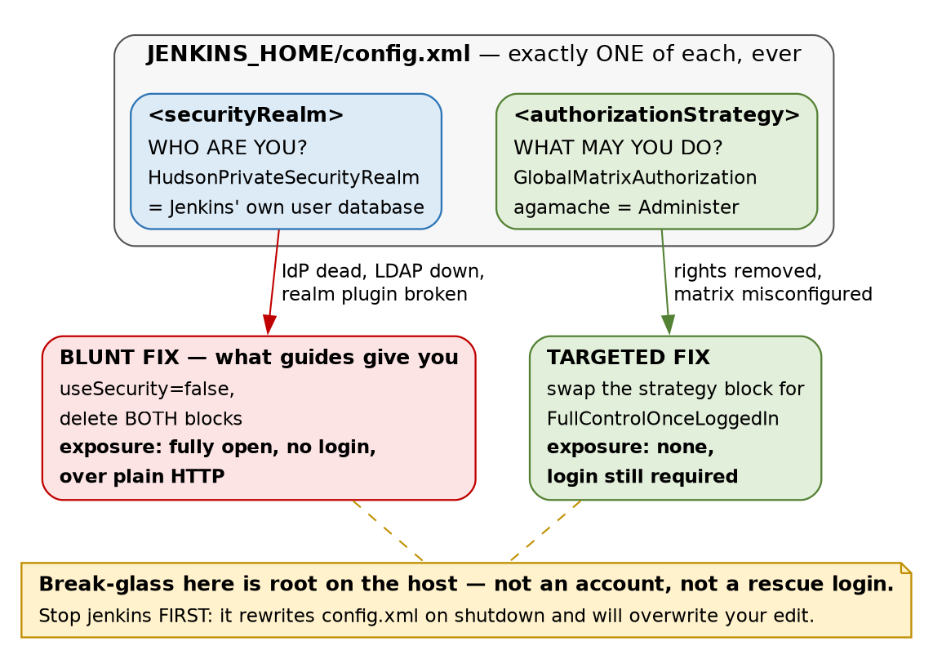
Figure 1 — the two security slots, and why each failure needs a different recovery
That single-slot design is the thing to carry out of this chapter, because it contradicts a habit built up almost everywhere else. A router keeps a local admin behind RADIUS. A database keeps superuser access behind its own authentication when the directory is unreachable. PAM is literally a stack. So the instinct that there is always a local login hiding behind the corporate one is well earned — and on Jenkins it is false. Configure an OAuth realm and the local user database is not a fallback; it is gone from the login path entirely.

2. The belief this project had in writing, and had to correct
Phase 17’s build standard originally specified: create a local admin as a break-glass account, then add GitLab OAuth on top. The reasoning was explicit and it sounded careful — if GitLab is down, the local admin still gets you in.
It was wrong, and it was wrong in the way that costs you an outage rather than an argument. The OAuth realm would have replaced the user database. That local admin could not have logged in at all, and we would have discovered it at exactly the moment we needed it — with GitLab already down, which is to say with the thing we were relying on already broken.
⭐ The generalisation is more useful than the Jenkins detail: a fallback exists only if the mechanism supports a fallback. Before you design around one, go and look at whether the configuration slot is a list or a single value. If it is a single value, whatever you were planning to keep in reserve is not in reserve — it has been displaced, silently, by the thing you added. That question takes thirty seconds to answer from the configuration schema and it is almost never asked.
Then OAuth was dropped altogether
Having established that the local admin was not what it claimed to be, the next decision was whether to wire GitLab OAuth anyway. It was dropped, for two reasons, and the second is much stronger than the first:
- The vendor does not transfer. GitLab’s app-registration flow and its group-mapping semantics are GitLab’s. The Jenkins mechanic — one realm, no form fallback, filesystem recovery — is learnable without any identity provider at all, and that is the part that moves to another firm.
- 🚨 Part 6 of this phase deliberately breaks the Jenkins↔GitLab path. Wiring Jenkins login to GitLab would have put the instrument inside the experiment: a failed drill would have had two candidate causes instead of one, and one of those causes would have locked us out of the console we needed to diagnose it.
⭐ Worth stealing as a planning habit: the transferable part of an integration is usually the failure mode, not the vendor. Re-pointing the identity provider — from GitLab OAuth to a local database — cost this track nothing, because the lesson was never about GitLab. If dropping a vendor from your plan destroys the lesson, the lesson was product training.
Lab vs PROD — Jenkins’ own user database is the security realm. In the lab: one local account in HudsonPrivateSecurityRealm, with signup disabled. Why it’s acceptable here: a single operator who is also the only person with root on the host, so a central directory would add a dependency and remove nothing. In production: the realm is the corporate IdP — SAML or OIDC — so that joining, moving and leaving are handled in one place, with MFA enforced there. If you carry the habit: 🚨 a local Jenkins account survives the person leaving the company, because nothing in the offboarding process knows it exists. And the CI system is the worst place for a forgotten account: it does not merely read data, it ships code to production. ⚠️ The PROD answer here is recited, not built — nothing in this lab terminates SAML.

3. The lockout drill that refused to fire, twice
The plan for Part 2 was to break authorization on purpose — in a lab, on a snapshotted VM, where being locked out is a lesson and not an incident. Switch from the wizard’s default to matrix authorization, grant the bare minimum, and see what the recovery actually feels like.
It did not work. Neither attempt.
# | What was done | Expected | Observed
1 | Switch to Matrix-based security, granting only authenticated: Overall/Read | locked out | Still admin. The plugin had pre-seeded a row nobody added: USER:hudson.model.Hudson.Administer:agamache
2 | Delete that agamache row in the UI and save | locked out | Still admin. The row came back
Attempt 2 is the interesting one, and it is worth restating in prose because the mechanics are easy to skim past in a table. The form accepted the deletion. The row disappeared from the screen. The save succeeded, and it genuinely rewrote the file — config.xml’s mtime moved to 15:40:13. And the permission was still there afterwards. There was no warning in the UI and no line in journalctl -u jenkins.
🚨 Three layers reported success at something that never happened — the form, the save, and the service log. That is Chapter 1’s spine reappearing inside a safety feature: the layer that reports is not the layer that decides. Here it turned up in a protection rather than in a package or a signing key, which is the version of it that is hardest to be suspicious of, because the outcome is the one you wanted.
⭐ A benevolent silent override is still a silent override. The behaviour is correct — it stops people destroying their own instance — but anyone trying to learn their permission model from that screen was actively misinformed by it. The screen said the admin row was gone. It was not. If you are auditing who holds Administer on a Jenkins, read config.xml, not the matrix.
✅ This is intentional and documented, which we only confirmed after observing it: matrix-auth’s own README states “It is not possible to remove access … from Jenkins administrators.” Jenkins’ Jira carries an epic titled “Matrix Auth: Accidental lockouts” (JENKINS-10871, JENKINS-46832 — both Resolved). The guard rail was built deliberately, years ago, in response to people falling off this exact cliff.
There is a lesson about drills here, separate from the lesson about Jenkins
A drill that cannot fire is not a wasted drill — but only if you go and find out why it could not fire. Had we shrugged and moved on, the takeaway would have been “matrix auth seems safe”, which is the same sentence as the truth and carries none of its information. The actual finding is narrower and far more useful: this specific class of lockout was closed by the plugin, on purpose, and a different class is still wide open. That is §4.

4. The lockout moved; the folklore did not
Search for Jenkins lockouts and you will find a decade of advice about being careful in the matrix screen. That advice is now stale for the mechanism it describes — you can no longer lock yourself out by clicking. The failure did not disappear, it relocated, and the current reports are plugin-upgrade incompatibilities:
- matrix-auth 3.0 changed the format in which it stores SIDs — the permission entries themselves.
- role-strategy was not yet compatible with the new format.
- Administrators lost their own rights on restart, having changed nothing about permissions.
⚠️ That sequence is reported from the plugins’ issue trackers and release notes, not measured here — no upgrade lockout was reproduced on .185.
The format in question is visible in our own file. Every permission line carries a USER: or GROUP: prefix:
<permission>USER:hudson.model.Hudson.Administer:agamache</permission>
<permission>GROUP:hudson.model.Hudson.Read:authenticated</permission>
Those prefixes are the 3.x format — the thing that changed. Reading them tells you that this instance is on the new side of that migration, which is a more direct answer than the plugin’s version number, because the version tells you what is installed and the file tells you what is stored.
🚨 This lands squarely on Chapter 1 §4. Six deliberate plugin choices produced 73 plugins. Adding ssh-slaves (Chapter 1) and matrix-auth (this chapter) — two more deliberate decisions — took the instance to 79. So the count of things you chose went from 6 to 8, and the count of things running in your JVM went up by six. The 71 you did not choose are precisely the ones whose interdependencies you cannot enumerate, and upgrade-time incompatibility is a property of interdependencies.
⭐ The operational conclusion is not “avoid plugins” — it is that a Jenkins upgrade is a security-configuration change even when you did not touch security. Which means the break-glass procedure in §6 should be to hand before an upgrade, not looked up afterwards, and config.xml should be copied somewhere first.

5. What is actually configured, read from the file
Not from the screen — §3 is the reason for that distinction:
<useSecurity>true</useSecurity>
<authorizationStrategy class="hudson.security.GlobalMatrixAuthorizationStrategy">
<permission>USER:hudson.model.Hudson.Administer:agamache</permission>
<permission>GROUP:hudson.model.Hudson.Read:authenticated</permission>
</authorizationStrategy>
<securityRealm class="hudson.security.HudsonPrivateSecurityRealm">
<disableSignup>true</disableSignup>
<enableCaptcha>false</enableCaptcha>
</securityRealm>
Four things are worth naming in that block:
- authorizationStrategy comes before securityRealm in the file — authorization is written first, authentication second, which is the reverse of the order they execute in. Cosmetic, but it matters at 3am when you are sed-ing a file you cannot see rendered.
- disableSignup is true. Without it, HudsonPrivateSecurityRealm offers a Create an account link, and self-registration into a CI system is a straight path to the deploy pipeline. The wizard sets this correctly; it is worth knowing it is a setting rather than a law.
- Two permission rows, and only one of them does anything today. authenticated → Overall/Read is a no-op on a single-user instance — it becomes meaningful the moment a second account exists, and writing it now means the default for the next person is read rather than everything.
- Anonymous holds nothing. There is no GROUP:…:anonymous line, so an unauthenticated request gets a login page and no more.
The realm’s storage is on disk under JENKINS_HOME/users/, one directory per account — agamache_<64 hex characters>. The hex suffix is Jenkins’ on-disk name-mangling, not the password; it exists so that user IDs cannot collide on a case-insensitive filesystem. The password itself is inside that directory’s own config.xml as #jbcrypt:$2a$10$… — bcrypt at cost factor 10, which is a reasonable answer and not one you should have to take on trust. There is exactly one such directory on this instance.
Two defaults that the wizard chose, and one it disabled
<slaveAgentPort>-1</slaveAgentPort>
<disableRememberMe>false</disableRememberMe>
<crumbIssuer class="hudson.security.csrf.DefaultCrumbIssuer"/>
slaveAgentPort is -1, which means the inbound agent port is switched off. Chapter 1 described two directions an agent can attach from; on this box one of those two directions is not listening at all. That is a genuine reduction in surface — a port that authenticates agents is a port worth attacking — and it is also a trap for later: an inbound JNLP agent configured on this controller would never connect, and the symptom would appear on the agent host, which is not where the cause is.
disableRememberMe is false, so remember-me is enabled. On an HTTPS instance that is a convenience. On this one, it is a long-lived session cookie crossing a LAN in cleartext, which is ledger row J1 getting slightly worse rather than a new problem. It is left on deliberately and recorded here so it is a decision rather than an oversight.

6. Break-glass is root on the host, not an account
Once §2 has removed the idea of a rescue login, the question “what do I actually do when I cannot get into Jenkins” has exactly one answer: stop the service, edit the file, start the service.
sudo cp -a /var/lib/jenkins/config.xml /var/lib/jenkins/config.xml.known-good
sudo systemctl stop jenkins # MUST be first — see below
# ... edit /var/lib/jenkins/config.xml ...
sudo systemctl start jenkins
🚨 The stop is not tidiness, and getting the order wrong is the classic way to lose an hour. Jenkins rewrites config.xml on shutdown from the configuration it holds in memory. Edit the file on a running instance and your change is erased by the very restart you made it for — and it will look as though the edit did not take, which sends you looking for a syntax error that is not there.
Choose the smallest fix that matches what is broken
What broke | Fix | Exposure while you work
Authorization only — matrix misconfigured, rights removed | replace the <authorizationStrategy> block with FullControlOnceLoggedInAuthorizationStrategy | none — login is still required
The realm — IdP dead, LDAP unreachable, realm plugin broken | <useSecurity>false</useSecurity> and delete both blocks | 🚨 Jenkins fully unauthenticated, over plain HTTP, until you finish
Both of those belong in prose, because the difference between them is the entire point of the section and a table row is a thing you skim. If only your permissions are broken, your identity system still works — swapping the strategy for “logged-in users can do anything” restores your access while still making every user prove who they are. Turning security off entirely also restores your access, and it does so by making the controller answer to anyone who can reach port 8080, with no password, on a cleartext connection, for as long as the repair takes.
🚨 Every guide on the internet hands you the second one. It propagates because it works for both cases — a remedy that always works is a remedy nobody has to diagnose before applying. This is the same shape as Phase 16’s docker swarm leave --force: the universally-recommended remediation is more destructive than the situation requires. Diagnose which layer failed before choosing the tool, and if you cannot diagnose it under pressure, that is the argument for writing the targeted version down now.
⭐ And the structural point about Jenkins break-glass, which is uncomfortable once you see it: the set of people who can recover Jenkins from an auth failure is exactly the set who can already read JENKINS_HOME. Chapter 1 §7 reached that boundary from the inside, asking what the agent account could read. This arrives at the same line from the outside — and it means your Jenkins authorization model is bounded above by host access, so an “operator” with sudo on the controller is an administrator of Jenkins whether or not the matrix says so.
Lab vs PROD — the break-glass procedure has been written and never rehearsed. In the lab: the runbook above is recorded, and nobody has executed it on .185. Why it’s acceptable here: the VM is snapshotted, a full rebuild costs an evening, and there is no user to be down. In production: recovery procedures are rehearsed on a schedule, against a non-production controller, and the rehearsal is what turns them from prose into a procedure. If you carry the habit: ⚠️ the first time you run it will be during the outage — at 3am, on the box that holds every deployment credential, with an audience. An untested runbook fails in ways that look like the original incident, which is how a thirty-minute recovery becomes a four-hour one.

7. What this closed, and the plane it does not touch
Closed: Chapter 1 §2 flagged that the wizard had left authorization at “logged-in users can do anything”. That is no longer true — agamache holds Overall/Administer and everyone else who authenticates holds Overall/Read. On a single-account instance the practical change is small; the change in default is not, because the next account created here starts with read and nothing else.
Not closed, and this is the important half. Authorization governs human requests through the web UI and the API. It does not govern builds. Chapter 1 §7 showed a build log reading Running as SYSTEM while the OS process ran as unprivileged jenkins-agent; nothing in this chapter altered that. A pipeline still executes with Jenkins’ full internal identity, and no row in the matrix constrains it.
⭐ So there are now three privilege planes on this host, and hardening any one of them tells you nothing about the other two:
Plane | Governed by | Hardened in
Operating system | UIDs and file modes | Chapter 1 §7 — jenkins-agent cannot read secrets/
Jenkins, for humans | the authorization strategy | This chapter
Jenkins, for builds | SYSTEM, and what a pipeline is permitted to invoke | not yet — Parts 5 and 7
Stating that as a sentence, since it is the one to keep: a Jenkins whose matrix is immaculate can still run a pipeline that does anything Jenkins can do. The three planes have three separate fixes, and the vocabulary invites you to believe they are one system because all three get called “permissions”.

8. Commands to know by heart
# read the security configuration from the file, never from the screen
sudo sed -n '/<authorizationStrategy/,/<\/authorizationStrategy>/p' /var/lib/jenkins/config.xml
sudo grep -n 'useSecurity\|securityRealm\|slaveAgentPort\|RememberMe' /var/lib/jenkins/config.xml
sudo ls -1 /var/lib/jenkins/users/ # one directory per local account
# who Jenkins thinks you are, and what it will let you do
curl -s -u <user>:<pass> 'http://<host>:8080/whoAmI/api/json?pretty=true'
curl -s -o /dev/null -w '%{http_code}\n' 'http://<host>:8080/api/json' # 403 = anonymous has nothing
# break-glass, in the only order that works
sudo cp -a /var/lib/jenkins/config.xml /var/lib/jenkins/config.xml.known-good
sudo systemctl stop jenkins # FIRST. Jenkins rewrites config.xml on shutdown
sudo systemctl start jenkins
sudo journalctl -u jenkins -n 50 --no-pager # and it will not warn you about permissions
# before any plugin upgrade, because an upgrade is a security change
sudo cp -a /var/lib/jenkins/config.xml /var/lib/jenkins/config.xml.pre-upgrade
⭐ The habit worth building from §3: when the UI and the file disagree, the file is what Jenkins loads. The matrix screen showed a permission row deleted that was never deleted. Two commands would have caught it in a second, and neither of them is clever.

9. Glossary
Term | Meaning
Security realm | The answer to who are you. Jenkins holds exactly one — configuring a new one replaces the old, it does not stack
Authorization strategy | The answer to what may you do. Also exactly one at a time
HudsonPrivateSecurityRealm | Jenkins’ own user database, stored under JENKINS_HOME/users/. Passwords as bcrypt
Matrix authorization | Permissions granted per user or group, per Jenkins permission, in a grid. Plugin short name matrix-auth
matrix-project | An unrelated plugin: multi-configuration jobs. Third name collision this track has hit
SID | The identifier in a permission entry — a user or a group. matrix-auth 3.0 changed how these are stored
authenticated | A built-in pseudo-group meaning anyone who has logged in, whoever they are
anonymous | The pseudo-user for an unauthenticated request. Holds nothing on this instance
FullControlOnceLoggedIn… | The wizard’s default strategy: authenticate and you can do everything. The targeted break-glass value
useSecurity | The master switch. false means no authentication at all — the blunt break-glass
Break-glass | On Jenkins: root on the host, not an account. Stop, edit config.xml, start
Crumb | Jenkins’ CSRF token. DefaultCrumbIssuer is on here, and is why raw curl POSTs get rejected

10. Check yourself
Answer these out loud. Section references, not answers — reconstructing is the exercise.
- You are about to wire an OAuth realm into a Jenkins that has a local admin. What happens to that admin, and when would you find out? (§1, §2)
- Generalise question 1 into a check you can run against any system before relying on a fallback. (§2)
- You delete your own Administer row in the matrix screen and click save. Describe what the UI, the file, and the service log each report — and what is actually true. (§3)
- A colleague says “matrix auth is safe, you can’t lock yourself out any more”. What is right about that, and what has it missed? (§3, §4)
- Nothing about your permissions was changed, and after a restart you have lost Administer. What is the most likely cause, and what should you have copied beforehand? (§4)
- Your authorization strategy is broken but LDAP is fine. Name the fix, and say what an operator using the internet’s standard recipe would have exposed instead. (§6)
- Why must systemctl stop jenkins come before editing config.xml, and what does the failure look like if you get it backwards? (§6)
- Who can perform break-glass on a Jenkins controller, and what does that imply about the ceiling on your authorization model? (§6)
- Your matrix is perfect and every user is scoped correctly. What can a pipeline still do, and which plane governs it? (§7)
- slaveAgentPort is -1. State one thing that makes safer and one future symptom it will cause, on a host where the symptom will not appear. (§5)

