Kubernetes (CKA) · Chapter 3 — A Network, and a Control Plane of Three
Series: Home-Lab Education · Phase 18 (Kubernetes HA + CKA) Built and verified: September 17, 2026 on VMs 201–205 (192.168.1.201–205) Versions at time of writing: Kubernetes v1.35.8 · Calico v3.32.2 (Tigera operator) · kube-vip v1.2.3 · etcd 3.6.6 · containerd 2.3.5 · Ubuntu 24.04.4 LTS · kernel 6.8.0-139 Read this after: Chapter 2 (the first control plane) · before: Chapter 4 (proving the HA)

What this chapter covers
Chapter 2 ended with one control plane that was Ready to nothing: the node read NotReady and CoreDNS sat Pending, because Kubernetes ships no pod network at all. This chapter installs one, then grows the cluster from one node to five — two more control planes, then two workers.
Two things make it more than a sequence of joins. The first is that the CNI’s own install file disagrees with the address plan, and the documentation tells you it doesn’t. The second is that between the second and third control-plane joins the cluster passes through the least available configuration it will ever have, and it is worth knowing that while you are in it.

What a CNI is, and why nothing works without one
A pod needs an address, a route to every other pod, and a way for Services to find it. The kubelet does none of that itself. It calls a CNI plugin — a binary in /opt/cni/bin configured from /etc/cni/net.d — each time it creates a pod, and the plugin is what gives the pod its network namespace, interface and address.
With no plugin installed, the kubelet reports the node’s network as not ready, the node reads NotReady, and the scheduler will not place CoreDNS anywhere. ⭐ That is not a fault to diagnose; it is the designed resting state of a cluster with no network, and recognising it at a glance is worth marks in the exam’s Troubleshooting domain.
We use Calico, chosen for one reason that matters for the CKA: it enforces NetworkPolicy, which is on the syllabus. Flannel, which k3s bundles, cannot.

The procedure
Each step says how to confirm it took effect. Several of the confirmations exist because the obvious check gives the wrong answer on these machines.
1. Check the host will let a CNI manage it
Calico requires that no other iptables manager is running and that NetworkManager is not holding the interfaces it creates.
sudo ufw status # must read: inactive
systemctl is-active firewalld 2>/dev/null # absent or inactive
dpkg-query -W network-manager 2>/dev/null # not installed
🚨 Do not check ufw with systemctl is-active ufw. On these nodes it printed active while sudo ufw status printed inactive. ufw.service is a one-shot unit that stays “active” after it has run, so it reports that the unit ran, not that the firewall is on. Read the firewall, not the unit.
2. Check the CNI supports your Kubernetes version
Calico v3.32 is tested against Kubernetes 1.34, 1.35 and 1.36, per its own requirements page. We run v1.35.8, which is in range. ⚠️ Do this before choosing a CNI version, not after — a CNI that does not support the API it runs against fails in ways that look like networking faults.
3. Choose the install path — and avoid the tech-preview one
Calico’s documentation offers several paths on tabs of one page. Two are relevant:
- The Tigera operator — a small Deployment that reads one Installation object and generates and maintains everything else. Calico labels it recommended.
- A raw manifest — one large YAML file applied once, with nothing watching it afterwards.
We used the operator, because it is what a production estate runs and because installing it is a live example of the CRDs-and-operators competency.
⛔ Avoid the “Manifest (v3 CRDs)” tab. It is tech preview, and on Kubernetes 1.34–1.35 it needs an API-server feature gate enabled and hand-made TLS certificates for an admission webhook. Until those exist, writes to Calico’s policy resources fail closed — so NetworkPolicy, a syllabus item, would silently refuse to apply.
4. Install the operator and its CRDs
kubectl create -f https://raw.githubusercontent.com/projectcalico/calico/v3.32.2/manifests/v1_crd_projectcalico_org.yaml
kubectl create -f https://raw.githubusercontent.com/projectcalico/calico/v3.32.2/manifests/tigera-operator.yaml
Confirm:
kubectl -n tigera-operator get pods # tigera-operator 1/1 Running before continuing
⚠️ Read the list of CRDs that first command created, rather than scrolling past it. One of them is gatewayapis.operator.tigera.io: Calico’s operator can deploy a Gateway API implementation, and it is Envoy Gateway underneath. Whether it works on open-source Calico is not verified here — its own description mentions Calico Enterprise.
5. Fix the pod CIDR — the install file disagrees with your cluster
curl -O https://raw.githubusercontent.com/projectcalico/calico/v3.32.2/manifests/custom-resources.yaml
cp custom-resources.yaml custom-resources.yaml.orig-upstream
grep -E "^kind:|cidr:" custom-resources.yaml
The Installation resource in that file reads:
calicoNetwork:
ipPools:
- name: default-ipv4-ippool
blockSize: 26
cidr: 192.168.0.0/16 # hard-coded
encapsulation: VXLANCrossSubnet
🚨 192.168.0.0/16 contains this lab’s 192.168.1.0/24, and it does not match the 10.244.0.0/16 passed to kubeadm init. Applied as shipped, Calico would allocate pod addresses from a range that includes real machines on the LAN.
⚠️ The documentation will tell you not to worry. Calico’s install page says that with kubeadm and a non-default pod CIDR, no changes are required because Calico detects the CIDR. That sentence sits on the manifest tabs. The operator path hands you a file with the CIDR written into it, and no detection happens. ⭐ Advice on one tab of a tabbed page reads as advice for the whole page — check which install path a sentence was written for before you rely on it.
Edit it, and remove the two optional components while you are there. Goldmane (flow aggregation) and Whisker (an observability UI) are separate resources in the same file, so leaving them out is all it takes to switch them off — worthwhile on nodes with 4 GB of memory.
sed -i 's#cidr: 192.168.0.0/16#cidr: 10.244.0.0/16#' custom-resources.yaml
sed -i '/^# Configures the Calico Goldmane flow aggregator\./,$d' custom-resources.yaml
diff custom-resources.yaml.orig-upstream custom-resources.yaml
grep -E "^kind:|cidr:" custom-resources.yaml # Installation + APIServer only, cidr 10.244.0.0/16
Do not apply it until that grep shows exactly two kinds and the right CIDR. Keep the APIServer resource: it is what lets kubectl get ippools read Calico’s own objects without a separate tool.
6. Apply it, and let the operator report
kubectl create -f custom-resources.yaml
watch kubectl get tigerastatus
Confirm: apiserver, calico, ippools and tiers all read True. ⭐ goldmane and whisker must be absent from that list — their absence is the confirmation that the edit held, not the diff you ran before applying.
7. Prove the pod network from a pod’s address, not from the configuration
kubectl get nodes # NotReady -> Ready
kubectl get pods -n kube-system -o wide | grep coredns # Running, with an address
kubectl get ippool default-ipv4-ippool -o yaml | grep -E "cidr|blockSize|ipipMode|vxlanMode"
Confirm: CoreDNS holds 10.244.48.66 and 10.244.48.67, and the pool reads cidr: 10.244.0.0/16, blockSize: 26, ipipMode: Never, vxlanMode: CrossSubnet.
⭐ The pod’s address is the outcome; everything else is configuration reporting on itself. If CoreDNS had come up with a 192.168.x.y address, that would be the collision, and it is far easier to fix before any workload exists.
⚠️ kubectl get ippools -o wide prints only a name and an age — this CRD defines no display columns. Ask for the YAML.
What ipipMode: Never with vxlanMode: CrossSubnet means here: encapsulation is used only between nodes on different subnets. All five nodes share one, so pod traffic between them is routed directly with no overlay. Chapter 4 proves it with a packet.
Two allocators, and only one of them decides
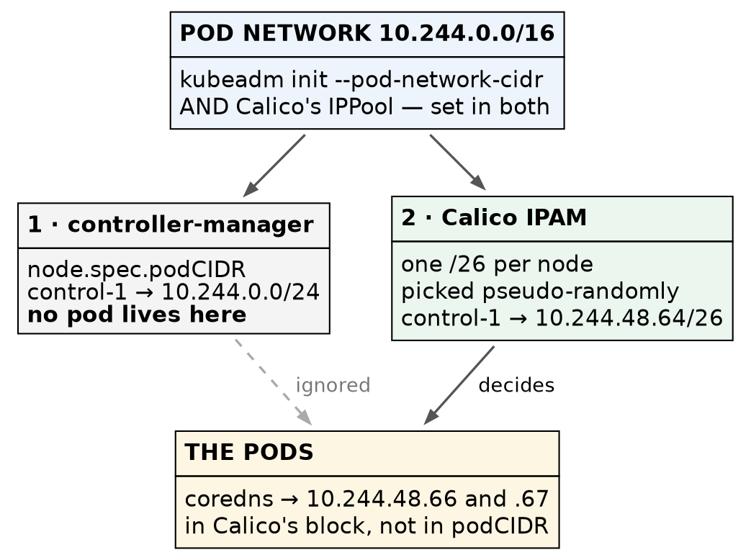
kubeadm assigns each node a podCIDR that no pod uses; Calico’s IPAM assigns the real addresses
Read the node’s podCIDR and you get 10.244.0.0/24 — but no pod lives there. kubeadm’s controller-manager assigns each node a /24, and Calico’s own IPAM ignores it and carves /26 blocks from the pool instead. Triaging a routing problem by reading node.spec.podCIDR means reasoning about a range no pod occupies.
kubectl get node vm-k8s-cka-control-1 -o jsonpath='{.spec.podCIDR}{"\n"}' # 10.244.0.0/24 — inert
kubectl get ipamblocks -o custom-columns=BLOCK:.spec.cidr,AFFINITY:.spec.affinity # the real blocks
⚠️ The blocks are chosen pseudo-randomly, not in order. Ours came out as .48.64, .55.192, .177.0, .58.192 and .81.192. Guessing a node’s block from its position in the list is wrong; ask Calico.
8. Join the second control plane — by hand, through the VIP
kubeadm init printed a control-plane join command. Run it on control-2, adding the node’s own address:
sudo kubeadm join 192.168.1.206:6443 \
--token <token> \
--discovery-token-ca-cert-hash sha256:<hash> \
--control-plane \
--certificate-key <certificate-key> \
--apiserver-advertise-address 192.168.1.202
⏱️ The certificate key expires two hours after init. Past that, regenerate it on control-1 with kubeadm init phase upload-certs --upload-certs rather than debugging a join that fails for no visible reason. The token lasts 24 hours.
⭐ Notice what this command connects to: 192.168.1.206, the VIP. Control-2 bootstraps through the virtual address that control-1 holds — the first real use of the HA endpoint by anything other than kubectl.
Confirm it in the output:
[download-certs] Downloading the certificates in Secret "kubeadm-certs" ...
[certs] apiserver serving cert is signed for ... IPs [10.96.0.1 192.168.1.202 192.168.1.206]
[certs] Using the existing "sa" key
[etcd] Announced new etcd member joining to the existing etcd cluster
⚠️ Near the top you will also see a W… warning — The recommended value for “bindAddress” in “KubeProxyConfiguration” is: ::. It appears on every init and join because these nodes have IPv6 addresses and kubeadm is recommending a dual-stack bind. This cluster is IPv4-only by choice, so it is advice declined, not a fault.
Each line proves something specific. The VIP appears in control-2’s own API-server certificate, so the endpoint chosen at init carries through every join. And Using the existing "sa" key matters more than it looks: the key that signs service-account tokens must be identical on every control plane, or a token minted by one API server would be rejected by another. Moving it safely is what --upload-certs and the kubeadm-certs Secret exist for.
🚨 You are now in the most fragile state this cluster will ever be in. etcd needs a majority — floor(n/2) + 1 — to accept a write. One member needs one. Two members need two. So a two-member etcd tolerates no failures while having twice the hardware to fail. Go straight to step 9, and do not reboot anything until it is done.
9. Join the third control plane, without lingering
The same command on control-3, with --apiserver-advertise-address 192.168.1.203. (In this build it was scripted; the first join was done by hand to learn it.)
Confirm — three members, and all three agreeing:
kubectl -n kube-system exec etcd-vm-k8s-cka-control-1 -- etcdctl \
--cacert /etc/kubernetes/pki/etcd/ca.crt \
--cert /etc/kubernetes/pki/etcd/server.crt \
--key /etc/kubernetes/pki/etcd/server.key \
endpoint status --cluster -w table
Three rows, one reading IS LEADER true, and matching RAFT INDEX values — ours read 9367 on all three. ⭐ A member listed as started is only in the membership list; matching raft indices mean all three have applied the same log. That is the difference between three members existing and three members agreeing.
⚠️ A spread of one or two between the indices is normal — members are queried one after another, so the numbers are sampled microseconds apart. Thousands apart would be lag.
10. Put kube-vip on the new control planes — exactly as generated
kube-vip runs on every control plane so that any of them can take over the VIP. Copy the manifest from control-1, which by now has been reverted to admin.conf (chapter 2, step 10).
🚨 This is where the chapter-2 asymmetry bites. super-admin.conf exists only on the first control plane. A manifest still pointing at it would mount a file that does not exist on control-2 and control-3. Check the source before copying:
sudo grep -E "^ path:" /etc/kubernetes/manifests/kube-vip.yaml # must be admin.conf
Get a copy onto each new control plane — we read it with sudo cat on control-1 and scp’d it to /tmp/kube-vip.yaml on control-2 and control-3. Then, on each of them, pre-pull the image into the namespace the kubelet reads (chapter 2, step 2) and install the file atomically — the kubelet on these nodes is running and watching that directory:
sudo ctr -n k8s.io image pull ghcr.io/kube-vip/kube-vip:v1.2.3
sudo install -o root -g root -m 0600 /tmp/kube-vip.yaml /etc/kubernetes/manifests/.kube-vip.yaml.tmp
sudo mv /etc/kubernetes/manifests/.kube-vip.yaml.tmp /etc/kubernetes/manifests/kube-vip.yaml
⭐ The temporary name starts with a dot, and that is deliberate. The kubelet ignores dotfiles, so it never tries to run a half-written manifest, and mv within one filesystem is atomic — it sees either no file or the whole file.
Confirm — three kube-vip pods, and exactly one VIP:
kubectl get pods -n kube-system -o wide | grep kube-vip # three, Running
ip -br addr show eth0 # on each control plane
Exactly one control plane should show 192.168.1.206/32. ⛔ Two holders would mean duplicate addresses on the wire, which is worse than none.
11. Join the workers — and read how little happens
The worker join is the same command without --control-plane, --certificate-key or --apiserver-advertise-address:
sudo kubeadm join 192.168.1.206:6443 \
--token <token> \
--discovery-token-ca-cert-hash sha256:<hash>
⭐ Put the two outputs side by side. The difference is the definition of a control plane.
 | Control-plane join | Worker join
Output, non-blank lines | 64 | 16
kubeadm phases run | 12 | 4
Downloads the shared PKI | ✅ [download-certs] | —
Generates API-server and etcd certificates | ✅ | —
Writes static pod manifests | ✅ apiserver, controller-manager, scheduler, etcd | —
Joins etcd | ✅ [etcd] Announced new etcd member | —
Writes kubelet.conf, starts the kubelet, gets a client cert | ✅ | ✅ — and that is all
A worker join writes a kubelet configuration, starts the kubelet, and stops. Everything that makes a control plane — the shared certificates, the four static pods, the etcd membership — is absent. The kubelet itself is the same program on both.
Confirm:
kubectl get nodes
⭐ The workers read <none> under ROLES, not worker. Kubernetes has no worker role; a worker is simply a node without the control-plane label. The role you see in that column is a label someone applied — the same lesson as the hostnames in chapter 1, one layer up.
12. Prove a pod can be scheduled and addressed
All three control planes carry node-role.kubernetes.io/control-plane:NoSchedule, so ordinary pods must land on the workers. Test with the pause image, which every node already has because every pod’s sandbox uses it — no registry pull, and no guessed tag.
kubectl create deployment stage1-check --image=registry.k8s.io/pause:3.10.2 --replicas=4
kubectl rollout status deployment/stage1-check
kubectl get pods -l app=stage1-check -o wide
Confirm: all four on the workers, two each, and each address inside its own node’s block — worker-1’s pods at 10.244.58.194 and .195 in 10.244.58.192/26, worker-2’s at 10.244.81.194 and .195 in 10.244.81.192/26.
And that Services route, from a node:
curl -sk https://10.96.0.1:443/livez # ok
⭐ 10.96.0.1 is the API server’s ClusterIP, and that address is on no interface anywhere. It exists only as rules kube-proxy wrote into the host’s packet filter. Getting ok back proves those rules work.
Then remove the test deployment — chapter 4 snapshots this cluster as a clean baseline:
kubectl delete deployment stage1-check
⚠️ This step does not prove pod-to-pod traffic across nodes, or DNS. pause has no shell, so it cannot ping or look anything up. Both are proven in chapter 4 — a cluster that schedules but cannot resolve names looks healthy and is not.

Where this lab differs from production
Lab vs PROD — a flat pod network with no policy. In the lab: Calico is installed and enforces nothing, because no NetworkPolicy exists, so every pod can reach every other pod and every Service. Why it’s acceptable here: no workload runs on this cluster that holds data worth protecting. In production: namespaces start from a default-deny policy and traffic is allowed explicitly (standard practice; not exercised here yet). If you carry the habit: a compromise of one pod becomes a compromise of everything that pod can reach — which, with no policy, is all of it.
Lab vs PROD — one subnet, so no encapsulation. In the lab: all five nodes share one layer-2 segment, so VXLANCrossSubnet never encapsulates and packets route directly. Why it’s acceptable here: it is simply the topology we have. In production: nodes span racks or subnets, cross-subnet traffic is wrapped in VXLAN, and every packet carries around 50 bytes of overhead. If you carry the habit: you will miss the MTU problem that only appears across subnets — large transfers stall while pings succeed, which is one of the hardest symptoms to read.
Honest limitations of this build. The encapsulation path is configured and untested, because nothing here crosses a subnet. Control-3 and worker-2 were joined by script after the first of each was done by hand, so their output was read rather than typed. We passed through the two-member etcd window quickly and deliberately did not test a failure inside it. And the Gateway API resource the operator installed is noted, not exercised.

Commands to know by heart
Question | Command
Is the firewall really off? | sudo ufw status — not systemctl is-active ufw
Is Calico healthy, by its own account? | kubectl get tigerastatus
What pod CIDR is Calico actually using? | kubectl get ippool default-ipv4-ippool -o yaml \| grep cidr
Which address blocks has Calico handed out? | kubectl get ipamblocks -o custom-columns=BLOCK:.spec.cidr,AFFINITY:.spec.affinity
Do the etcd members agree? | etcdctl ... endpoint status --cluster -w table — compare RAFT INDEX
Which control plane holds the VIP? | ip -br addr show eth0 on each
Has the certificate key expired? | regenerate: kubeadm init phase upload-certs --upload-certs
Why can’t this node take ordinary pods? | kubectl describe node <n> \| grep Taints
Does Service routing work? | curl -sk https://10.96.0.1:443/livez from a node

Glossary
CNI (Container Network Interface) — the plugin standard the kubelet calls to give each pod its network. Kubernetes ships none, which is why a new cluster is NotReady.
Tigera operator — the Deployment that installs and maintains Calico from a single Installation object. It reverts hand edits to what it manages.
IPPool — Calico’s definition of the address range pods draw from. Must agree with the --pod-network-cidr given to kubeadm init.
IPAM block — a /26 slice of the pool that Calico assigns to one node. Pods on that node get addresses from it.
podCIDR — the per-node range kubeadm’s controller-manager records on each Node object. With Calico’s IPAM in charge, nothing uses it.
stacked etcd — etcd running as a static pod on each control plane, rather than on separate machines.
quorum — the majority etcd needs to accept a write: floor(n/2) + 1. Three members survive one failure; two members survive none.
taint — a mark on a node that repels pods unless they tolerate it. Control planes carry control-plane:NoSchedule.

Check yourself
Answer these out loud. Section references, not answers.
- A new cluster’s node reads NotReady and CoreDNS is Pending. Is anything broken? What would you check first? (What a CNI is)
- systemctl is-active ufw says active. Is the firewall on? How do you actually find out? (§1)
- Calico’s documentation says no change is needed for a kubeadm cluster with a custom pod CIDR. Under what condition is that wrong, and how would you have caught it? (§5)
- node.spec.podCIDR says 10.244.0.0/24 but a pod on that node has 10.244.48.66. Which is right, and why do they differ? (§7)
- Why is a two-member etcd less available than a one-member one? (§8)
- What must be identical on every control plane, and what moves it there? (§8)
- Why must the kube-vip manifest on control-2 use admin.conf when control-1’s used super-admin.conf during init? (§10)
- Name three things a control-plane join does that a worker join does not. (§11)
- kubectl get nodes shows <none> under ROLES. Is the node misconfigured? (§11)
- The pause test passed. Name two things it did not prove. (§12)

