Kubernetes (CKA) · Chapter 4 — Proving It: Failover, a Baseline, and a Rollback You Can Trust
Series: Home-Lab Education · Phase 18 (Kubernetes HA + CKA) Built and verified: September 17, 2026 on VMs 201–205 (192.168.1.201–205) Versions at time of writing: Kubernetes v1.35.8 · kube-vip v1.2.3 · Calico v3.32.2 · etcd 3.6.6 · Proxmox VE 9 · busybox 1.38.0 Read this after: Chapter 3 (the network and the joins) · before: the CKA exercise chapters

What this chapter covers
Chapter 3 ended with five nodes Ready. That is a claim about the cluster, and this chapter tests it by trying to break it — then takes the snapshot that every later exercise rolls back to, and proves the rollback works.
The order matters, and it is the first thing in this chapter that is easy to get wrong. The failover test cuts the power to a control plane, which is an unclean shutdown of an etcd member. So the baseline snapshot comes before the destructive test, not after it. If the failover works, nothing is lost; if it doesn’t, you roll back two minutes instead of rebuilding a cluster.

What “highly available” means here — precisely
Three control planes do not share the load. kube-vip in ARP mode gives the VIP to exactly one control plane at a time, so every request through 192.168.1.206 reaches one API server. When that node dies, another claims the address. This is failover, not load balancing.
And “the leader” is not one thing. A cluster like this runs several independent elections:
- etcd elects a raft leader among its three members.
- kube-vip elects which node holds the VIP.
- kube-controller-manager and kube-scheduler each elect one active instance.
⭐ They do not have to agree on a node, and after a restart they often won’t. Ours didn’t — see step 6. Assuming the VIP holder is also the etcd leader is a natural mistake, and it makes a failover test ambiguous.

Part A — sign off the healthy cluster
Chapter 3 proved scheduling, addressing and Service routing from a node. Two things were still unproven, because the pause image has no shell: traffic between pods on different nodes, and DNS.
1. Prove pod-to-pod traffic across nodes
Use a small image with a shell and basic tools. ⚠️ Pin a tag you have verified exists rather than one remembered from a tutorial — we read busybox:1.38.0 from the registry’s own tag list before using it. A guessed tag fails at pull time, in the middle of a test.
kubectl run netcheck-a --image=busybox:1.38.0 \
--overrides='{"spec":{"nodeName":"vm-k8s-cka-worker-1"}}' -- sleep 3600
kubectl run netcheck-b --image=busybox:1.38.0 \
--overrides='{"spec":{"nodeName":"vm-k8s-cka-worker-2"}}' -- sleep 3600
kubectl wait --for=condition=Ready pod/netcheck-a pod/netcheck-b --timeout=120s
kubectl get pods netcheck-a netcheck-b -o wide
Pinning each pod to a named node guarantees the test crosses a node boundary. Left to the scheduler, both could land on one worker and prove nothing about the network between them.
kubectl exec netcheck-a -- ping -c3 -W2 <netcheck-b IP>
Confirm: three replies. Ours: ttl=62, round trip about 0.35 ms.
⭐ Read the TTL — it is better evidence than the reply. A packet starts at 64 and loses one per routing hop, so 62 means it was routed through both nodes, not wrapped in a tunnel. That is the vxlanMode: CrossSubnet setting from chapter 3 doing exactly what it claims on a single subnet — confirmed by a field nobody usually reads.
2. Prove DNS, both inside the cluster and out of it
kubectl exec netcheck-a -- nslookup kubernetes.default.svc.cluster.local
kubectl exec netcheck-a -- nslookup kubernetes.io
Confirm: the server is 10.96.0.10 (CoreDNS’s ClusterIP), kubernetes.default.svc.cluster.local resolves to 10.96.0.1, and the external name resolves too — ours returned two addresses, which will differ on your run because they belong to someone else’s CDN.
⭐ The internal lookup proves CoreDNS answers; the external one proves it forwards. They fail separately and for different reasons.
3. Prove Service routing from inside a pod
kubectl exec netcheck-a -- wget -qO- --no-check-certificate --timeout=5 https://10.96.0.1/livez
Confirm: ok. Chapter 3 ran the same check from a node. ⚠️ From inside a pod the packet takes a different path — out through the pod’s interface and the CNI before kube-proxy’s rules rewrite it — so both checks are worth running, because they can fail independently.
Then clean up:
kubectl delete pod netcheck-a netcheck-b

Part B — take the baseline before breaking anything
4. Shut down gracefully, and refuse to snapshot until all five have stopped
The snapshot is taken with the machines off. An offline snapshot is consistent by construction rather than by freezing a running filesystem, and etcd — a write-ahead-log database — is exactly what you want captured at rest.
On the Proxmox host, workers first, then control planes:
for id in 204 205 201 202 203; do qm shutdown $id --timeout 120; done
for id in 201 202 203 204 205; do qm status $id; done # all must read: status: stopped
⭐ Workers first, because they run work and the control planes decide where work goes. Stopping the workers first means the control plane is not processing evictions while it is itself shutting down.
⛔ Do not snapshot until every one reads stopped. qm shutdown returning is not the same as the guest having stopped, and a snapshot of a machine still shutting down defeats the point of doing it offline. If one times out, stop and decide — do not fall back to qm stop on an etcd member without meaning to.
5. Snapshot all five with one name, and confirm at two layers
for id in 201 202 203 204 205; do qm snapshot $id c02-virgin-cluster --description "..."; done
for id in 201 202 203 204 205; do qm listsnapshot $id; done
zfs list -t snapshot -o name,creation | grep -E 'vm-20[1-5]-disk'
⭐ All five together, under the same name, or not at all. Rolling one node of an etcd cluster back to a different point from the others creates a debugging session nobody asked for.
⭐ Check the storage, not just the bookkeeping. qm listsnapshot is Proxmox’s own record; the ZFS snapshot underneath is the independent witness. ⚠️ This check exists because the previous stage’s snapshot was recorded as taken and had not been — a record that a snapshot exists is not a snapshot.
6. Power on — and treat the first full cold start as a test
for id in 201 202 203; do qm start $id; sleep 5; done
for id in 204 205; do qm start $id; done
Control planes first, so the API is back before the workers try to report to it. Give it about 90 seconds, then check:
kubectl get nodes
kubectl -n kube-system exec etcd-vm-k8s-cka-control-1 -- etcdctl \
--cacert /etc/kubernetes/pki/etcd/ca.crt --cert /etc/kubernetes/pki/etcd/server.crt \
--key /etc/kubernetes/pki/etcd/server.key endpoint status --cluster -w table
What we saw, and what it proves:
 | Before the shutdown | After the cold start
etcd leader | control-1 | control-2
Raft term | 2 | 5
Raft index | 1–2 apart | identical on all three
VIP holder | control-1 | control-3
This was the cluster’s first complete power cycle, and it passed. All three etcd members replayed their logs to the same point, and the term rising from 2 to 5 records the elections held as members came back. Most usefully, the etcd leader and the VIP landed on different nodes — the independent-elections point from the start of this chapter, demonstrated. ⚠️ Where the leader and the VIP land after a restart carries no meaning; expect them to move.
7. Record certificate expiry now
sudo kubeadm certs check-expiration
Ours: all ten control-plane certificates expire Sep 17, 2027.
🚨 The kubelet’s client certificates are not in that list. They live in /var/lib/kubelet/pki, rotate automatically, and on a much shorter cycle. That matters for a lab you roll back for months: restore a snapshot long after it was taken and the control-plane certificates may still be valid while the kubelet’s have expired inside the frozen image. It presents as TLS or authentication errors, not as “this snapshot is old”. Recording the dates on day one is what makes it recognisable later.

Part C — break it
8. Choose the target, and make sure you know who leads
Find the VIP holder and the etcd leader:
for n in 201 202 203; do ssh 192.168.1.$n "ip -br addr show eth0 | grep -q 192.168.1.206 && hostname"; done
kubectl -n kube-system exec etcd-vm-k8s-cka-control-1 -- etcdctl ... endpoint status --cluster -w table
Ours: the VIP on control-3, etcd led by control-2. So control-3 is the target — killing the VIP holder while leaving the etcd leader alive tests one thing: VIP failover, without a raft election mixed in.
⚠️ Read the IS LEADER column yourself before relying on it. The script used in this build to find the leader printed an empty value, and the next line of the same script stated the target was not the leader. It happened to be true. A check that prints nothing has not answered the question — had control-3 been the leader, the test would have measured two things and reported one.
9. Write the predictions down before acting
# | Prediction | Basis
1 | kubectl through the VIP fails, then recovers on its own | failover exists
2 | Recovery takes 15–20 s | kube-vip manifest: lease 15 s, renew 10 s, retry 2 s
3 | The VIP reappears on a surviving control plane | leader election
4 | etcd keeps quorum at 2 of 3, and the leader does not change | a follower is being killed
5 | The dead node reads NotReady after the grace period | controller-manager’s --node-monitor-grace-period
⭐ Written first so the result can be scored rather than explained afterwards. Prediction 4 matters most: killing a follower should not trigger an election. If it did, something about who held what was wrong.
10. Cut the power, and time the outage
Use an abrupt stop, not a shutdown. A graceful shutdown lets kube-vip hand its lease over cleanly, which proves much less than a real failure does.
qm stop 203 # on the Proxmox host — the power cut
From another control plane, poll the API through the VIP until it answers:
while ! timeout 3 kubectl get --raw /livez >/dev/null 2>&1; do sleep 2; done
Measured: the API answered again after about 17 seconds, inside the predicted 15–20.
11. Read the aftermath
ip -br addr show eth0 # on control-1 and control-2 — who has .206 now?
kubectl -n kube-system exec etcd-vm-k8s-cka-control-1 -- etcdctl ... endpoint status --cluster -w table
kubectl get nodes
What we saw:
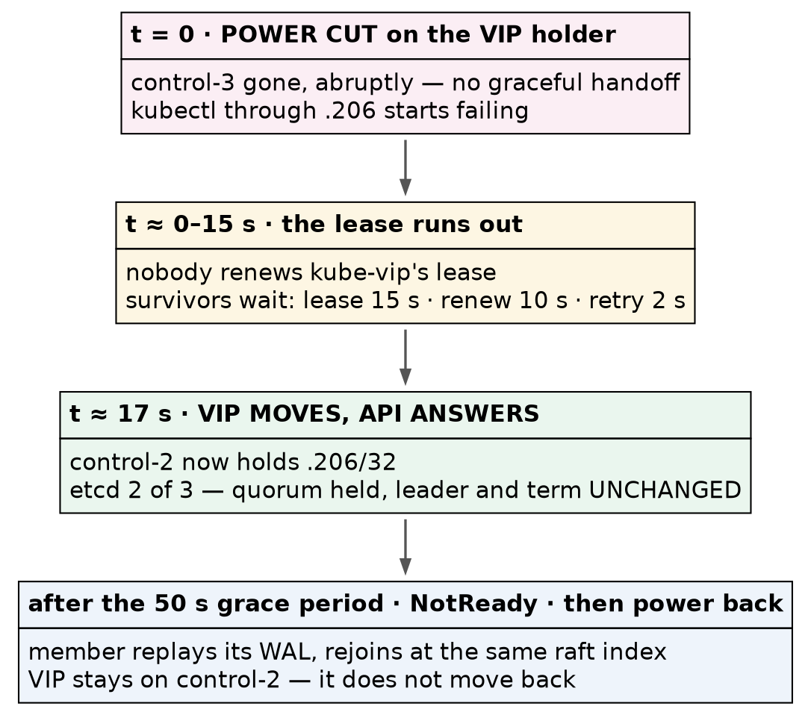
Failover after an abrupt power cut to the VIP holder
The VIP moved to control-2. etcdctl printed a context deadline exceeded error for control-3’s endpoint — expected, and not a fault of the tool — and then the table for the two members still answering. control-2 was still leader and the term was still 5: no election.
kubectl get nodes showed control-3 as NotReady when checked, about a minute after the cut.
⚠️ Prediction 5 was right for the wrong reason, and the reason is the lesson. We predicted NotReady “after about 40 seconds”. The v1.35.8 binary’s own help says the default grace period is 50 seconds — 40 is an older default. The prediction still looked correct only because the check ran after both numbers had passed. ⭐ A measurement too coarse to distinguish the prediction from its alternative cannot confirm it. To actually test it, poll the node status once a second from the moment of the cut.
kubectl -n kube-system exec kube-controller-manager-vm-k8s-cka-control-1 -- \
kube-controller-manager --help 2>&1 | grep -A1 node-monitor-grace-period # ask, don't recite
12. Bring it back, and check that it rejoined cleanly
qm start 203
After about a minute:
Confirm: five nodes Ready, etcd back to three members with identical raft indices (ours: 18843 on all three), and no pod outside Running or Completed.
⭐ The matching index is the real test of an unclean shutdown. The member lost power mid-operation, replayed its write-ahead log on restart, and caught up completely. The VIP stayed on control-2 — it does not move back when the original holder returns, and it doesn’t need to.

Part D — prove the rollback works
A snapshot that has never been restored is a hope. Every later exercise depends on this one.
13. Plant markers first
⭐ A successful restore and an ordinary reboot print exactly the same thing — five nodes Ready, three etcd members, the VIP up. Test only that the cluster comes back and you cannot tell whether anything was restored. So leave something behind that must disappear:
STAMP="rollback-test-$(date +%H%M%S)"
kubectl create configmap rollback-marker --from-literal=stamp="$STAMP"
for n in 201 202 203 204 205; do
ssh 192.168.1.$n "echo $STAMP | sudo tee /etc/kubernetes/ROLLBACK_MARKER >/dev/null"
done
Two markers, because they test different layers. The file proves the disk was reverted; the ConfigMap proves etcd’s contents went back with it. A restore that recovered the filesystem but left the database ahead would be the subtle failure, and only the ConfigMap catches it.
14. Roll back, and time it
Shut down as in step 4, then:
for id in 201 202 203 204 205; do qm rollback $id c02-virgin-cluster; done
Power on as in step 6.
Measured: the rollback of five VMs took 6 seconds, and all five were reachable over SSH 49 seconds after that. The graceful shutdown before it was not timed.
⭐ That cost is the number that decides how you use this lab. A restore that costs about two minutes means the cluster can be broken freely; one that cost fifteen would make you start avoiding the interesting exercises.
15. The markers must be gone
for n in 201 202 203 204 205; do
ssh 192.168.1.$n 'sudo test -f /etc/kubernetes/ROLLBACK_MARKER && echo STILL-PRESENT || echo GONE'
done
kubectl get configmap rollback-marker # must fail: NotFound
Confirm: GONE five times, and Error from server (NotFound). Ours: both.
⛔ Check the file with sudo. An unprivileged test on a root-owned path can fail for lack of permission and read as “gone”.
16. Write down what healthy looks like
A later “something is wrong” is only meaningful against a recorded normal:
Check | Healthy on this cluster
kubectl get nodes | 5 Ready, v1.35.8; workers <none>
etcd endpoint status --cluster | 3 members, one leader, indices equal or 1–2 apart
VIP | 192.168.1.206/32 on exactly one control plane
kubectl get tigerastatus | apiserver, calico, ippools, tiers all True; no goldmane/whisker
IPPool | 10.244.0.0/16, blockSize: 26, ipipMode: Never, vxlanMode: CrossSubnet
Pods | 43 system pods, none outside Running/Completed
Cross-node ping | succeeds, ttl=62
Control-plane certs | expire Sep 17, 2027
The two lines worth memorising: exactly one VIP holder, and etcd indices that agree. Two VIP holders means duplicate addresses on your network; indices thousands apart means a member is falling behind.

Where this lab differs from production
Lab vs PROD — VM snapshots as the cluster’s backup. In the lab: the baseline is a set of Proxmox snapshots taken with all five machines powered off, and “restore” means rolling every VM back. Why it’s acceptable here: the cluster exists to be broken and restored, and two minutes of downtime costs nothing. In production: etcd is backed up from a live member with etcdctl snapshot save and restored with etcdctl snapshot restore — no outage to take it, and no rolling back whole machines (standard practice; that drill comes in the exam chapters). If you carry the habit: backups that need the control plane switched off stop getting taken, and a whole-VM rollback also rewinds every certificate, log and OS change on the machine.
Honest limitations of this build. All three etcd members are virtual machines on one physical host, so this chapter demonstrates the loss of a member, never the loss of a host. We killed a follower, deliberately; losing the etcd leader — which forces a raft election — is not tested here and belongs in the exercise chapters. The full rollback cycle including shutdown was not timed precisely. And the NotReady timing was observed too coarsely to confirm the grace period, as step 11 explains.

Commands to know by heart
Question | Command
Who holds the VIP? | ip -br addr show eth0 on each control plane
Who leads etcd, and do the members agree? | etcdctl ... endpoint status --cluster -w table
Is the API up through the VIP? | kubectl get --raw /livez
Can pods on different nodes reach each other? | pin two pods with nodeName, then kubectl exec ... ping
Does CoreDNS answer, and forward? | nslookup kubernetes.default.svc.cluster.local and an external name
When do certificates expire? | sudo kubeadm certs check-expiration (control plane only)
What is the node-failure grace period, really? | kube-controller-manager --help \| grep -A1 node-monitor-grace-period
Does a snapshot exist? | qm listsnapshot <id> and zfs list -t snapshot

Glossary
failover — moving a service to a surviving node when its current one fails. Not the same as load balancing, where every node serves at once.
raft term — a counter etcd increments at each leader election. A term that does not change across a failure means no election happened.
raft index — the position in etcd’s replicated log. Members that agree have the same index.
write-ahead log (WAL) — the log etcd writes before applying a change. It is what a member replays to recover after losing power.
node-monitor grace period — how long the controller-manager waits without hearing from a node before marking it NotReady. 50 seconds by default in v1.35.
offline snapshot — a snapshot of a powered-off machine, consistent on disk by construction.
marker — something planted before a restore that must be gone after it. Without one, a restore cannot be told apart from a reboot.

Check yourself
Answer these out loud. Section references, not answers.
- Why is the baseline snapshot taken before the failover test? (What this chapter covers)
- Three control planes are running. How many API servers is your kubectl actually talking to, and why? (What “highly available” means here)
- A ping between pods shows ttl=62. What does that tell you about the network? (§1)
- The internal DNS lookup works and the external one fails. Where do you look? (§2)
- After a cold start the VIP is on control-3 and the etcd leader is control-2. Is anything wrong? (§6)
- Why test the failover by killing a follower first? (§8)
- You predicted NotReady after 40 s and saw it after a minute. Was the prediction confirmed? (§11)
- What single number shows that a member which lost power recovered completely? (§12)
- Why plant two markers, and what does each one prove? (§13)
- You restore this snapshot six months from now and get TLS errors. What do you suspect first? (§7)

