Kubernetes (CKA) · Chapter 2 — Giving a Node a Role
Series: Home-Lab Education · Phase 18 (Kubernetes HA + CKA) Built and verified: September 17, 2026 on VMs 201–205 (192.168.1.201–205) Versions at time of writing: Kubernetes v1.35.8 · kube-vip v1.2.3 · containerd 2.3.5 · etcd 3.6.6 · Ubuntu 24.04.4 LTS · kernel 6.8.0-139 Read this after: Chapter 1 (preparing a node) · before: Chapter 3 (the CNI and the joins)

What this chapter covers
Chapter 1 ended with five machines that were identical and had no role at all. This chapter runs one command on one of them and turns it into a control plane — then stops and reads what that command actually did.
The reading is the point. A control plane you have never looked inside is one you cannot repair, and repairing one is 30% of the CKA.
There is a complication to get past first, and it is the thing that makes this step confusing for everyone: we want a virtual IP to exist before kubeadm init runs, and the only thing that can create that virtual IP is started by kubeadm init.

The ordering problem, and why it is not a problem
kube-vip runs as a static pod — a pod defined by a file in /etc/kubernetes/manifests/ and run by the kubelet directly. But on a freshly prepared node the kubelet cannot start at all: it dies on a missing /var/lib/kubelet/config.yaml, and kubeadm init is what writes that file.
So the instinct — bring the VIP up, then initialise against it — describes something that cannot happen.
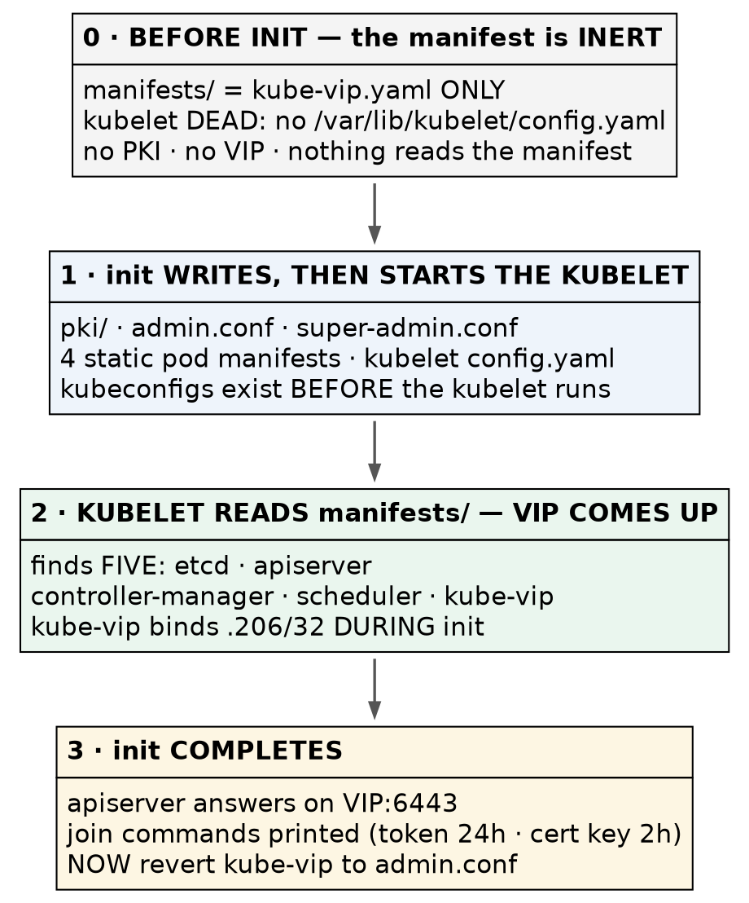
The ordering: the manifest is placed while nothing can read it, and the VIP appears during init
The resolution is that kubeadm init writes the kubeconfigs BEFORE it starts the kubelet. By the time anything reads the manifests directory, the files that kube-vip needs already exist. Place the manifest, then initialise; the VIP comes up in the middle of init.
⛔ Do not wait for the VIP to answer a ping before running kubeadm init. It never will, and the build will look stuck when nothing is wrong.
Why a VIP at all. kubeadm init bakes the control-plane endpoint into the API server certificate’s Subject Alternative Names at the moment it runs. Give it a node’s own address and every other control plane must also answer on that address — which they cannot. Give it a floating address and any of them can answer on it, one at a time. The VIP is not a performance feature; it is what makes the second and third control plane possible at all.

Three values are fixed at init, not one
Most guides flag --control-plane-endpoint as the irreversible flag. There are three, and the other two are the ones people omit.
Flag | Ours | Why it cannot be changed afterwards
--control-plane-endpoint | 192.168.1.206:6443 | Written into the API server certificate’s SANs. Without it, additional control planes can never join
--pod-network-cidr | 10.244.0.0/16 | Written into the cluster config and the controller-manager’s --cluster-cidr
--service-cidr | 10.96.0.0/12 | Determines the API server’s own ClusterIP
🚨 The pod CIDR is not a free choice, and the default will collide with a home or office network. Calico’s default pool is 192.168.0.0/16, which contains a lab on 192.168.1.0/24. Calico hands out /26 blocks, so it can and eventually will give a pod a real address on your wire — possibly one belonging to a node, a router, or a hypervisor. The symptoms are intermittent and look like a CNI bug or a faulty switch, and nothing points at a CIDR chosen days earlier.
⭐ The general rule is worth more than the number: a default CIDR is a guess about someone else’s network. Invert it for a corporate estate — on a 10.x network the dangerous default is Kubernetes’ own service CIDR 10.96.0.0/12. Check both against the network you are actually on, every time.

The procedure
Each step says how to confirm it took effect, and several confirmations check something other than the thing you just typed.
1. Choose the kube-vip version deliberately
export KVVERSION=v1.2.3
export VIP=192.168.1.206
export INTERFACE=eth0
⚠️ The documented way to discover the latest version uses jq, which we deliberately did not install — the exam ships yq. Either pin it by hand as above, or:
curl -sL https://api.github.com/repos/kube-vip/kube-vip/releases | yq -p json '.[0].tag_name'
⭐ We pinned one release behind the newest on purpose. The current release had been published the day before. A release with no community exposure means a crash-loop has two possible causes — your mistake, or a regression — during the one step that cannot be half-done.
🚨 INTERFACE is eth0 here, and every kube-vip example says ens160 or ens192 because they assume VMware. A wrong interface binds the VIP nowhere and reports nothing. Check with ip -br addr.
2. Pull the image into the namespace the kubelet actually reads
sudo ctr -n k8s.io image pull ghcr.io/kube-vip/kube-vip:$KVVERSION
Confirm — ask crictl, which is what Kubernetes sees:
sudo crictl images | grep kube-vip
🚨 ctr defaults to the default namespace; the kubelet uses k8s.io. Pull without -n k8s.io and the image is invisible to crictl and the kubelet fetches it again — from the internet, in the middle of kubeadm init. ⭐ Two image stores disagreeing about reality, except this time it is containerd disagreeing with itself. Pre-pulling removes an external network dependency from the irreversible step.
3. Verify the flags against the binary, not against the documentation
sudo ctr run --rm --net-host ghcr.io/kube-vip/kube-vip:$KVVERSION vip-help \
/kube-vip manifest pod --help
Confirm: --controlplane, --arp and --leaderElection all appear.
⚠️ The casing is inconsistent and cannot be guessed. --controlplane is all lowercase, --leaderElection has a capital E, and --controlPlaneHealthCheckAddress uses camelCase — three spellings of the same words in one flag set. Most published examples were written for a v0.x release. Ask the binary you are about to run.
4. Generate the manifest — to a temp file, and read it
sudo ctr run --rm --net-host ghcr.io/kube-vip/kube-vip:$KVVERSION vip-gen \
/kube-vip manifest pod \
--interface $INTERFACE \
--address $VIP \
--controlplane \
--arp \
--leaderElection > /tmp/kube-vip.yaml
cat /tmp/kube-vip.yaml
⭐ The published procedure pipes this straight into /etc/kubernetes/manifests/. We did not, because the file needs an edit first and a wrong manifest should never sit in the static-pod directory at all, even briefly.
Four things to check in what it produced:
Check | Expected
Image tag | v1.2.3 — not latest
hostPath | /etc/kubernetes/admin.conf — the line we are about to change
hostAliases | maps kubernetes → 127.0.0.1, present
svc_enable | absent — confirms --services really stayed off rather than defaulting on
⚠️ Note what else is in there that nobody asked for: prometheus_server: :2112. kube-vip will open an unauthenticated metrics port on every control plane, on host networking. Harmless in a lab; worth knowing before someone scans the estate.
5. Apply the v1.29+ bootstrap workaround — on the first control plane ONLY
sed -i 's#path: /etc/kubernetes/admin.conf#path: /etc/kubernetes/super-admin.conf#' /tmp/kube-vip.yaml
grep -nE "mountPath:| path:" /tmp/kube-vip.yaml
# mountPath: /etc/kubernetes/admin.conf <- UNCHANGED
# path: /etc/kubernetes/super-admin.conf <- changed
🚨 Since Kubernetes v1.29, admin.conf no longer carries cluster-admin at bootstrap time. kubeadm writes a second file, super-admin.conf, and creates the binding that makes admin.conf useful only after the control plane is up. Point kube-vip at admin.conf during init and the static pod crashes, the API endpoint never appears, and kubeadm init times out after about four minutes leaving an unusable cluster.
⭐ Only the hostPath changes. The mountPath stays. The container keeps seeing a file called admin.conf; we change which host file is mounted there. The sed pattern is safe because it matches lowercase path: and the mount line reads mountPath: — if it matched both you would break it in a way a diff makes look correct.
🚨 THE ASYMMETRY IS THE PART TO REMEMBER: super-admin.conf exists ONLY on the first control plane. Control planes two and three use the manifest exactly as generated. Reverse that and the joins fail instead of the init.
6. Place it — and confirm that nothing happens
sudo install -o root -g root -m 0600 /tmp/kube-vip.yaml \
/etc/kubernetes/manifests/kube-vip.yaml
systemctl is-active kubelet # still activating — correct
sudo crictl ps -a # empty — nothing started
ip -br addr show eth0 # no .206 — correct
sudo journalctl -u kubelet -n 3 --no-pager
⭐ install rather than cp because it sets owner and mode as part of the copy. The source came from a shell redirect and carried your umask; sudo cp would have produced a world-readable file in the static-pod directory and nothing would have said so.
⚠️ “I placed a manifest and nothing happened” must be a confirmed expectation, not a hope. The kubelet’s error is unchanged because it still dies before it ever reads that directory.
7. Dry-run the init and check the certificate SANs before committing
sudo kubeadm init \
--control-plane-endpoint 192.168.1.206:6443 \
--apiserver-advertise-address 192.168.1.201 \
--pod-network-cidr 10.244.0.0/16 \
--service-cidr 10.96.0.0/12 \
--kubernetes-version v1.35.8 \
--upload-certs \
--dry-run 2>&1 | tee /tmp/init-dryrun.txt
grep -iE "apiserver serving cert|podSubnet|serviceSubnet" /tmp/init-dryrun.txt
Confirm the VIP is in the SANs before running this for real:
apiserver serving cert is signed for ... IPs [10.96.0.1 192.168.1.201 192.168.1.206]
⭐ This is the whole reason to dry-run. The SAN list is the irreversible part of the irreversible step, and a dry run shows it to you while you can still change your mind. If .206 is absent, stop — additional control planes would never be able to join.
⚠️ --kubernetes-version is pinned so kubeadm does not ask dl.k8s.io what the newest patch is. Same reasoning as pre-pulling the image: take the network out of the step that cannot be half-done.
🚨 Then clean up, because --dry-run writes to disk. It generated a complete PKI, private keys included, under /etc/kubernetes/tmp/kubeadm-init-dryrun*/. Mode 0600, so not an exposure — but they are real cryptographic keys belonging to no cluster, which nothing will ever rotate or account for.
sudo rm -rf /etc/kubernetes/tmp
sudo find /etc/kubernetes \( -name "*.key" -o -name "*.conf" \) -print
⛔ Check that with sudo. That directory is drwx------, so an unprivileged ls returns a permission error — and if you also redirect stderr away, empty output reads as “clean” when it means “I could not look”.
8. Run it for real
sudo kubeadm init \
--control-plane-endpoint 192.168.1.206:6443 \
--apiserver-advertise-address 192.168.1.201 \
--pod-network-cidr 10.244.0.0/16 \
--service-cidr 10.96.0.0/12 \
--kubernetes-version v1.35.8 \
--upload-certs 2>&1 | tee /tmp/init-real.txt
Save that output. It contains a join token valid 24 hours and a certificate key valid two hours, and the shorter clock starts the moment init finishes.
⚠️ Two expiries with very different consequences. The token expires and you generate another (kubeadm token create). The certificate key expires and additional control planes cannot join until you run kubeadm init phase upload-certs --upload-certs. ⭐ A deliberate, unhurried pace makes the two-hour one MORE likely to bite, not less.
9. Read what appeared — this inspection is the chapter
sudo ls -l /etc/kubernetes/ /etc/kubernetes/manifests/
sudo crictl pods
systemctl is-active kubelet
What was not there ten seconds ago:
Appeared | What it is
manifests/etcd.yaml, kube-apiserver.yaml, kube-controller-manager.yaml, kube-scheduler.yaml | The control plane itself — four static pods, read off local disk
pki/ | The cluster CA and every certificate derived from it
admin.conf, super-admin.conf, controller-manager.conf, scheduler.conf, kubelet.conf | Five kubeconfigs, five different identities
/var/lib/etcd | The datastore
/var/lib/kubelet/config.yaml | The file whose absence was killing the kubelet
⭐ The kubelet is now active for the first time in the machine’s life. And the deepest point in this chapter: the kubelet is IDENTICAL on a control plane and on a worker. A control plane is simply a node whose kubelet additionally runs four static pods. That is why a dead API server is repaired by editing a file in /etc/kubernetes/manifests/ and waiting, and why kubectl cannot help you: the thing you need to fix is the thing that serves kubectl.
⚠️ kube-vip will NOT crash-loop, though the upstream notes suggest it might. Measured: ATTEMPT 0, zero restarts. The crash-loop is a symptom of the broken configuration, and applying the workaround beforehand removed the symptom rather than shortening it. ⭐ A predicted problem that fails to appear is worth understanding, not just enjoying — otherwise you cannot tell it apart from a check that silently did not run.
10. Revert the kubeconfig, and watch what that costs
sudo sed -i 's#path: /etc/kubernetes/super-admin.conf#path: /etc/kubernetes/admin.conf#' \
/etc/kubernetes/manifests/kube-vip.yaml
Confirm the VIP survives it:
sleep 15
sudo crictl ps -a --name kube-vip
ip -br addr show eth0
sudo KUBECONFIG=/etc/kubernetes/admin.conf kubectl get nodes
⭐ sed -i is the right tool on a directory the kubelet is now watching, because it writes a temp file in the same directory and renames it over the original — and rename(2) within one filesystem is atomic. The kubelet sees the old file or the new one, never half of one.
🚨 Editing a static pod manifest DELETES AND RECREATES the pod — so RESTARTS tells you nothing about it. Measured: new pod UID, new creationTimestamp, and a restart counter back at zero.
kubectl get pod -n kube-system kube-vip-<node> \
-o custom-columns=UID:.metadata.uid,CREATED:.metadata.creationTimestamp,RESTARTS:.status.containerStatuses[0].restartCount
⚠️ RESTARTS 0 does not mean a static pod was untouched. Compare its creationTimestamp against the API server’s: ours read 15:49 against 15:45, and that four-minute gap is the entire record of the edit.
11. Get a kubeconfig for your own user — on the node
mkdir -p $HOME/.kube
sudo cp -i /etc/kubernetes/admin.conf $HOME/.kube/config
sudo chown $(id -u):$(id -g) $HOME/.kube/config
kubectl get nodes
⭐ That result came back through the VIP, because admin.conf points at https://192.168.1.206:6443. The first useful kubectl is also the proof the virtual address works.
And the node will read NotReady, with CoreDNS Pending. That is correct — Kubernetes ships no pod network, so nothing can give a pod an address yet. Chapter 3 installs one.

Where this lab differs from production
Lab vs PROD — an ARP virtual IP is failover, not load balancing. In the lab: kube-vip in ARP mode with leader election, so exactly one control plane holds .206 and every kubectl request reaches that one API server. Why it’s acceptable here: five nodes and one operator, where availability is the only property we need. In production: a real load balancer distributes across all API servers, or kube-vip runs in BGP mode where every node advertises the address. If you carry the habit: you will size a control plane believing three API servers share the load when one of them is taking all of it — and the capacity model is wrong in the direction that only shows up under stress.
Lab vs PROD — a cluster-admin credential printed to a terminal. In the lab: the certificate key from --upload-certs is echoed to stdout, captured with tee, and pasted between SSH sessions. Why it’s acceptable here: it expires in two hours and the network is a single-operator LAN. In production: joins are automated, the key is injected from a secret store, and nothing that grants cluster-admin is ever written to a log. If you carry the habit: a credential to the entire cluster ends up in shell history and CI output, where it outlives the two hours that made it feel safe.
Honest limitations of this build, stated plainly. The three etcd members are virtual machines on one physical host, sharing a hypervisor, a ZFS pool and a power supply — so anything we demonstrate is member failure and never host failure. The VIP works by ARP on a single layer-2 segment; a routed or multi-site control plane needs BGP instead, which is a different configuration and a different chapter. And this chapter builds one control plane: whether the endpoint genuinely survives losing a node is asserted here and proven in chapter 4.

Commands to know by heart
Question | Command
Does this flag actually exist in this version? | <tool> --help — on the binary you will run
Which images can the kubelet see? | sudo crictl images (not ctr -n default images ls)
What does the API server certificate really cover? | sudo openssl x509 -in /etc/kubernetes/pki/apiserver.crt -noout -text \| grep -A1 "Subject Alternative Name"
Why will the kubelet not start? | sudo journalctl -u kubelet -n 3 --no-pager
Which node holds the VIP? | ip -br addr show eth0
Was this static pod replaced, or just restarted? | kubectl get pod X -o jsonpath='{.metadata.uid}' and creationTimestamp
What settings did init actually record? | kubectl -n kube-system get cm kubeadm-config -o yaml
Has the certificate key expired? | kubeadm init phase upload-certs --upload-certs (reissues it)
Is there a free address for the VIP? | delete the neighbour entry, ping once, then ip neigh show <ip> — a lladdr means occupied even if the ping failed

Glossary
static pod — a pod defined by a YAML file in /etc/kubernetes/manifests/ and run by the kubelet directly. Not scheduled by the API server, which is how the control plane bootstraps itself and why it can be repaired when the API is down.
VIP (virtual IP) — an address that belongs to no single machine. Here exactly one control plane holds it at a time and it moves when that node fails.
ARP mode — kube-vip claims the VIP by answering ARP for it on the local segment. Simple, and confined to one layer-2 network.
leader election — the mechanism deciding which kube-vip instance holds the VIP. ⭐ Separate from etcd’s raft leader and from the controller-manager’s own election: a cluster runs several independent elections and they need not agree on a node.
SAN (Subject Alternative Name) — the names and addresses a certificate is valid for. Fixed when the certificate is generated, which is why the control-plane endpoint cannot be changed later.
super-admin.conf — since v1.29, the kubeconfig that actually carries full privilege at bootstrap. admin.conf gets its privilege through a role binding created during init, so it is not usable by tools while init is still running.
certificate key — the short-lived secret that lets an additional control plane download the shared PKI from the kubeadm-certs Secret. Two hours.
bootstrap token — the credential a joining node uses to authenticate before it has a certificate. 24 hours.

Check yourself
Answer these out loud. Section references, not answers.
- Someone tells you to “bring the VIP up before running kubeadm init.” Why is that impossible, and what do you do instead? (The ordering problem)
- You run kubeadm init and it times out after four minutes with the API endpoint never appearing. What is the first file you look at, and which single line in it? (§5)
- Name the three values fixed at init that cannot be changed afterwards, and what breaks for each. (Three values are fixed at init)
- Your lab is on 10.20.0.0/16. Which Kubernetes default is now dangerous, and which one is safe? (Three values are fixed at init)
- You edited a static pod manifest an hour ago. RESTARTS reads 0. What have you learned, and what would you check instead? (§10)
- sudo crictl images does not list an image you definitely pulled. What happened? (§2)
- You are handed a control plane and asked whether additional ones can join it. What do you inspect, and what exactly are you looking for? (§7)
- Why is super-admin.conf needed on the first control plane but not on the second and third? (§5)

