Chapter 2 — The Object Model: Deployments, Rollouts, and the Two Probes
Who this chapter is written for. Andrew is interviewing for an SRE / DevOps role on an order management system. So this chapter is not “how to write a Deployment.” It is about what happens when you ship a bad build at 3am: what stops, what keeps serving, what lies to you, and which reflex turns a stalled deploy into an outage.

Verified facts header
Everything here was run on vm-k8-redpanda-1 (192.168.1.186), single-node k3s v1.36.2, on 27 July 2026 — the object-model session in the morning and the probe/rollout session at 15:05–15:30. Every command was executed and every output quoted is real.
Thing | Value as tested
Image | nginx:1.27-alpine (pre-cached, so pods start in ~1 s)
Namespace | default (Redpanda was never touched)
Strategy | RollingUpdate, maxSurge: 1, maxUnavailable: 0
Revisions produced | 5, across 4 ReplicaSets
Manifest | manifests/web-deployment.yaml

What this chapter covers
- One manifest, three objects — and the ownership chain
- The pod-template-hash, and why rolling updates would deadlock without it
- Labels are per-object (a trap that cost us ten minutes)
- Imperative vs declarative drift — the best argument for GitOps you will ever run
- Rolling updates: what maxSurge and maxUnavailable actually do
- Readiness probes — the gate that saves you
- Liveness probes — the one that causes outages
- Rollback, revision renumbering, and the landmine rollout undo leaves behind
- Does a rolling update protect quorum? (No. This matters for Redpanda.)
- Requests, limits, the three QoS classes, and OOMKilled
- Production gap, commands, glossary, self-test

1. One manifest, three objects
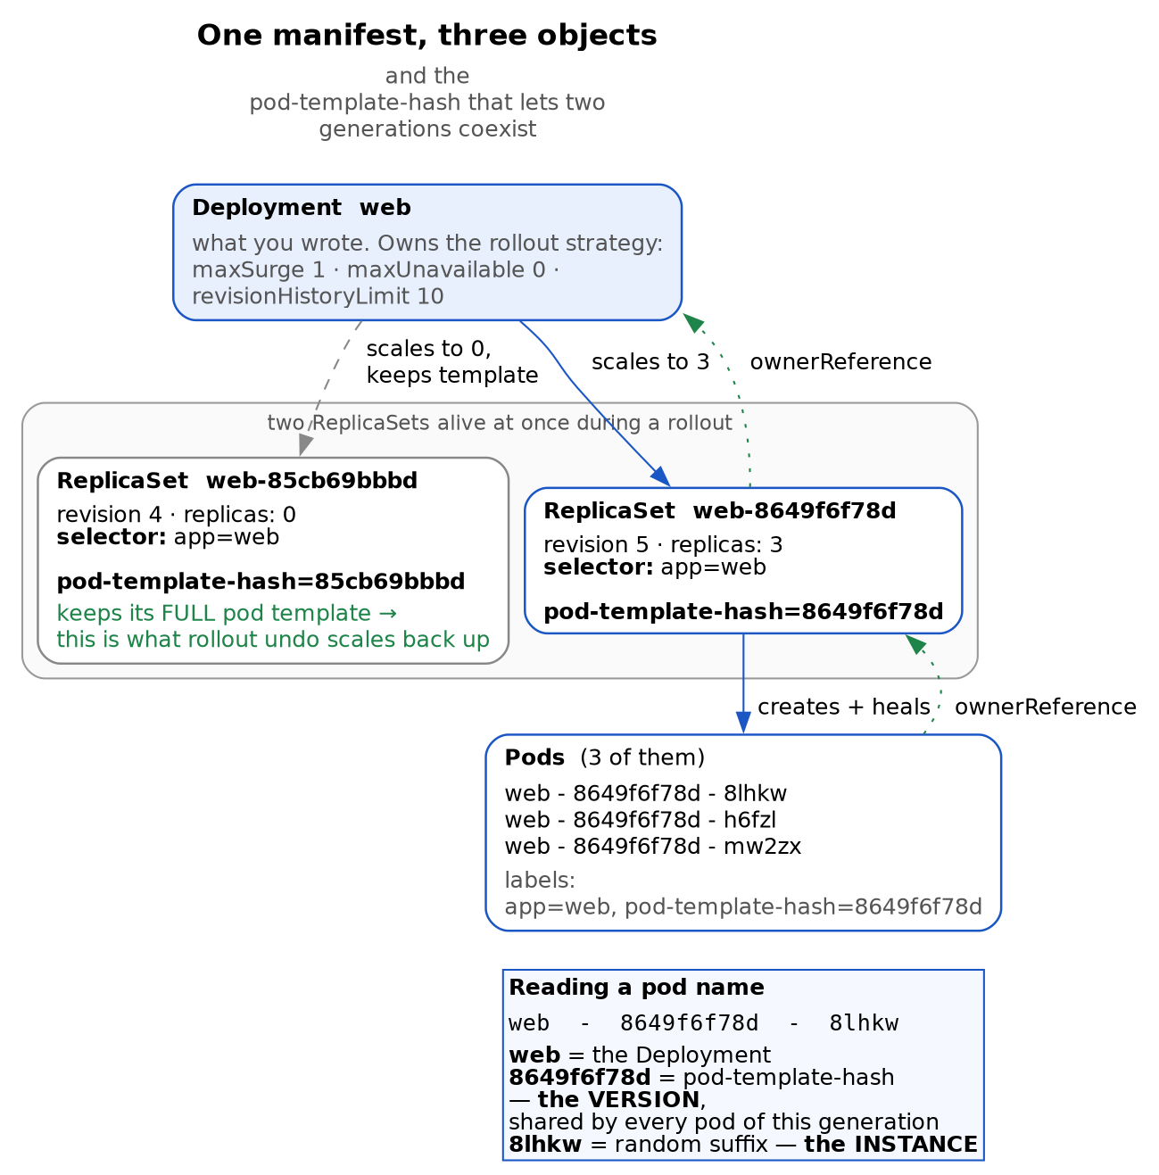
Figure 1 — the ownership chain and the pod-template-hash
Why the hash has to exist
Your manifest only said selector: matchLabels: app=web. Kubernetes silently ADDS pod-template-hash to each ReplicaSet’s selector and to every pod it creates. Without it, both ReplicaSets above would match all 3 pods on app=web alone, each would count 3 and consider itself satisfied, and the rollout would deadlock. The hash is what lets each generation say “these are mine, those are not.” Follow the dotted ownerReferences up and you have garbage collection: delete the Deployment and the ReplicaSets and Pods are collected automatically.
You apply one YAML file and get three API objects, each with a different job:
Object | Responsibility
Deployment | How to change. Owns the rollout strategy and the revision history.
ReplicaSet | How many. Keeps exactly N pods of one specific template alive.
Pod | The thing that runs. Holds one or more containers.
A container is a fourth thing, but it is not an API object — you cannot kubectl get containers. It exists only as a field inside a pod spec.
The split exists because “keep 3 copies alive” and “replace v1 with v2 safely” are different problems. A ReplicaSet solves the first and is deliberately stupid about versions. The Deployment solves the second by creating a second ReplicaSet and shifting replicas between them.
The ownership chain
kubectl get pods -l app=web -o jsonpath='{range .items[*]}{.metadata.name} {.metadata.ownerReferences[0].kind}/{.metadata.ownerReferences[0].name}{"\n"}{end}'
web-dbb6fffff-4wfdz ReplicaSet/web-dbb6fffff
web-dbb6fffff-58snx ReplicaSet/web-dbb6fffff
web-dbb6fffff-6t9hj ReplicaSet/web-dbb6fffff
and the ReplicaSet in turn is owned by Deployment/web. Those ownerReferences are what make kubectl delete deploy web clean everything up — the garbage collector walks the chain downward. It is also why deleting a pod achieves nothing permanent: its owner immediately notices the shortfall and makes another. We proved that in Chapter 1 by deleting coredns.

2. The pod-template-hash
This is the mechanism that makes everything else in the chapter possible, and it is invisible in your manifest.
kubectl get rs -l app=web -o jsonpath='{.items[0].metadata.labels.pod-template-hash}'
dbb6fffff
Kubernetes hashes your pod template, then stamps the result as a real label on the ReplicaSet, on every pod it creates, and — critically — into the ReplicaSet’s own selector.
Your manifest said:
selector:
matchLabels:
app: web
The live ReplicaSet is actually selecting on app=web AND pod-template-hash=dbb6fffff.
Why it must exist. During a rollout two ReplicaSets are alive at once, both matching app=web. Without the hash, each would look at all the pods, count enough, decide it was satisfied, and do nothing. The rollout would deadlock. The hash is what lets each generation distinguish “my pods” from “the other generation’s pods.”
Reading a pod name
web - 8649f6f78d - 8lhkw
│ │ └── random suffix = this INSTANCE
│ └───────────────── pod-template-hash = this VERSION
└──────────────────────────── the Deployment
The hash does not distinguish instances — it groups them. All pods of one generation share it.
Change the template, get a new hash, get a new ReplicaSet. That is the entire trigger condition for a rollout, and §5 shows what does not trigger one.

3. Labels are per-object
A trap worth writing down because it wasted real time.
The first manifest put labels only in spec.template. Then:
kubectl get deploy,rs,pods -l app=web # returned the pods, but NOT the Deployment
spec.template.metadata.labels describes the pods the Deployment will create. It says nothing about the Deployment object itself, which had no labels at all and therefore matched no selector.
Real manifests repeat them in both places:
metadata:
name: web
labels:
app: web # ← labels the Deployment object
spec:
selector:
matchLabels:
app: web # ← how the Deployment finds its pods
template:
metadata:
labels:
app: web # ← labels each pod
Three separate places, three separate meanings. With that fixed, -l app=web matched all three object types:
deployment.apps/web 3/3 3 3 9s
replicaset.apps/web-dbb6fffff 3 3 3 9s
pod/web-dbb6fffff-4wfdz 1/1 Running 0 9s

4. Imperative vs declarative drift
Two experiments, both of which end the same way.
Scaling by hand:
kubectl scale deploy web --replicas=3
kubectl apply -f web.yaml # file still says replicas: 1
The Deployment snapped straight back to 1. apply does not merge your intent with the cluster’s current state — the file wins.
Also worth noting: scaling does not create a new ReplicaSet. The pod template is unchanged, so the hash is unchanged, so there is no new revision. Only template changes make revisions.
And the dangerous version — rollout undo: covered in §8. It changes the cluster and tells nothing else, which is how a rollback gets silently re-broken by the next deploy.
The rule: anything you do imperatively is a change your Git repository does not know about, and the next apply will overwrite it. Imperative commands are for diagnosis and emergencies. The fix always goes in the file.

5. Rolling updates: maxSurge and maxUnavailable
We set these explicitly rather than taking the defaults (25% each):
strategy:
type: RollingUpdate
rollingUpdate:
maxSurge: 1 # at most 1 EXTRA pod above the desired count
maxUnavailable: 0 # never drop below the desired count
Read as a pair, they define a window: with replicas: 3 you may have 3 or 4 pods, and at least 3 must be available. So the controller must add before it removes. For anything serving orders, maxUnavailable: 0 is the setting you want — capacity never dips.
The progression is visible in rollout status:
Waiting for deployment "web" rollout to finish: 0 out of 3 new replicas have been updated...
Waiting for deployment "web" rollout to finish: 1 out of 3 new replicas have been updated...
Waiting for deployment "web" rollout to finish: 2 out of 3 new replicas have been updated...
Waiting for deployment "web" rollout to finish: 1 old replicas are pending termination...
deployment "web" successfully rolled out
One new pod, wait for Ready, delete one old pod, repeat.
The trade-off: maxUnavailable: 0 requires spare capacity to surge into, and it makes rollouts slower — strictly serialised. maxUnavailable: 1, maxSurge: 0 is the opposite choice: no extra capacity needed, but you run degraded during the deploy. Neither is universally right, and being able to explain the trade-off is the interview answer.
What does not trigger a rollout
Re-applying a file whose pod template is byte-identical to what is running:
deployment.apps/web configured
…and yet nothing rolled. Same ReplicaSets, same pod ages, no new revision. Only the last-applied-configuration annotation changed.
“configured” does not mean “rolled out.” Only pod-template changes cause pod churn. Change a Deployment label or fix an annotation and apply reports configured while your pods sit undisturbed. People see that word and assume they caused a restart.

6. Readiness probes — the gate
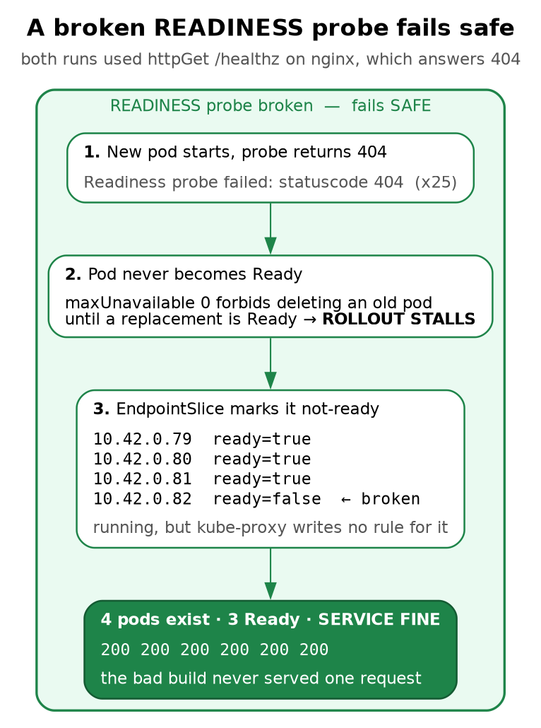
Figure 2 — a broken readiness probe fails safe
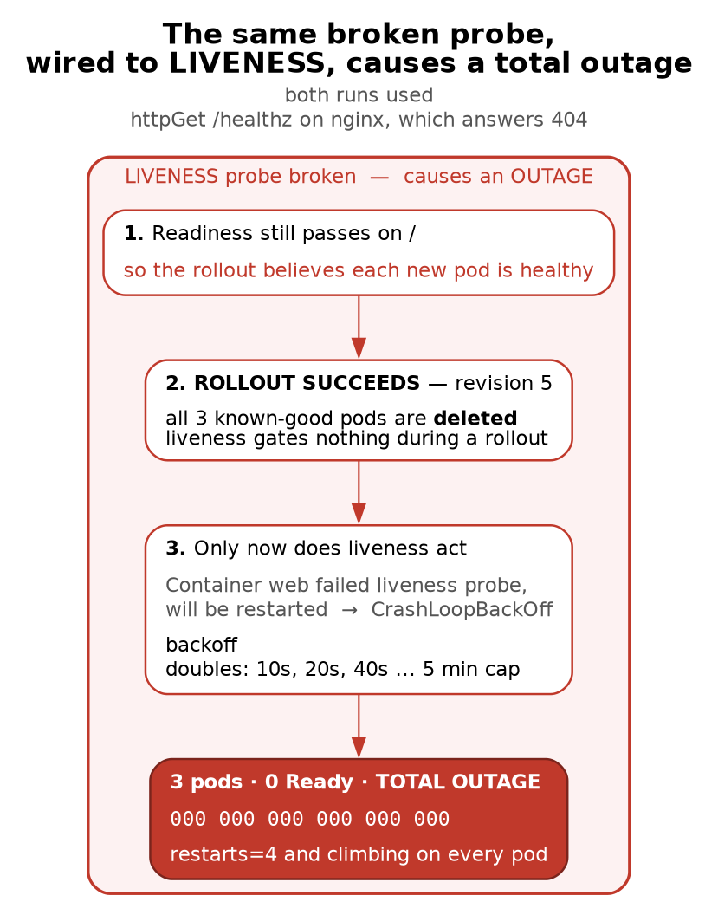
Figure 3 — the same broken probe, wired to liveness, causes a total outage
The asymmetry, and the rules that follow from it
Readiness gates the rollout. Liveness does not. A bad readiness probe stops the deploy and protects you. A bad liveness probe ships cleanly, destroys the good pods, and only then starts killing.
Debugging heuristic: CrashLoopBackOff with Exit Code: 0 means something EXTERNAL killed the container — nearly always the liveness probe. A real app crash gives a non-zero code or a signal.
Never let a liveness probe check a dependency. If it returns unhealthy because the database is down, Kubernetes kills every replica at once and the restart storm hammers the recovering database. Dependency health belongs in READINESS, which only removes you from the load balancer.
Slow starters need a startupProbe, or liveness kills the app before it finishes booting.
Without a probe, Kubernetes calls a pod Ready as soon as the container process starts. For most real applications that is a lie — a JVM or a Python service accepts a TCP connection long before it can answer a request.
readinessProbe:
httpGet:
path: /
port: 80
initialDelaySeconds: 2
periodSeconds: 2
Breaking it on purpose
We pointed the probe at /healthz, which nginx answers with a 404. An httpGet probe counts only 200–399 as success, so the pod could never become Ready.
Readiness probe failed: HTTP probe failed with statuscode: 404 (x25 over 2m31s)
The result, exactly as the arithmetic predicts:
NAME READY STATUS RESTARTS AGE
web-749d9d4b8-q4294 0/1 Running 0 77s ← the new, broken pod
web-85cb69bbbd-h2fzc 1/1 Running 0 6m17s
web-85cb69bbbd-rfjgr 1/1 Running 0 6m23s
web-85cb69bbbd-vm2lj 1/1 Running 0 6m20s
NAME DESIRED CURRENT READY AGE
web-749d9d4b8 1 1 0 78s ← wants 1, has 1, READY 0
web-85cb69bbbd 3 3 3 6m23s
maxSurge: 1 permitted the 4th pod. maxUnavailable: 0 forbade deleting any of the 3 good ones until a replacement went Ready. It never did. The rollout parked itself and stopped.
The EndpointSlice is where you see it working
kubectl get endpointslices -l kubernetes.io/service-name=web \
-o jsonpath='{range .items[*].endpoints[*]}{.addresses[0]} ready={.conditions.ready}{"\n"}{end}'
10.42.0.79 ready=true
10.42.0.80 ready=true
10.42.0.81 ready=true
10.42.0.82 ready=false ← the broken pod
Same mechanism as Chapter 1 §5, now doing its real job. The broken pod is in the slice but flagged not-ready, so kube-proxy writes no iptables rule for it. It runs, consumes memory, and receives nothing:
200 200 200 200 200 200
You shipped a broken build to production and not one user request touched it.
Two status conditions that disagree, deliberately
Available=True MinimumReplicasAvailable
Progressing=True ReplicaSetUpdated
Available=True while the deploy is broken, because three pods are serving. Availability answers “is the service up,” not “did my deployment work.” Monitor both; they are different questions.
The timeout that does nothing
kubectl rollout status --timeout=60s failed after 60 seconds. That is client-side impatience only — it killed your kubectl, not the rollout:
progressDeadlineSeconds=600 # 10 minutes before the Deployment gives up... on reporting
new RS age: 2m54s # still going
And progressDeadlineSeconds does less than its name suggests. It is easy to read it as “the Deployment stops after ten minutes.” It does not stop. When the deadline passes with no progress, the controller sets a status condition — Progressing=False with reason ProgressDeadlineExceeded — and then carries on trying forever. Nothing is rolled back, nothing is paused, no pod is deleted. It is a flag for you and your monitoring to read, not a circuit breaker:
kubectl get deploy web -o jsonpath='{.status.conditions[?(@.type=="Progressing")].reason}'
# ProgressDeadlineExceeded
That condition is what kubectl rollout status watches for to decide a rollout has failed, which is why the distinction is easy to miss — the tooling behaves as if something happened, while in the cluster nothing did.
Operational consequence: a CI job that times out and exits red leaves a half-rolled deployment still grinding in the cluster. The pipeline says “failed,” everyone assumes nothing shipped, and a surge pod sits there. If you want it stopped, say so: kubectl rollout undo or kubectl rollout pause. Automatic rollback is not a Deployment feature — if you want it, it belongs in your deployment tooling, and it must key off that condition.

7. Liveness probes — the dangerous one
Same broken path, wired as liveness instead, with readiness left working:
livenessProbe:
httpGet:
path: /healthz # still 404
port: 80
initialDelaySeconds: 3
periodSeconds: 3
failureThreshold: 2
The rollout succeeded. Revision 5 went out cleanly, all three known-good pods were deleted, and only then did the killing start:
NAME READY STATUS RESTARTS AGE
web-8649f6f78d-8lhkw 0/1 CrashLoopBackOff 4 (19s ago) 100s
web-8649f6f78d-h6fzl 0/1 CrashLoopBackOff 4 (49s ago) 106s
web-8649f6f78d-mw2zx 0/1 CrashLoopBackOff 4 (46s ago) 103s
000 000 000 000 000 000
Total outage.
Why the difference
Readiness gates the rollout. Liveness does not.
Readiness is consulted before a pod is allowed to count as available, so a failure stops the deploy. Liveness only acts on an already-running pod. The Deployment controller saw readiness pass, declared each new pod healthy, deleted an old one, and moved on — completely unaware that a liveness probe was about to start killing them. By the time it did, the good pods were gone.
 | Broken readiness | Broken liveness
Rollout | stalls at 4 pods | succeeds
Good pods | kept | deleted
Service | 200 200 200 | 000 000 000
A debugging heuristic worth memorising
Last State: Terminated
Reason: Completed
Exit Code: 0
Reason: CrashLoopBackOff
CrashLoopBackOff with exit code 0. The application never crashed — nginx caught SIGTERM, shut down cleanly, and reported success. The kubelet killed it:
Container web failed liveness probe, will be restarted
CrashLoopBackOff + Exit Code: 0 means something external killed the container, and it is almost always the liveness probe. A genuine crash gives a non-zero exit code or a signal. That one rule saves you from reading application logs that show nothing wrong.
Note also that the pod names never changed while the restart counter climbed — the same three pods (8lhkw, h6fzl, mw2zx) went from restarts=2 to restarts=4 over about a minute. These are container restarts inside surviving pods, not pod replacements — the Chapter 1 distinction, confirmed. A crash-looping pod keeps its identity, and therefore its IP; only its container is being recreated.
The production version of this mistake
Backoff is exponential — roughly 10s, 20s, 40s, doubling to a 5-minute cap. A struggling app therefore recovers more slowly the longer it struggles.
The classic amplifier, and a strong thing to say in an interview:
Never let a liveness probe check a dependency. If your probe reports unhealthy because the database is unreachable, then a brief database blip makes Kubernetes kill every replica simultaneously, and the restart storm hammers the recovering database. You have converted a dependency hiccup into a self-inflicted outage.
Liveness should answer only “is this process wedged and unrecoverable?” Dependency health belongs in readiness, which merely removes you from the load balancer and lets you recover in place.
For slow-starting applications use a startupProbe, which suspends liveness until the app finishes booting. Otherwise liveness kills a healthy JVM halfway through startup, forever.

8. Rollback
kubectl rollout undo deploy web
The old ReplicaSet is a complete snapshot
web-dbb6fffff revision=1 desired=0 probePath=<none>
web-85cb69bbbd revision=4 desired=3 probePath=/
web-749d9d4b8 revision=3 desired=0 probePath=/healthz
Each retired ReplicaSet still holds its own full pod template — not a diff, not a tombstone. Rollback is therefore instant and involves no reconstruction: it just scales an old snapshot back up. revisionHistoryLimit (default 10) is literally how many of these snapshots are kept, and therefore how far back you can roll.
Revision numbers move
Before the rollback the history read 1, 2, 3. Afterwards:
REVISION CHANGE-CAUSE
1 <none>
3 <none>
4 <none>
Revision 2 vanished. The ReplicaSet that was revision 2 is now revision 4 — a ReplicaSet carries only its most recent revision number, so rolling back re-tags it.
Consequence: if someone in the incident channel says “roll back to revision 2,” that revision may no longer exist and --to-revision=2 will fail. Always re-read rollout history before acting on a number somebody quoted earlier.
The first rollback was free; the second was not
- After the readiness stall: the three good pods were never touched. Rollback merely scaled the broken ReplicaSet from 1 to 0, and the ages prove nothing restarted:
web-749d9d4b8 0 0 0 3m33s ← scaled to zero
web-85cb69bbbd 3 3 3 8m38s ← same pods, still ageing
Zero disruption, because maxUnavailable: 0 had protected them all along. - After the liveness outage: the good pods had already been destroyed, so rollback had to create new ones (d88ns, jxn44, s2spp) under the same hash. Same template, new instances, real downtime until they came up.
The landmine rollout undo leaves behind
kubectl warns about this and it is easy to skim past:
Warning: resource deployments/web was previously managed with 'kubectl apply'.
Rolling back will not update the kubectl.kubernetes.io/last-applied-configuration annotation...
Measured immediately after a successful rollback:
Where | Probe path
Live cluster | / ✅
File on disk | /healthz ❌
last-applied-configuration | /healthz ❌
The cluster is healthy; both your file and the annotation Kubernetes diffs against still describe the broken version. The next apply — yours, or CI’s from an unchanged Git repo — re-ships the outage.
rollout undo buys you minutes, not a fix. Revert in Git. This is the 3am failure mode: roll back, go to bed, and the morning’s first pipeline redeploys the break.

9. Does a rolling update protect quorum?
No. This matters because Chapter 3 runs a three-broker Raft cluster.
maxUnavailable is a capacity guarantee, not a consensus guarantee. The Deployment controller counts pods reporting Ready. It has no concept of voting, majorities, or Raft. Point one at three brokers with maxUnavailable: 1 and it will take one down, see two Ready, and proceed — because two Ready satisfies its arithmetic.
There is a subtler trap, and Chapter 3 §9 demonstrates it: a pod reporting Ready is not the same as the cluster being healthy. After a broker failure, Under-replicated partitions read 0 because the metric lagged; after recovery the cluster reported Healthy: true while one broker led zero partitions. A readiness probe checking “is my port open” would have said yes throughout, and a rollout driven by it would have marched straight on to the next broker.
What actually protects a quorum:
- A StatefulSet, which updates one pod at a time in reverse ordinal order and waits for each to be Ready. Part of why Redpanda uses one.
- A PodDisruptionBudget, which guards against voluntary disruptions such as kubectl drain during node maintenance. Note it does not restrain your own Deployment rollout.
- A readiness probe that reflects cluster health, not process liveness — for a broker, closer to “am I caught up and serving my partitions” than “is my socket open.”

10. Requests, limits, and the three QoS classes
Every pod spec so far has carried a resources: block that I have not explained. It is the most consequential four lines in a manifest, it is where most production incidents that look like “Kubernetes is flaky” actually come from, and it is close to guaranteed as an interview topic.
resources:
requests: {cpu: 50m, memory: 64Mi} # for the SCHEDULER
limits: {cpu: 500m, memory: 256Mi} # for the KERNEL
Requests and limits are read by different things at different times, and that is the whole idea.
The request is a scheduling claim. The scheduler sums the requests of all pods already on a node and will only place your pod where the remainder fits. It is a promise made once, at placement time, and nothing enforces it afterwards — a container requesting 64Mi may happily use 200Mi if the node has it spare.
The limit is a runtime ceiling enforced by the kernel through cgroups, and the two resources behave completely differently at the ceiling:
 | Over the CPU limit | Over the memory limit
What happens | Throttled — the cgroup is given fewer scheduler slices | Killed — the kernel OOM killer terminates the process
Recoverable | Yes, continuously | No. The container is dead
How it looks | Latency, timeouts, probe failures | OOMKilled, exit 137, restart
CPU is compressible; memory is not. You cannot give a process 90% of a byte, so there is no throttling option — the only enforcement available is killing it. This one asymmetry explains most of the advice you will hear about resource configuration.
The three QoS classes
You never set the QoS class. The kubelet derives it from what you did or did not specify, and it decides who gets evicted when the node runs short of memory. All three, on this cluster:
$ kubectl -n qos-demo get pods -o custom-columns='NAME:.metadata.name,QOS:.status.qosClass'
NAME QOS
qos-guaranteed Guaranteed # limits == requests, for every resource, on every container
qos-burstable Burstable # requests set, limits higher or partly absent
qos-besteffort BestEffort # no requests and no limits at all
Class | How you get it | Evicted under node pressure
Guaranteed | requests equal limits, for every resource in every container | Last
Burstable | anything in between | Second, worst offender relative to its request first
BestEffort | no requests or limits specified | First
Two consequences worth stating out loud, because they are what interviewers are probing for:
Setting no resources does not make a pod modest, it makes it a liability. BestEffort is the first thing killed when a node comes under memory pressure, whatever the pod is doing. A BestEffort database is evicted before a Burstable batch job that is causing the pressure.
Guaranteed costs you utilisation and buys you predictability. Requests equal to limits means the scheduler reserves your peak, so the node runs emptier. For a broker or a position keeper that is the right trade. For a bursty stateless web tier it usually is not.
OOMKilled, and how to recognise it
A container that exceeds its memory limit is killed by the kernel, not by Kubernetes, and the evidence is specific. A pod limited to 64Mi, allocating 10MB at a time:
$ kubectl -n qos-demo logs oom-victim
30 MB
40 MB
50 MB <- last line before death; no error, no traceback
$ kubectl -n qos-demo get pod oom-victim -o jsonpath='{.status.containerStatuses[0].state}'
{"terminated":{"exitCode":137,"reason":"OOMKilled","startedAt":"...","finishedAt":"..."}}
Exit code 137 is 128 + 9 — the process was SIGKILLed. Chapter 6 §9 reaches the same 137 from a kill -9, and that ambiguity is the point: 137 alone does not tell you who did the killing. The reason: OOMKilled field is what distinguishes the kernel’s OOM killer from an operator, a node shutdown, or a failed liveness probe’s escalation.
Note what the application saw: nothing. No exception, no chance to flush, no shutdown hook, because SIGKILL cannot be caught. This is the same class of failure as the SIGKILL in Chapter 5 §6 and it has the same consequence for a consumer — offsets not committed, and the successor replays. An OOMKilled consumer is a duplicate-generating machine, and if the limit is genuinely too low it will do it on a loop.
The diagnostic sequence to have cold:
kubectl get pod <p> -o jsonpath='{.status.containerStatuses[0].lastState.terminated}' # 137? OOMKilled?
kubectl describe pod <p> | grep -E 'Reason|Exit Code|Limits|Requests'
kubectl top pod <p> # current usage against the limit
And the thing to say next, which matters more than the diagnosis: an OOMKill is not automatically a reason to raise the limit. It is evidence of one of three things — a limit set below the real working set, a workload whose memory grows with input it does not bound, or a leak. Raising the limit fixes the first and merely postpones the other two. Chapter 6’s consumer had the second kind: an unbounded per-order dictionary under a 256Mi limit, which is fine for 2,000 orders and fatal for a week of production flow.

11. Where this differs from production
Sandbox | Production
Image pre-cached, pods start in ~1 s | image pull often dominates rollout time
One node | surge pods need capacity somewhere; a full cluster stalls a rollout with maxUnavailable: 0
kubectl apply by hand | GitOps (Argo/Flux) reconciling from Git — which makes the §8 drift trap much worse, since the controller re-applies automatically
No PodDisruptionBudgets | PDBs required for anything quorum-based
Probes hit / | real probes hit a purpose-built endpoint that checks internal state
No startupProbe | needed for anything slow to boot
CHANGE-CAUSE empty | populated via kubectl.kubernetes.io/change-cause, so history is readable during an incident

12. Commands to know by heart
# ---- see the whole chain ----
kubectl get deploy,rs,pods -l app=web
kubectl get rs -l app=web -o wide
kubectl get pods -o jsonpath='{range .items[*]}{.metadata.name} {.metadata.ownerReferences[0].name}{"\n"}{end}'
# ---- rollouts ----
kubectl rollout status deploy web --timeout=60s # CLIENT-side timeout only
kubectl rollout history deploy web
kubectl rollout history deploy web --revision=3 # the full template of that revision
kubectl rollout undo deploy web
kubectl rollout undo deploy web --to-revision=N
kubectl rollout pause deploy web # stop a bad rollout mid-flight
kubectl rollout restart deploy web # re-roll without changing the template
# ---- diagnosis ----
kubectl describe pod <pod> | grep -E 'Unhealthy|Killing|BackOff|Exit Code|Last State'
kubectl get endpointslices -l kubernetes.io/service-name=web -o yaml
kubectl get deploy web -o jsonpath='{range .status.conditions[*]}{.type}={.status} {.reason}{"\n"}{end}'
kubectl get deploy web -o jsonpath='{.metadata.annotations.kubectl\.kubernetes\.io/last-applied-configuration}'
# ---- the validation habit ----
kubectl apply -f web.yaml --dry-run=client # catches YAML errors before the cluster does
kubectl diff -f web.yaml # what WOULD change

13. Glossary
Term | Meaning
Deployment | Declares desired state and how to move between versions.
ReplicaSet | Keeps N pods of one exact template alive. Version-blind.
pod-template-hash | Label derived from the pod template; added to the RS selector so generations don’t collide.
Revision | A numbered point in rollout history, tagged onto a ReplicaSet. Re-tagged on rollback.
maxSurge | Extra pods allowed above the desired count during a rollout.
maxUnavailable | How far below the desired count you may drop. 0 = never lose capacity.
progressDeadlineSeconds | How long without progress before the Deployment sets Progressing=False / ProgressDeadlineExceeded. Default 600. It sets a status condition only — the rollout keeps retrying, nothing is rolled back (§6).
Readiness probe | “Should I receive traffic?” Failure removes you from the EndpointSlice and stalls a rollout.
Liveness probe | “Should I be killed and restarted?” Failure restarts the container. Gates nothing.
Startup probe | Suspends liveness until a slow app finishes booting.
CrashLoopBackOff | The kubelet is backing off between restart attempts. Exponential to a 5-min cap.
Request | A scheduling claim, read once by the scheduler at placement. Not enforced at runtime (§10).
Limit | A runtime ceiling enforced by the kernel via cgroups. CPU is throttled, memory is killed (§10).
QoS class | Derived by the kubelet from your requests and limits — Guaranteed, Burstable, BestEffort. Decides eviction order under node pressure (§10).
OOMKilled | The kernel’s OOM killer terminated the container for exceeding its memory limit. Exit 137, no chance to clean up (§10).
PodDisruptionBudget | Limits voluntary disruptions (drains). Does not restrain your own rollout.

14. Check yourself
- You apply one Deployment manifest. Which three API objects appear, and which is not an object? (§1)
- What does ownerReferences make possible? (§1)
- Your manifest’s selector says app: web. What is the live ReplicaSet actually selecting on? (§2)
- Why would rolling updates deadlock without the pod-template-hash? (§2)
- In web-8649f6f78d-8lhkw, what do the second and third segments mean? (§2)
- kubectl get deploy -l app=web returns nothing, but the pods have that label. Why? (§3)
- You kubectl scale to 3, then re-apply an unchanged file. What happens, and why is that the argument for GitOps? (§4)
- Does scaling create a new ReplicaSet? Why or why not? (§4)
- With replicas: 3, maxSurge: 1, maxUnavailable: 0, what is the legal range of total pods? (§5)
- apply prints configured but no pods restart. What changed? (§5)
- A readiness probe fails on every new pod. How many pods exist, how many are Ready, and is the service up? (§6)
- The broken pod is in the EndpointSlice. Why does it get no traffic? (§6)
- Available=True and the deploy is broken. Explain. (§6)
- Your CI job’s rollout status --timeout=60s fails. Is the rollout stopped? (§6)
- A broken liveness probe: does the rollout stall or succeed? Why is that worse? (§7)
- State the one-line asymmetry between readiness and liveness. (§7)
- CrashLoopBackOff with Exit Code: 0 — what does that tell you? (§7)
- Why must a liveness probe never check the database? (§7)
- What is a startupProbe for? (§7)
- Why is rollout undo instant? What is a retired ReplicaSet actually holding? (§8)
- History read 1, 2, 3; after a rollback it reads 1, 3, 4. Where did 2 go? (§8)
- One rollback caused zero disruption and another caused downtime. What was different? (§8)
- After rollout undo, name the three places the config lives and which are now wrong. (§8)
- Why is “roll back and go to bed” dangerous? (§8)
- Does maxUnavailable: 1 protect a 3-node Raft quorum? (§9)
- Name three things that do protect a quorum during maintenance. (§9)
- Why is “is my port open” a bad readiness probe for a Redpanda broker? (§9)
- Which of requests and limits does the scheduler read, and which does the kernel enforce? (§10)
- Why is exceeding a CPU limit survivable and exceeding a memory limit not? (§10)
- How do you get each of the three QoS classes, and which is evicted first? (§10)
- A pod with no resources: block at all — is that cautious or dangerous? (§10)
- A container shows exit code 137. Name three different causes, and the field that tells them apart. (§10, Ch6 §9)
- Your consumer is OOMKilled once a day. Why might raising the limit be the wrong fix? (§10)
- What does an OOMKill cost a Kafka consumer specifically, beyond the restart? (§10, Ch5 §6)

What’s next
- Chapter 3 — Redpanda applies all of this: why brokers need a StatefulSet rather than a Deployment, and what a real quorum does when you break it.
- Consumer groups and rebalancing — the next Redpanda topic.
- Chapter 6 — the Python producer/consumer application.

