Chapter 3 — Redpanda: A Replicated Log You Can Break and Heal
Who this chapter is written for. Andrew is interviewing for an SRE / DevOps role on an order management system. That shapes everything here: the emphasis is on operational reasoning — what breaks, what the cluster does about it, what you do at 3am, and which reflexes make an incident worse. Application design is secondary. Wherever a concept has a consequence for order and trade processing, that consequence is called out explicitly.

Verified facts header
Everything in this chapter was run on vm-k8-redpanda-1 (192.168.1.186) on 27 July 2026. Every command shown was executed and every output quoted is real. Nothing is illustrative.
Thing | Value as tested
Kubernetes | k3s, single node, vm-k8-redpanda-1
Helm | v3.21.3
Redpanda chart | redpanda-26.1.9
Redpanda | v26.1.12
rpk | v26.1.14
Namespace | redpanda
Brokers | redpanda-0/1/2, pod IPs 10.42.0.69 / .74 / .73 at the time of writing
CoreDNS | 10.43.0.10
Test topic | market-ticks, 6 partitions, RF 3
Values file | manifests/redpanda-values.yaml
Those broker pod IPs appear throughout the chapter and yours will be different — they change every time a pod is recreated, which on this cluster has already happened several times since (they are now .112 / .144 / .114). That is not an erratum, it is the point of §5: the stable identity of a broker is its DNS name redpanda-0.redpanda.redpanda.svc.cluster.local, never its address. Any command you write against a pod IP is correct for about as long as the pod lives.

What this chapter covers
- What Redpanda is, and the honest answer to “why not Kafka?”
- Topics, partitions, offsets — and the ordering guarantee that causes real outages
- Replication, partition leadership, and why every partition is its own Raft group
- Quorum arithmetic: why 3 brokers, why not 2, why not 4
- Why brokers need a StatefulSet and a headless Service
- The install, step by step — a re-usable runbook, including the failed first attempt
- Wiring up rpk — and the advertised-listener problem that blocked it
- Verified demos — partitioning, keys, and reading a log without hanging your terminal
- Failure drills — kill one broker, kill two, prove nothing was lost, and what to alert on
- Rolling restarts and upgrades — the same thing done deliberately, without an outage
- Where this sandbox differs from production
- Commands, glossary, and self-test

1. What Redpanda actually is
Redpanda is a streaming data platform that speaks the Kafka wire protocol. Any Kafka client library connects to it unchanged — that compatibility is the entire commercial premise: keep the ecosystem, replace the implementation.
The implementation differences are what interviews probe:
- A single C++ binary. No JVM, so no garbage collector and no GC pauses. This is the reason trading firms look at it — GC pauses are tail-latency events, and tail latency is what hurts.
- Thread-per-core (built on the Seastar framework). Work is pinned to cores rather than shared across a thread pool. It is also why the Helm chart insists on allocating whole CPU cores.
- No ZooKeeper and no separate controller cluster. One process to deploy, monitor and upgrade.
- fsync by default. Redpanda writes durably rather than trusting the OS page cache.
“Why not just use Kafka?” — answer honestly. Kafka is more mature and has a far larger ecosystem of connectors and tooling. Redpanda buys lower tail latency and dramatically simpler operations. For market data and order flow, tail latency and operational simplicity are exactly the axes that matter. Saying “Kafka is worse” is a weaker answer than naming the trade-off.

2. Topics, partitions, offsets
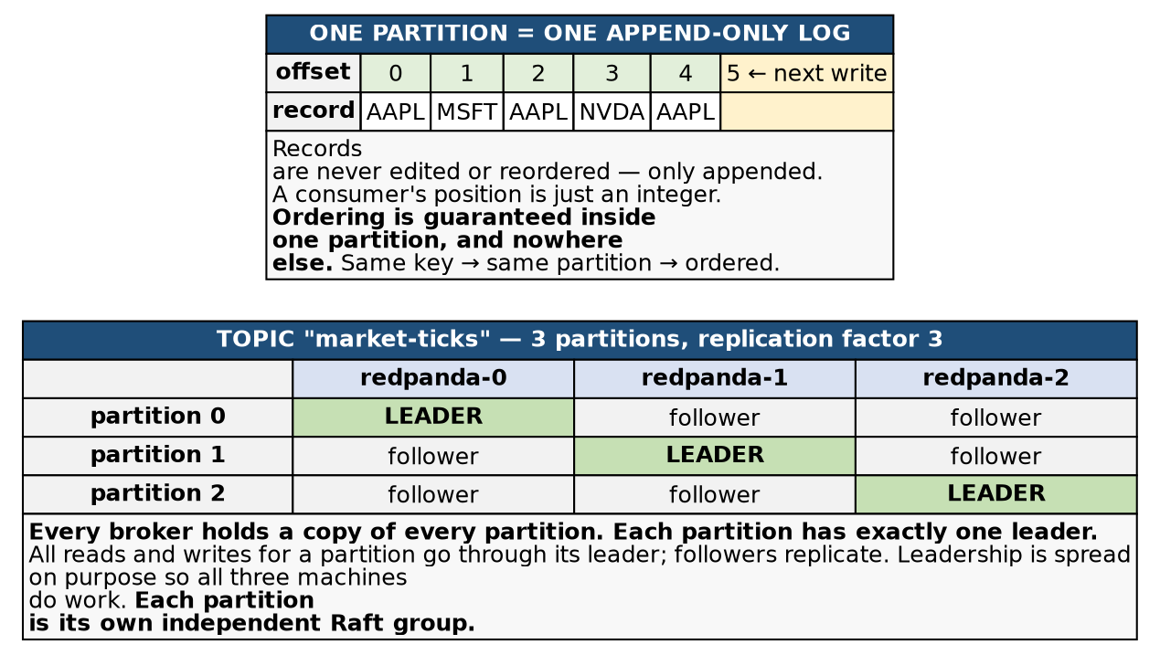
Figure 1 — a topic is partitions; a partition is a replicated log
A topic is a named stream, such as market-ticks. It is split into partitions, and each partition is an append-only log. Records are appended, never edited and never reordered, and each receives a monotonically increasing offset. A consumer’s entire position in the stream is one integer per partition.
Partitions exist to give you parallelism — six partitions allow six consumers to read at once. But they come with the single most important caveat in this chapter:
Ordering is guaranteed within a partition and nowhere else. There is no global order across a topic.
2a. How a record actually picks its partition
This is where the received wisdom is wrong, and where we measured something more interesting.
The common explanation is “with a key it hashes; without a key it round-robins across partitions.” The first half is right. The second half is not how modern clients behave, and the difference is the reason ordering bugs hide in development.
With a key, the partition is hash(key) % partitions. Deterministic and stable — the same key always lands in the same partition, forever, so all records for that key stay ordered.
Without a key, the client is merely free to put each record anywhere, and it uses a sticky partitioner: it picks one partition and keeps filling batches there, only switching when a batch closes. In practice a short-lived producer sends everything to a single partition.
We measured exactly that (§8b has the commands):
What we produced | Where it landed
6 unkeyed records, one producer | all 6 to one partition
300 unkeyed records, one producer | all 300 to one partition
Three hundred records and it never switched. So “unkeyed spreads your data evenly” is false at small scale. Each producer session effectively picks a partition. Spread emerges across many producers and long-running ones, not within a single burst.
Which partition it picks is arbitrary and differs every run — we saw partition 1 on one run and partition 5 on the next for the identical command. Contrast that with keys, which are perfectly reproducible: AAPL landed in partition 3 on every run, days apart. Keyed placement is deterministic; unkeyed placement is sticky but random.
2b. Why this matters for an OMS
Send order events for one account, or one instrument, without a key and they scatter — eventually. The failure mode is not “slightly out of order”; it is a cancel processed before the order it cancels, or a fill applied against a stale position.
Now combine that with the sticky partitioner and you get the genuinely dangerous property:
The bug is invisible in development. Your test producer sends 50 unkeyed records, the sticky partitioner puts all 50 in one partition, one consumer reads them in perfect order, and every test passes. In production, with many producers and long-lived sessions, records spread across partitions and the ordering you were accidentally relying on evaporates.
A correctness bug that only appears at volume is the worst kind there is, and “we didn’t set a key” is one of the most common root causes in real Kafka deployments.
2c. Hashing is deterministic, not fair
We produced under five keys and recorded where each landed:
Key | Partition
AAPL | 3
GOOG | 3
MSFT | 0
TSLA | 5
AMZN | 5
Five keys, six partitions, and only three partitions used. AAPL collided with GOOG, TSLA with AMZN, and partitions 1, 2 and 4 received nothing at all. Re-sending AAPL later landed in partition 3 again, confirming the mapping is stable.
Two operational consequences:
- Idle partitions are normal. A partition with zero records is not a broken partition. Do not go hunting for a fault.
- Collisions create shared fate. AAPL and GOOG now share a partition, therefore share a leader, a disk and a single-threaded write path. If AAPL goes wild during the open, GOOG queues behind it. This is the hot partition problem, and adding partitions does not necessarily fix it — it reshuffles every key and may just create a different collision.
The rule: key by whatever must stay ordered — account, instrument, order ID — and understand that this choice simultaneously decides your parallelism ceiling and your hot-spot risk.
2d. Partition count is effectively permanent
(Measured on orders, 3 Aug 2026.)
Everything above depends on hash(key) % partition_count. Change the divisor and every key is re-evaluated. This is the single most damaging thing you can do to a keyed topic, and it takes one command.
We keyed four orders into a 6-partition topic, three events each, and recorded where they landed:
Key | Partition
ORD-1001 | 1
ORD-1002 | 0
ORD-1003 | 2
ORD-1004 | 3
Then grew the topic and produced one more event per order — same keys, same code, no deploy:
rpk topic add-partitions orders -n 6 # 6 -> 12
ORD-1001 -> p1 unchanged
ORD-1002 -> p6 moved
ORD-1003 -> p8 moved
ORD-1004 -> p9 moved
Three of four keys relocated. The arithmetic is worth internalising: going from 6 to 12, hash % 12 can only be hash % 6 or hash % 6 + 6. Every key either stays put or shifts by exactly the old partition count, and on a doubling roughly half of all keys move.
What that does to an order’s history
ORD-1001, which didn’t move, is intact:
p1 off=0 NEW
p1 off=1 PARTIAL_FILL
p1 off=2 CANCEL
p1 off=3 AMEND
p1 off=4 FILL_AFTER_REPART
ORD-1002, which moved, is now split across two partitions:
p0 off=0 NEW
p0 off=1 PARTIAL_FILL
p0 off=2 CANCEL
-----------------------------
p6 off=0 FILL_AFTER_REPART
Read that carefully. The fill sits at offset 0 of partition 6 — a consumer assigned to that partition sees a fill as the first thing it has ever heard about the order, with no NEW preceding it. A fill for an order that was never placed. Downstream that is a reconciliation break, or a message your consumer rejects as referencing an unknown order.
The offsets actively mislead too: the CANCEL is at offset 2 and the later FILL is at offset 0, because offsets only mean anything within a partition.
Why this is so dangerous
- It is silent. No error, no failed write, no warning. rpk cluster health still reports Healthy: true. Producers notice nothing. No metric moves.
- Partial breakage is worse than total breakage. If every key moved you would know every order was affected. Instead most orders are fine and some are corrupted, and separating them means re-computing the hash for every key ever written.
- It is irreversible. You can add partitions; you can never remove them.
What to do instead
- Treat partition count as immutable after creation. Size it once, with headroom.
- Size for consumer parallelism, not throughput. Partition count is the ceiling on active consumers in a group — you can never have more consumers than partitions. Plan for the peak parallelism you will ever want.
- To genuinely grow a keyed topic, migrate rather than repartition: create orders.v2 at the new count, replay or dual-write, cut consumers over, retire the old topic.
- Guard the operation with ACLs, and alert on partition-count changes — nothing else will tell you.
The interview trap: “Consumers are lagging and the topic is at capacity — do you add partitions?” On an unkeyed topic, fine. On a keyed topic carrying order state, no, not without a migration plan, because you would break per-key ordering for about half your keys. This is also the sharpest argument for keeping topic definitions in version control: not bureaucracy, but because one of the fields is irreversible and silently corrupts ordering when changed.
2e. Debugging an ordering complaint
A trap we walked straight into while producing the data above. This listing appears to show a cancel arriving before the order it cancels:
1 ORD-1001 {"event":"CANCEL"}
1 ORD-1001 {"event":"NEW"}
1 ORD-1001 {"event":"PARTIAL_FILL"}
It is not real. The command ended in | sort, and CANCEL precedes NEW alphabetically. The log itself was always correct — offsets 0, 1, 2 in the right order. The display lied, not the data.
When someone reports “events arrived out of order,” the first question is how are you looking at them? Read one partition at a time, with offsets (-p N -f '%o %k %v\n') before believing any ordering complaint. A view merged across partitions has no meaningful order at all, and neither does anything you have piped through sort.
The three real causes, in the order worth checking: the producer wasn’t keyed (§2a), someone changed the partition count (§2d), or a consumer group rebalanced mid-stream.

3. Replication and partition leadership
Look at the lower half of Figure 1. With replication factor 3, every broker holds a copy of every partition, but each partition has exactly one leader. All reads and writes for a partition go through its leader; the other two replicate from it.
Leadership is spread deliberately so all three machines share the work instead of one becoming a bottleneck. “Is leadership balanced?” is a real operational health question, not a cosmetic one — and §9 shows a case where the cluster reports itself perfectly healthy while one broker does nothing at all.
The structural fact that makes the failure drills make sense:
Each partition is its own independent Raft group.
A topic with 6 partitions at RF 3 has 18 replicas and 6 independent Raft groups, with each broker holding 6 replicas and leading 2 on average. So when a broker dies you do not see “the cluster” fail over — you see the specific partitions it led elect new leaders, while every other partition carries on completely untouched.

4. Quorum: why three
Quorum = majority = floor(3/2) + 1 = 2 of 3
State | Brokers up | Majority? | Result
Healthy | 3 of 3 | yes — 3 ≥ 2 | Writes accepted. Leader + 1 follower must ack.
Lose one | 2 of 3 | yes — 2 ≥ 2 | Writes still accepted. If the dead one led a partition, a new leader is elected in ~1 second. No data loss.
Lose two | 1 of 3 | NO — 1 < 2 | Writes REFUSED. The survivor steps down rather than accept writes it cannot prove are safe.
The point of the third broker
With 2 brokers, a majority is still 2 — so losing either one halts writes. Two brokers buy you a second copy of the data and zero fault tolerance.
Odd numbers are what buy availability. 3 survives 1 failure, 5 survives 2. Going 3 → 4 costs a machine and improves nothing: a majority of 4 is 3.
Refusing writes is the correct behaviour, not a bug. A minority that kept accepting trades could not guarantee they survive — that is how you lose money.
Raft requires a majority to agree. For a group of three, that is two.
Brokers up | Majority reachable? | Result
3 of 3 | yes | Writes accepted — leader + 1 follower must ack
2 of 3 | yes | Writes still accepted; new leaders elected in ~1s; no data loss
1 of 3 | no | Writes refused
Refusing writes is correct behaviour, not a bug. A lone survivor cannot prove that a write it accepts would survive, so accepting one risks silently losing an acknowledged order. Halting is the safe choice. Be ready to defend this — it is a favourite interview probe, and the wrong answer (“it should stay up”) reveals that you would happily trade correctness for uptime.
Two brokers is a trap. A majority of two is still two, so a two-broker cluster gives you a second copy of the data and zero fault tolerance. Odd numbers buy availability: 3 survives one failure, 5 survives two. Going 3 → 4 costs a machine and improves nothing, because a majority of four is three.
The degraded-cluster trap (an SRE question, not a developer one)
A broker dies. You are at 2 of 3 and writes are flowing. A colleague says “we’re fine, we still have redundancy.”
He is conflating two different things:
- Copies of the data: still 2. Nothing is lost or at risk of being lost.
- Fault tolerance: now zero. One more failure halts all writes.
So the cluster is not “degraded but fine” — it is one failure away from a write outage.
The operational consequence matters more than the semantics: while degraded, do not perform any maintenance that takes another broker down. No rolling restart, no node drain, no kernel patch, no “let me just bounce it and see.” The reflex to start restarting things when a cluster looks unhealthy is exactly what converts a degraded cluster into an outage.

5. Why a StatefulSet, and why a headless Service
A Deployment replaces a dead pod with a completely new object — new name, new IP, no memory of its predecessor, and with node-local storage no way to reattach the old volume.
Apply that to a Raft group and it collapses: the surviving members see a voter vanish and an unrelated stranger appear, with no way to know they are the same logical broker or to trust its data.
A StatefulSet provides the three things a broker needs:
- Stable ordinal identity — redpanda-0, redpanda-1, redpanda-2. A replacement pod reclaims the same name.
- Its own PersistentVolumeClaim, created from volumeClaimTemplates and bound to the identity, so redpanda-1 always remounts redpanda-1’s data.
- Ordered operations — brokers start, stop and upgrade one at a time rather than all at once.
5a. Headless does not mean “no Service”
The most common misconception, and worth correcting precisely: a headless Service is a normal Service that has no IP address of its own. The object exists, it has a name, a DNS entry, a label selector and EndpointSlices. Only the virtual IP is missing.
Your cluster runs one of each, in the same namespace, from the same Helm release:
$ kubectl -n redpanda get svc \
-o custom-columns='NAME:.metadata.name,TYPE:.spec.type,CLUSTER-IP:.spec.clusterIP,SELECTOR:.spec.selector'
NAME TYPE CLUSTER-IP SELECTOR
redpanda ClusterIP None map[app.kubernetes.io/instance:redpanda app.kubernetes.io/name:redpanda]
redpanda-console ClusterIP 10.43.128.189 map[app.kubernetes.io/instance:redpanda app.kubernetes.io/name:console]
redpanda-external NodePort 10.43.3.201 map[app.kubernetes.io/instance:redpanda app.kubernetes.io/name:redpanda]
The first two are type: ClusterIP. Both have selectors. The difference is the third column, and what it changes is who picks the pod.
Note the selectors are real chart labels, not the tidy name=redpanda you might expect — Helm charts label on app.kubernetes.io/{name,instance} so that two releases of the same chart in one namespace do not select each other’s pods. It matters here because if you write a NetworkPolicy or a second Service by hand and guess the label, it will select nothing, and a Service that selects nothing looks identical to a Service whose pods are all unhealthy. Read the selector, don’t assume it.
redpanda-external is the third one, and it is the closest thing this cluster has to an external boundary: a NodePort onto the same broker pods, with no TLS and no authentication in front of it. §11 comes back to what that would need before anyone outside the cluster could be allowed near it.
Normal ClusterIP — Kubernetes picks, and hides the pods:
redpanda-console.redpanda.svc.cluster.local -> 10.43.128.189
actual console pod = 10.42.0.63
The name resolves to a virtual IP that belongs to no pod at all. Nothing listens on it; kube-proxy DNATs you to a real pod. The client never learns pod addresses and has no say in which it gets. That is the Chapter 1 §5 machinery, including per-connection rather than per-request balancing.
Headless — Kubernetes steps aside and shows you the pods:
redpanda.redpanda.svc.cluster.local -> 10.42.0.69
10.42.0.73
10.42.0.75
No virtual IP, no kube-proxy, no DNAT. DNS returns all three real pod IPs and the client chooses. So the collective name is still something you can “call” — it is a list, not a load balancer.
And because a headless Service exists, each pod additionally gets its own DNS name:
redpanda-0.redpanda.redpanda.svc.cluster.local -> 10.42.0.69
redpanda-1.redpanda.redpanda.svc.cluster.local -> 10.42.0.75
redpanda-2.redpanda.redpanda.svc.cluster.local -> 10.42.0.73
One name, one broker, every time. These per-pod records are the “stable network identity” StatefulSets are known for, and a normal ClusterIP Service does not create them.
5b. How a client actually connects
The collective name is used only for the first handshake:
1. BOOTSTRAP client -> redpanda.redpanda.svc.cluster.local:9093
DNS returns 3 IPs; client connects to any one
2. METADATA that broker replies with the real roster:
ID HOST PORT
0 redpanda-0.redpanda.redpanda.svc.cluster.local 9093
1 redpanda-1.redpanda.redpanda.svc.cluster.local 9093
2 redpanda-2.redpanda.redpanda.svc.cluster.local 9093
...plus the leader of every partition
3. STEADY STATE client opens direct connections to specific brokers by those
per-pod names and stops using the Service name entirely
Reaching any one broker is sufficient to discover them all — that is what “bootstrap server list” means, and why the list is not a connection list.
Why load balancing would be actively wrong. Writes must go to the leader of the target partition. With leadership spread as p0→b0, p1→b1, p2→b2, p3→b1 …, a produce for partition 3 has to reach broker 1; broker 0 cannot accept it. Behind a load-balancing virtual IP, writes would land on an arbitrary broker and be rejected as NOT_LEADER_FOR_PARTITION roughly two thirds of the time. The client’s whole job is to route deliberately, based on leadership it learned in step 2 — so it needs individually addressable brokers.
The Console next door is a plain Deployment behind a plain ClusterIP precisely because any Console pod can serve any request. Same namespace, same release, two Services, two routing models — chosen by whether the backends are interchangeable.
One caveat worth knowing. The chart sets publishNotReadyAddresses: true on the headless Service, which StatefulSets generally need so members can discover each other during initial bootstrap, before any of them are ready. The side effect: DNS will hand you a broker that is not ready yet. The headless name protects you from a dead broker, not an unready one — which is exactly the race a seeding Job hits at deploy time (Chapter 4).

6. The install — step by step
A re-usable runbook. Values chosen for a single-node learning cluster are flagged as such, with the production equivalent noted.
6a. Prerequisites
# Helm
curl -fsSL https://raw.githubusercontent.com/helm/helm/main/scripts/get-helm-3 | bash
helm version --short # v3.21.3 at time of writing
# The Redpanda chart repository
helm repo add redpanda https://charts.redpanda.com
helm repo update
helm search repo redpanda/redpanda # chart 26.1.9 / app v26.1.12
6b. Read the defaults before installing anything
The habit worth forming — never install a chart blind:
helm show values redpanda/redpanda | less
What matters on a single-node cluster:
Setting | Chart default | Decision here | Why
statefulset.replicas | 3 | keep | a real quorum
resources.cpu.cores | 1 | keep | 3 of the node’s 8 vCPU; Redpanda wants whole cores (thread-per-core)
resources.memory.container.max | 2.5Gi | keep | 7.5 GB reserved of the node’s 16 GB
storage.persistentVolume.size | 20Gi | keep, pin class | resolves to local-path
tls.enabled | true | false | sandbox shortcut — production keeps TLS on
pod anti-affinity | hard | soft | see 6c — this one bit us
Those first two rows are not just Kubernetes bookkeeping — the chart turns them into Seastar’s startup flags, which you can read off the running broker:
kubectl exec -n redpanda redpanda-0 -c redpanda -- cat /proc/1/cmdline | tr '\0' ' '
# /opt/redpanda/bin/redpanda --redpanda-cfg /etc/redpanda/redpanda.yaml \
# --default-log-level=info --memory=2048M --reserve-memory=205M --smp=1 --lock-memory=false
--smp=1 is resources.cpu.cores: 1 — one shard, one core, because of thread-per-core. --memory=2048M plus --reserve-memory=205M is roughly 88% of the 2,560 MiB container limit, the rest left to the OS and non-Seastar allocations. Redpanda claims that memory up front and manages it itself; this is why the broker’s real usage sits far below its limit and never drifts toward it the way a JVM heap does.
Worth noticing: these flags are derived from the container’s limits, not from how much RAM the machine has. When this VM was later cut from 32 GB to 16 GB, the brokers started with byte-for-byte identical flags and did not care. A process that sizes itself from the host instead would have silently changed behaviour — which is exactly the class of surprise that makes “it works on my node” bugs.
6c. The anti-affinity problem, and a chart trap
The chart ships hard anti-affinity on kubernetes.io/hostname. That is the correct production default: it forbids two brokers from sharing a node, so losing one machine cannot cost you two replicas of the same partition. On a single-node cluster it means only one broker can ever schedule and the other two sit Pending forever.
The documented override is:
statefulset:
podAntiAffinity:
type: soft
In chart 26.1.9 this key is vestigial. Setting it changes nothing. We set it, reinstalled, and the pods stayed Pending with the identical event. The live path is statefulset.podTemplate.spec.affinity, and the working override nulls the hard rule and substitutes a preference — see manifests/redpanda-values.yaml.
The habit this should install in you: render before you install.
helm template redpanda redpanda/redpanda -n redpanda -f redpanda-values.yaml \
| grep -A14 podAntiAffinity
You want to see preferredDuringScheduling... and not requiredDuringScheduling.... This takes five seconds and would have saved twenty minutes. Do it every time you override a chart value you have not overridden before — documentation drifts from templates, and the template is the thing that is actually true.
Verify the saved values file still does what it claims:
helm template redpanda redpanda/redpanda -n redpanda -f redpanda-values.yaml \
| grep -c requiredDuringSchedulingIgnoredDuringExecution # must be 0
6d. Install
kubectl create namespace redpanda # if it does not exist
helm install redpanda redpanda/redpanda \
--namespace redpanda \
-f redpanda-values.yaml \
--wait --timeout 10m
--wait blocks until the StatefulSet is Ready and the post-install hooks finish. Without it Helm returns immediately and reports success on a cluster that has not started.
6e. What success looks like
kubectl -n redpanda get pods
kubectl -n redpanda get sts,pvc
kubectl -n redpanda get svc
NAME READY STATUS RESTARTS AGE
redpanda-0 2/2 Running 0 43m
redpanda-1 2/2 Running 0 43m
redpanda-2 2/2 Running 0 43m
redpanda-configuration-hmmxw 0/1 Completed 0 43m
redpanda-configuration-x5gsc 0/1 Error 0 43m
redpanda-console-59d88b855c-c4rl6 1/1 Running 0 43m
Three services are created, and the difference between them is the whole of §5 and §7:
Service | Type | Purpose
redpanda | headless (CLUSTER-IP None) | per-broker DNS; how brokers find each other
redpanda-console | ClusterIP :8080 | the web UI (not exposed outside the cluster)
redpanda-external | NodePort 9094:31092, 9645:31644 | intended path for outside clients
Note the Error pod, because it is not a failure. The post-install configuration Job ran before the brokers’ admin API was listening:
Error: Get "http://redpanda-0...:9644/v1/cluster_config/schema":
dial tcp 10.42.0.69:9644: connect: connection refused
The Job retried and the second pod completed. kubectl -n redpanda get jobs shows redpanda-configuration Complete 1/1 in 37s. A failed pod belonging to a Complete Job is normal Kubernetes backoff, and the Job — not the pod — is the thing to judge. Leaving the corpse around is deliberate: it is where the logs live.
6f. What failure looks like (our first attempt)
Worth reading because the symptom you see is four layers away from the cause:
helm install ... --wait --timeout 10m # hangs, then times out
The cascade, top to bottom:
- Helm hangs waiting on a StatefulSet that will never be Ready.
- redpanda-1 and redpanda-2 are Pending.
- Their PVCs are Pending too — local-path uses WaitForFirstConsumer, so the volume is not created until the pod is scheduled. Pending PVCs here are a symptom, not the cause.
- redpanda-0 is Running but never Ready, because it cannot form a quorum alone.
- The configuration Job fails permanently and Console crash-loops.
The one command that gives you the answer:
kubectl -n redpanda describe pod redpanda-1 | tail -20
0/1 nodes are available: 1 node(s) didn't match pod anti-affinity rules.
The lesson: read the Events on the earliest thing that is stuck, not the loudest thing that is broken. Console crash-looping was the noisiest symptom and the least informative. Scheduling failures always surface in pod events, and the scheduler tells you exactly which predicate it failed.
6g. Uninstalling — the part people get wrong
helm uninstall redpanda -n redpanda
kubectl -n redpanda get pvc # ← they are STILL THERE
helm uninstall does not delete PersistentVolumeClaims created from a StatefulSet’s volumeClaimTemplates. Kubernetes leaves them deliberately — deleting a StatefulSet is not assumed to mean “destroy the data.”
For a genuinely clean reinstall you must remove them yourself:
kubectl -n redpanda delete pvc --all
Skipping this is how you get a “fresh” cluster that comes up carrying a previous cluster’s identity and refuses to form a quorum. In production this default is a feature that saves you; in a sandbox loop it is a trap that confuses you. Know which situation you are in.

7. Wiring up rpk
rpk is Redpanda’s CLI — the equivalent of kubectl for the data plane.
7a. Install the binary
It is not an alias and not a wrapper script — it is a single static binary on the host:
curl -LO https://github.com/redpanda-data/redpanda/releases/latest/download/rpk-linux-amd64.zip
sudo unzip -o rpk-linux-amd64.zip -d /usr/local/bin/
rm rpk-linux-amd64.zip
rpk version
rpk version: v26.1.14
Redpanda Cluster
node-0 v26.1.12
node-1 v26.1.12
node-2 v26.1.12
You can also run it inside a broker with kubectl -n redpanda exec -it redpanda-0 -c redpanda -- rpk ..., which sidesteps every networking problem in §7c. Having it on the host is nicer, and the reason it took work is itself the lesson.
7b. Two APIs, two ports — do not confuse them
API | Port | What it does
Kafka API | 9093 | data plane — produce, consume, topics
Admin API | 9644 | control plane — cluster health, config, broker state
rpk cluster health uses the Admin API; rpk topic produce uses the Kafka API. When one works and the other does not, that is your first clue about which port is misconfigured.
7c. The advertised-listener problem
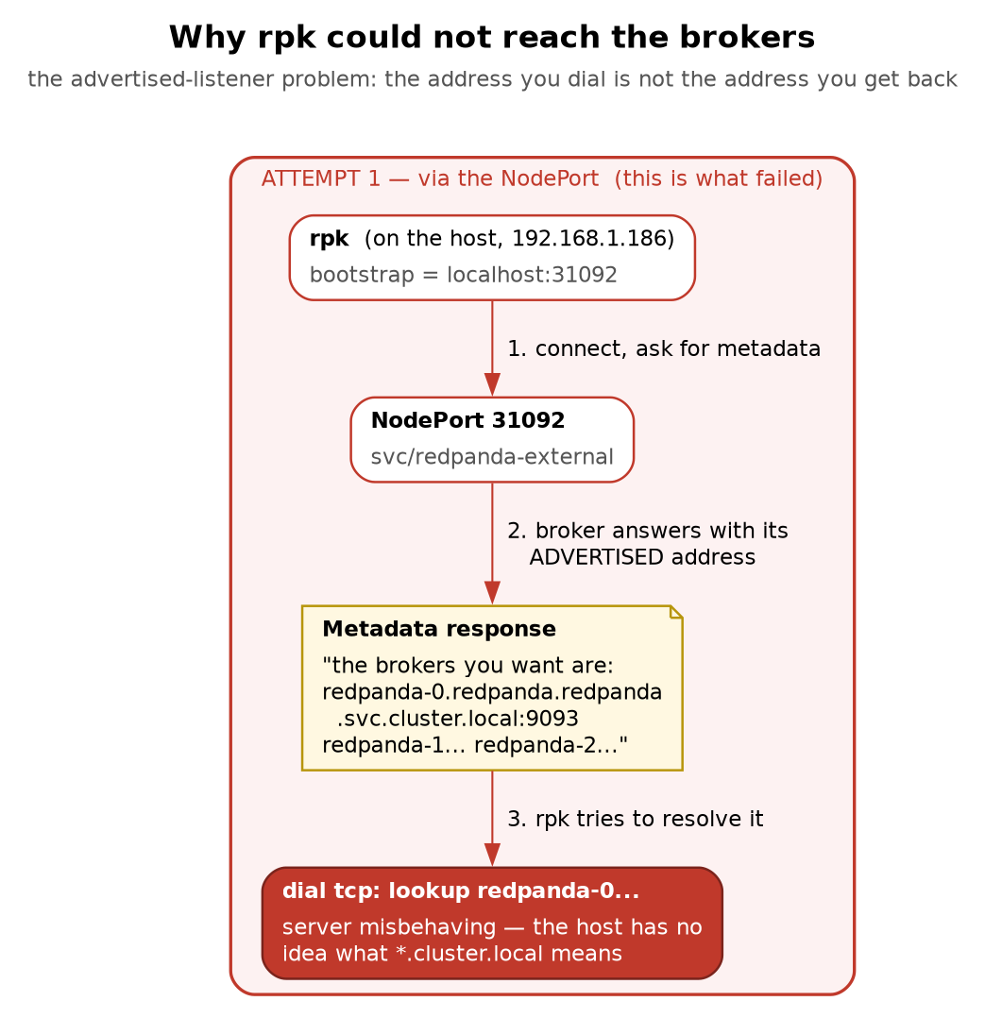
Figure 2 — why rpk could not reach the brokers
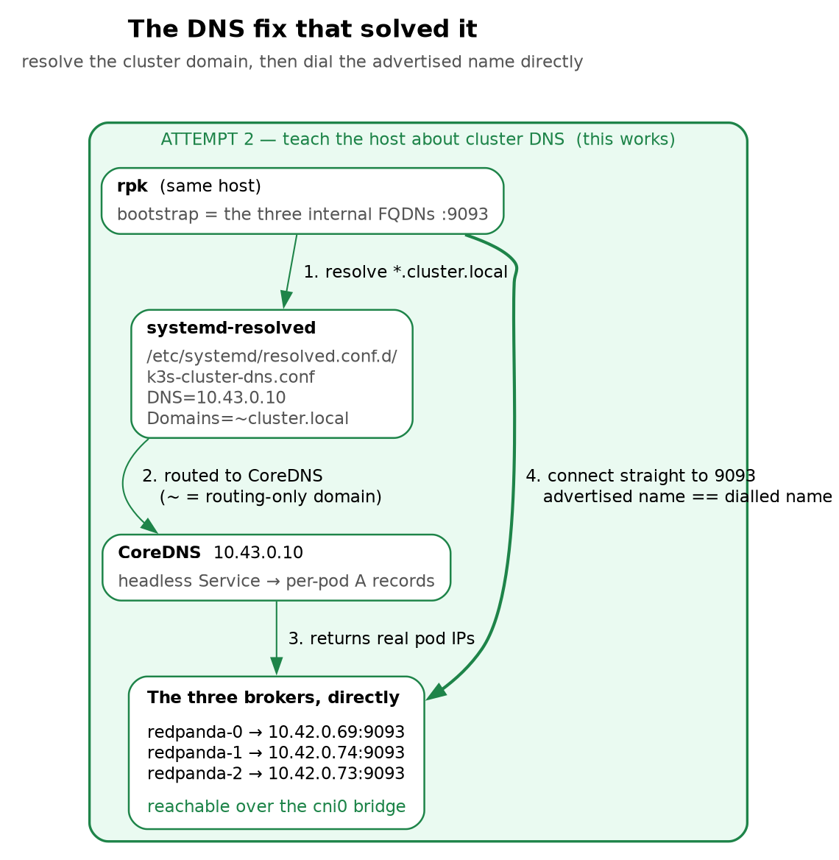
Figure 3 — the DNS fix that solved it
Why this shortcut is legitimate here — and why it would not be in production
The host IS the Kubernetes node, so the pod network (10.42.0.0/24) sits on a local bridge and is directly routable. From any OTHER machine on the LAN those pod IPs are unreachable and this fails.
The real fix is to configure external.advertisedPorts / external.domain so brokers advertise an address clients can actually reach. The general rule, and the interview answer:
a broker must advertise an address its clients can resolve AND route to — from where the client is.
Pointing rpk at the NodePort looked obviously right and failed:
rpk profile create local \
--set kafka_api.brokers=localhost:31092 \
--set admin_api.addresses=localhost:31644
rpk topic create market-ticks -p 6 -r 3
unable to dial: dial tcp: lookup redpanda-0.redpanda.redpanda.svc.cluster.local.:
server misbehaving
Read that error carefully: we dialled localhost and it failed on redpanda-0.... That mismatch is the diagnosis.
Every Kafka client connects to a bootstrap address only to ask “who are the brokers?” The cluster replies with its advertised listeners, and the client then opens a new connection to each broker directly — because it must reach the specific leader of each partition. Our brokers advertised their internal cluster DNS names, which the host could not resolve.
The general rule, and the interview answer: a broker must advertise an address that its clients can both resolve and route to, from where the client actually is. Bootstrap connectivity proves nothing about whether the rest will work.
This is the single most common Kafka networking problem in the wild. It bites people behind NAT, in Docker, across VPCs, and through load balancers — always the same shape.
The fix we chose: teach the host to resolve cluster DNS, then talk to brokers directly.
# The drop-in directory does not exist on a stock Ubuntu install -- systemd
# reads it if present but does not ship it. Without this line `tee` fails with
# "No such file or directory", and because the redirect swallows stdout the
# error is easy to skim past and conclude that DNS simply did not take effect.
sudo mkdir -p /etc/systemd/resolved.conf.d
sudo tee /etc/systemd/resolved.conf.d/k3s-cluster-dns.conf >/dev/null <<'EOF'
# Route *.cluster.local queries to k3s CoreDNS so host tools (rpk) can resolve
# the internal, headless-Service broker names. "~" = routing-only domain.
[Resolve]
DNS=10.43.0.10
Domains=~cluster.local
EOF
sudo systemctl restart systemd-resolved
resolvectl query redpanda-0.redpanda.redpanda.svc.cluster.local
redpanda-0.redpanda.redpanda.svc.cluster.local: 10.42.0.69 -- link: cni0
10.43.0.10 is CoreDNS’s ClusterIP (kubectl -n kube-system get svc kube-dns). The ~ prefix makes cluster.local a routing-only domain: send queries for it to this server, but do not append it as a search suffix to unrelated lookups.
Then point the profile at all three brokers by their internal names:
rpk profile set kafka_api.brokers=\
redpanda-0.redpanda.redpanda.svc.cluster.local:9093,\
redpanda-1.redpanda.redpanda.svc.cluster.local:9093,\
redpanda-2.redpanda.redpanda.svc.cluster.local:9093
rpk profile set admin_api.addresses=\
redpanda-0.redpanda.redpanda.svc.cluster.local:9644,\
redpanda-1.redpanda.redpanda.svc.cluster.local:9644,\
redpanda-2.redpanda.redpanda.svc.cluster.local:9644
rpk profile print # config lives in ~/.config/rpk/rpk.yaml
List all three. The bootstrap list only needs one broker to answer, so listing all three means rpk still works when the first one is down — which matters enormously in §9, where you are deliberately killing brokers and do not want your diagnostic tool to be a casualty of the incident.
Does this survive pods being replaced? Yes. Nothing here references a pod IP. The StatefulSet guarantees stable names, the headless Service publishes whatever IP the pod currently has, and CoreDNS is looked up fresh. Delete every broker and this keeps working — that is precisely what stable identity buys.
Why this shortcut is legitimate here and nowhere else: the host is the Kubernetes node, so pod IPs sit on a local cni0 bridge and are directly routable. From any other machine on the LAN they are unreachable. The production answer is to configure external.domain / external.advertisedPorts so brokers advertise addresses real clients can reach.
7d. Profiles are contexts
rpk profile list # local*
rpk profile use <name>
The direct analogue of kubectl config use-context. When you have a staging and a production Redpanda, this is how you move between them — and being slightly paranoid about which profile is active before running a destructive command is a good habit to build now, cheaply, on a sandbox.
7e. Reaching the Console UI
Console is a ClusterIP service, so it is not exposed to the LAN:
kubectl -n redpanda port-forward svc/redpanda-console 8080:8080
# then browse http://localhost:8080 (or http://192.168.1.186:8080 with --address 0.0.0.0)

8. Verified demos
Every command below was run and produced the output shown.
These run on a throwaway topic, demo-ticks, so the offsets you see match the offsets printed here. market-ticks accumulates records through the failure drills in §9, so re-running these against it gives correct behaviour but different numbers. Clean up at the end with rpk topic delete demo-ticks.
8a. Create a topic and look at it
rpk topic create demo-ticks -p 6 -r 3
rpk topic describe demo-ticks -p
PARTITION LEADER EPOCH REPLICAS LOG-START-OFFSET HIGH-WATERMARK
0 0 1 [0 1 2] 0 0
1 0 1 [0 1 2] 0 0
2 1 1 [0 1 2] 0 0
3 2 1 [0 1 2] 0 0
4 1 1 [0 1 2] 0 0
5 0 1 [0 1 2] 0 0
Read this table fluently, because it is the single most useful diagnostic in Redpanda:
- REPLICAS [0 1 2] — all three brokers hold a copy. This column contains spaces, which will wreck naive awk parsing; the high-watermark is field 8, not 6.
- LEADER — who serves this partition. It is not evenly spread on creation — here broker 0 took three and broker 2 only one — and the leader balancer evens it out shortly after. The initial assignment varies between runs, so expect different numbers when you repeat this.
- HIGH-WATERMARK — the next offset to be written. It equals the number of committed records only while LOG-START-OFFSET is 0, which is true for every topic in this chapter because none of them has yet had a segment expired by retention. Once retention deletes the head of the log, the high-watermark keeps counting from the beginning of time while those records are gone, and the count you want is HIGH-WATERMARK - LOG-START-OFFSET. Get into the habit now:
# records actually present, correct even after retention has expired segments
rpk topic describe demo-ticks -p | awk 'NR>1 && NF {s += $8 - $7} END {print s}'
This is the difference between “how many records has this partition ever held” and “how many can I still read”, and on a topic with a seven-day retention those two numbers diverge on day eight. The NF guard skips the trailing blank line that would otherwise contribute an empty field.
# total committed records — note field 8
rpk topic describe market-ticks -p | awk 'NR>1 && NF {s+=$8} END {print s}'
# who leads what
rpk topic describe market-ticks -p | awk 'NR>1&&NF{print $2}' | sort -n | uniq -c
8b. Keys, and the sticky partitioner
One producer, six keyed records:
printf 'k1\nk2\nk3\nk4\nk5\nk6\n' | rpk topic produce demo-ticks -k AAPL
Produced to partition 3 at offset 0 with timestamp 1785177684983.
Produced to partition 3 at offset 1 with timestamp 1785177684983.
...all six to partition 3, offsets 0-5
One producer, six unkeyed records:
printf 'u1\nu2\nu3\nu4\nu5\nu6\n' | rpk topic produce demo-ticks
Produced to partition 5 at offset 0 with timestamp 1785178172751.
...all six to partition 5, offsets 0-5
Not round-robin — all six to one partition. Which partition is arbitrary and changes every run; on an earlier run this same command sent all six to partition 1. Only the stickiness is guaranteed, not the choice.
Push it harder and it still does not switch:
seq 1 300 | sed 's/^/big-/' | rpk topic produce demo-ticks >/dev/null
# unkeyed records print as "<partition> " with an empty key, so NF==1 selects them
rpk topic consume demo-ticks -o :end -f '%p %k\n' | awk 'NF==1' | sort -n | uniq -c
300 3
6 5
Three hundred records, one partition — and a different partition from the six-record run, because each producer session makes its own independent choice. This is §2a made concrete, and it is the mechanism by which an ordering bug passes every test you write.
Now five different keys:
for k in AAPL MSFT TSLA GOOG AMZN; do
printf "$k-1\n$k-2\n$k-3\n" | rpk topic produce demo-ticks -k $k
done
rpk topic consume demo-ticks -o :end -f '%k %p\n' | grep -v '^ ' | sort -u
AAPL→3, GOOG→3, MSFT→0, TSLA→5, AMZN→5 — two collisions, three partitions unused (§2c).
Note the two rpk topic produce forms and why the difference matters:
printf 'a\nb\nc\n' | rpk topic produce t -k K # ONE producer, 3 records — realistic
for i in a b c; do echo $i | rpk topic produce t -k K; done # THREE producers
The loop spawns a fresh producer per record, and each makes an independent sticky choice. If you demo unkeyed partitioning with a loop you will see records scattered and conclude “unkeyed round-robins” — the wrong lesson, from an artefact of your test harness.
8c. Reading a log without hanging your terminal
The trap that caught us twice:
rpk topic consume market-ticks -o start -n 100 # HANGS if there are < 100 records
-n means “give me exactly this many”, so it waits — correctly — for records that do not exist yet. Piping into wc -l makes it worse: you see no output at all, because wc prints nothing until EOF.
Form | Behaviour
rpk topic consume t | stream forever — the tail -f form
rpk topic consume t -o :end | read everything committed, then exit — the cat form
rpk topic consume t -o start -n N | exactly N records, blocking until they exist
rpk topic consume t -o start:end | ⚠️ silently returns 0 records — looks like data loss
rpk topic consume market-ticks -o :end -f '%p %o %k %v\n' # the one to memorise
rpk topic consume market-ticks -o :end -f 'x\n' | wc -l # count everything
When a consume command “produces no output”, ask whether it exited. A hung command and an empty topic look identical through wc -l, and confusing the two during an incident will send you chasing phantom data loss.

9. Failure drills
9a. Kill one broker
# 1. baseline
rpk topic describe market-ticks -p | awk 'NR>1&&NF{print $2}' | sort -n | uniq -c
# broker 0 leads 2 / broker 1 leads 2 / broker 2 leads 2
# 2. kill it
kubectl -n redpanda delete pod redpanda-1 --wait=false
# 3. WAIT until it is actually gone ← do not skip this
kubectl -n redpanda wait --for=delete pod/redpanda-1 --timeout=120s
# 4. observe
rpk cluster health
rpk topic describe market-ticks -p | awk 'NR>1&&NF{print $2}' | sort -n | uniq -c
echo "during-drill" | timeout 20 rpk topic produce market-ticks -k AAPL
Step 3 is the one that makes the drill trustworthy. Running the checks immediately catches an intermediate state — a pod still Terminating is still serving — and you will draw a confident conclusion from a cluster that was never in the state you thought. This bit us during the two-broker drill in §9b, where a write succeeded that “should” have failed, purely because the second broker had not finished dying.
Observed:
Healthy: false
Nodes down: [1]
Leaderless partitions (0): []
Under-replicated partitions (0): []
broker 0 leads 2 partitions
broker 2 leads 4 partitions
Produced to partition 3 at offset 14 with timestamp ... ← the write SUCCEEDED
Three things to take away:
- Failover is surgical. Only the two partitions redpanda-1 led changed hands. The other four never noticed.
- Failover is not load-balanced. Broker 2 took both orphaned partitions (leading 4, not 3). The new leader is whichever eligible replica wins the election first; nothing is trying to be fair in the moment.
- Writes never stopped. 2 of 3 is a quorum.
9b. Kill two brokers — lose quorum
kubectl -n redpanda scale statefulset redpanda --replicas=1
kubectl -n redpanda wait --for=delete pod/redpanda-1 --timeout=180s
kubectl -n redpanda wait --for=delete pod/redpanda-2 --timeout=180s
rpk cluster health
echo "quorum-test" | timeout 20 rpk topic produce market-ticks -k AAPL
Observed:
redpanda-0 1/2 Running ← the survivor is NOT Ready
Nodes down: [1 2]
Leaderless partitions (8): [kafka/market-ticks/0 ... kafka_internal/id_allocator/0
redpanda/controller/0]
Under-replicated partitions (0): []
The produce command hung until the timeout and wrote nothing.
Four observations that are each worth an interview answer:
- The survivor steps down. A leader that cannot reach a majority does not keep serving — it demotes itself. That is Raft refusing to risk a split brain.
- redpanda/controller/0 is leaderless too. The cluster’s own metadata Raft group is subject to the same arithmetic, so you lose administration as well as data: you cannot create a topic or change config to dig yourself out.
- Under-replicated partitions reads 0 during a total outage. This is the counter-intuitive one. Under-replication is measured by a leader comparing itself to followers, and with no leaders there is nobody to measure. A metric that reads zero because the thing computing it is dead looks exactly like healthy. Alert on Leaderless partitions and Nodes down — never rely on Under-replicated alone.
- Producers hang; they do not error. From the application’s point of view this is a latency event, not a failure, until its own timeout fires. Client-side timeouts are therefore a correctness control, not a tuning knob: with no timeout, an OMS queues orders in memory indefinitely and loses them on restart.
9c. Recover, and prove nothing was lost
kubectl -n redpanda scale statefulset redpanda --replicas=3
kubectl -n redpanda rollout status statefulset redpanda --timeout=5m
rpk cluster health
rpk topic describe market-ticks -p
rpk topic consume market-ticks -o :end -f 'x\n' | wc -l
The reconciliation that matters — every record we had produced up to this point, accounted for:
Partition | HWM | Contents
p3 | 14 | 12 keyed AAPL + during-outage + should-fail
p4 | 12 | 12 unkeyed
p2 / p0 / p5 | 3 / 1 / 2 | the 6 batch-N records
p1 | 0 | never received anything
total | 32 | and -o :end read back exactly 32
Chronology and naming note, because the payloads above do not match the commands earlier in this chapter. The table is the state at the end of the original two-broker drill, in which the two test writes were called during-outage and should-fail. The commands printed in §9a and §9c were re-run afterwards to verify them exactly as written, and that pass used the clearer names during-drill and quorum-test — the re-run added during-drill at p3 offset 14, so the topic now holds 33. Same drill, same result, different payload strings; during-outage corresponds to §9a’s during-drill, and should-fail to a second successful write during the outage. Your own numbers will differ. What must hold is that the -o :end count equals the sum of the high-watermarks, and that no acknowledged write is missing.
Every write that was acknowledged survived. The write that could not be safely acknowledged never appeared.
during-outage and should-fail were both written while a broker was down, and both are present. quorum-test, the one that hung, is absent — not silently dropped after being accepted, and not silently accepted after appearing to fail. It simply never happened.
That is the property an order management system actually requires. Not “never goes down” — that is unachievable — but never lies about whether an order was accepted. A system that hangs is recoverable, because the client still holds the order and can retry. A system that acknowledges a write it then loses is not, because nobody knows the order is missing.
9d. Healthy is not the same as balanced
Immediately after recovery:
Healthy: true
Nodes down: []
Leaderless partitions (0): []
Under-replicated partitions (0): []
broker 0 leads 2 partitions
broker 2 leads 4 partitions ← broker 1 is back, and leads NOTHING
The cluster reports perfect health while one third of it does no work. Redpanda’s leader balancer redistributes leadership on its own timer, so there is a window — minutes, not seconds — where you have full redundancy and skewed load.
Practical consequences:
- After any broker restart, expect a period of uneven load. Latency on the overloaded broker can rise without a single health check going red.
- During a rolling restart this compounds. Restart brokers in sequence without pausing and leadership can pile onto the last broker standing.
- rpk cluster health is a liveness check, not a performance check. The leader distribution from §8a is the query that tells you whether the cluster is actually working properly.
9e. What to alert on
Signal | Meaning | Urgency
Nodes down > 0 | fault tolerance reduced or gone | page — you are one failure from an outage
Leaderless partitions > 0 | those partitions are down — no reads, no writes | page immediately
Under-replicated partitions > 0 | replicas lagging; durability reduced | investigate — lagging and unreliable
Producer p99 latency spike | often quorum loss presenting as a hang | correlate with the above
The trap is treating Under-replicated as your primary durability alarm. We watched it read 0 both immediately after a broker died (before the leader noticed) and throughout a total quorum outage (no leader to compute it). Leaderless is the honest signal.
9f. Where those numbers actually come from
An alert you cannot collect is a wish. Everything above comes from rpk cluster health, which is a human command — fine at 3 a.m. with a terminal open, useless as a monitoring input. The real source is the Admin API’s Prometheus endpoints on port 9644:
Endpoint | Contents
:9644/public_metrics | The curated set — stable names, intended for dashboards and alerts
:9644/metrics | Everything, including internal seastar counters. Large, and not a stable contract
Prefer /public_metrics. On this cluster it exposes 2,114 series; /metrics is far larger and its names can change between releases.
The families worth knowing by name, all confirmed on this cluster:
redpanda_kafka_under_replicated_replicas{redpanda_topic="orders",redpanda_partition="0",...} 0
redpanda_kafka_consumer_group_committed_offset{redpanda_group="oms-processor",
redpanda_topic="orders",
redpanda_partition="1",...} 375
redpanda_storage_disk_free_bytes{} 301212672000
redpanda_storage_disk_free_space_alert{} 0
Consumer lag is not published directly, and this catches people out. The broker exposes the group’s committed offset per partition and the partition’s high-watermark separately; lag is the subtraction, and you do it in the query:
max by (redpanda_topic, redpanda_partition) (
redpanda_kafka_max_offset - on(redpanda_topic, redpanda_partition)
redpanda_kafka_consumer_group_committed_offset{redpanda_group="position-keeper"}
)
Alert on the max across partitions, never the sum or the average — Chapter 5 §3 is the whole argument for why. One badly stuck partition is invisible in a total that six partitions contribute to, and it is the only one that matters.
There is a second source people forget: the client. Set statistics.interval.ms and librdkafka hands your application a JSON blob per interval containing its own view of lag per partition (consumer_lag), which is the only number that reflects what your consumer actually sees rather than what the broker last heard it commit. Chapter 6 §14 makes the related point that lag in records is not directly actionable — a count means nothing without a rate — which is why the consumer there also emits an event-age measurement.
redpanda_storage_disk_free_space_alert deserves its own line. It is Redpanda’s own assessment of disk pressure, and it changes broker behaviour, not just your dashboard: as free space falls the broker begins throttling and eventually rejects writes rather than filling the disk. That matters disproportionately in this lab, because §6c established that local-path capacity requests are a fiction — all three “brokers” share one unquotaed filesystem, so a single runaway topic can take the entire quorum down at once, which is a failure mode a real three-node cluster does not have.

10. Rolling restarts and upgrades — the routine task
Everything in §9 was a failure being inflicted. This section is the opposite: the ordinary, scheduled, deliberate version of taking a broker down, and it is the single most common real task in operating a cluster like this. Patching, resizing, changing a config that needs a restart, or a version upgrade all reduce to the same procedure.
The naive version is one command:
kubectl rollout restart sts/redpanda -n redpanda # DON'T
It is not enough, and §9d already showed why. A StatefulSet restarts pods one at a time in reverse ordinal order and waits for each to be Ready before moving on, which sounds exactly right. But Ready is a Kubernetes-level assertion about the pod, and it knows nothing about Raft leadership. Restart a broker that currently leads twenty partitions and those partitions are leaderless — no reads, no writes — for as long as it takes the surviving brokers to hold elections. Do it three times in a row and you have inflicted three avoidable write outages during a maintenance window.
Drain leadership first
Redpanda has an explicit mechanism for this: maintenance mode moves every partition leadership off a broker before you touch it, so the restart costs nothing.
rpk cluster maintenance enable 1 --wait
Successfully enabled maintenance mode for node 1. Waiting for node to drain...
NODE-ID ENABLED FINISHED ERRORS PARTITIONS ELIGIBLE TRANSFERRING FAILED
1 true true false 42 0 14 0
Read that last row: 42 partitions on the broker, 0 still eligible to lead, 14 transferred, 0 failures. --wait is what makes the command useful in a script — without it you get the enable and have to poll rpk cluster maintenance status yourself.
The drain is visible in the leadership distribution. Before, the six partitions of orders-v2 were spread across all three brokers; during maintenance on node 1:
rpk topic describe orders-v2 -p | awk 'NR>1 && NF {print $2}' | sort | uniq -c
3 0 # broker 0 leads three
3 2 # broker 2 leads three
# broker 1 leads NOTHING -- safe to restart
Now the restart is uneventful, because nothing depends on that broker to serve a request. Afterwards, return it to service and confirm before moving on:
kubectl -n redpanda delete pod redpanda-1 # plain delete; never --force ( 9b, Ch1 7)
kubectl -n redpanda wait --for=condition=Ready pod/redpanda-1 --timeout=300s
rpk cluster health # Healthy: true BEFORE the next broker
rpk cluster maintenance disable 1
Healthy: true
Nodes down: []
Leaderless partitions (0): []
One broker at a time, and the health check between them is the whole procedure. With RF 3 you can lose one broker and keep quorum; start the second restart before the first broker has caught up and you are down two, which on a three-node cluster means the topic stops accepting writes — the §9c outage, self-inflicted during planned maintenance. That is how a routine patch night becomes an incident, and it is why the gate is rpk cluster health rather than kubectl get pods: the pod is Ready well before the broker has finished recovering its Raft groups.
The whole loop
for id in 0 1 2; do
rpk cluster maintenance enable "$id" --wait || exit 1
kubectl -n redpanda delete pod "redpanda-$id"
kubectl -n redpanda wait --for=condition=Ready "pod/redpanda-$id" --timeout=300s || exit 1
until rpk cluster health | grep -q 'Healthy:.*true'; do sleep 5; done
rpk cluster maintenance disable "$id"
done
Two things to say about that loop in an interview. It restarts brokers in ascending order while a StatefulSet would go descending — the order does not matter as long as it is one at a time, and doing it yourself is the point, because you are not letting the StatefulSet controller decide the pace. And there is no --force anywhere: every broker gets its full 90-second grace period (Ch1 §7) to flush and leave its Raft groups.
For an actual version upgrade, the same loop applies with two additions: change the image once in the StatefulSet (or run helm upgrade with --set image.tag=) so each restarted pod comes back on the new version, and check the release notes for the supported upgrade path — Redpanda, like Kafka, does not promise that you can skip arbitrary versions. Upgrade one broker, verify it rejoins and the cluster is healthy, and only then continue. A mixed-version cluster running for ten minutes is normal; one running for a week because nobody finished is a genuine hazard.
And the thing people forget: rpk cluster maintenance disable at the end. A broker left in maintenance mode leads no partitions, so the remaining two carry all the work and you have quietly reduced a three-broker cluster to two — with no alert anywhere, because every pod is Running and Healthy: true. Check rpk cluster maintenance status after any maintenance window.

11. Where this sandbox differs from production
State these before you are asked. Volunteering a limitation reads as competence; being caught unaware of it does not.
Sandbox | Production | Consequence
3 brokers on 1 node | 3 nodes, ideally 3 failure domains | RF 3 buys zero hardware fault tolerance here. Losing the VM loses all three “brokers”.
soft anti-affinity | hard, and on the right topology key | the sandbox setting is the thing hard affinity exists to prevent
local-path on one NVMe | per-node PVs, replicated or cloud-backed | one disk failure destroys every replica
TLS off | TLS + SASL/mTLS | no encryption, no authentication, no authorisation
host resolves cluster.local | proper external advertised listeners | works only because the host is the node
No monitoring stack | Prometheus + Grafana + alerting | drills are run by eye rather than by alert
Single consumer, manual | consumer groups, autoscaling | rebalancing not yet exercised
The honest framing: this cluster teaches you Redpanda’s behaviour faithfully — quorum, failover, ordering and recovery are all real — while teaching you nothing about hardware fault tolerance, because there is only one piece of hardware.
Two of those rows are worth expanding, because they are the ones an interviewer will push on.
Anti-affinity has two independent settings, and getting either wrong is a silent failure. The requiredDuringScheduling… / preferredDuringScheduling… choice is hard versus soft: hard leaves a broker Pending forever rather than co-locating it, soft schedules it anyway and logs nothing you will ever read. The topologyKey is a separate question — kubernetes.io/hostname spreads across nodes, topology.kubernetes.io/zone across availability zones. You want hard on hostname as the minimum, because a soft rule gives you exactly what this sandbox has: three replicas that look distributed in kubectl get pods and share one kernel, one disk, and one power supply. Zone spread on top of that only helps if your nodes are actually labelled with zones, which a bare-metal cluster usually is not. Check what the labels say before claiming a topology guarantee.
“No monitoring stack” is doing a lot of work in that table. §9f showed the metrics exist and are already being exported on :9644 — what is missing is anything scraping them, storing them, or paging on them. That distinction matters in an interview: the gap here is not instrumentation, it is the absence of Prometheus, a retention window, alert rules and a route to a human. Every drill in §9 was verified by a person typing rpk cluster health and reading it, which is precisely the practice §9e argues against.

12. Commands to know by heart
# ---- cluster ----
rpk cluster health # Admin API :9644 — liveness
rpk cluster info # brokers + topics
rpk topic describe <t> -p | awk 'NR>1&&NF{print $2}' | sort -n | uniq -c # leader balance
# ---- maintenance: drain a broker before restarting it (10) ----
rpk cluster maintenance status
rpk cluster maintenance enable <id> --wait # move leadership off, then wait
rpk cluster maintenance disable <id> # ALWAYS, or the broker stays idle
# ---- topics ----
rpk topic create <t> -p 6 -r 3
rpk topic list
rpk topic describe <t> -p # HWM is field 8, LOG-START is 7 — [0 1 2] contains spaces
rpk topic describe <t> -p | awk 'NR>1 && NF {s += $8 - $7} END {print s}' # records present
rpk topic delete <t>
# ---- metrics (9f) ----
curl -s localhost:9644/public_metrics | grep redpanda_kafka_under_replicated_replicas
curl -s localhost:9644/public_metrics | grep redpanda_storage_disk_free_space_alert
# ---- produce / consume ----
printf 'a\nb\n' | rpk topic produce <t> -k KEY # one producer, keyed
rpk topic consume <t> -o :end -f '%p %o %k %v\n' # read all, then EXIT
rpk topic consume <t> # stream forever
# ---- kubernetes side ----
kubectl -n redpanda get pods,sts,pvc
kubectl -n redpanda describe pod redpanda-1 | tail -20 # scheduling failures live here
kubectl -n redpanda wait --for=delete pod/redpanda-1 --timeout=120s
kubectl -n redpanda rollout status statefulset redpanda --timeout=5m
kubectl -n redpanda exec -it redpanda-0 -c redpanda -- rpk cluster health
# ---- helm ----
helm get values redpanda -n redpanda # what was ACTUALLY supplied
helm template ... -f values.yaml | grep -A14 affinity # verify before installing
helm history redpanda -n redpanda

13. Glossary
Term | Meaning
Broker | One Redpanda process. Here, one pod in the StatefulSet.
Topic | A named stream, divided into partitions.
Partition | An append-only log; the unit of ordering, parallelism and replication.
Offset | A record’s position within its partition. Monotonic, never reused.
High-watermark | Next offset to be written; equivalently, the committed record count.
Replication factor | Copies of each partition. RF 3 = three brokers hold it.
Leader | The single replica serving reads and writes for a partition.
Raft group | The consensus group for one partition. Six partitions = six independent groups.
Quorum | A majority of a Raft group. 2 of 3.
Leaderless partition | No leader elected — that partition is fully unavailable.
Under-replicated | Followers lagging the leader. Requires a live leader to be measured.
Advertised listener | The address a broker tells clients to reach it on. Cause of most Kafka networking failures.
Sticky partitioner | Client behaviour of sending unkeyed records to one partition per batch run.
Hot partition | A partition receiving disproportionate traffic, often via key collision.
Leader balancer | Background process that redistributes leadership after topology changes.
rpk | Redpanda’s CLI. Kafka API :9093, Admin API :9644.

14. Check yourself
Answer out loud. Section references, not answers.
- Why does Redpanda avoid a JVM, and why would a trading firm care? (§1)
- A topic has 6 partitions and RF 3. How many replicas and how many Raft groups? (§3)
- You produce 200 unkeyed records from one producer. How many partitions do they land in, and why is that surprising? (§2a)
- Why does that behaviour make ordering bugs invisible in development? (§2b)
- Five keys, six partitions. Why might only three partitions have data? (§2c)
- What is a hot partition, and why might adding partitions not fix it? (§2c)
- Explain to a colleague why a 2-of-3 cluster is not “fine, we still have redundancy”. (§4)
- Why is refusing writes at 1 of 3 correct rather than a bug? (§4)
- Why is a 4-broker cluster no more available than a 3-broker one? (§4)
- Why can’t brokers run under a Deployment? Name all three things a StatefulSet provides. (§5)
- Why a headless Service rather than ClusterIP? (§5)
- The chart’s documented anti-affinity override did nothing. What habit would have caught it in five seconds? (§6c)
- Helm times out; PVCs are Pending. Why are the PVCs a symptom rather than the cause? (§6f)
- Which single command diagnoses a Pending pod? (§6f)
- You helm uninstall and reinstall, and the cluster misbehaves. What did you forget? (§6g)
- You dialled localhost:31092 and the error names redpanda-0.... What does that mismatch tell you? (§7c)
- State the advertised-listener rule in one sentence. (§7c)
- Why list all three brokers in the rpk bootstrap list? (§7c)
- Pods are deleted and recreated with new IPs. Why does the DNS wiring keep working? (§7c)
- Which API does rpk cluster health use, and on which port? (§7b)
- rpk topic consume -o start -n 100 | wc -l shows nothing. Is the topic empty? (§8c)
- Which consume form reads the whole log and exits? (§8c)
- Why is -o start:end dangerous? (§8c)
- Why is for i in ...; do echo | rpk topic produce; done a misleading way to demo partitioning? (§8b)
- You kill one broker. Why does the survivor count of led partitions go 2/2/2 → 2/4 rather than 3/3? (§9a)
- Why must you wait for a pod to be fully deleted before judging a failure drill? (§9a)
- Two brokers down. Why is Under-replicated partitions 0? (§9b)
- Why is redpanda/controller/0 being leaderless especially bad? (§9b)
- A producer hangs rather than erroring during quorum loss. Why is that a correctness concern for an OMS? (§9b)
- Which write survived the outage, which did not, and why is that distinction the whole point? (§9c)
- The cluster reports Healthy: true but one broker leads no partitions. Is anything wrong? (§9d)
- Which single metric would you page on, and which one would mislead you? (§9e)
- rpk cluster health is a human command. Where would a monitoring system get the same numbers, and which endpoint should it scrape? (§9f)
- Consumer lag is not published as a metric. How do you compute it, and why alert on the max across partitions rather than the total? (§9f)
- Why is kubectl rollout restart sts/redpanda insufficient for a broker upgrade, given that a StatefulSet already restarts one pod at a time and waits for Ready? (§10)
- What does rpk cluster maintenance enable --wait do, and how would you prove it worked? (§10)
- Why is rpk cluster health the gate between brokers rather than kubectl get pods? (§10)
- Someone forgets maintenance disable after a patch. What breaks, and why does nothing alert? (§10)
- This cluster has RF 3. How much hardware fault tolerance does it have? (§11)
- All three brokers share one filesystem. What does Redpanda do as it fills, and why is this lab more exposed to it than a real three-node cluster? (§9f, §11)

What’s next
- Chapter 4 — provisioning and state: declaring topics as data rather than creating them by hand, and what happens to a cluster’s state when the volumes underneath it disappear.
- Chapter 5 — consumer groups and rebalancing: how partitions are assigned to consumers, what a rebalance costs, and why it is another way to break ordering.
- Chapter 6 — the application: the Python producer and consumer, and the delivery semantics that decide whether the numbers they produce are correct.

