pyvar
The iron triangle:
cost, speed, accuracy.
How pyvar positions against traditional risk vendors — and where it doesn't
Prepared by Fibtec Limited (United Kingdom)
Subject pyvar — pyvar.com
Status Directional positioning — not an independent or audited benchmark
Prepared August 2026

Read this first: what this document is, and isn't
This is a directional, qualitative positioning exercise, not a controlled or independently audited benchmark. pyvar's own figures below are real and sourced from this codebase and its public documentation. Figures characterising "traditional enterprise vendors" are drawn from publicly reported pricing and industry commentary, not from head-to-head testing against live vendor systems pyvar has never had access to — no vendor's product was run, licensed, or benchmarked to produce this document. Treat every vendor-side figure here as illustrative of a category, not a claim about any single named product's actual performance. Before using this externally in a definitive way (a funder-facing claim, a competitive sales comparison), commission an independent benchmark against specific named products under a specific, disclosed methodology.

The iron triangle, applied to risk infrastructure
"Pick two" is the usual framing of the iron triangle (cost, speed, quality) — the premise being that no system delivers all three at once. pyvar's design argument is narrower and more falsifiable than "we do all three": that being free and open source removes cost as a constraint almost entirely, that a JIT-compiled parallel compute engine keeps speed competitive without needing proprietary infrastructure, and that open methodology is a different, arguably stronger, kind of accuracy claim than a vendor's own internal validation — auditable correctness rather than trust in a brand.

pyvar's own figures — real, sourced from this codebase

Cost
- MIT licence — the compute engine, the API server, and the client library are all fully open source; nothing about using pyvar requires a commercial licence.
- A free tier requiring no payment card exists today (portal/index.html's "Get API key" flow) — full access to all 385 functions, rate-limited rather than feature-limited.
- Paid tiers (Pro, Enterprise, pyvar Local) are proposed as usage-correlated subscriptions, not seat licences — see the accompanying monetization strategy document.

Speed
The Monte Carlo VaR engine (engine/montecarlo.py) is Numba JIT-compiled with parallel execution (@njit(parallel=True, cache=True)) and pre-drawn random draws outside the JIT region. The platform's own published API documentation states large-scale Monte Carlo VaR — up to 100,000 simulated paths — completes in 2–10 seconds; a smaller 1,000-path run typically completes in low single-digit seconds. The other 384 of pyvar's 385 functions are synchronous request/response calls with no job-queue latency at all.
This figure was itself corrected during this project's own development: an earlier public demo had reported roughly 154 seconds for a 1,000-path run because of a Lambda cache-hit defect in the metric it displayed, not the engine's real compute time — fixed and re-verified before being cited here. It is included as a data point in favour of the platform's engineering rigor, not glossed over.

Accuracy — more precisely, methodological transparency and reproducibility
Risk models do not have a single external ground truth to score prediction accuracy against, so "accuracy" here means something specific and checkable: does the implementation match the published regulatory formula, and does it behave the same way every time it's run.
- Deterministic and seed-reproducible: identical inputs and seed always produce an identical result — tested directly (tests/test_engine.py), not assumed.
- Automated numerical-property tests run on every change: VaR is always positive, CVaR is always ≥ VaR, 99% VaR always exceeds 95% VaR, absolute VaR scales linearly with portfolio value.
- Basel traffic-light backtesting uses exactly 250 trading days and the Basel Committee's own green/yellow/red breach thresholds and 3.0–4.0 capital multipliers — not an approximation of them.
- Every formula is publicly readable on GitHub under the MIT licence and cross-validated against the published Basel/FRTB reference documents — independently checkable by a regulator, an academic, or a rival risk team, which a proprietary implementation is not.

Traditional enterprise vendors — publicly known characteristics
The comparison category here spans platforms such as Bloomberg (Terminal, PORT, MARS), MSCI (RiskMetrics, BarraOne), Moody's Analytics, and enterprise risk/derivatives platforms like Murex, Calypso and SS&C Algorithmics. These are mature, widely-deployed, and regulator-accepted products with genuine strengths this document does not dispute.

Cost
Bloomberg Terminal's per-seat annual cost is widely reported in business press in the region of US$25,000–32,000 per year (figures vary by report and region and are not Bloomberg's own published list price). Enterprise risk and derivatives platforms such as Murex or Calypso are not seat-priced at all — implementations typically involve six- to seven-figure licensing plus substantial systems-integration cost, per industry commentary rather than any single public price list. No vendor here publishes a simple comparable number, which is itself part of the contrast with pyvar's free tier.

Speed
Not independently comparable from public information. Modern vendor platforms increasingly offer cloud-hosted, low-latency calculation services and can be very fast for the workloads they are tuned for; some legacy enterprise risk installations remain batch-oriented, on-premises, and overnight-cycle by design. This varies enormously by vendor, deployment model, and workload, and none of it is published in a way that allows a fair single number here.

Accuracy / methodology
Traditional vendors bring a long regulatory track record and extensive internal validation — a real and legitimate form of trust that a newer open-source project has not yet accumulated. What they generally do not offer is external auditability: the exact formula behind a given output is typically proprietary, so a client, regulator, or researcher must trust the vendor's own validation rather than inspect the calculation directly.

Positioning chart (illustrative — see caveat above)
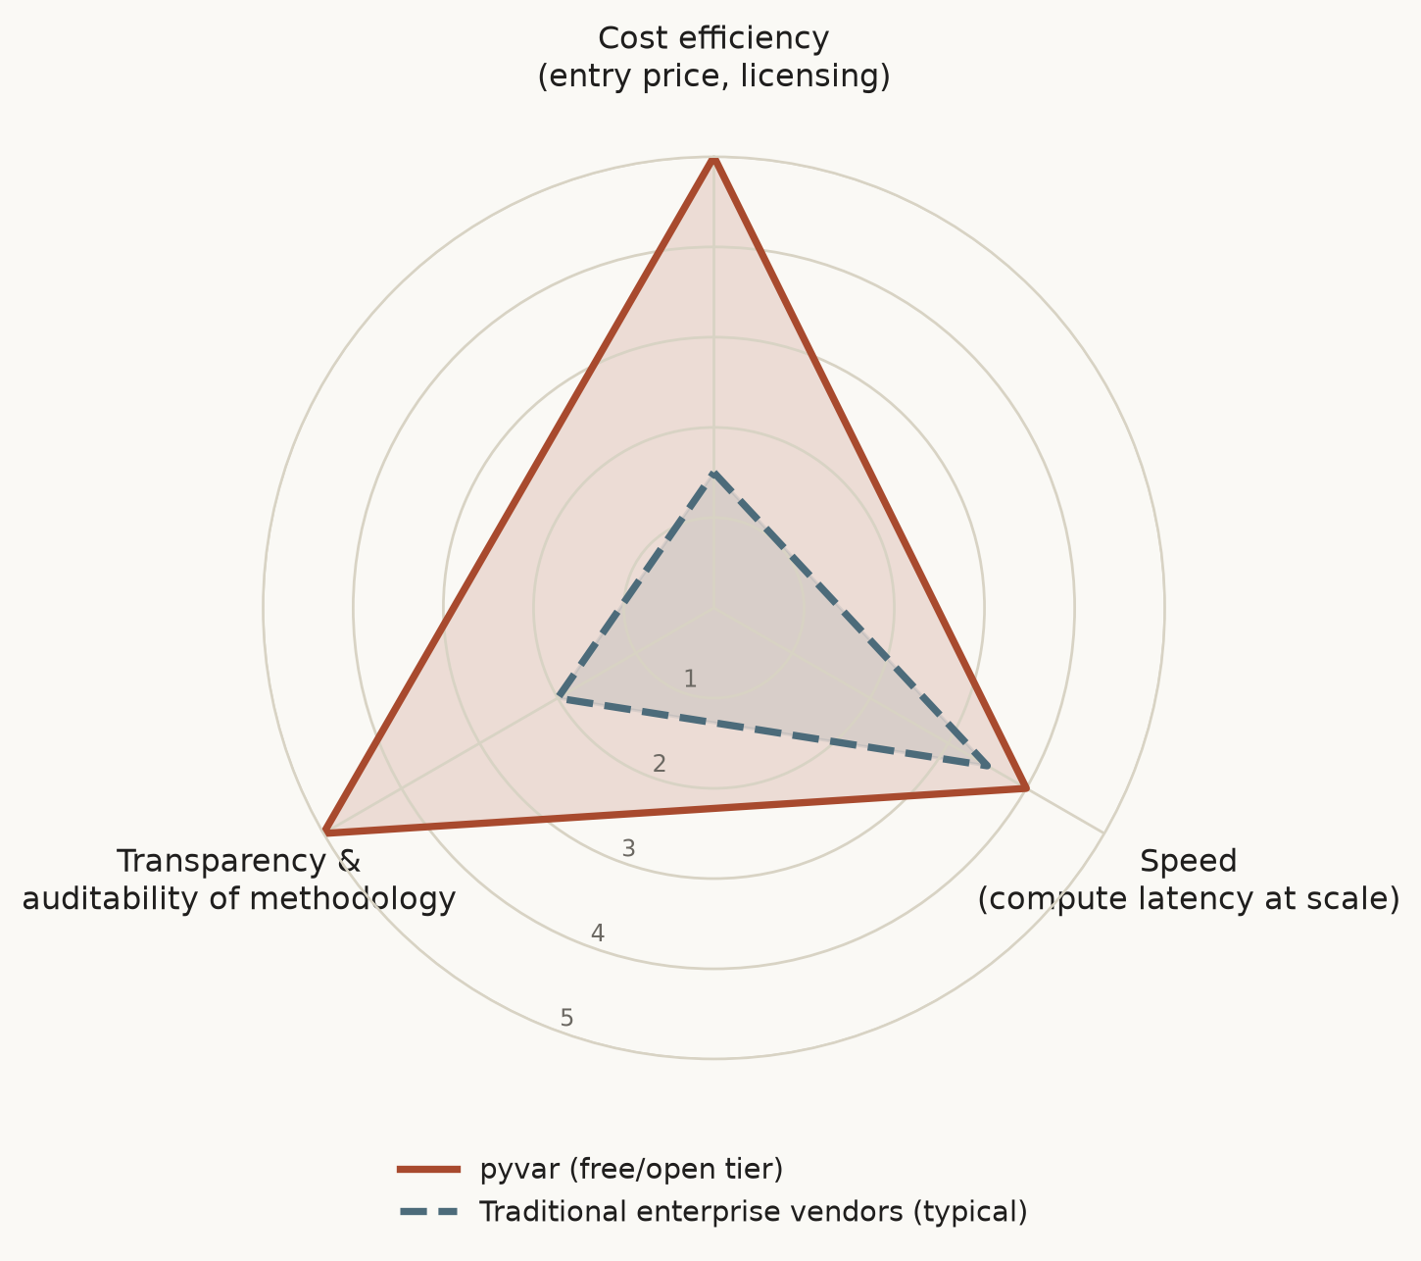
Illustrative 1–5 qualitative positioning, not measured units. pyvar's axes are grounded in the figures above; vendor axes are directional characterisations of a category, not a scored test of any named product.

Where traditional vendors still win
- Decades of regulatory acceptance and institutional trust that a project launched in 2026 has not yet earned.
- Breadth beyond pure risk calculation — market data terminals, trading connectivity, portfolio management workflow — that pyvar does not attempt to replace.
- Dedicated account management and contractual liability/indemnification structures that an open-source MIT project does not offer by default (addressed commercially via Fibtec's Enterprise tier, not by the free tier).
- Proven performance at extreme scale and workload diversity that only comes from many years of production use across many institutions.

Recommended next step
If this comparison is going to be used in a funder-facing or public document beyond this internal brief, commission a small, disclosed, reproducible benchmark: the same well-defined risk calculation (e.g. a 99% 1-day historical VaR on a fixed public dataset), run against pyvar and at least one named vendor product under a licence that permits publishing the comparison, with the methodology published alongside the result. That is the credible version of this document; this version is the honest, currently-available one.

Architecture: how these numbers are actually produced
Three design decisions carry essentially the entire cost and speed story. The compute kernel never leaves pure Python and never recompiles unnecessarily: random numbers are pre-drawn outside the JIT region, the outer simulation loop uses prange under @njit(parallel=True, cache=True), and cache=True means a fresh Celery worker scaling up from zero does not pay a full LLVM compilation cost on every job.
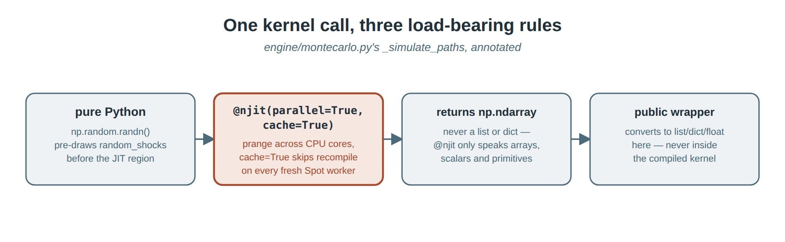
One kernel call, three load-bearing rules (engine/montecarlo.py's _simulate_paths, annotated).
Only one function in the whole API is actually asynchronous. The MCP server, pyvar-client, and pyvar-jupyter all converge on one SDK, so there is no duplicated auth or retry logic to keep in sync across three surfaces. 384 of 385 functions return a direct JSON response; only var.compute goes through Celery/SQS FIFO, with task_acks_late=True so a Spot interruption never silently loses a job mid-run.
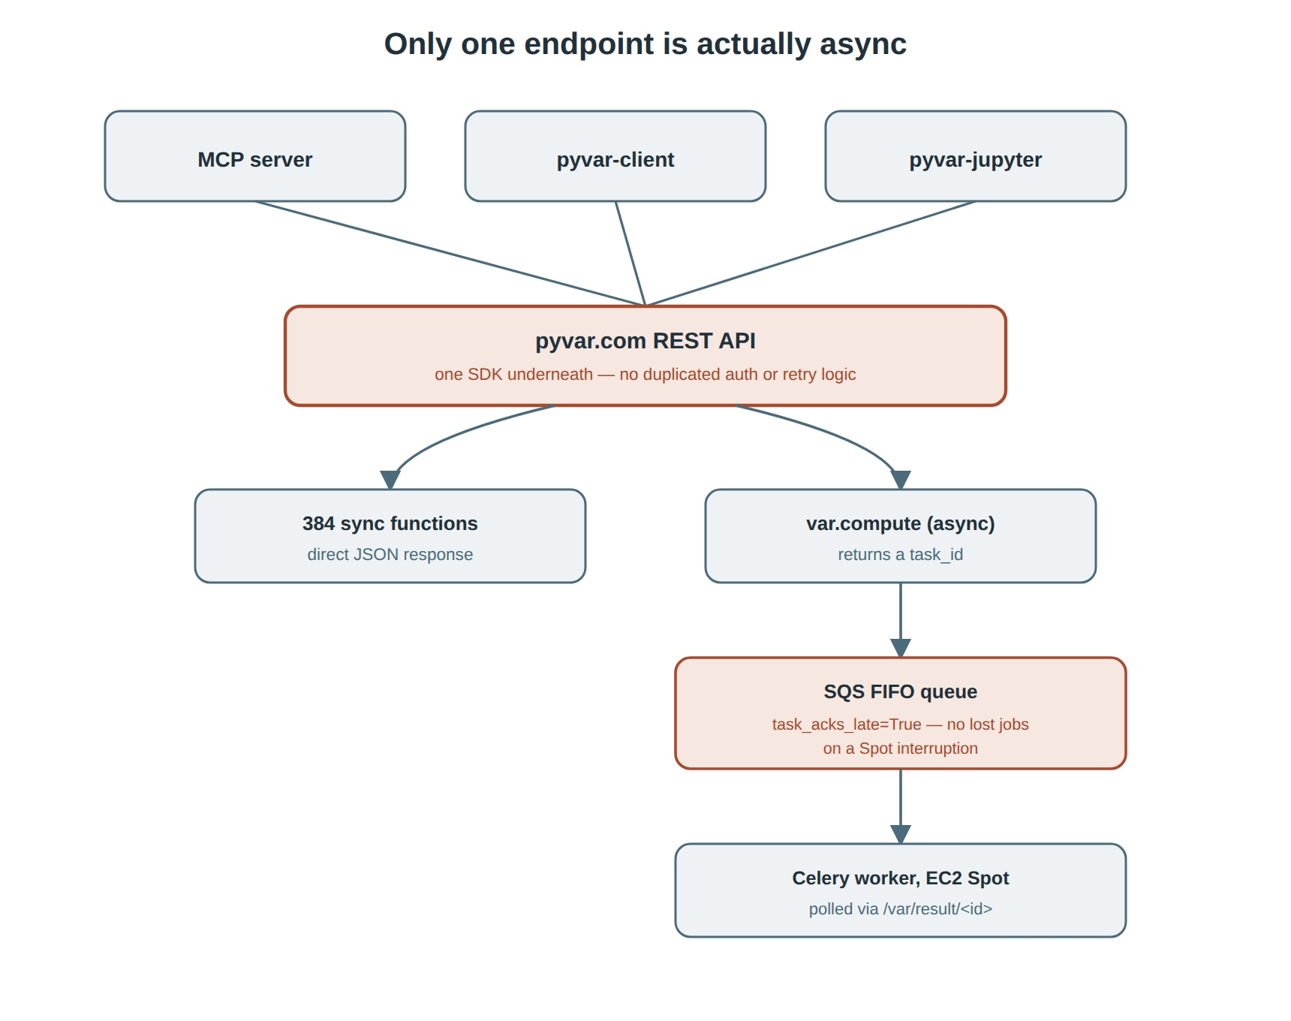
Only one endpoint is actually async — the sync/async split across all three client surfaces.
Every layer scales down to (near) zero independently, on its own schedule: Celery workers on EC2 Spot scale to exactly zero when the job queue is empty, the API mixes a small always-on Fargate base with Spot burst capacity, and Aurora Serverless v2 steps up from a 0.5-ACU floor with no cold start of its own.
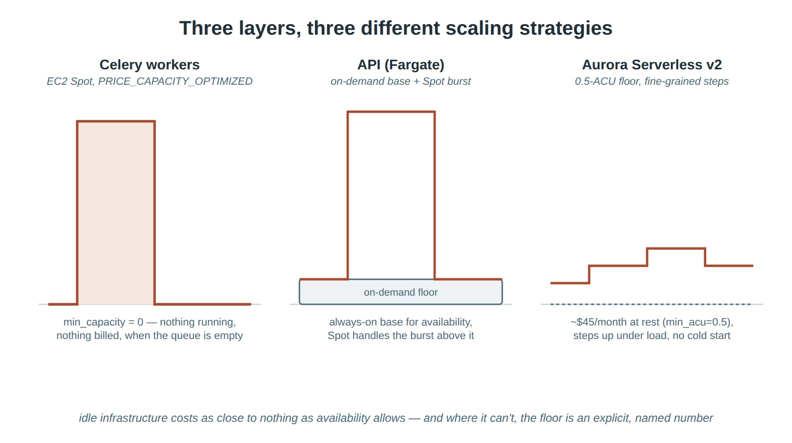
Three layers, three different scaling strategies, chosen per layer for what that layer actually needs.

The technology stack — and why each piece was cherry-picked
Every choice below was made against at least one real alternative, not by default. None of it is exotic; the discipline is in picking boring, well-supported technology for each specific constraint rather than one framework for everything.
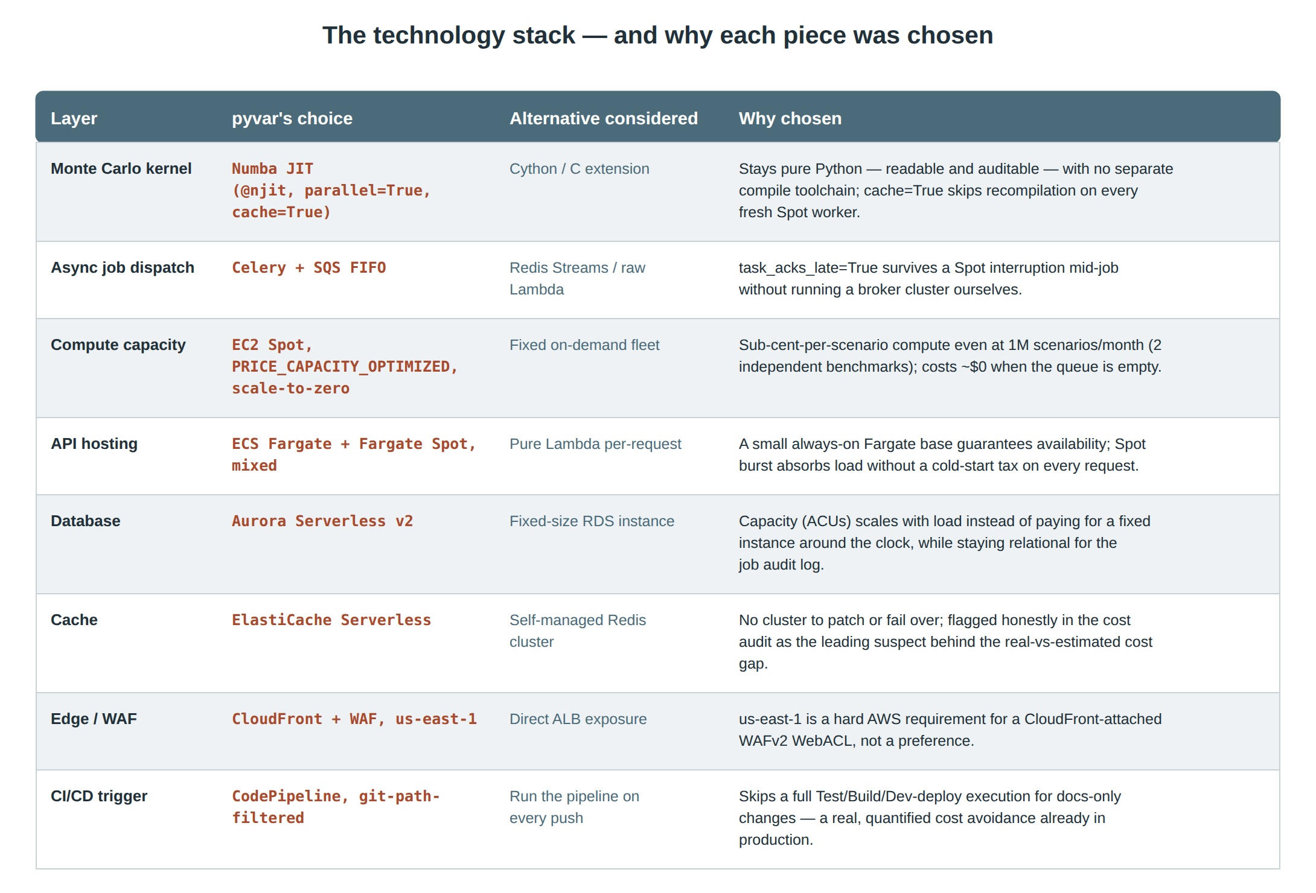
The common thread: almost every choice above is either usage-correlated cost (pay only for what runs) or a deliberate trade of a small amount of latency for a large amount of operational simplicity. The one non-cost-driven choice — CloudFront + WAF pinned to us-east-1 — is a hard AWS platform requirement for a CloudFront-attached WAFv2 WebACL, not a design preference, and is called out as such rather than presented as a clever decision.

Methodology: how these figures were measured, and corrected when wrong
Two of the three headline figures were themselves corrected during this project's own development — worth including precisely because the honesty mechanism this project describes only means something if it also applies to its own numbers.
The speed figure was corrected once.
An earlier public demo reported roughly 154 seconds for a 1,000-path run — a Lambda cache-hit metric problem, not the engine's real compute time. Separately, the benchmark script's first version measured “cold start” by calling each function twice in-process, which only measures a genuine cold-compile cost if Numba's on-disk cache starts empty — and in that first run, it didn't. The fix: point NUMBA_CACHE_DIR at a fresh, empty temp directory before importing anything that touches Numba, since Numba reads that variable once, at import time. That forces a genuine first-ever compilation on the first call, and is exactly how scripts/p7_bench.py's published, reproducible numbers are produced today.
The cost figure was corrected once, in the opposite direction.
A bottom-up estimate assembled entirely from repo artifacts projected a fixed infrastructure baseline of roughly $349–430/month, essentially flat across 10,000, 100,000, or 1,000,000 Monte Carlo scenarios per month (actual compute runs at sub-cent per scenario on two independent benchmarks). The real prod invoice came back at $900–1,000/month — about 2.2x that estimate. The estimate's own methodology had already flagged this exact risk in writing beforehand; fixed-cost line items (ElastiCache at real traffic, Aurora's actual ACU rate, NAT Gateway data processing) are the leading suspects, honestly flagged as unresolved rather than papered over.
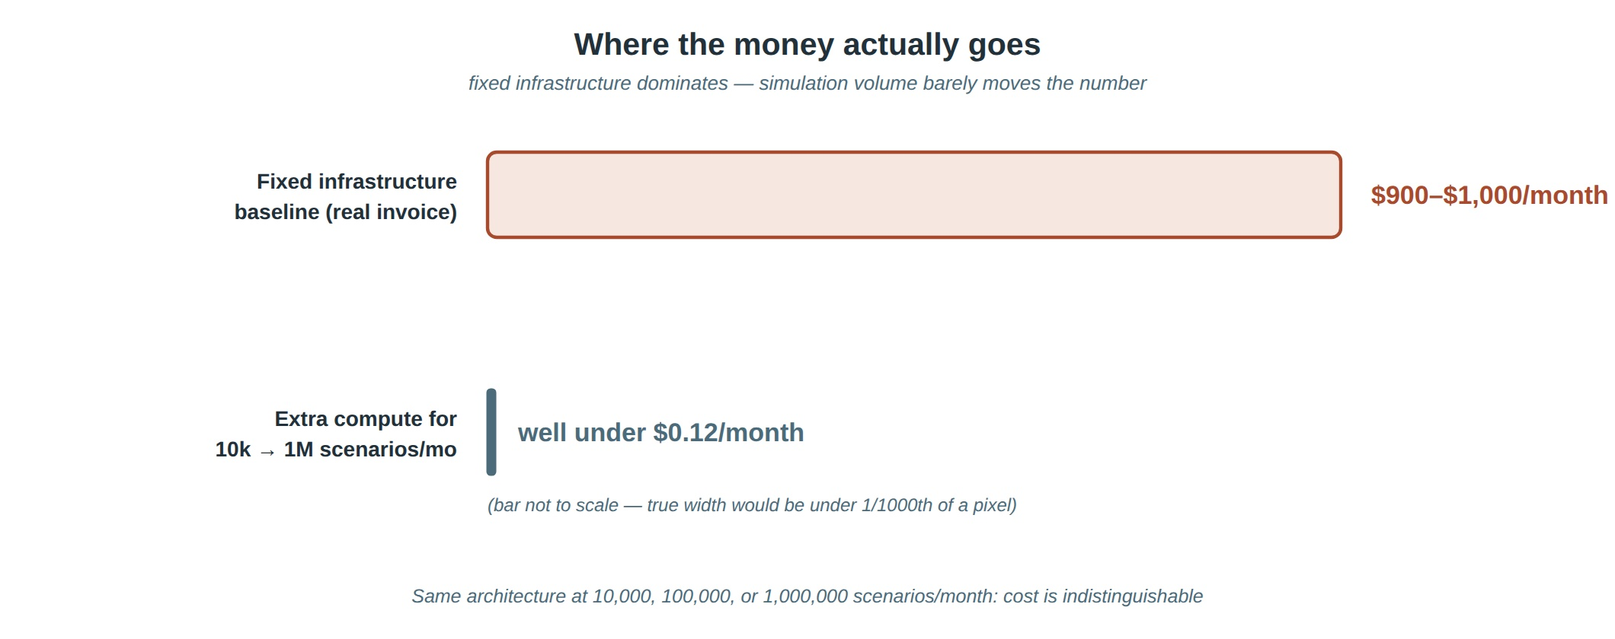
The accuracy figure has no live equivalent to correct against, by design.
A production VaR or pricing request has no ground-truth answer to compare against at request time, so “accuracy” here is deliberately a static, validation-derived score rather than a fabricated per-request percentage: 627 test assertions across 8 domain suites, checked against closed-form solutions and published Basel/FRTB worked examples, re-run on every change and again per release — not a live metric, and not presented as one.

How pyvar's speed compares to what the industry itself has published
No named vendor's product was tested to produce the Iron Triangle chart above. But public, dated, named case studies exist for how long comparable risk calculations take at enterprise scale, and they set a real bar — one worth stating plainly rather than hedging around.
• Amazon Web Services' own published FRTB IMA case study cites a baseline overnight Internal Model Approach batch run of 85 hours on a single Spark/EMR cluster — and getting that down to a 5-hour target takes 17 clusters of 200 c5.24xlarge instances each. That is a real, dated industry data point on what a full FRTB IMA batch costs in wall-clock time before an institution buys its way out with that much parallel infrastructure.
• SS&C's own published case study for Bank Hapoalim reports its Algorithmics HiPER engine cutting a full-simulation XVA/CCR batch from 20 hours to 15 minutes — a named bank, a named vendor, a named product, and the vendor's own best-case, fully-optimized result, not an industry average.
pyvar's published number — 100,000-path Monte Carlo VaR completing in 2–10 seconds (docs/p7-numba-profiling-results.md, reproducible offline via scripts/p7_bench.py) — measures a different unit of work than either case study above: one portfolio's VaR request, not an enterprise-wide overnight batch spanning thousands of positions across multiple desks. Those numbers are not directly comparable, and this document is not claiming they are — the honesty discipline running through this whole positioning does not get suspended for the one section that is most flattering.
What is fair to say, and checkable from the sources named above: in this exact industry, the fastest publicly disclosed, fully-optimized, named result anyone has published measures its win in minutes, not seconds — and that is after a bank bought dedicated acceleration technology and ran it as a batch job. pyvar's number is what a single default request costs today, with no comparable acceleration purchase, specialized cluster, or batch window required. That gap is real even without comparing like-for-like workloads.
External sources for this section: AWS, “How to improve FRTB’s Internal Model Approach implementation using Apache Spark and Amazon EMR” (aws.amazon.com/blogs/industries/how-to-improve-frtbs-internal-model-approach-implementation-using-apache-spark-and-amazon-emr); SS&C Technologies, “Bank Hapoalim Transforms XVA/CCR Batch From 20 Hours to 15 Minutes” (ssctech.com/resources/form/bank-hapoalim-transforms-xvaccr-batch-20-hours-15-minutes).

