pyvar
The iron triangle:
cost, speed, accuracy.
How pyvar positions against traditional risk vendors — and where it doesn't
Prepared by Fibtec Limited (United Kingdom)
Subject pyvar — pyvar.com
Status Directional positioning — not an independent or audited benchmark
Prepared August 2026

Read this first: what this document is, and isn't
This is a directional, qualitative positioning exercise, not a controlled or independently audited benchmark. pyvar's own figures below are real and sourced from this codebase and its public documentation. Figures characterising "traditional enterprise vendors" are drawn from publicly reported pricing and industry commentary, not from head-to-head testing against live vendor systems pyvar has never had access to — no vendor's product was run, licensed, or benchmarked to produce this document. Treat every vendor-side figure here as illustrative of a category, not a claim about any single named product's actual performance. Before using this externally in a definitive way (a funder-facing claim, a competitive sales comparison), commission an independent benchmark against specific named products under a specific, disclosed methodology.

The iron triangle, applied to risk infrastructure
"Pick two" is the usual framing of the iron triangle (cost, speed, quality) — the premise being that no system delivers all three at once. pyvar's design argument is narrower and more falsifiable than "we do all three": that being free and open source removes cost as a constraint almost entirely, that a JIT-compiled parallel compute engine keeps speed competitive without needing proprietary infrastructure, and that open methodology is a different, arguably stronger, kind of accuracy claim than a vendor's own internal validation — auditable correctness rather than trust in a brand.

pyvar's own figures — real, sourced from this codebase

Cost
- MIT licence — the compute engine, the API server, and the client library are all fully open source; nothing about using pyvar requires a commercial licence.
- A free tier requiring no payment card exists today (portal/index.html's "Get API key" flow) — full access to all 385 functions, rate-limited rather than feature-limited.
- Paid tiers (Pro, Enterprise, pyvar Local) are proposed as usage-correlated subscriptions, not seat licences — see the accompanying monetization strategy document.

Speed
The Monte Carlo VaR engine (engine/montecarlo.py) is Numba JIT-compiled with parallel execution (@njit(parallel=True, cache=True)) and pre-drawn random draws outside the JIT region. The platform's own published API documentation states large-scale Monte Carlo VaR — up to 100,000 simulated paths — completes in 2–10 seconds; a smaller 1,000-path run typically completes in low single-digit seconds. The other 384 of pyvar's 385 functions are synchronous request/response calls with no job-queue latency at all.
This figure was itself corrected during this project's own development: an earlier public demo had reported roughly 154 seconds for a 1,000-path run because of a Lambda cache-hit bug in the metric it displayed, not the engine's real compute time — fixed and re-verified before being cited here. It is included as a data point in favour of the platform's engineering rigor, not glossed over.

Accuracy — more precisely, methodological transparency and reproducibility
Risk models do not have a single external ground truth to score prediction accuracy against, so "accuracy" here means something specific and checkable: does the implementation match the published regulatory formula, and does it behave the same way every time it's run.
- Deterministic and seed-reproducible: identical inputs and seed always produce an identical result — tested directly (tests/test_engine.py), not assumed.
- Automated numerical-property tests run on every change: VaR is always positive, CVaR is always ≥ VaR, 99% VaR always exceeds 95% VaR, absolute VaR scales linearly with portfolio value.
- Basel traffic-light backtesting uses exactly 250 trading days and the Basel Committee's own green/yellow/red breach thresholds and 3.0–4.0 capital multipliers — not an approximation of them.
- Every formula is publicly readable on GitHub under the MIT licence and cross-validated against the published Basel/FRTB reference documents — independently checkable by a regulator, an academic, or a rival risk team, which a proprietary implementation is not.

Traditional enterprise vendors — publicly known characteristics
The comparison category here spans platforms such as Bloomberg (Terminal, PORT, MARS), MSCI (RiskMetrics, BarraOne), Moody's Analytics, and enterprise risk/derivatives platforms like Murex, Calypso and SS&C Algorithmics. These are mature, widely-deployed, and regulator-accepted products with genuine strengths this document does not dispute.

Cost
Bloomberg Terminal's per-seat annual cost is widely reported in business press in the region of US$25,000–32,000 per year (figures vary by report and region and are not Bloomberg's own published list price). Enterprise risk and derivatives platforms such as Murex or Calypso are not seat-priced at all — implementations typically involve six- to seven-figure licensing plus substantial systems-integration cost, per industry commentary rather than any single public price list. No vendor here publishes a simple comparable number, which is itself part of the contrast with pyvar's free tier.

Speed
Not independently comparable from public information. Modern vendor platforms increasingly offer cloud-hosted, low-latency calculation services and can be very fast for the workloads they are tuned for; some legacy enterprise risk installations remain batch-oriented, on-premises, and overnight-cycle by design. This varies enormously by vendor, deployment model, and workload, and none of it is published in a way that allows a fair single number here.

Accuracy / methodology
Traditional vendors bring a long regulatory track record and extensive internal validation — a real and legitimate form of trust that a newer open-source project has not yet accumulated. What they generally do not offer is external auditability: the exact formula behind a given output is typically proprietary, so a client, regulator, or researcher must trust the vendor's own validation rather than inspect the calculation directly.

Positioning chart (illustrative — see caveat above)
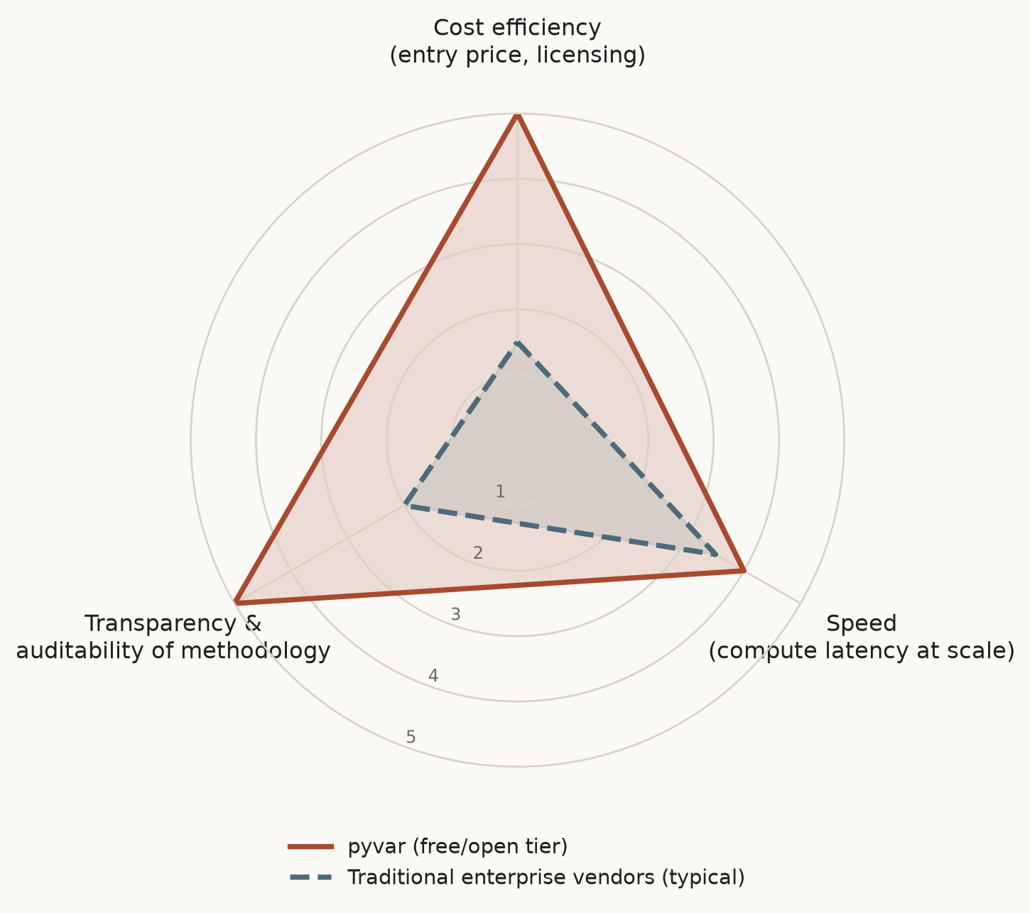
Illustrative 1–5 qualitative positioning, not measured units. pyvar's axes are grounded in the figures above; vendor axes are directional characterisations of a category, not a scored test of any named product.

Where traditional vendors still win
- Decades of regulatory acceptance and institutional trust that a project launched in 2026 has not yet earned.
- Breadth beyond pure risk calculation — market data terminals, trading connectivity, portfolio management workflow — that pyvar does not attempt to replace.
- Dedicated account management and contractual liability/indemnification structures that an open-source MIT project does not offer by default (addressed commercially via Fibtec's Enterprise tier, not by the free tier).
- Proven performance at extreme scale and workload diversity that only comes from many years of production use across many institutions.

Recommended next step
If this comparison is going to be used in a funder-facing or public document beyond this internal brief, commission a small, disclosed, reproducible benchmark: the same well-defined risk calculation (e.g. a 99% 1-day historical VaR on a fixed public dataset), run against pyvar and at least one named vendor product under a licence that permits publishing the comparison, with the methodology published alongside the result. That is the credible version of this document; this version is the honest, currently-available one.

