**Clack Part 1 Report**

**Group members:** Anthony Scaltsas (0937939) & Justin Ficci (0942191)

A)

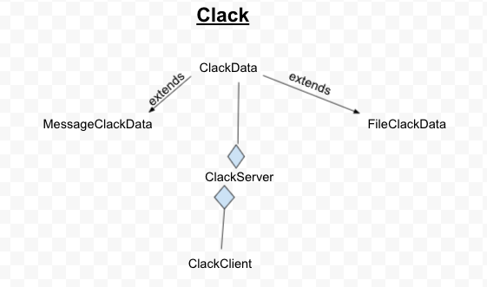

B) This early in the project, there aren’t any methods that would cause the program to fail if a negative port number is assigned. We know this after creating the test classes and testing for this issue specifically. Despite that, we suspect that this may turn out to be an issue later on in the project. If this becomes a problem at any point, we think that we can fix this issue without crashing the program by having an if conditional test if the port number is less than 0. If it is less than 0, then the program will assign the specific object a new and unused port number to fix the issue.

Another issue we were prompted to check was an object having a null value for a user. There was no issue with these test classes either. Just like the negative port number check, we believe that this may cause an issue once more methods are being implemented by the program. When this needs to be addressed, the program would check if the whole class is null as soon as it would come up on a null client. If it is just the user that is null and not the whole class, then an error message would pop up.