Facebook App

Specification Document

Feature Explanation

# Canned Posts

Canned posts gives you post templates that you can use for common situations.

You can create a template and fill in the blanks whenever the need arises. Another friends has a birthday. Pop open a canned post with a great birthday greeting. Just fill in the blanks.

To find specific classes relating to this feature look at the 2nd class diagram.

# Post Filtering

Post filtering allows you to reorder the news feed according to matched rules. The rules include a group of regular expressions that allow you to match a post's content.

There are 3 Priorities that can be set to a post:

1. Hidden – The post is not shown
2. Demoted – The post is shown at the end of the news feed
3. Promoted – The post is moved to the top of the news feed

This post is useful to hide spoilers or promote feed items that might interest you.

To find specific classes relating to this feature look at the 3rd class diagram.

Sequence Diagrams

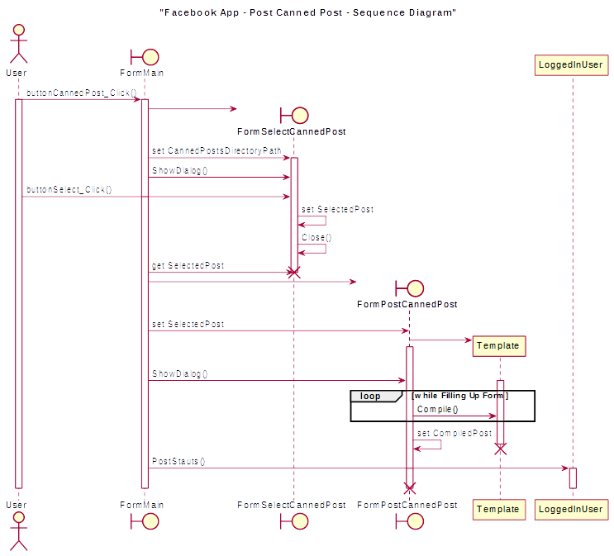

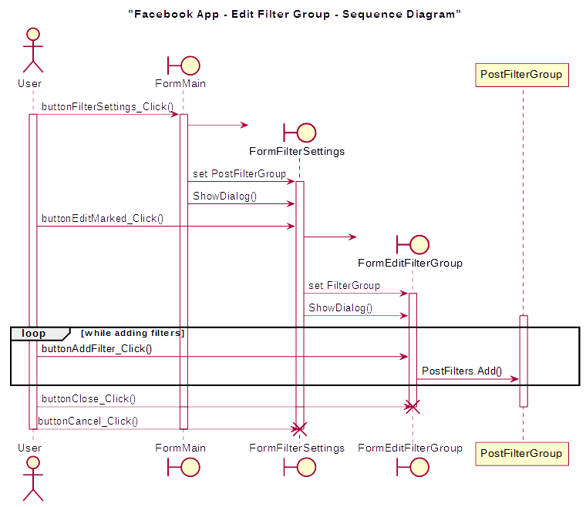

Use Case Diagram

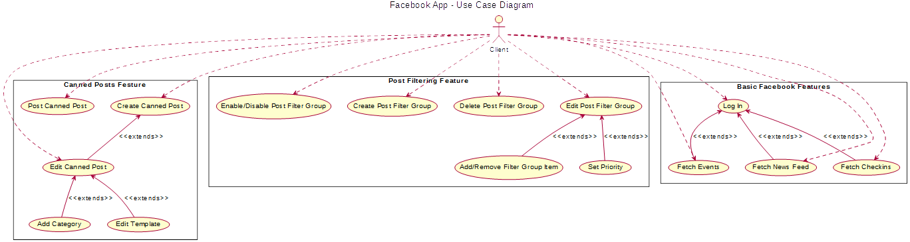

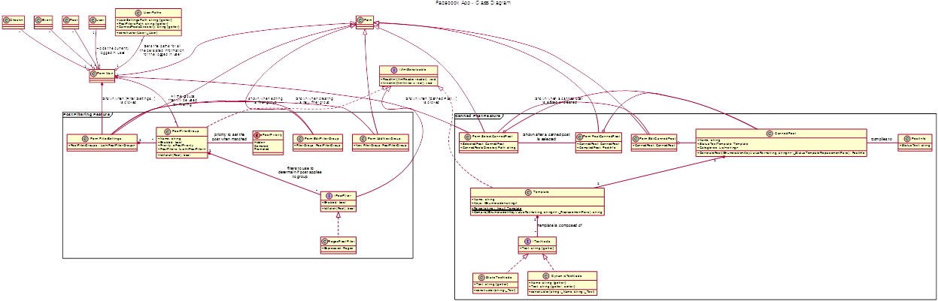Class Diagrams

