

TECHNICAL DESIGN DOCUMENT

|  |  |
| --- | --- |
| **Author** | William Watlington |
| **Last Updated** | 1/10/2023 5:17 PM |
| **Version Number** | 3.0.1 |

**Version History**

|  |  |  |  |
| --- | --- | --- | --- |
| Name | Date | Reason for Change | Version |
| *Krasso, Richard* | *10/17/2019* | *New document format* | *3.0.0* |
| Watlington, William | 01/05/2023 | Personas/Prototype | 3.0.1 |
|  |  |  |  |
|  |  |  |  |
|  |  |  |  |
|  |  |  |  |
|  |  |  |  |
|  |  |  |  |
|  |  |  |  |
|  |  |  |  |

Table of Contents

SECTION 1: INTRODUCTION 3

1.1. Purpose 3

1.2. Terminology 3

1.3. User Personas 3

1.4. User Stories 3

1.5. Time Estimations 3

SECTION 2: PROCESS DESIGN 4

2.1. Prototypes 4

2.2. ORD (Object Relational Diagram(s) 4

2.3. NoSQL Document Diagram 4

2.4. NoSQL Data Structure 4

SECTION 3: QA TESTING 4

3.1. QA Test Plan 4

3.2. Unit Tests 4

SECTION 4: REFERENCES 5

# SECTION 1: INTRODUCTION

## Purpose

nodebucket is task management software designed to simplify the way you create, track, edit, and delete time sensitive material. This is a full-stack MEAN (MongoDB, Express, Angular, and Node.js) application, utilizing the concepts that were taught in previous courses. MongoDB will be used for data persistence. Node.js will be used for manipulating and returning saved records, SoapUI for unit testing, and Angular for user interactions.

## Terminology

|  |  |
| --- | --- |
| **Name** | **Comments** |
| MEAN Stack | MongoDB, Express, Angular, and Node.js |
| VS Code | Development IDE |
| SoapUI | API testing tool |
| MongoDB Compass | Database development IDE |
| Angular Material | <https://material.angular.io/> |
| Flex-layout | <https://github.com/angular/flex-layout> |

## User Personas

|  |  |  |  |  |
| --- | --- | --- | --- | --- |
| **Name** | **Age** | **Gender** | **Job Title** | **Marital Status** |
| Kerry Williams | 61 | Female | Retired | Widow |
| James Bond | 47 | Male | Detective | Single |
| Shallan Davar | 18 | Female | Student | Single |

**Bio:**

Kerry Williams

* Kerry Williams is a retired widow who mainly learns of new technology from her children and grandchildren. She has minimal digital literacy and is impatient with complicated applications.

James Bond

* James Bond is a detective who often travels to exotic locations. He expects applications to be simple and effective and is willing to pay for the best in everything he uses.

Shallan Davar

* Shallan Davar is a university student. She has used modern technology such as the internet and mobile phones for her entire life and is comfortable using any application. She expects applications to have little latency and feature modern styling.

## User Stories

## Kerry Williams

* + As a user, I want to track my bill due dates, so I do not forget them.
  + As a user, I want a larger text font, so that the text is easy to read.
  + As a user, I want to be able to set reminders, so that I do not forget to pay my bills.
  + As a user, I want reoccurring payments, so that I can pay my bills online.
  + As a user, I want to color code tasks, so that I can organize tasks by paid and unpaid.
* James Bond
  + As a user, I want to keep a list of tasks, so that I do not forget them.
  + As a user, I want a simple layout, so that the application is easy to use.
  + As a user, I want notifications/alerts for upcoming tasks, so that I am reminded if I do not check the app directly.
  + As a user, I want to be able to delete items, so that I can remove completed items.
  + As a user, I want to be able to view completed tasks, so that I can see what I have completed.
* Shallan Davar
  + As a user, I want to be able to reorganize tasks, so that I can put the most important ones on top.
  + As a user, I want notifications, so that I know what tasks I am working on.
  + As a user, I want to drag and drop tasks, so that I can use the app on my phone.
  + As a user, I want to be able to set task priorities, so that I know which tasks to complete first.
  + As a user, I want to be able to log out of the application, so I do not keep getting notifications.

## Time Estimations

**Points Legend**

Most difficult – 5

Moderately difficult – 3

Least difficult - 1

|  |  |
| --- | --- |
| Story | Points |
| As a user, I want to track my bill due dates, so I do not forget them. | 3 |
| As a user, I want a larger text font, so that the text is easy to read. | 1 |
| As a user, I want to be able to set reminders, so that I do not forget to pay my bills. | 5 |
| As a user, I want reoccurring payments, so that I can pay my bills online. | 5 |
| As a user, I want to color code tasks, so that I can organize tasks by paid and unpaid. | 1 |

|  |  |
| --- | --- |
| Story | Points |
| As a user, I want to keep a list of tasks, so that I do not forget them. | 1 |
| As a user, I want a simple layout, so that the application is easy to use. | 1 |
| As a user, I want notifications/alerts for upcoming tasks, so that I am reminded if I do not check the app directly. | 5 |
| As a user, I want to be able to delete items, so that I can remove completed items. | 3 |
| As a user, I want to be able to view completed tasks, so that I can see what I have completed. | 1 |

|  |  |
| --- | --- |
| Story | Points |
| As a user, I want to be able to reorganize tasks, so that I can put the most important ones on top. | 5 |
| As a user, I want notifications, so that I know what tasks I am working on. | 5 |
| As a user, I want to drag and drop tasks, so that I can use the app on my phone. | 5 |
| As a user, I want to be able to set task priorities, so that I know which tasks to complete first. | 3 |
| As a user, I want to be able to log out of the application, so I do not keep getting notifications. | 3 |

# SECTION 2: PROCESS DESIGN

## 2.1. Prototypes

Link to interactive prototype: <https://xd.adobe.com/view/e524f0d7-5193-4fe1-a2e5-7d559775556f-b077/?fullscreen&hints=off>

Prototype images:

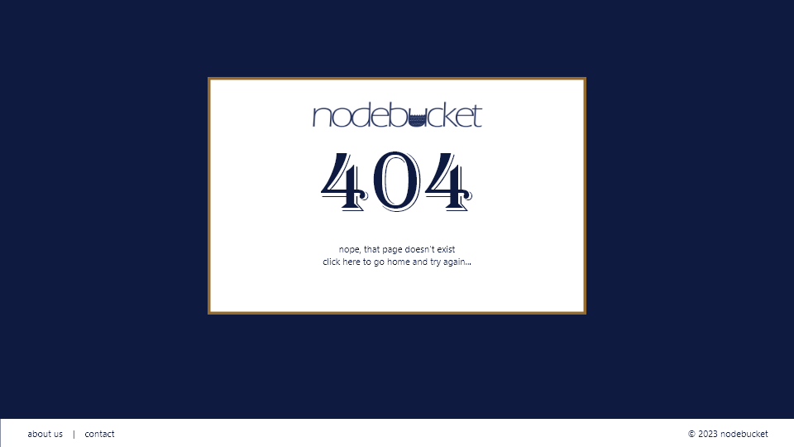

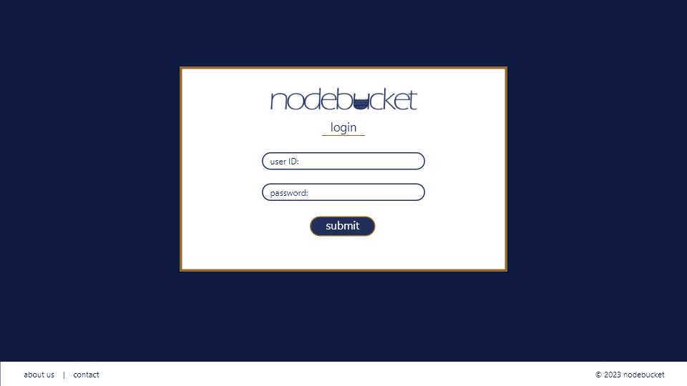

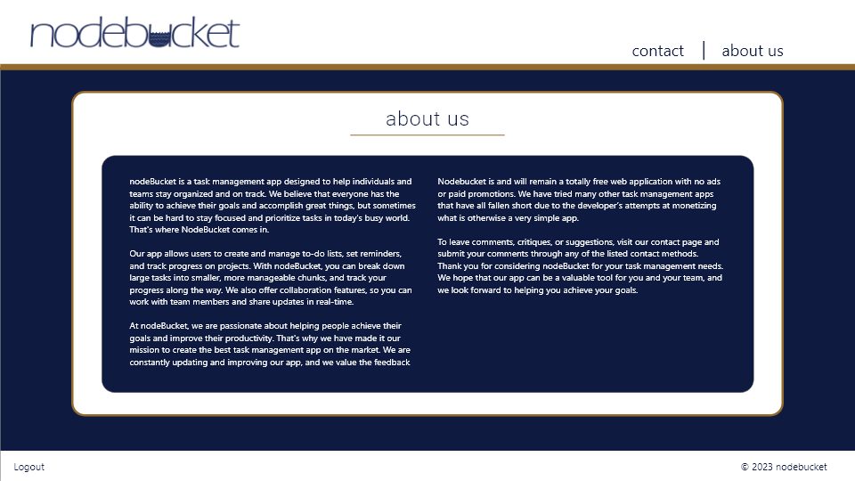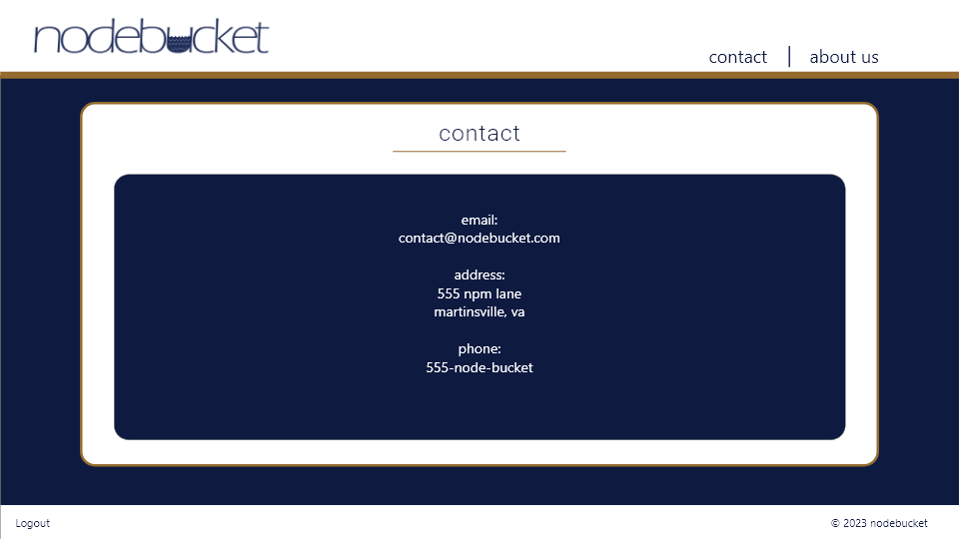

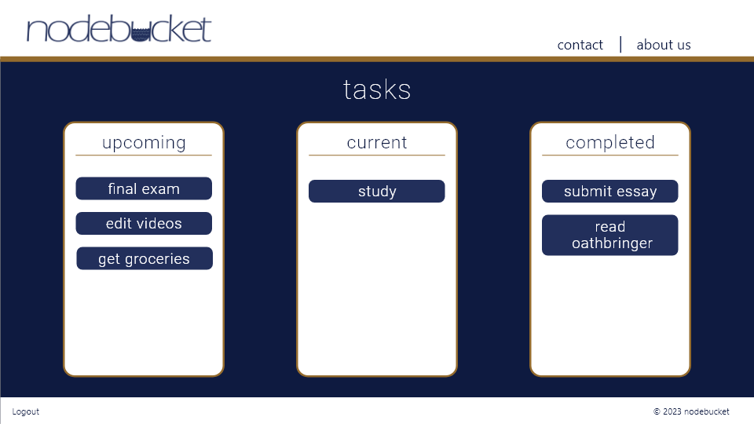

## 2.2. ORD (Object Relational Diagram(s)

has

Upcoming

Tasks

Employee

* empId
* firstName
* lastName
* title
* dueDate

has

## 

Upcoming

Tasks

has

* title
* dueDate

Upcoming

Tasks

* title
* dueDate

## 2.3. NoSQL Document Diagram

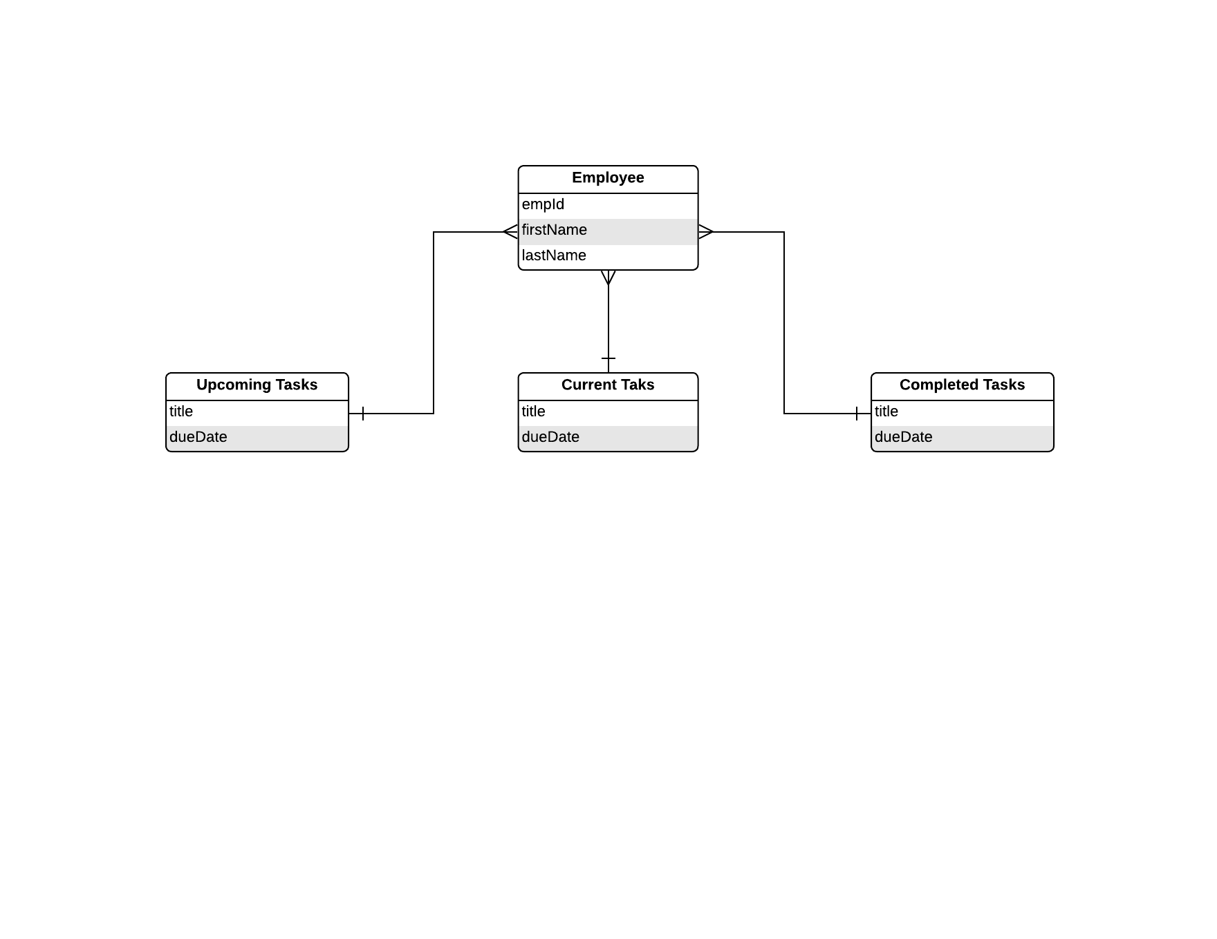

## 2.4. NoSQL Data Structure

{

    "empId": 1010,

    "firstName": "Sookie",

    "lastName": "Suzuki",

    "upcomingTasks": [

        {

            "title": "task1",

            "dueDate": 20220130

        }

    ],

    "currentTasks": [

        {

            "title": "task2",

            "dueDate": 20220110

        }

    ],

    "completedTasks": [

        {

            "title": "task3",

            "dueDate": 20220103

        }

    ]

}

# SECTION 3: QA TESTING

## 3.1. QA Test Plan

*[Weekly Test Cases]*

## 3.2. Unit Tests

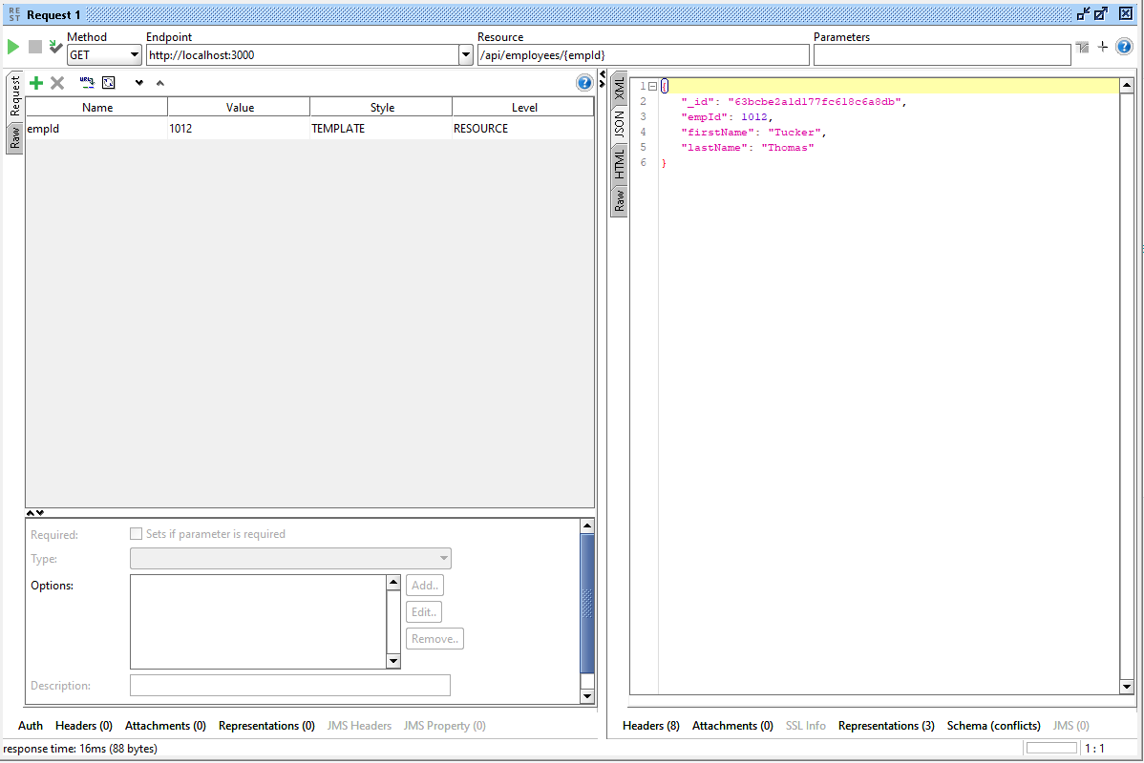

# SECTION 4: REFERENCES

*[APA Reference List]*