WEB231

William Watlington

3/18/2022

Assignment 1.2

Directory

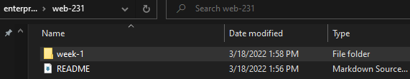

Repository

