William Watlington

3/20/2022

Assignment 1.3

**HTML Validation:**

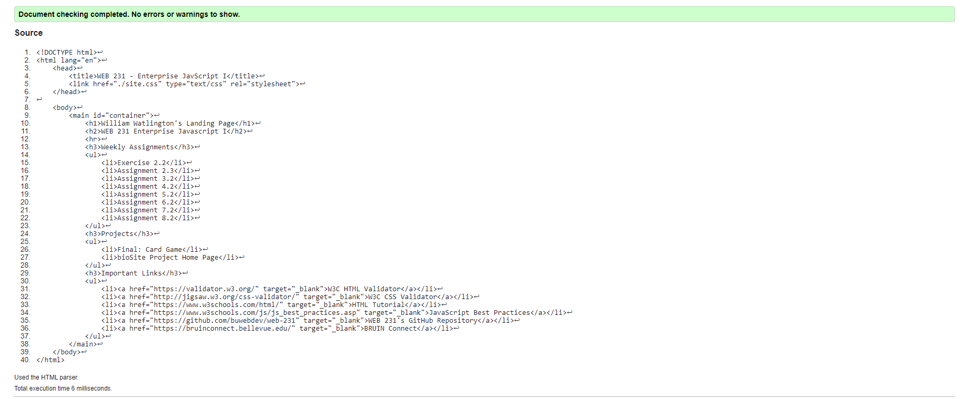

**CSS Validation:**

