William Watlington

WEB 330 – Enterprise JavaScript II

5/23/2022

Assignment 1.2 – GitHub Repository Setup

# Screenshot of local directory

# Screenshot of GitHub Repository

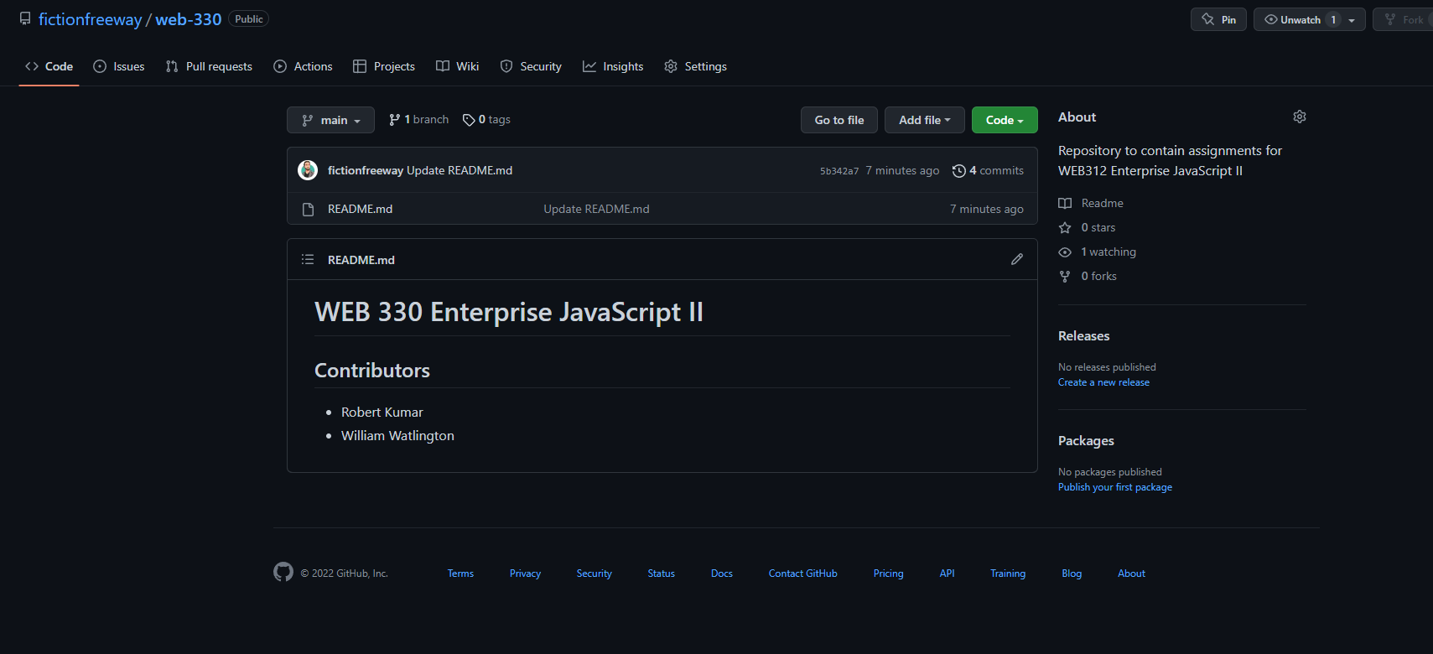

# [Link to GitHub Repository](https://github.com/fictionfreeway/web-330)