William Watlington

WEB 330 – Enterprise JavaScript II

Assignment 1.3

May 29, 2022

HTML Validation

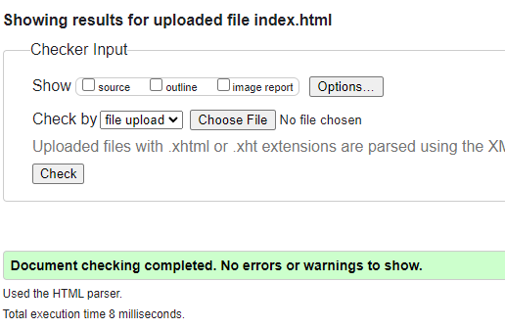

Site.css validation

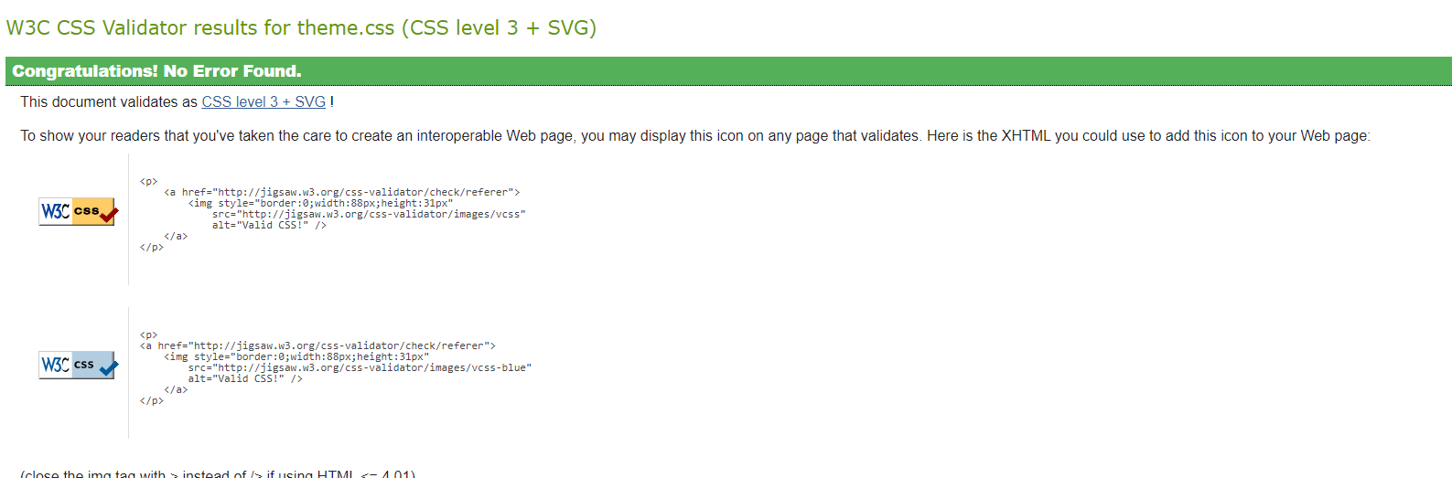

Theme.css Validation

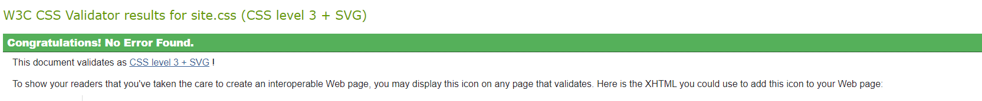

GitHub Pages Deployment Landing Page

