William Watlington

September 10th, 2022

WEB 335

Assignment 4.2 MongoDB Atlas Setup

Web335DB database with users collection

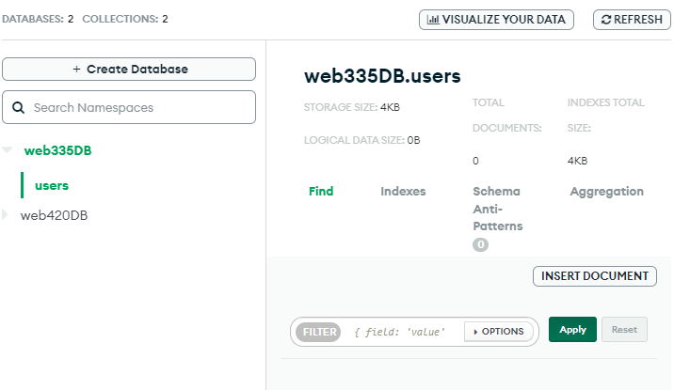

Web335Admin custom role

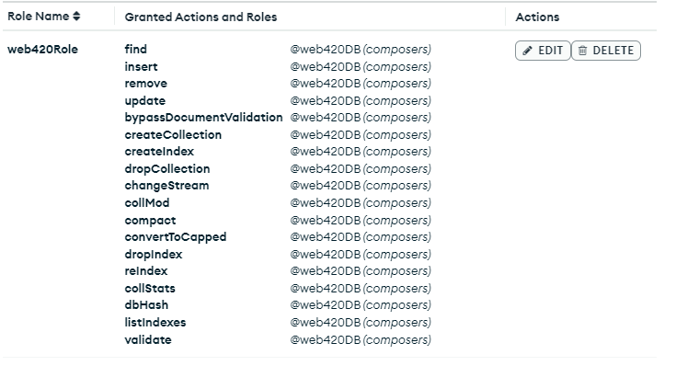

Webb335_user user



Mongosh –help test

