William Watlington

WEB 340

Assignment 1.3

May 28, 2022

Node version

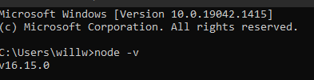

Npm version



Nvs help

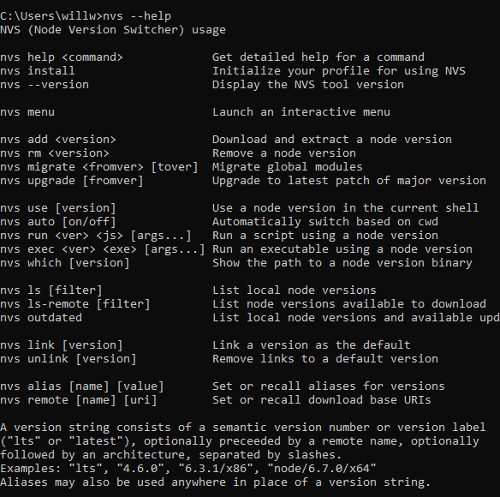

Node help

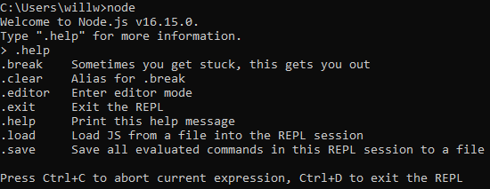

Chrome inspect

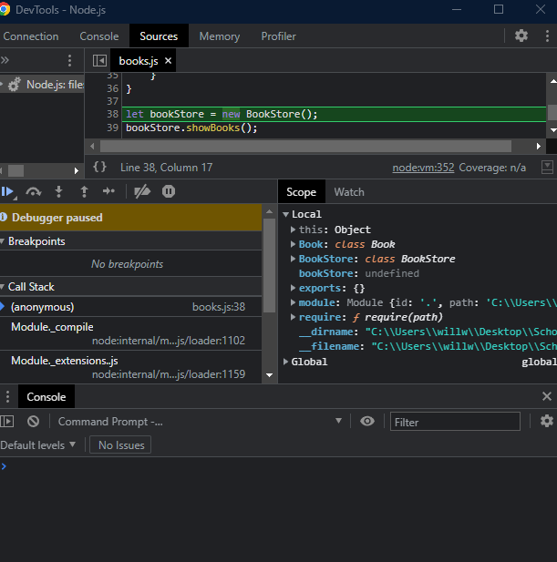

Inspect

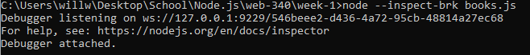

Iterations

