## Great Britain

**Maps**

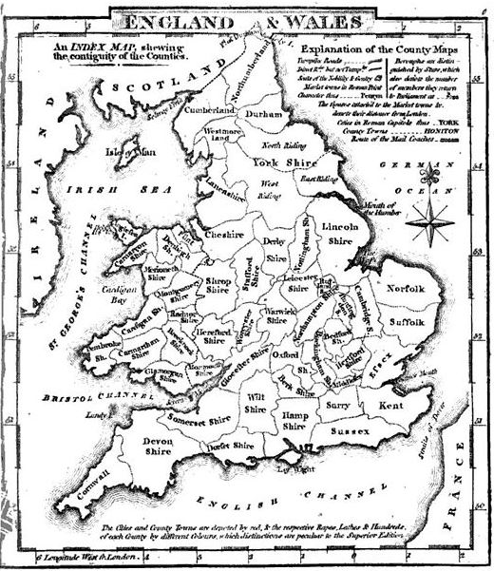

*Shropshire*

*Mining Regions of Wales*

*Map corresponding to 1841 or 1851 British Census*

*L.D.S. Branches (circa 1845-1850) – from “Unidentified Pioneers – Staffordshire Branches”*

*“Mormon Congregations of Wales”*

**Links**

British Mission and Early Mormon Missionaries - <https://history.lds.org/missionary/mission/british?lang=eng>

Missionary Thomas Dunlop Brown, who baptized Robert’s fellow passenger, Thomas Davies - <https://history.lds.org/missionary/individual/thomas-d-dunlop-brown-1807?lang=eng>

Welsh Mormon History - <http://welshmormon.byu.edu/Immigrants_Listing.aspx>

British Mission - <https://history.lds.org/missionary/mission/british?lang=eng>

The Church in the British Isles - <http://www.lightplanet.com/mormons/daily/history/british/html>.