## California Gold

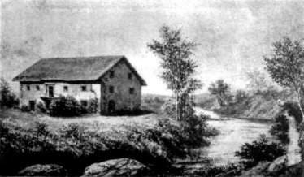

**Maps**

?

**Links**

?