## Liverpool to New Orleans

**Maps**

*Routes between Liverpool and New Orleans*

*City of New Orleans* – from book coming in inner-library loan titled something like The Saints in Louisiana

*Shipping routes up Mississippi and Missouri Rivers to Kanesville, Iowa*

**Links**

Mormon Migration – Voyages and passengers -

<https://mormonmigration.lib.byu.edu/mii/voyage/214?mii=on&query=Poppett&voyage=on&scandinavia=on&dateFrom=&sweden=on&europe=on&netherlands=on&account=on&passenger=on&dateTo>=

New Orleans Passenger Lists – 7 Feb to 29 May 1849 - <https://familysearch.org/ark:/61903/3:1:33SQ-G5JH-56P?cc=1916009>

Journal of Church Agent at New Orleans, Elder Lucias Scovil - <https://dcms.lds.org/delivery/DeliveryManagerServlet?dps_pid=IE407735&page=328>

**Pictures**

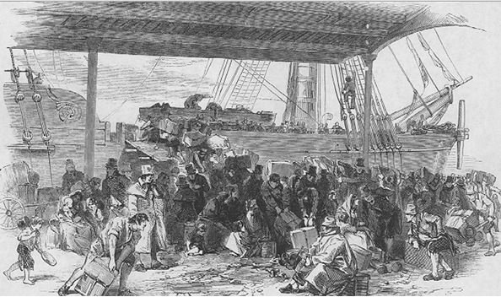

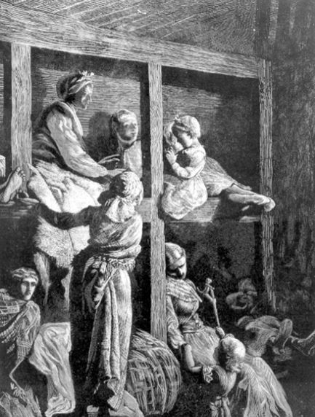

Emigrant Ship Circa 1850[1]

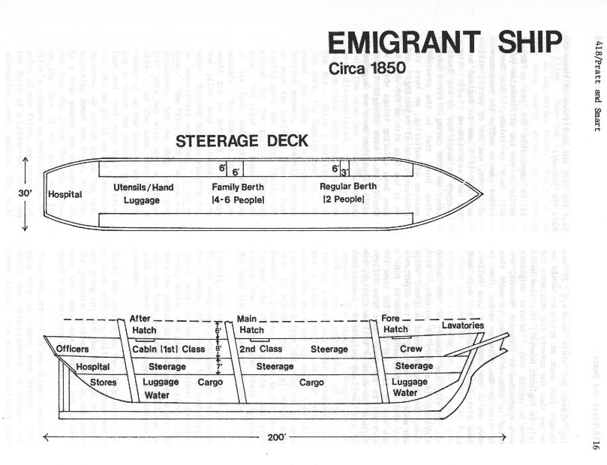

1. Pratt and Smart, “Life On Board a Mormon Emigrant Ship,” 16.