## San Bernardino Colony (no general CA or SB history?)

**Maps**

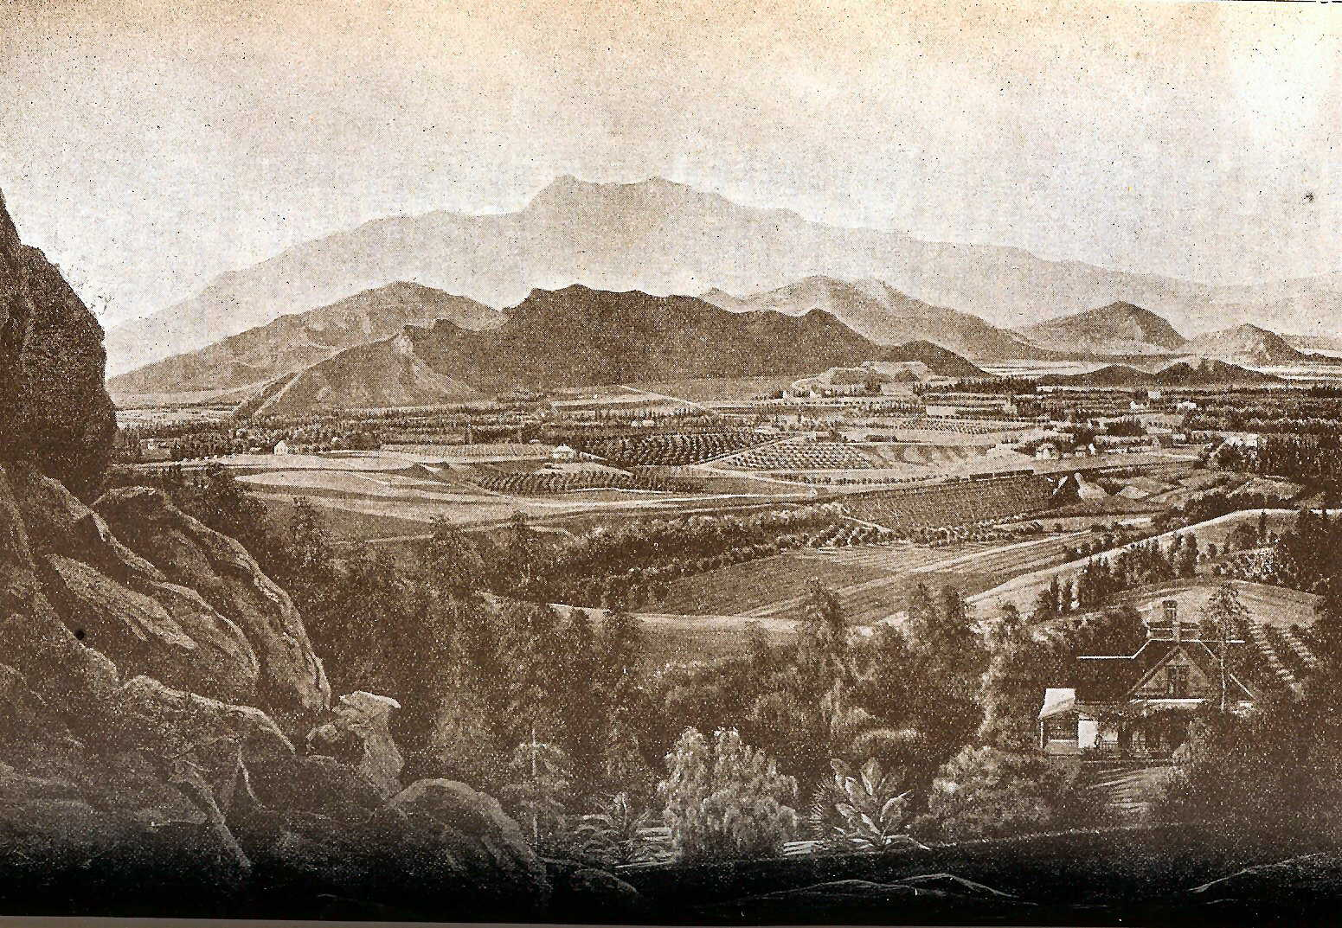

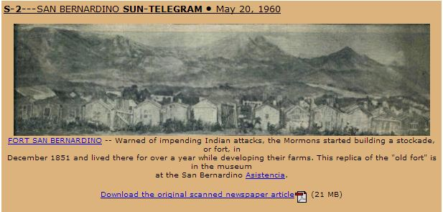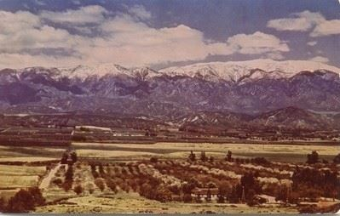

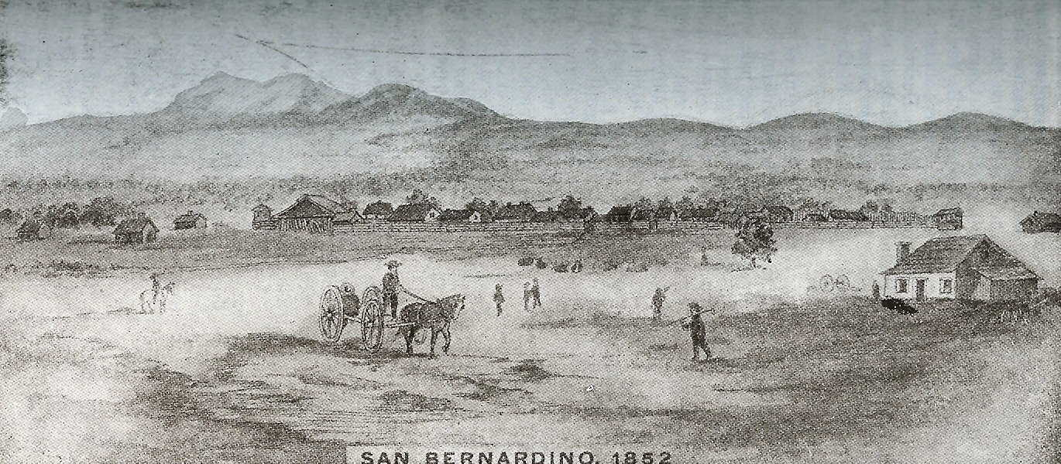

*Early plot laid out by Lyman & Rich*

*The San Bernardino Valley, including the Mission and San Salvador area*

**Links**

Pioneers of San Bernardino - <http://www.empirenet.com/~sbpl/index_pioneers.html>

Native Daughters of the Golden West California Pioneer Project Master Surname Index

<http://www.cagenweb.com/cpl/ndgwmaster.htm>

Valley Quarterly (San Bernardino) - <https://familysearch.org/search/catalog/1477021?availability=Family%20History%20Library>

Mary L. Lewis, San Bernardino County, Genealogical Collection - <https://familysearch.org/search/catalog/836077?availability=Family%20History%20Library>

Mormon Colony in San Bernardino - <http://score.rims.k12.ca.us/score_lessons/willis/>

Mojave Desert – Mormon Pioneers - <http://mojavedesert.net/mormon-pioneers/>

Historic Tour of San Bernardino - <http://www.sbsun.com/lifestyle/20150126/take-an-historic-tour-of-san-bernardino>

San Bernardino History Central, Historical and Pioneer Society -<http://www.sbhistoricalsociety.com/links/>

San Bernardino Bibliography and Related Links of Interest - <http://user.xmission.com/~nelsonb/sb_links.htm>