## Staging Areas (Iowa)

**Maps**

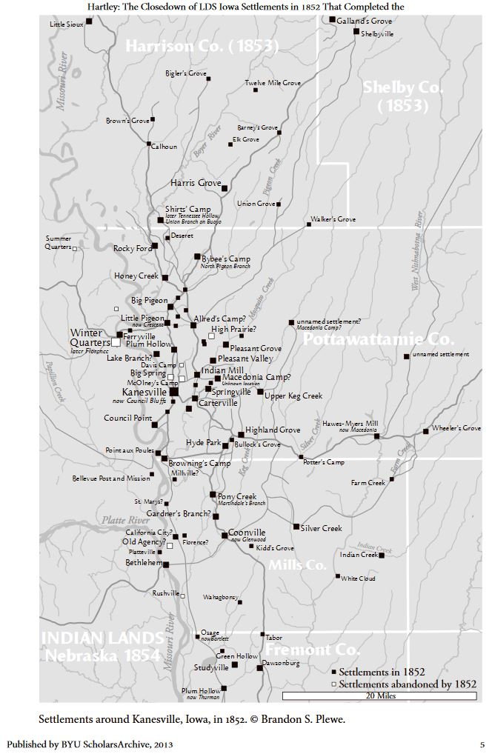

1852 Map of Mormon Settlements

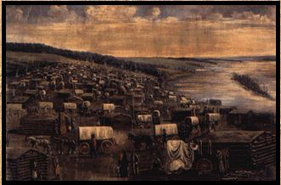

**Links**