## Trail to San Bernardino

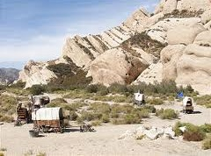 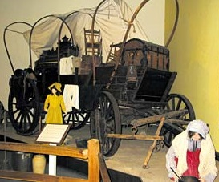

**Maps**

*Spanish Trail connecting Utah and Southern California (Lyman)*

*Cajon Pass* 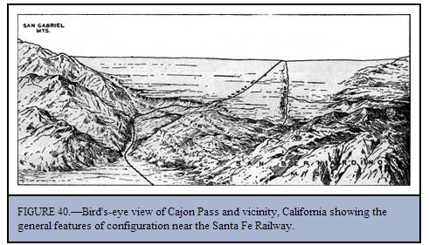

**Links**

Cajon Pass and San Bernardino - <http://www.legendsofamerica.com/ca-sanbernardino.html>