Trek to Utah

**Maps**

<https://www.lds.org/church/news/5-things-we-learn-from-database-of-mormon-pioneers?lang=eng>

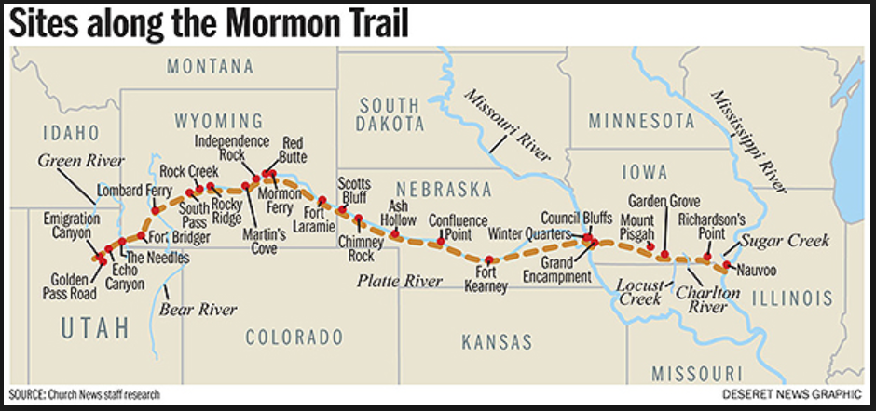

**Links**

Mormon Overland Travel – Wagon trains and passengers - <https://history.lds.org/overlandtravel/?lang=eng>

Overland Diaries and Letters, 1846-1869 (BYU Lee Library) - <http://overlandtrails.lib.byu.edu/>

Journal History of the Church - <https://history.lds.org/article/journal_history_guide?lang=eng>

**Pictures**

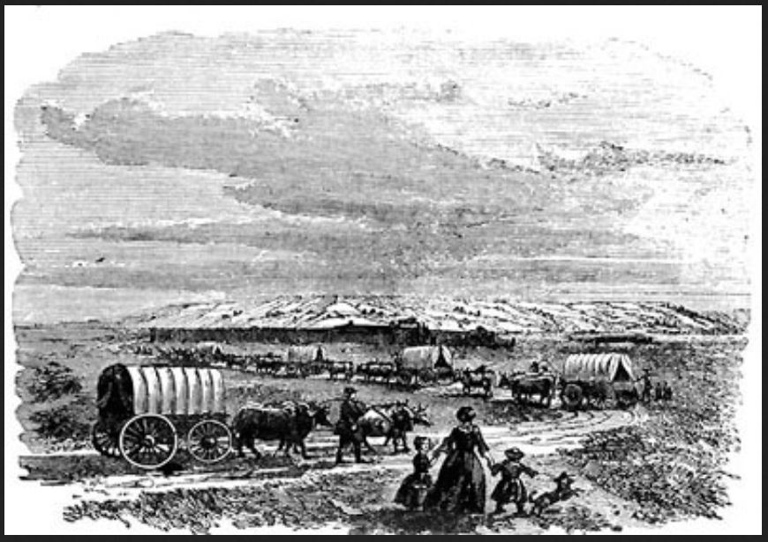

Scene Along the Mormon Trail - <https://heritage.utah.gov/wp-content/uploads/4-A-scene-along-the-Mormon-trail..jpg>