## Utah

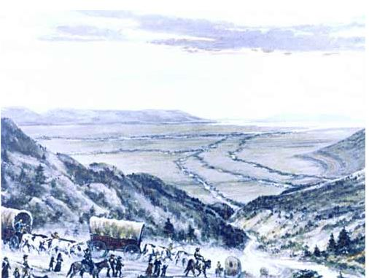

**Maps**

1852 Utah Mormon Settlements (already in Workflowy)

LDS Map of Mormon Settlements in the Intermountain West (already in Workflowy)

**Links**

Daughters of Utah Pioneers - <http://www.dupinternational.org/index.php>