The Business Scenario

🏢 GLOBALSHOP
Global E-Commerce Company · Est. 1997 · Operations across 50+ countries
"Data is our most underused asset. We need an analyst who can tell us what it means."
— GlobalShop CEO

I have been hired as a freelance data analyst by GlobalShop, a growing e-commerce business operating across multiple countries and sales channels. The company has several years of transactional data — but the leadership team has never had a dedicated analyst turn that data into business strategy.

The CEO is presenting to the board next month. She wants a comprehensive analytics report: clear findings, data-backed recommendations, and SQL evidence she can point to as the source of truth. She has given me access to the Oracle database (SH schema) and a clear brief.

📦  My Role  Freelance Data Analyst on contract to GlobalShop | 🗄️  The Data  Oracle SH Schema — 5 years of sales, customer, and product data | 🎯  The Goal  A complete analytics report with SQL evidence and business recommendations

The Six Questions the CEO Needed Answered

1. How is our revenue trending, and what seasonal patterns should we plan around?
2. Who are our most and least valuable customers — and what should we do about each group?
3. Which products are our stars, and which are quietly underperforming?
4. Which sales channels are growing, and where should we invest more?
5. How loyal are our customers — do they come back, and how quickly?
6. Where in the world is our business growing — and where should we expand next?

💡 | Each question maps directly to one Part of this project. The SQL answers the question — the written insight explains what it means for the business. Both are equally important.

PART 1 · Revenue Trend Analysis

GlobalShop's finance team tracks annual totals — but the CEO suspects there is important monthly variation that is being missed. She wants to see how revenue moves month by month, whether it is growing, and what the running year-to-date looks like.

💡 | Business Summary  The overall revenue remained relatively stable across 2020 and 2021, with several months showing positive growth after periods of decline. The weakest performance occurred in March 2020 (30% MoM), while the strongest growth was observed in July 2020 (+15% MoM). Although some stronger months appear toward the end of the year, two years of data are not enough to confirm a clear seasonal pattern. These results suggest that further analysis is needed to understand what drove the changes in monthly performance.

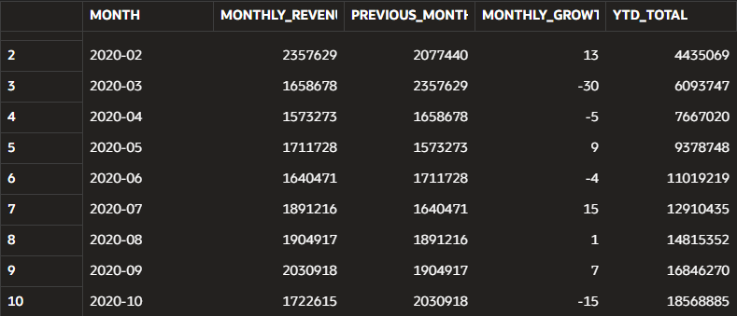

PART 2 · Customer Value Segmentation (RFM)

The CEO suspects that GlobalShop is treating all customers the same — the same email campaigns, the same promotions. She needs to know: who are the most valuable customers, who is slipping away, and who has already been lost? This intelligence should drive the CRM strategy for the next 12 months.

💡 | Business Summary  Champions – are the company’s most valuable customers and should receive things like exclusive rewards to maintain their loyalty.  Loyal Customers – contribute a large share of revenue and should receive things like personalized offers to encourage repeat purchases.  At Risk – offers greatest revenue recovery opportunity due to its high historical revenue contribution and declining engagement.  Needs Attention – is the largest customer segment, so regular reminders and personalized promotions may help to increase customer engagement.  Lost – customers have not purchased for the longest time, so they may require significant effort to re-engage.

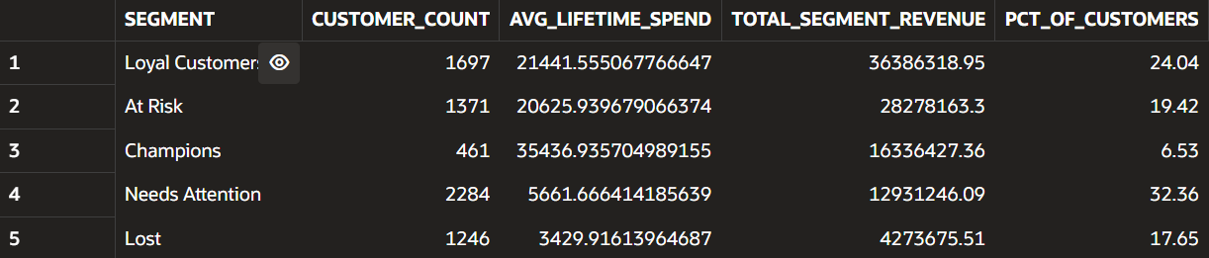

PART 3 · Product Portfolio Review

GlobalShop carries hundreds of products across multiple categories. The Head of Product wants to know which products are generating the most revenue, which are growing fast, and — critically — which are quietly declining and may need to be phased out or discounted. She needs data to make range decisions.

💡 | Business Summary  Based on the analysis, the Gold category should receive increased investment because it generated the highest revenue among the top 10 products. Products in the Watch List category should be reviewed for possible discontinuation due to declining year-over-year sales. There is no significant concentration risk because the top 10 products are evenly distributed across five categories, with two products in each category.

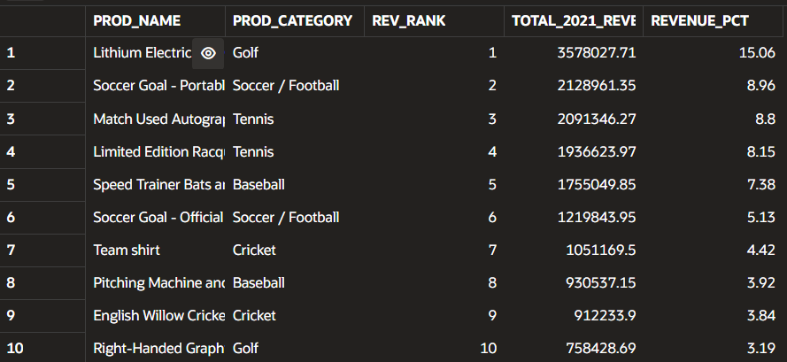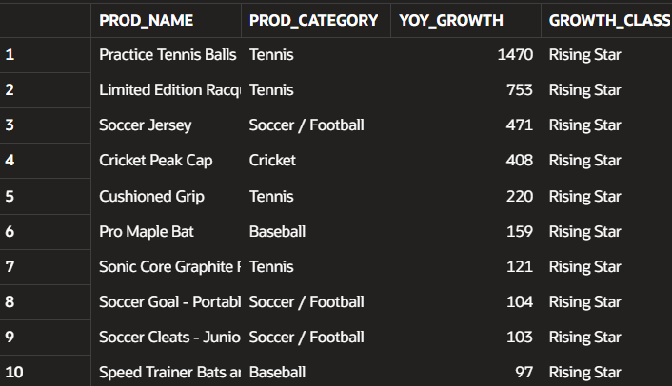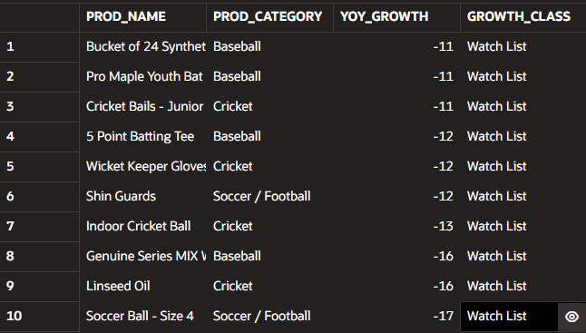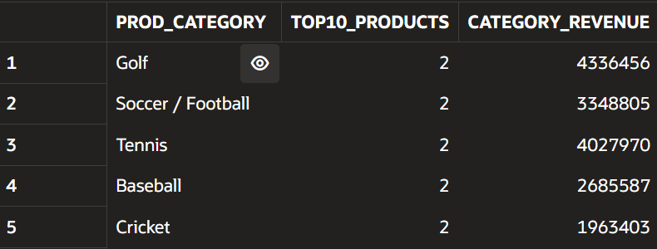

PART 4 · Channel Effectiveness & Strategy

GlobalShop sells through four channels: Direct Sales, Internet, Partners, and Tele Sales. The Head of Sales does not know which channel is growing fastest or whether the quarterly pattern differs by channel. She needs a single-view crosstab and a clear growth story to bring to the board.

💡 | Business Summary  Partners showed the strongest growth from 2020 to 2021, increasing by 44%, making it the best candidate for additional investment. Although Direct Sales remained the largest revenue-generating channel in 2021 (14,26M), its revenue declined slightly by 3%, suggesting the channel should be maintained rather than heavily expanded. Baseball was the top-performing category in both Direct Sales and Partners, indicating strong customer demand. Therefore, GlobalShop should focus future investment on expanding Partners channel while continuing to leverage the successful Baseball category to maximize revenue.

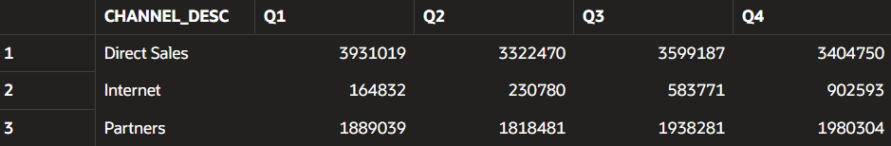
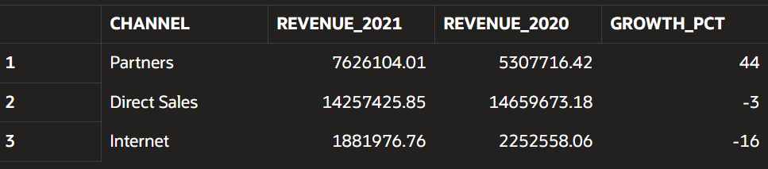
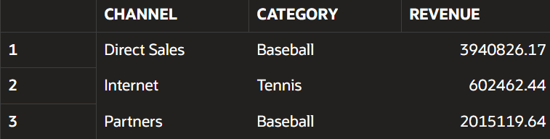

PART 5 · Customer Loyalty & Retention Analysis

Acquiring a new customer costs significantly more than retaining an existing one. GlobalShop's Head of CRM wants to understand how loyal their customers actually are: how many come back after their first purchase, how quickly they do so, and who the most committed repeat buyers are.

💡 | Business Summary  Customer retention and purchase frequency vary across acquisition cohorts. For example the January cohort achieved 88% 90-day return rate, while April cohort reached only 64%. The average time between first and second purchases also ranged from 15 to 56 days, indicating inconsistent customer engagement. Focusing on underperforming cohorts with personalized promotions, reminders and loyalty incentives might help to encourage faster repeat purchases and improve retention.

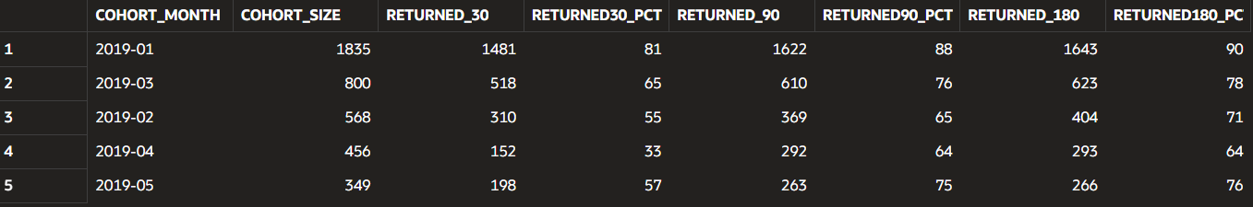

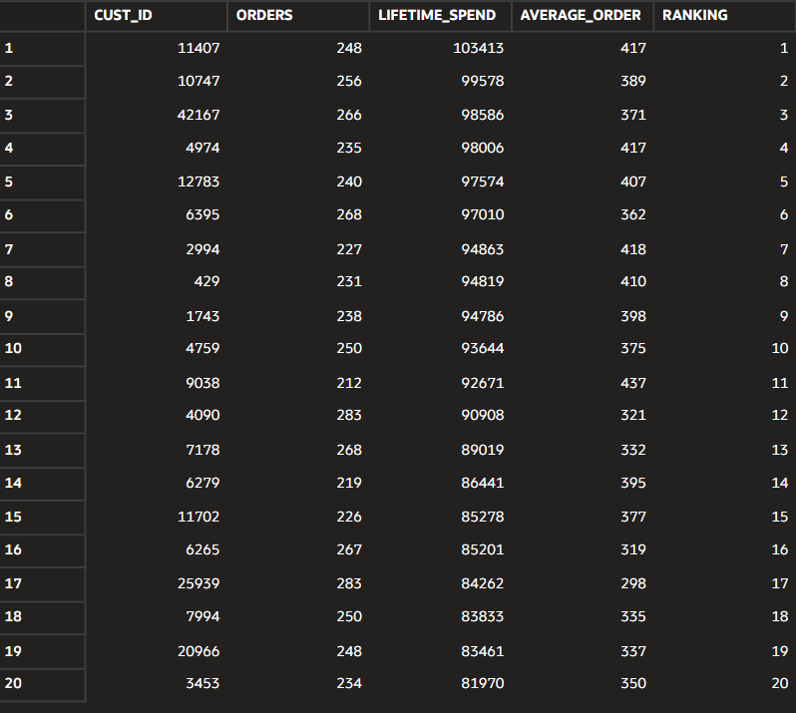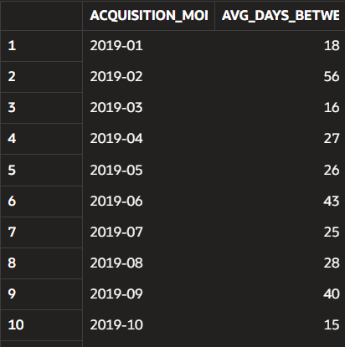

PART 6 · Geographic Reach & Expansion Opportunity

GlobalShop operates in 50+ countries but the leadership team has never done a structured geographic analysis. The CEO wants to know where revenue is concentrated, which markets are growing fastest, and — most importantly — where the data suggests GlobalShop should invest in expansion.

💡 | Business Summary  Country 52790 is GlobalShop’s largest market, with the highest 2021 revenue and 2,556 active customers, while still growing 11% YoY. Within top 10, country 52778 achieved the highest growth (14%). Outside top 10, country 52775 recorded 163% YoY growth, making it strong candidate for future expansion.

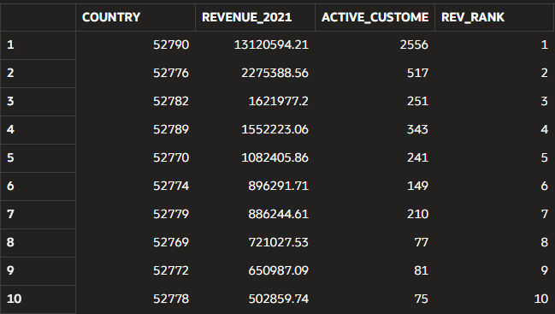

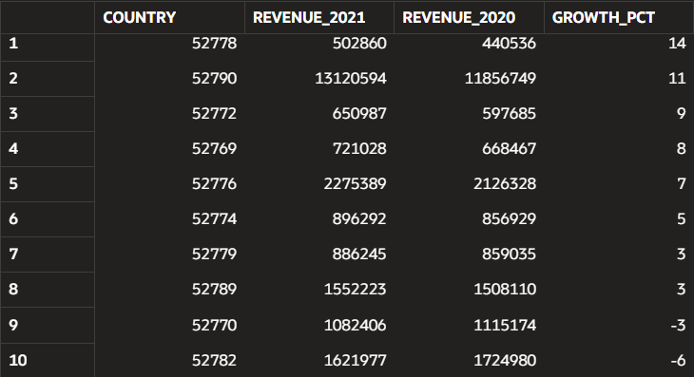

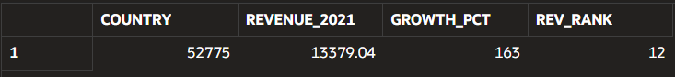

📋 EXECUTIVE SUMMARY
GlobalShop operates in over 50 countries and wants to better understand its customers, marketing performance, and expansion opportunities to support future growth.

Marketing Effectiveness
The clearest opportunity lies in sales channels. Partners grew 44% year-over-year from 2020 to 2021, while Direct Sales — still the largest channel at $14.26M in 2021 — declined 3%. This signals a shift in customer buying behavior toward the Partners channel that current marketing investment does not yet reflect.

Geographic Expansion
Geography tells a similar story of untapped growth. Within GlobalShop's top 10 markets, country 52778 grew fastest at 14%, but the real standout is outside the top tier: country 52775 grew 163% year-over-year, suggesting a small but rapidly emerging market worth early investment before competitors move in.

Customer Loyalty
Customer loyalty is inconsistent and represents a retention gap. Customers acquired in January returned within 90 days at an 88% rate, compared to just 64% for the April cohort — a 24-point swing that has nothing to do with product and everything to do with how new customers are engaged after their first purchase.

Recommendations
- Reallocate marketing budget toward the Partners channel. With 44% YoY growth against a 3% decline in Direct Sales, shifting even a modest share of marketing and account-management resources toward Partners should compound an already-proven trend.
- Prioritize investment in emerging markets, starting with country 52775. A 163% YoY growth rate from a low base is a strong early signal. Piloting localized marketing and inventory support there now positions GlobalShop ahead of competitors before the market matures.
- Launch targeted retention campaigns for weaker acquisition cohorts. Closing even half the gap between the April cohort's 64% return rate and the January cohort's 88% — through structured follow-up emails and time-bound incentives in the first 90 days — would meaningfully lift repeat purchase revenue across every future cohort.

GlobalShop is not short of growth — it is short of focus: the data shows precisely where that growth is concentrated, and the next 12 months should be built around doubling down on it rather than spreading resources evenly across every channel, market, and customer segment.

THE COMPLETE SQL CODE FROM ORACLE
/* REVENUE TREND ANALYSIS

The overall revenue remained relatively stable across 2020 and 2021, with several months showing positive growth after periods of decline.
The weakest performance occurred in March 2020 (-30% MoM), while the strongest growth was observed in July 2020 (+15% MoM).
Although some stronger months appear toward the end of the year, two years of data are not enough to confirm a clear seasonal pattern.
These results suggest that further analysis is needed to understand what drove the changes in monthly performance. */

-- Raw Monthly Revenue
WITH monthly_rev AS (
SELECT
TRUNC(time_id,'MM') as Sale_Month,
ROUND(SUM(amount_sold),0) as Monthly_Revenue
FROM sh.sales
WHERE TO_CHAR(time_id,'YYYY') IN ('2020','2021')
GROUP BY TRUNC(time_id,'MM')
ORDER BY TRUNC(time_id,'MM')),

-- Month-over-month (MoM) growth percentage
mom_growth_pct AS (
SELECT
Sale_Month,
Monthly_Revenue,
LAG(Monthly_Revenue,1) OVER (ORDER BY Sale_Month) AS Previous_Month_Revenue,
ROUND((Monthly_Revenue - LAG(Monthly_Revenue,1) OVER (ORDER BY Sale_Month))/
LAG(Monthly_Revenue,1) OVER (ORDER BY Sale_Month) *100,0) AS Monthly_Growth_Percentage,
ROUND(SUM(Monthly_Revenue) OVER (
PARTITION BY EXTRACT (YEAR FROM Sale_Month)
ORDER BY Sale_Month),0) AS YTD_Total
FROM monthly_rev)

-- Final Query
SELECT TO_CHAR(Sale_Month, 'YYYY-MM') AS Month,
Monthly_Revenue,
Previous_Month_Revenue,
Monthly_Growth_Percentage,
YTD_Total
FROM mom_growth_pct
ORDER BY Sale_Month;

/*CUSTOMER VALUE SEGMENTATION (RFM)

Champions – are the company’s most valuable customers and should receive things like exclusive rewards to maintain their loyalty.
Loyal Customers – contribute a large share of revenue and should receive things like personalized offers to encourage repeat purchases.
At Risk – offers greatest revenue recovery opportunity due to its high historical revenue contribution and declining engagement.
Needs Attention – is the largest customer segment, so regular reminders and personalized promotions may help to increase customer engagement.
Lost – customers have not purchased for the longest time, so they may require significant effort to re-engage.*/

-- CTE 1:Calculate RFM Metrics
WITH rfm_metrics AS (
SELECT
cust_id,
DATE '2022-12-31' - MAX(time_id) AS recency_days,
COUNT(*) AS frequency,
SUM(amount_sold) AS monetary
FROM sh.sales
GROUP BY cust_id),
-- CTE 2: Assign scores to each metric
rfm_scored AS (
SELECT
cust_id, recency_days, frequency, monetary,
NTILE(4) OVER (ORDER BY recency_days DESC) AS r_score,
NTILE(4) OVER (ORDER BY frequency ASC) AS f_score,
NTILE(4) OVER (ORDER BY monetary ASC) AS m_score
FROM rfm_metrics),
-- CTE 3: Classify customers into RFM segments
rfm_segments AS (
SELECT
cust_id, recency_days, frequency, monetary,
r_score, f_score, m_score,
CASE
WHEN r_score=4 AND f_score=4 AND m_score=4 THEN 'Champions'
WHEN r_score>=3 AND f_score>=3 THEN 'Loyal Customers'
WHEN r_score<=2 AND f_score>=3 THEN 'At Risk'
WHEN r_score=1 THEN 'Lost'
ELSE 'Needs Attention' END AS segment
FROM rfm_scored)
-- Main Query
SELECT
segment,
COUNT(cust_id) AS customer_count,
AVG(monetary) AS avg_lifetime_spend,
SUM(monetary) AS total_segment_revenue,
ROUND(COUNT(*)/(SELECT COUNT(*) FROM rfm_segments)*100,2) AS pct_of_customers
FROM rfm_segments
GROUP BY segment
ORDER BY total_segment_revenue DESC;

/*PRODUCT PORTFOLIO REVIEW

Based on the analysis, the Gold category should receive increased investment because it generated the highest revenue among the top 10 products.
Products in the Watch List category should be reviewed for possible discontinuation due to declining year-over-year sales.
There is no significant concentration risk because the top 10 products are evenly distributed across five categories, with two products in each category.*/

-- QUERY 1 – Top 10 Products
SELECT
p.prod_name,
p.prod_category,
RANK() OVER (ORDER BY SUM(s.amount_sold) DESC) AS rev_rank,
SUM(s.amount_sold) AS total_2021_revenue,
ROUND(SUM(s.amount_sold)/SUM(SUM(s.amount_sold)) OVER ()*100,2) AS revenue_pct
FROM sh.products p JOIN sh.sales s ON p.prod_id=s.prod_id
WHERE TO_CHAR(time_id,'YYYY')= '2021'
GROUP BY p.prod_name,p.prod_category
ORDER BY SUM(s.amount_sold) DESC
FETCH FIRST 10 ROWS ONLY;
-- QUERY 2 – Growth Classification
WITH prod_sales AS(
SELECT
p.prod_name,
p.prod_category,
TO_CHAR(s.time_id,'YYYY') AS year,
ROUND(SUM(s.amount_sold)) AS revenue
FROM sh.sales s JOIN sh.products p ON s.prod_id=p.prod_id
WHERE TO_CHAR(s.time_id,'YYYY') IN ('2020','2021')
GROUP BY p.prod_name, p.prod_category,TO_CHAR(s.time_id,'YYYY')),
yearly_sales AS(SELECT prod_name, prod_category, year, revenue,
LAG(revenue) OVER (PARTITION BY prod_name ORDER BY year) AS prev_rev
FROM prod_sales),
yoy_growth AS(
SELECT
prod_name, prod_category, year, revenue,prev_rev,
ROUND(((revenue-prev_rev)/prev_rev)*100,0) AS yoy_growth
FROM yearly_sales
WHERE prev_rev IS NOT NULL),
classified AS (SELECT
prod_name, prod_category,yoy_growth,
CASE
WHEN yoy_growth >10 THEN 'Rising Star'
WHEN yoy_growth BETWEEN -10 AND 10 THEN 'Stable'
ELSE 'Watch List' END AS growth_class
FROM yoy_growth)
--We have to run two different Selects in different times
SELECT *
FROM classified
WHERE growth_class = 'Rising Star'
ORDER BY yoy_growth DESC
FETCH FIRST 10 ROWS ONLY;

SELECT *
FROM classified
WHERE growth_class = 'Watch List'
ORDER BY yoy_growth DESC
FETCH FIRST 10 ROWS ONLY;

-- QUERY 3 – Category Concentration
WITH top_products AS(
SELECT
p.prod_name,
p.prod_category,
RANK() OVER (ORDER BY SUM(s.amount_sold) DESC) AS rev_rank,
SUM(s.amount_sold) AS total_2021_revenue,
ROUND(SUM(s.amount_sold)/SUM(SUM(s.amount_sold)) OVER ()*100,2) AS revenue_pct
FROM sh.products p JOIN sh.sales s ON p.prod_id=s.prod_id
WHERE TO_CHAR(time_id,'YYYY')= '2021'
GROUP BY p.prod_name, p.prod_category
ORDER BY SUM(s.amount_sold) DESC
FETCH FIRST 10 ROWS ONLY)
SELECT
prod_category,
COUNT(*) AS top10_products,
ROUND(SUM(total_2021_revenue),0) AS category_revenue
FROM top_products
GROUP BY prod_category;

/*CHANNEL EFFECTIVENESS AND STRATEGY

Partners showed the strongest growth from 2020 to 2021, increasing by 44%, making it the best candidate for additional investment.
Although Direct Sales remained the largest revenue-generating channel in 2021 (14,26M),
its revenue declined slightly by 3%, suggesting the channel should be maintained rather than heavily expanded.
Baseball was the top-performing category in both Direct Sales and Partners, indicating strong customer demand.
Therefore, GlobalShop should focus future investment on expanding Partners channel while continuing to leverage the successful Baseball category to maximize revenue.*/

-- QUERY 1 – Channel Crosstab (PIVOT)
SELECT *
FROM(SELECT
c.channel_desc,
t.calendar_quarter_desc,
ROUND(SUM(s.amount_sold),0) AS revenue
FROM sh.channels c JOIN sh.sales s ON c.channel_id=s.channel_id
JOIN sh.times t ON s.time_id=t.time_id
WHERE TO_CHAR(s.time_id, 'YYYY') = '2021'
GROUP BY t.calendar_quarter_desc, c.channel_desc)

PIVOT (SUM(revenue) FOR calendar_quarter_desc IN (
'2021-01' AS Q1, '2021-02' AS Q2,'2021-03' AS Q3,'2021-04' AS Q4))
ORDER BY channel_desc;
-- QUERY 2 – YOY Channel Growth
WITH yearly_channel_sales AS (
SELECT
c.channel_desc AS Channel,
TO_CHAR(s.time_id, 'YYYY') AS Year,
SUM(s.amount_sold) AS Revenue
FROM sh.channels c JOIN sh.sales s ON c.channel_id=s.channel_id
WHERE TO_CHAR(s.time_id, 'YYYY') IN ('2020','2021')
GROUP BY c.channel_desc, TO_CHAR(s.time_id, 'YYYY')),
channel_growth AS (
SELECT
Channel, Year, Revenue,
LAG(Revenue) OVER (PARTITION BY Channel ORDER BY Year) AS Revenue_2020
FROM yearly_channel_sales),
yoy_growth AS (
SELECT
Channel, Year, Revenue AS Revenue_2021,Revenue_2020,
ROUND(((Revenue-Revenue_2020)/Revenue_2020) *100,0) AS growth_pct
FROM channel_growth
WHERE Revenue_2020 IS NOT NULL)
SELECT
Channel, Revenue_2021, Revenue_2020, growth_pct
FROM yoy_growth
ORDER BY growth_pct DESC;
-- QUERY 3 – Channel x Category
WITH channel_category AS
(SELECT
c.channel_desc AS Channel,
p.prod_category AS Category,
SUM(s.amount_sold) AS Revenue
FROM sh.channels c JOIN sh.sales s ON c.channel_id=s.channel_id
JOIN sh.products p ON s.prod_id=p.prod_id
WHERE TO_CHAR(s.time_id,'YYYY')='2021'
GROUP BY c.channel_desc,p.prod_category),
ranked AS (
SELECT Channel, Category, Revenue,
RANK() OVER (PARTITION BY Channel ORDER BY Revenue DESC) AS Ranking
FROM channel_category)
SELECT
Channel,Category,Revenue
FROM ranked
WHERE ranking = 1;

/*CUSTOMER LOYALTY AND RETENTION ANALYSIS

Customer retention and purchase frequency vary across acquisition cohorts.
For example the January cohort achieved 88% 90-day return rate, while April cohort reached only 64%.
The average time between first and second purchases also ranged from 15 to 56 days, indicating inconsistent customer engagement.
Focusing on underperforming cohorts with personalized promotions, reminders and loyalty incentives might help to encourage faster repeat purchases and improve retention.*/

--QUERY 1 – Muli-interval Retention
-- Earliest purchase date
WITH first_purchases AS(
SELECT
cust_id AS Customer,
MIN(time_id) AS first_purchase
FROM sh.sales
GROUP BY cust_id),
-- Later purchases
second_purchases AS(
SELECT
f.Customer,f.first_purchase,
(MIN(s.time_id)-first_purchase) AS days_after_first
FROM first_purchases f LEFT JOIN sh.sales s ON f.Customer=s.cust_id
AND s.time_id>first_purchase
GROUP BY f.Customer,f.first_purchase),
-- Creating Monthly Cohorts
cohorts AS(
SELECT
TRUNC(first_purchase,'MM') AS cohort_month,
COUNT(*) AS cohort_size,
SUM(CASE WHEN days_after_first<=30 THEN 1 ELSE 0 END) AS returned_30,
SUM(CASE WHEN days_after_first<=90 THEN 1 ELSE 0 END)AS returned_90,
SUM(CASE WHEN days_after_first<=180 THEN 1 ELSE 0 END)AS returned_180
FROM second_purchases
GROUP BY TRUNC(first_purchase,'MM'))
SELECT
TO_CHAR(cohort_month,'YYYY-MM') AS cohort_month,
cohort_size,
returned_30,
ROUND((returned_30/cohort_size)*100,0) AS returned30_pct,
returned_90,
ROUND((returned_90/cohort_size)*100,0) AS returned90_pct,
returned_180,
ROUND((returned_180/cohort_size)*100,0) AS returned180_pct
FROM cohorts
ORDER BY cohort_size DESC
FETCH FIRST 5 ROWS ONLY;
-- QUERY 2 – Most Loyal Customers
WITH customer_info AS
(SELECT
cust_id,
COUNT(*) AS orders,
ROUND(SUM(amount_sold)) AS lifetime_spend,
ROUND(AVG(amount_sold)) AS average_order
FROM sh.sales
GROUP BY cust_id
HAVING COUNT(*)>=5)
SELECT cust_id, orders, lifetime_spend,average_order,
ROW_NUMBER() OVER (ORDER BY lifetime_spend DESC) AS ranking
FROM customer_info
ORDER BY ranking
FETCH FIRST 20 ROWS ONLY;
-- QUERY 3 – Average Days Between Orders
WITH ordered_purchases AS(
SELECT
cust_id,
time_id,
ROW_NUMBER() OVER (
PARTITION BY cust_id ORDER BY time_id) AS rn
FROM sh.sales),
purchase_gap AS (
SELECT
p1.cust_id,
p1.time_id AS first_purchase,
p2.time_id AS second_purchase,
p2.time_id-p1.time_id AS days_between
FROM ordered_purchases p1 JOIN ordered_purchases p2 ON p1.cust_id=p2.cust_id
WHERE p1.rn =1 AND p2.rn=2)
SELECT
TO_CHAR(TRUNC(first_purchase,'MM'),'YYYY-MM') AS acquisition_month,
ROUND(AVG(days_between),0) AS avg_days_between_orders
FROM purchase_gap
GROUP BY acquisition_month
ORDER BY acquisition_month;

/*GEOGRAPHIC REACH AND EXPANSION OPPORTUNITY

Country 52790 is GlobalShop’s largest market, with the highest 2021 revenue and 2,556 active customers,
while still growing 11% YoY. Within top 10, country 52778 achieved the highest growth (14%).
Outside top 10, country 52775 recorded 163% YoY growth, making it strong candidate for future expansion.*/

-- QUERY 1 – Top 10 Countries by 2021 Revenue
WITH country_info AS(
SELECT
c.country_id AS country,
SUM(s.amount_sold) AS revenue_2021,
COUNT(DISTINCT c.cust_id) AS active_customers_2021
FROM sh.sales s JOIN sh.customers c ON s.cust_id=c.cust_id
WHERE TO_CHAR(s.time_id,'YYYY')='2021'
GROUP BY c.country_id)
SELECT country, revenue_2021,active_customers_2021,
RANK() OVER (ORDER BY revenue_2021 DESC) AS rev_rank
FROM country_info
ORDER BY rev_rank
FETCH FIRST 10 ROWS ONLY;
-- QUERY 2 – Country YOY Revenue Growth
WITH top_10 AS (
SELECT
c.country_id AS country,
SUM(s.amount_sold) AS revenue_2021,
RANK() OVER(ORDER BY SUM(s.amount_sold) DESC) AS rev_rank
FROM sh.customers c JOIN sh.sales s ON c.cust_id=s.cust_id
WHERE TO_CHAR(s.time_id,'YYYY') = '2021'
GROUP BY c.country_id),
country_info AS(
SELECT
t.country,
TO_CHAR(s.time_id,'YYYY') AS year,
ROUND(SUM(s.amount_sold)) AS revenue
FROM sh.sales s JOIN sh.customers c ON s.cust_id=c.cust_id
JOIN top_10 t ON c.country_id=t.country
WHERE TO_CHAR(s.time_id,'YYYY') IN ('2020','2021') AND t.rev_rank<=10
GROUP BY t.country, TO_CHAR(s.time_id,'YYYY')),
yearly_sale AS(
SELECT
country,year, revenue,
LAG(revenue) OVER (PARTITION BY country ORDER BY year) AS revenue_2020
FROM country_info)
SELECT
country,
revenue AS revenue_2021,
revenue_2020,
ROUND(((revenue-revenue_2020)/revenue_2020)*100,0) AS growth_pct
FROM yearly_sale
WHERE revenue_2020 IS NOT NULL
ORDER BY growth_pct DESC;

-- QUERY 3 – Emerging Markets
WITH country_info AS (
SELECT
c.country_id AS country,
TO_CHAR(s.time_id,'YYYY') AS year,
SUM(s.amount_sold) AS revenue
FROM sh.sales s JOIN sh.customers c ON s.cust_id=c.cust_id
WHERE TO_CHAR(s.time_id,'YYYY') IN ('2020','2021')
GROUP BY c.country_id, TO_CHAR(s.time_id,'YYYY')),
yearly_sale AS (
SELECT
country,year,revenue,
LAG(revenue) OVER (PARTITION BY country ORDER BY year) AS revenue_2020
FROM country_info),
growth_rank AS(
SELECT
country,year,revenue AS revenue_2021,revenue_2020,
ROUND(((revenue-revenue_2020)/revenue_2020)*100,0) AS growth_pct,
RANK() OVER (ORDER BY revenue DESC) AS rev_rank
FROM yearly_sale
WHERE revenue_2020 IS NOT NULL)
SELECT
country,revenue_2021,growth_pct,rev_rank
FROM growth_rank
WHERE rev_rank BETWEEN 11 AND 30 AND growth_pct >15
ORDER BY growth_pct DESC;

