1.Verilən tam ədədin faktoriyalin hesapliyan algoritm yazin.

C#

int number = int.Parse(Console.ReadLine());

int factorial = 1;

for (int i =1; i <= number; i++)

{Console.Write("Type the number");

factorial = factorial *i;

}

Console.Write($"Factorial of { number} is: { factorial}");

Console.ReadLine();

5

Type the numberType the numberType the numberType the numberType the numberFactorial of 5 is: 120

JavaScript

function factorial(n) {

    let factorial = 1;

    if (n==0 || n==1) {

         return factorial;

    }else{

        for(var i = n; i>=1; i--){

            factorial=factorial * i;

        }

        return factorial;

    }

}

let n = 5

factorial = factorial(n)

console.log("Factorial" + n + factorial);

Windows PowerShell

Copyright (C) Microsoft Corporation. All rights reserved.

Install the latest PowerShell for new features and improvements! https://aka.ms/PSWindows

PS C:\Users\Fidan> node .\Fidan1.js

**Factorial5is120**

PS C:\Users\Fidan>

Flowchart

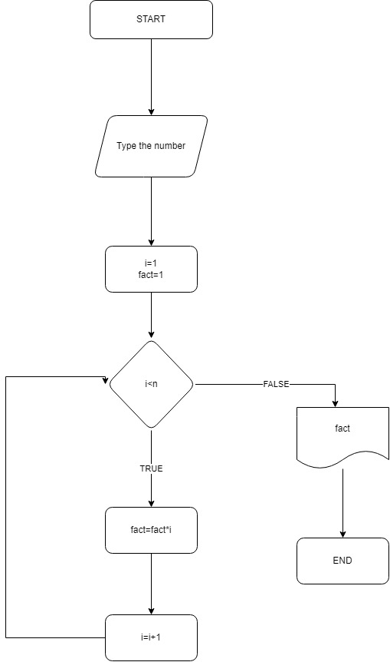

2.Verilən ədədin sadə və mürəkkəb olduğunu tapan program.

C#

var n = int.Parse(Console.ReadLine());

var prime = true;

for (var i = 2; i <= Math.Sqrt(n); i++)

{

if (n % i == 0)

{

prime = false;

break;

}

}

if (prime )

{

Console.WriteLine("Prime");

}

else

{

Console.WriteLine("Not prime");

}

23

Prime

C:\Users\Fidan\source\repos\sade ve murekkeb\sade ve murekkeb\bin\Debug\net6.0\sade ve murekkeb.exe (process 29028) exited with code 0.

Press any key to close this window . . .

JavaScript

function prime(n)

{

if (n===2)

{

return true;

}

else if(n ===1)

{

return false;

}else

{

for(var x = 2; x >n; x++)

{

if(n % x === 0)

{

return true;

}

}

return false;

}

}

console.log(prime(9));

Flowchart

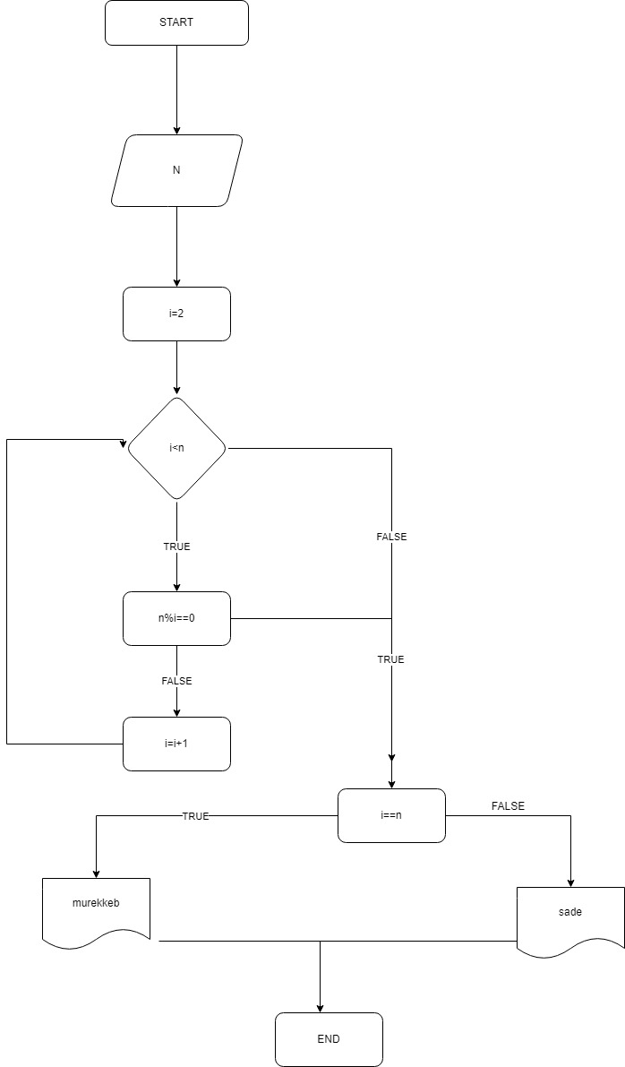

3.Ədədin neçə mərtəbəli olduğunu tapan algoritm.

Flowchart

