**Monitoring Report For demo**

**Project: bank_churn**

**Time Interval:** *2023-04-12* to *2023-05-12*

Project **bank_churn** contains **1 model(s)** and **1 dataset(s)** as summarized below. During this time interval a total number of **15 alert(s)** were triggered for this project.

**Datasets**

|  |  |  |
| --- | --- | --- |
| Dataset ID | Source | Size (#Rows) |
| bank_churn | baseline.csv | 4000 |

**Models**

|  |  |
| --- | --- |
| Model ID | Model Type |
| churn_classifier | binary_classification |

**Alert Summary**

|  |  |
| --- | --- |
| **Critical Alerts** | **Warning Alerts** |

**Alert Rules and Incidents**

**DATA_INTEGRITY Alerts**

**Rule:** Missing estimated salary 1

(model_id=churn_classifier, metric=MISSING_VALUE, column=estimatedsalary, warning_threshold=0.05, critical_threshold=0.1)

|  |  |  |  |
| --- | --- | --- | --- |
| model_id | severity | value | date |
| churn_classifier | CRITICAL | 29.0 | 2023-05-04 |
| churn_classifier | CRITICAL | 42.0 | 2023-05-05 |
| churn_classifier | CRITICAL | 35.0 | 2023-05-06 |
| churn_classifier | CRITICAL | 36.0 | 2023-05-07 |
| churn_classifier | CRITICAL | 44.0 | 2023-05-08 |

**PERFORMANCE Alerts**

**Rule:** Accuracy Churn Classifier

(model_id=churn_classifier, metric=ACCURACY, column=, warning_threshold=0.7, critical_threshold=0.65)

|  |  |  |  |
| --- | --- | --- | --- |
| model_id | severity | value | date |
| churn_classifier | WARNING | 0.67 | 2023-05-04 |
| churn_classifier | WARNING | 0.66 | 2023-05-05 |
| churn_classifier | WARNING | 0.66 | 2023-05-06 |
| churn_classifier | WARNING | 0.69 | 2023-05-07 |
| churn_classifier | WARNING | 0.66 | 2023-05-08 |

**DATA_DRIFT Alerts**

**Rule:** Output Drift Churn Classifier

(model_id=churn_classifier, metric=JSD, column=probability_churn, warning_threshold=0.15, critical_threshold=0.2)

|  |  |  |  |
| --- | --- | --- | --- |
| model_id | severity | value | date |
| churn_classifier | WARNING | 0.19 | 2023-05-04 |
| churn_classifier | CRITICAL | 0.22 | 2023-05-05 |
| churn_classifier | CRITICAL | 0.22 | 2023-05-06 |
| churn_classifier | WARNING | 0.2 | 2023-05-07 |
| churn_classifier | CRITICAL | 0.22 | 2023-05-08 |

**Baseline Model Performance**

**Performance Summary**

|  |  |  |  |  |  |
| --- | --- | --- | --- | --- | --- |
| Model | Dataset | Source | Accuracy | F1 | AUC |
| churn_classifier | bank_churn | baseline.csv | 0.82 | 0.88 | 0.89 |

**Performance Charts**

ROC Curves

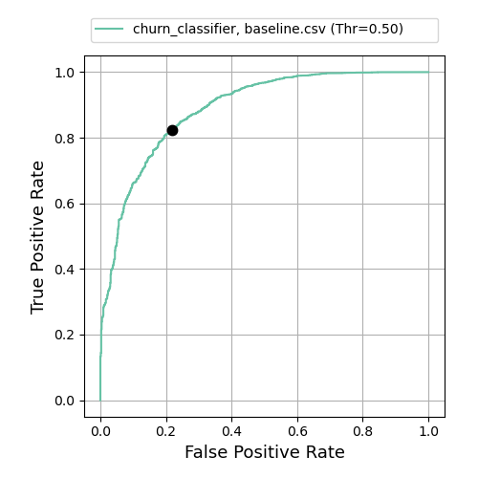

Confusion Matrices

|  |  |
| --- | --- |
| **Model:** churn_classifier **Dataset:** bank_churn **Source:** baseline.csv |  |

**Performance Analysis**

|  |  |
| --- | --- |
| **Model:** churn_classifier **Metric:** accuracy **Segmentation:** geography **Segmentation Mode:** |  |