TASK GUIDE (A1X.01)

1. Objectives.Students know how to start an Android Studio Project with blank layout.
2. Result

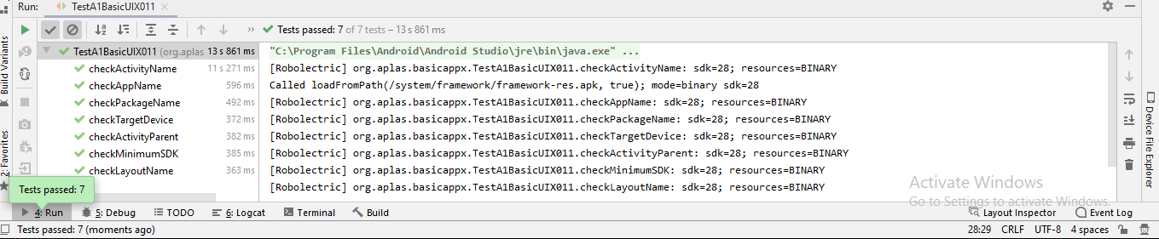

TASK GUIDE (A1X.02)

1. Objectives.Students know how to configure Android Studio project resources, like string and font
2. Result

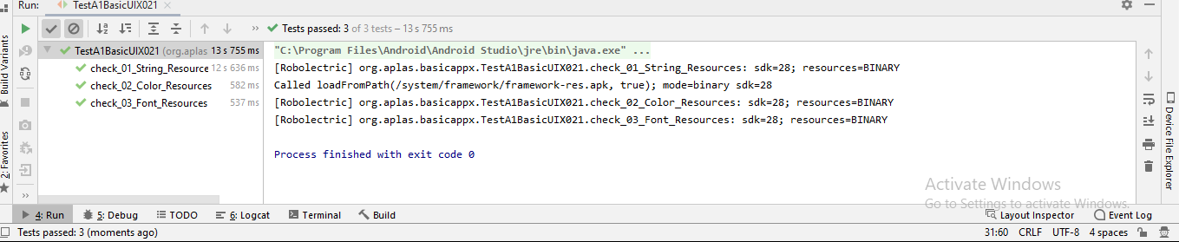

TASK GUIDE (A1X.03)

1. Objectives. Students know how to design basic layout, add TextView, and add a Button.
2. Result

