UNIVERSITY OF RWANDA
COLLEGE OF SCIENCE AND TECHNOLOGY
SCHOOL OF ICT
COMPUTER AND SOFTWARE ENGINEERING DEPARTMENT — NYARUGENGE CAMPUS
MODULE CODE/TITLE: WEB DESIGN
PROJECT TECHNICAL REPORT
Web Technology Technical Assessment 2026
Community Health Appointment Web Application
Registration Number: | 225039978
Department: | Computer Engineering
Year of Study: | Year One
Date: | 18/07/2026
Live Project Link:  Project sourecode link: | https://fideleihora.github.io/hospitalappointmentfidele/HTML%20assignment/HTML/index.html  https://github.com/fideleihora/hospitalappointmentfidele

Table of Contents
Table of Contents 2
Table of Figures 4
List of Abbreviations 5
Chapter 1. Introduction 6
1.1. Historical Background of the Case Study 6
1.2. Problem Statement 6
1.3. Objectives of the Project 6
1.4. Expected Outcomes 6
1.5. Project Rationale (Importance to the Community) 7
Chapter 2. System Analysis and Design 8
2.1. System Analysis 8
2.1.1. Intended Users of the Project 8
2.1.2. Intended System Partners 8
2.2. System Design 8
High-Level Architecture 8
UI Design (Sketch of the UI Module) and Flowcharts 10
Database Design with ERD and Relationships 13
Chapter 3. Implementation 16
3.1. Introduction of the Section 16
3.2. Screenshots, Captions and Discussion 16
3.2.1. Home / Landing Page 16
3.2.2. User Login Page 17
3.2.3. User Registration Page 18
3.2.4. Staff/Admin Login Page 19
Chapter 4. Conclusion and Recommendation 21
Recommendations 21
Appendix 22
Link to the GitHub Repository of the Deployed Project 22

Table of Figures
The figures below are numbered by the chapter and section in which they appear. In Word, this list can be refreshed automatically (References → Update Table) once figure captions are finalised.
- Figure 2.1 — High-Level System Architecture
- Figure 2.2 — Patient Appointment Booking Flowchart
- Figure 2.3 — Entity Relationship Diagram (ERD)
- Figure 3.1 — Home / Landing Page
- Figure 3.2 — User Login Page
- Figure 3.3 — User Registration Page
- Figure 3.4 — Staff/Admin Login Page
- Figure 3.5 — Booking and Doctor schedule form page

List of Abbreviations
- UI — User Interface
- UX — User Experience
- ERD — Entity Relationship Diagram
- IT — Information Technology
- SMS — Short Message Service
- HTML — HyperText Markup Language
- CSS — Cascading Style Sheets
- JS — JavaScript
- DB — Database
- KFH — King Faisal Hospital
- CHUK — Centre Hospitalier Universitaire de Kigali
- RMH — Rwanda Military Hospital

Chapter 1. Introduction

1.1. Historical Background of the Case Study
Access to timely medical care in Rwanda, as in many developing countries, has traditionally depended on patients physically travelling to a hospital or health centre simply to find out whether a doctor is available. Facilities such as King Faisal Hospital (KFH), CHUK, Butaro Cancer Center, RMH Kanombe and Legacy Clinics serve large catchment areas and, for years, have relied on manual, paper-based booking registers or first-come-first-served queuing at the reception desk. This approach worked reasonably well when patient volumes were small, but as Rwanda's population and its demand for specialized care have grown, the same manual process has become a source of long queues, double-bookings, and lost time for both patients and hospital staff.
Government-led digitization efforts in the health sector, together with the rapid growth of internet and smartphone access across the country, have created the right conditions for a shift away from manual scheduling towards web-based appointment systems. The Community Health Appointment Web Application presented in this report responds directly to that shift: it is a web platform through which a patient can view doctor availability and reserve a consultation slot without leaving home, while hospital staff retain full visibility and control over the schedule.

1.2. Problem Statement
In many communities, and particularly in developing regions such as Rwanda, patients face real difficulty booking medical appointments efficiently. Long queues, manual scheduling, and a general lack of transparency about doctor availability often delay the delivery of care. The situation is made worse by the fact that patients frequently have to visit a hospital in person just to secure a time slot, which wastes time, transport costs, and, in some cases, delays treatment for conditions that need prompt attention.

1.3. Objectives of the Project
The general objective of this project is to design and implement a Community Health Appointment Web Application that allows patients to book medical appointments online, reducing the need for physical queuing and improving the overall efficiency of hospital scheduling. The specific objectives are:
- To design a simple, accessible web interface through which patients can create an account and log in securely.
- To allow patients to view doctor availability and book, reschedule, or track appointments online.
- To provide hospital staff and administrators with a dedicated portal to manage appointments, doctors, and schedules.
- To reduce overcrowding at hospital reception desks by shifting the booking process to a digital platform.
- To lay a technical foundation (HTML/CSS front-end structure) that can later be extended with a working database and server-side logic.

1.4. Expected Outcomes
By the end of the project, the system is expected to provide patients with a straightforward way to register, sign in, and reach a booking interface from any internet-enabled device. Hospital staff and administrators are expected to have a distinct, secured entry point into the system, separate from the patient portal, reflecting the different responsibilities of the two user groups. More broadly, the project is expected to demonstrate, at a front-end level, how a centralized online platform can replace manual scheduling registers, reduce waiting times, and give patients clearer visibility into the appointment process.

1.5. Project Rationale (Importance to the Community)
A Community Health Appointment Web Application matters because it touches every stage of a patient's interaction with the health system, from the first search for a doctor to the confirmation of a consultation. For patients, it removes the need to queue physically and gives them a transparent view of what is available. For doctors, it reduces the administrative burden of manual diaries and gives clearer visibility of upcoming consultations. For hospital staff, it simplifies day-to-day appointment management and reduces the manual errors that come with paper registers.
Beyond the hospital walls, the platform is also relevant to a wider set of partners. IT support teams need a system that is easy to maintain and keep running smoothly; healthcare administrators need oversight tools that help them enforce medical policy and compliance; and government and health agencies benefit from a platform that can, over time, integrate with national health information systems and support broader digital-health goals. Taken together, these benefits show that even a modestly scoped student project of this kind speaks to a real and recognized need in the Rwandan healthcare sector.

Chapter 2. System Analysis and Design

2.1. System Analysis

2.1.1. Intended Users of the Project
The system is built around three internal groups of beneficiaries, each interacting with the platform in a different way:
- Patients — the primary users of the system. They can book appointments online, which saves them time and helps them avoid the queues that are common at hospital reception desks.
- Doctors — gain better visibility of their own schedules through the platform and experience a reduced administrative burden, since much of the coordination that used to happen manually is now recorded digitally.
- Hospital Staff — use the system to simplify appointment management day to day and to reduce the manual errors that tend to occur when bookings are tracked on paper.

2.1.2. Intended System Partners
Beyond the internal users, the system also depends on a set of external partners who keep it running and aligned with wider policy goals:
- IT Support Teams — responsible for maintaining the web application and ensuring it operates smoothly on a day-to-day basis.
- Healthcare Administrators — oversee the implementation of the system and ensure that it stays compliant with medical policies.
- Government and Health Agencies — support integration with national health systems and may provide funding, regulation, or broader policy direction.

2.2. System Design

High-Level Architecture
Figure 2.1 presents the platform's high-level architecture using the same web / mobile / IoT layering style used to plan the system's growth path. The Web Platform, shown on the left, lists the eleven core pages and modules that make up (or are planned for) the current browser-based application: the landing page, hospital and doctor information, user authentication, patient registration and management, doctor management, hospital management, appointment booking, appointment management, notification management, admin/staff management, and reporting and analytics. This is the layer implemented and demonstrated in Chapter 3.
To the right, the diagram sketches the platform's intended growth beyond the current browser-only implementation. A Patient Mobile App is shown as a future companion to the web platform, paired with an AI module that could, for example, help a patient describe symptoms and be matched to the right specialty automatically rather than searching the doctor list manually. Further out, a Remote Health Monitoring / IoT layer represents wearables or clinic-based sensors that could feed vital-sign data back into the platform for follow-up patients, again passing through an AI module before reaching the core system — the curved red lines indicate this continuous stream of sensor data flowing into the AI layer. Both the mobile and IoT layers, together with the web platform, communicate through a single central API, which in turn talks to the DB holding patient, doctor, hospital, and appointment records. Framing the architecture this way keeps the current HTML/CSS implementation and the system's longer-term direction on one diagram, so that the mobile and IoT extensions are understood as a natural next phase rather than an afterthought.

Figure 2.1 — High-Level System Architecture (Web, Mobile )
WEB PLATFORM
MOBILE PLATFORM
iot
1. Landing page
2. Hospital & doctor information
3. User authentication (login)
4. Patient registration & management
5. Doctor management
6. Hospital management
7. Appointment booking
8. Appointment management
9. Notification management
10. Admin / staff management
11. Reports & analytics
AI
Patient
Mobile App
AI
Remote Health
Monitoring

AI
API
DB
IOT
IOT
Figure 2.1 — High-Level System Architecture (Web, Mobile & IoT Integration)

UI Design (Sketch of the UI Module) and Flowcharts
The user interface was designed around a simple principle: a patient should never need more than a few clicks to move from arriving on the site to confirming an appointment. Figure 2.2 shows the flow that guided the design of the Home, Login, and Registration pages implemented in Chapter 3. A first-time visitor lands on the home page, decides whether they already hold an account, and is routed either to registration or straight to login. Once authenticated, the intended flow continues into viewing doctor availability, selecting a convenient time slot, and confirming the booking, after which the system is expected to issue a confirmation and a reminder.
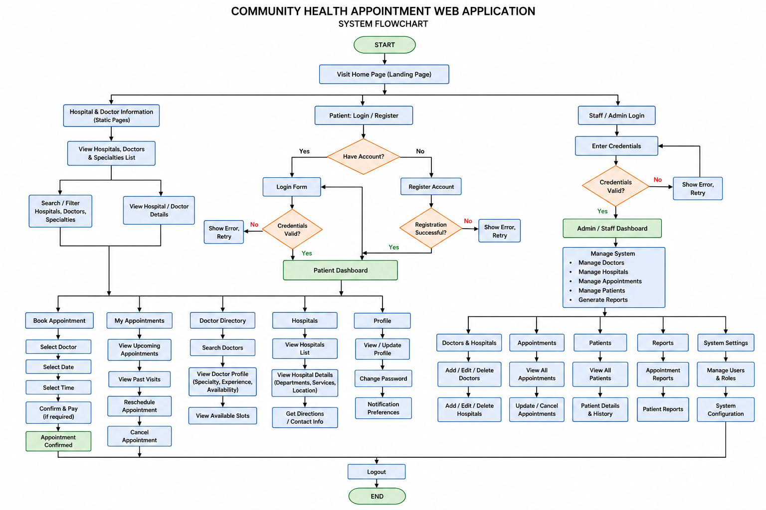
Figure 2.2 — Patient Appointment Booking Flowchart

Database Design with ERD and Relationships
Although the current implementation focuses on the front-end pages described in Chapter 3, the platform was designed with a relational data model in mind so that it can be extended with a working database in a later phase. Figure 2.3 shows the proposed Entity Relationship Diagram. A Patient books one or more Appointments; each Appointment is linked to exactly one Doctor and takes place at a specific date and time slot. Each Doctor is employed at one Hospital, and each Hospital may have several Admin/Staff accounts responsible for overseeing its schedules. This structure keeps the data normalized — patient details, doctor details, and appointment details are stored separately but linked through foreign keys — which will make it straightforward to add real booking logic once a database engine is connected to the front end.

ERD DIAGRAM WITH DESCRIPTION WITH TABLES,RELATIONSHIPS AND CARDINALITIES

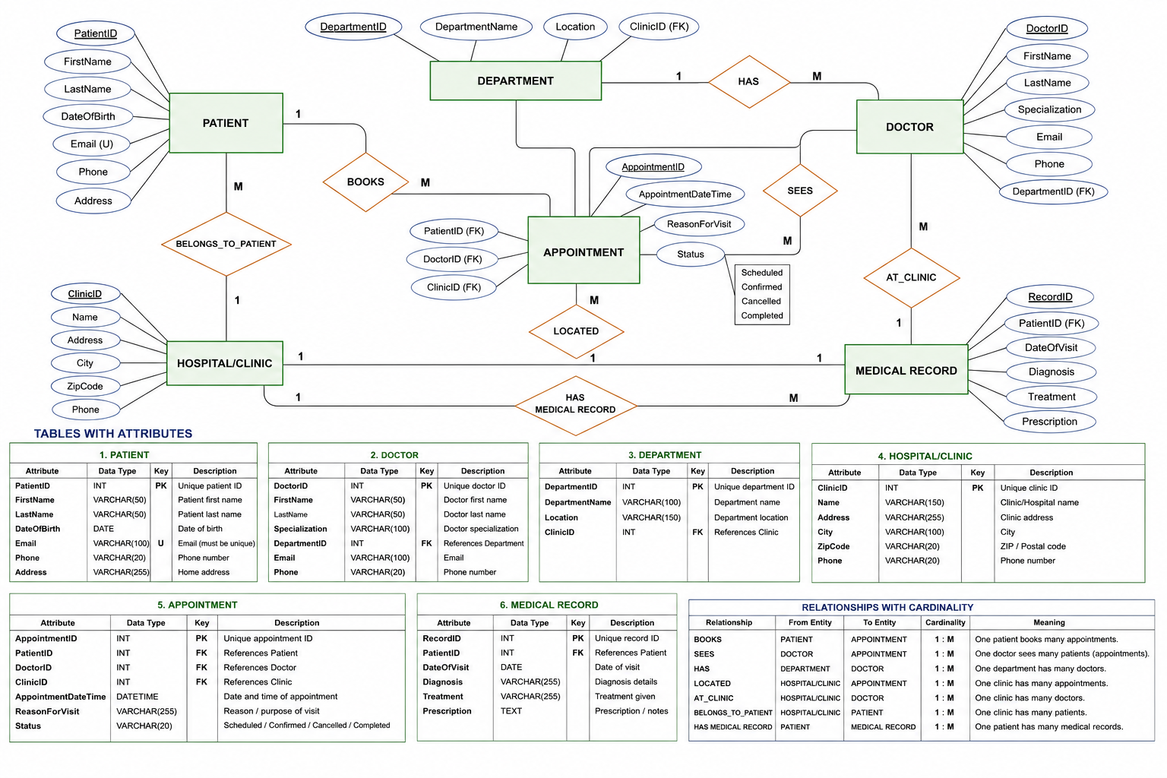
Figure 2.3 — Entity Relationship Diagram (ERD)

Chapter 3. Implementation

3.1. Introduction of the Section
This chapter presents the actual implementation of the Community Health Appointment Web Application. The front end was built using HTML5 for structure and CSS3 for styling, and the finished pages were deployed and hosted through GitHub Pages, where they can be reached at the following live link: https://fideleihora.github.io/hospitalappointmentfidele/HTML%20assignment/HTML/index.html.
Four pages form the core of the current implementation: a public Home page that introduces the platform, a Login page for returning patients, a Registration page for new patients, and a separate Staff/Admin Login page that keeps hospital-side access clearly distinct from patient access. Each page below is presented with a screenshot and a discussion of its purpose, layout, and role within the overall patient journey described in Chapter 2. The screenshot frames in this section are placeholders — because this report was compiled without direct browser access to capture live screenshots, each frame should be replaced with an actual screenshot of the corresponding page taken from the live link above before the report is submitted.

3.2. Screenshots, Captions and Discussion

3.2.1. Home / Landing Page
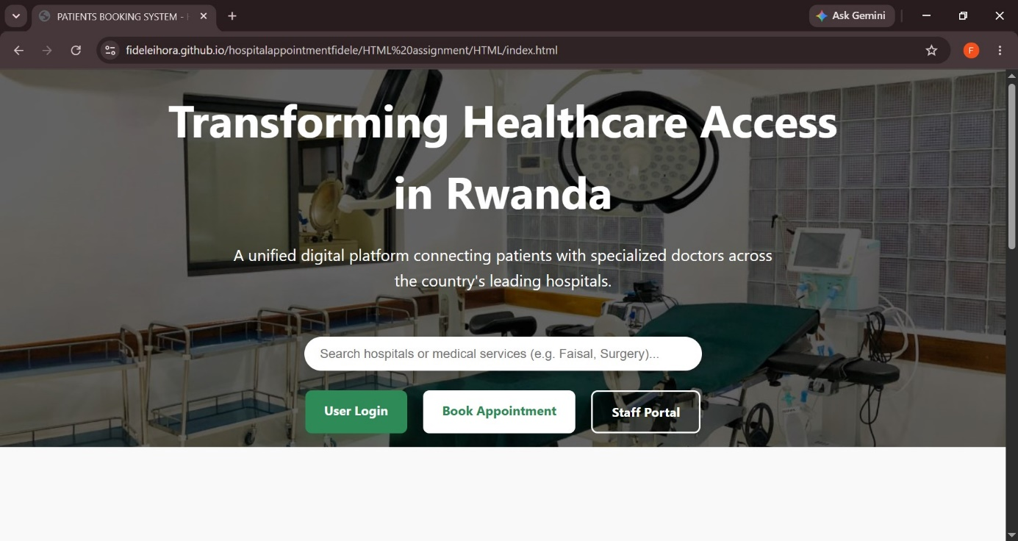
Figure 3.1 — Home / Landing Page
The Home page is the first point of contact for anyone visiting the platform, and it was designed to do three things quickly: explain what the system is for, build a small amount of trust, and point the visitor toward the right next step. The hero section carries the heading "Transforming Healthcare Access in Rwanda" together with a short line describing the platform as a unified digital gateway connecting patients with specialised doctors across the country's leading hospitals. Directly beneath it sit three calls to action — User Login, Book Appointment, and Staff Portal — so that a first-time visitor is never left wondering where to click next.
Below the hero area, a set of six feature cards summarizes the platform's value proposition in plain language: Instant Scheduling (booking a consultation in under two minutes), Live Doctor Tracking (real-time visibility of specialist availability), Seamless Referrals (moving between district and referral hospitals such as King Faisal and CHUK), Smart Reminders (automated SMS and email alerts), Centralized Records (a single place to keep appointment history and doctor notes), and Emergency Routing (integrated maps and contact details for the nearest emergency services). Presenting these as short, scanned cards rather than long paragraphs was a deliberate choice, since most visitors will skim a landing page rather than read it in full.
Further down, the page lists the hospitals the platform is designed to support — King Faisal Hospital (KFH), CHUK, Butaro Cancer Center, RMH Kanombe, and Legacy Clinics — which grounds the platform in real, recognizable institutions rather than presenting it as an abstract concept. The footer closes the page with a copyright line and the tagline "Improving lives through digital health innovation," reinforcing the platform's purpose one last time before the visitor moves on. Structurally, the page uses a clear vertical rhythm — hero, features, partners, footer — which keeps navigation predictable and reduces the cognitive load on a first-time user, something that matters when a meaningful share of the target audience may not be highly experienced with web applications.

3.2.2. User Login Page
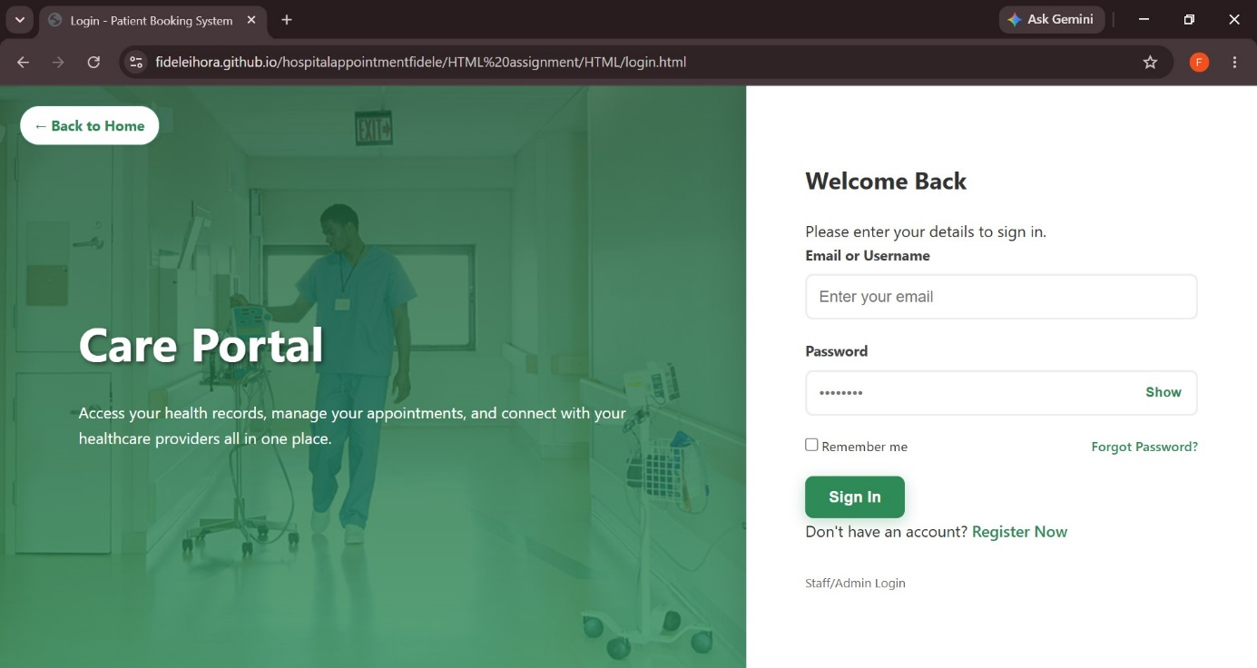
Figure 3.2 — User Login Page
The Login page, presented under the heading "Care Portal," is where a returning patient authenticates before reaching their appointments. It was kept deliberately narrow in scope: a short welcoming line ("Access your health records, manage your appointments, and connect with your healthcare providers all in one place"), followed by a compact form asking only for an email or username and a password. A "Show" toggle next to the password field lets the user confirm what they have typed before submitting, which reduces failed login attempts caused by simple typing mistakes — a small but meaningful usability detail for a health-related platform where frustration at the login stage can discourage use altogether.
A "Remember me" checkbox and a "Forgot Password?" link sit just below the form, covering the two most common friction points in any login flow: not wanting to re-enter credentials every visit, and needing a recovery path when a password is forgotten. Beneath the main Sign In button, the page offers a link to "Register Now" for anyone who reaches the login page without yet having an account, and a separate "Staff/Admin Login" link that clearly signals to hospital employees that they should use a different entry point rather than attempting to sign in through the patient form. This separation of patient and staff authentication is a direct reflection of the two distinct user groups identified in Chapter 2, and it also has a security benefit: keeping staff credentials on an entirely separate page reduces the chance of role confusion or accidental exposure of administrative login fields to the general public.
From a visual design standpoint, the Login page reuses the same "Care Portal" branding and colour language as the Home page, so that a patient moving from one page to the other does not feel as though they have left the platform. This kind of visual consistency across HTML pages is one of the fundamentals emphasised in the Web Design module, and it is applied here specifically because trust matters more on a health platform than on a typical e-commerce or entertainment site.

3.2.3. User Registration Page
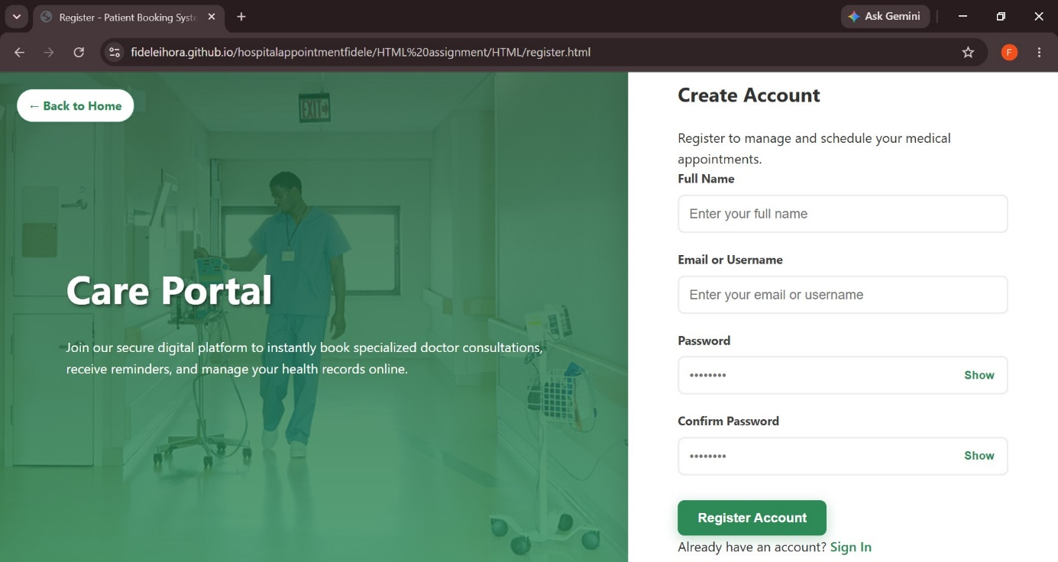
Figure 3.3 — User Registration Page
The Registration page extends the same "Care Portal" identity to new patients who do not yet have an account. Its introductory text sets clear expectations: joining the platform will let the patient instantly book specialised doctor consultations, receive reminders, and manage health records online. The form itself asks for a Full Name, an Email or Username, a Password with a visibility toggle, and a Confirm Password field, also with its own toggle. Asking for password confirmation twice, each independently revealable, is a deliberate safeguard against the single most common registration failure: a typo in the password field that the user only discovers when they try to log in for the first time and cannot.
Keeping the form to four fields was also a conscious design decision. Community health platforms often serve users who may be accessing a booking system online for the first time, and a long registration form is one of the most reliable ways to lose such users before they ever reach the feature that matters to them — booking an appointment. A single, prominent "Register Account" button submits the form, and a "Sign In" link below it lets anyone who already has an account, and has landed here by mistake, return to the Login page in one click rather than being stuck.
Together, the Login and Registration pages form a matched pair: they share layout, typography, and colour treatment, but each asks only for what is strictly necessary for its purpose. This pairing reflects a broader principle applied throughout the implementation — that every additional field or decision placed in front of a patient is a small barrier to care, and the interface should remove as many of those barriers as the platform's security and data needs allow.

3.2.4. Staff/Admin Login Page
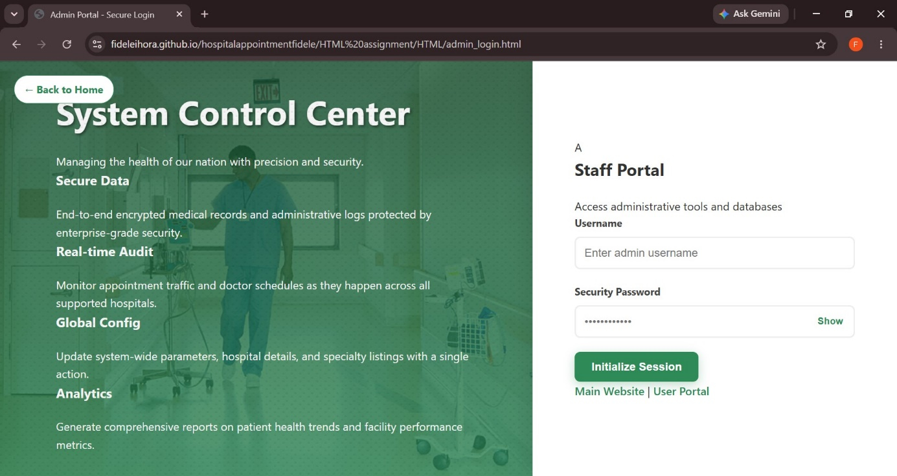
Figure 3.4 — Staff/Admin Login Page
The Staff/Admin Login page, branded as the "System Control Center," is intentionally styled to feel more technical and more restricted than the patient-facing pages, reinforcing that it is meant for a different audience. Its introductory line — "Managing the health of our nation with precision and security" — sits above four short descriptors of what the administrative side of the platform is meant to support: Secure Data (encrypted records and administrative logs), Real-time Audit (live monitoring of appointment traffic and doctor schedules), Global Config (system-wide parameter and hospital-detail management), and Analytics (reports on patient health trends and facility performance).
The login form itself asks for a Username and a Security Password, again with a visibility toggle, and submits through an "Initialize Session" button rather than the more casual "Sign In" wording used on the patient side. That small wording change is intentional: it signals a more formal, security-conscious tone appropriate for staff who will be handling sensitive hospital data rather than only their own personal appointments. Two links at the bottom of the page — "Main Website" and "User Portal" — give staff a way back to the public site or across to the patient login without needing to use the browser's back button, which keeps navigation between the three portals (public, patient, staff) consistent throughout the application.
Placing this page on its own separate URL, entirely apart from the patient Login page, also matters for the system's overall security posture. It means the administrative entry point is never advertised to ordinary patients browsing the Home page unless they deliberately look for the "Staff Portal" link, and it keeps the visual language distinct enough that a hospital employee can immediately tell, from the page's appearance alone, that they are on the correct portal for their role.
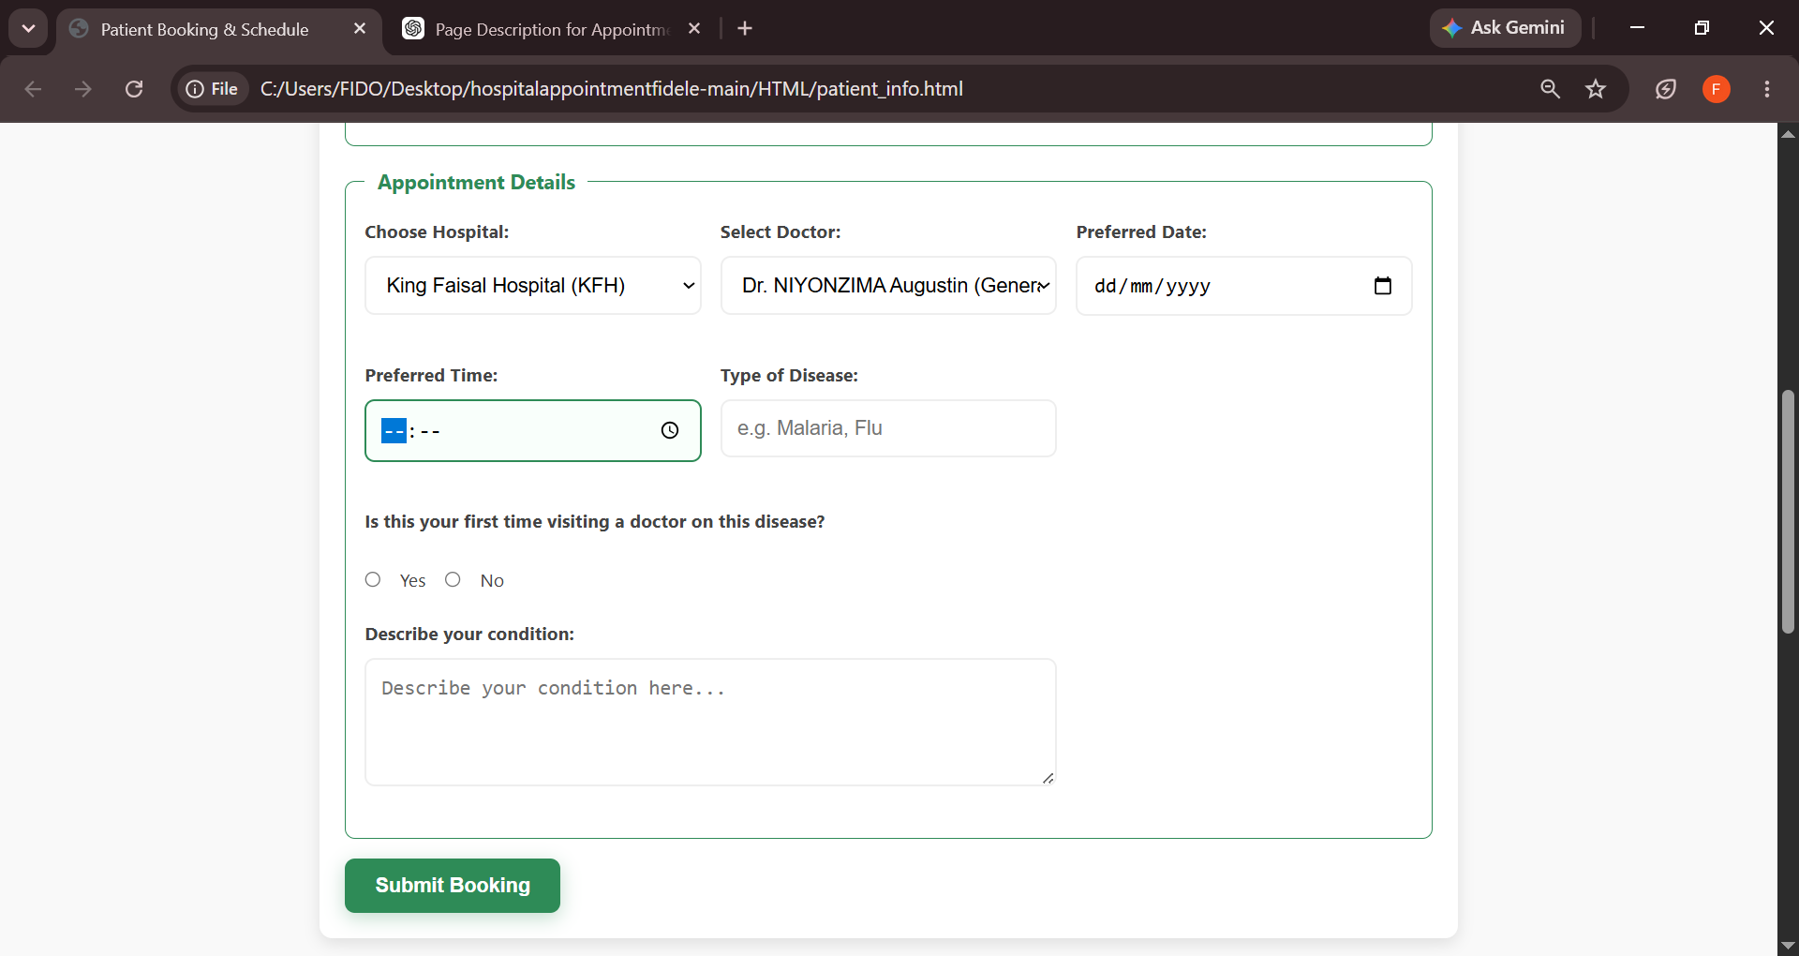
Fig 3.5:Patient information and doctor schedule page
The Patient Information & Doctor Schedule page is designed to collect the essential details required for booking a medical appointment. Patients begin by entering their personal information, including their full name, date of birth, email address, phone number, identification number, country, province, district, sector, and village. This information helps the hospital accurately identify patients and maintain complete medical records.
After completing the form, patients can review the available doctor schedules and appointment times to choose a convenient date and time for their visit. The page ensures that all necessary information is captured before an appointment is confirmed, reducing errors and improving the efficiency of the booking process. By combining patient registration with doctor availability on a single page, the system provides a simple, organized, and user-friendly experience for scheduling healthcare appointments.

Chapter 4. Conclusion and Recommendation
At this stage, the project has successfully delivered the front-end foundation described in the objectives of Chapter 1: a public Home page, a patient Login page, a patient Registration page, and a distinct Staff/Admin Login page, all built with HTML5 and CSS3 and deployed live through GitHub Pages. In terms of the objectives set out at the start of this report, roughly 60–70% of the overall vision has been realised — the interface layer, information architecture, and navigation flow between patient and staff portals are complete and functioning, while the deeper application logic (real authentication, a connected database, live doctor scheduling, and automated SMS/email reminders) remains to be implemented in a future phase. The system, as it stands, should be understood as a fully designed and navigable front-end prototype rather than a production-ready booking platform.

Recommendations
To the Lecturer, on technicalities:
- Consider allowing a follow-up phase of the assignment in which students connect their HTML/CSS front end to a simple back end (for example, a lightweight database and server-side scripting), since the current scope naturally sets up that next step.
To the School, on time constraints:
- A slightly longer assessment window would allow students to move beyond static front-end pages and demonstrate working authentication and booking logic, which is where much of the real learning value of a system like this lies.
To the Partners (the hospitals and health administrators this platform targets):
- Any real-world adoption of a system like this should be preceded by a review of data protection requirements for patient information, and by close consultation with hospital IT teams on how the platform would integrate with existing hospital records systems.
To the Users (patients and doctors):
- Basic digital literacy training would help ensure that all patients, including those less familiar with web applications, can comfortably use the registration and booking flow once it becomes fully functional.
To the Beneficiaries (the wider community served by these hospitals):
- As the system matures, community outreach explaining how to access and use the platform will be just as important as the technology itself, since the benefits described in Chapter 1 can only be realized if patients actually know the service exists and trust it enough to use it.

Appendix

Link to the GitHub Repository of the Deployed Project
Live deployed application: https://fideleihora.github.io/hospitalappointmentfidele/HTML%20assignment/HTML/index.html
sourecode link: https://github.com/fideleihora/hospitalappointmentfidele
GitHub account (username): fideleihora
Repository access / password: Repository is public

