Report on transaction analysis
Project title: customer transaction analysis and operational risk insight
Objective:
The objective of this project is to analyse transaction data to understand customer behaviour, transaction patterns, system performance, and potential risks areas such as fraud and transaction failures.
DATASET OVERVIEW:
The dataset used was gotten from Kaggle which I found out during my analysis that it was a synthetic dataset, there were a total of 1000 records in the dataset all unique, columns in the dataset are as follows
Transaction_id
Sender_id
Receiver_id
Transaction_amount
Transaction_type
Date
Time
Transaction_status
Fraud_flag
Latitude
Longitude
Device_used
Network_slice_id
Latency(ms)
Slice_bandwith(mbps)
DATA CLEANING
- I started first by standardizing the date column
- I also removed pin code column because it wasn’t necessary for the analysis I did
- I also looked at the data types and fixed the column with the wrong data type
- I checked the dataset to verify if there was a missing value which I did and found out that there was no missing value

METHODOLOGY (TOOLS AND APPROACH)
I made use of MYSQL for the querying and aggregation and power bi was used for visualization and dashboard creation. Analysis focused on. transaction trend, customer activity, fraud patterns, and system performance metrics.

KEY FINDINGS
- I found out that the total amount of money moved during all transactions were recorded to be $771165.29 but 49% of the transaction were flagged while 51% were not flagged, meaning that nearly half of the transactions were all flagged and it is extremely high exposure cos in real banking fraud flagged value is usually small often less than 5%, this suggest that it can be because the fraud detection system mechanism may be too aggressive.
- I also found out that 48.1% of the transactions were all fraud flagged which were 481 transactions out of 1000 of them and from the 481, 55.5% of them were from mobile device and 44.4% were from desktop device, this means that the cause of the fraud flag isn’t determined from the type of device used since they were all distributed
- I also found out that there were 167 fraud flag count from Deposit and 170 fraud flag count from Transfer and 144 fraud flag count from Withdrawal which means that fraud flag does not depend on the transaction type since the fraud flag count are distributed in the three-transaction type and also shows that risk is not Isolated toa particular type of transaction
- I also found out about the suspicious locations with highest fraud flag count which are
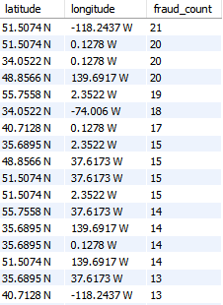



- I also discovered that the failed transactions exceeded successful transactions which indicated that there might be issues with the system which needs a serious consideration
- I also discovered that network latency has a little impact on the amount of transactions processed
that is slice2 has the lowest latency and performs the highest transactions though they handle nearly balanced transactions
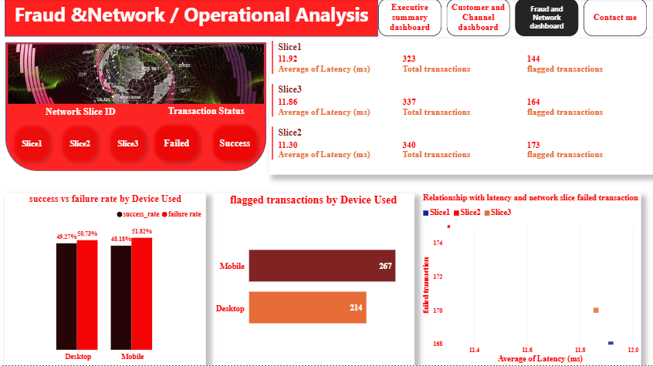

BUSINESS IMPACT
- the high volume of failed transactions may lead to poor customer experience and potential revenue loss.
- Distributed fraud risk increases the need for system-wide monitoring
- Misidentifying latency as root cause could lead to inefficient allocation of resources

RECOMMENDATIONS
- The rules set for fraud flag detection system should be checked to ensure that they are not too extreme thereby flagging transactions that are legal
- The locations with high fraud flag count should thoroughly investigated in other to reduce the risk of potential money loss
- Systems should be monitored in other to detect the reason for the high failed transactions to enable customers perform their transactions without issues
LIMITATIONS
The limitation for the project was the use of synthetic dataset, during my analysis I found that the values gotten were too extreme compared to a real dataset4
Therefore, findings should be interpreted as indicative rather than definitive

CONCLUSIONS
The analysis highlights key transaction patterns, risk exposure, and system performance issues, while latency was initially considered a potential cause of transaction failures, analysis shows other operational factors play a more significant role. The findings provide a foundation for improving system efficiency and risk management.

