**CS5800 – Advanced Software Engineering**

**Cal Poly Pomona**

**Homework 3**

**Spring 2024**

**Description:**

UML

Name: Fidelis Prasetyo

Email: ([fprasetyo@cpp.edu](mailto:fprasetyo@cpp.edu))

BroncoID: 015765555

Github & Source code:

<https://github.com/fidelisprasetyo/CS5800/tree/hw3/hw3>

# Class Diagrams

* Inheritance

* Polymorphism

* Aggregation

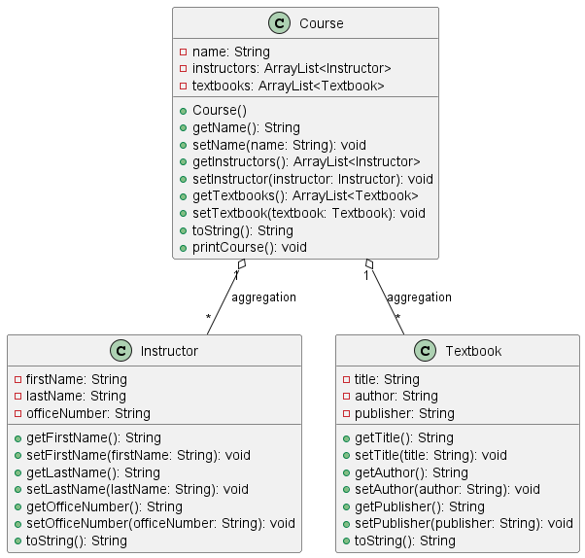

* Composition

# Object Diagrams

* Polymorphism

* Aggregation

* Composition

# Source Code & Supporting Files

The entire source code and other supporting documents/ files can be obtained from this GitHub repository:

<https://github.com/fidelisprasetyo/CS5800/tree/hw3/hw3>