This software is created using Java technology. In java we can create GUI application using:

1. AWT
2. Swing
3. JavaFX

There is No data base all Data Stored in Java Objects derived from Collection framework classes.

I am using Java Swing API for creating this system. In this System There are four kind of Users:

1. Student
2. Profession
3. Lecturer
4. Researcher

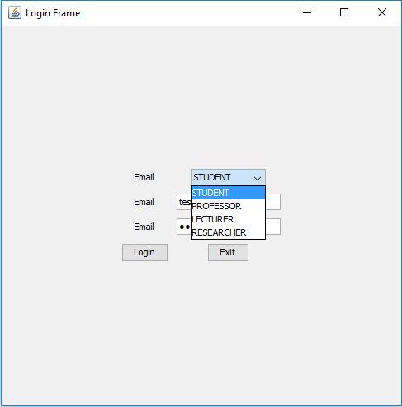

A Student have to login first for entering in System.



After successful login, He can able to:

1. Show All Instructors

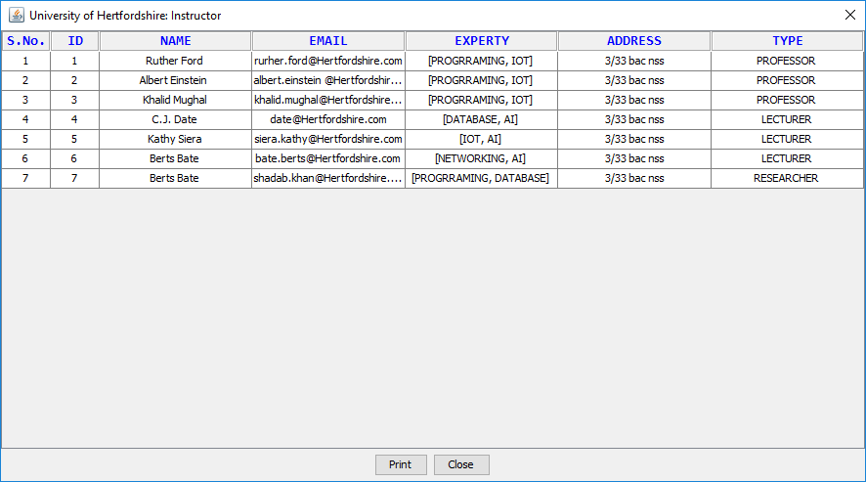

1. Show All Courses



1. Show All courses taken by him.

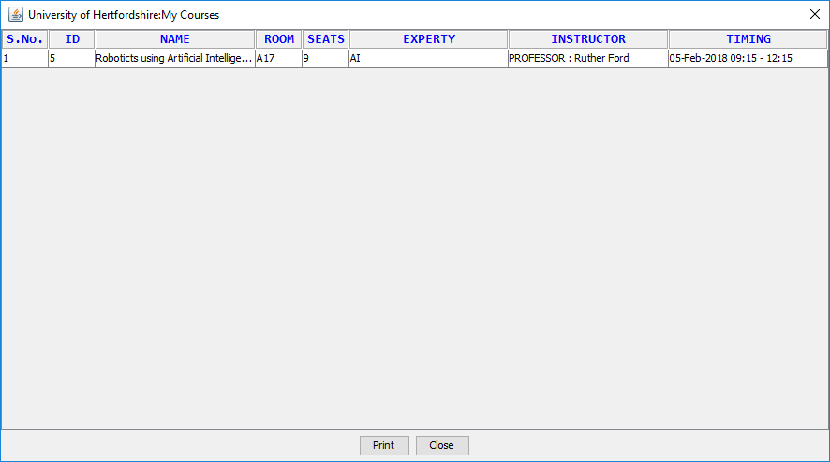

Student can Find Instructor details by different ways i.e. ID, NAME, EXPERTY. By this he/she can get information about particular Instructor

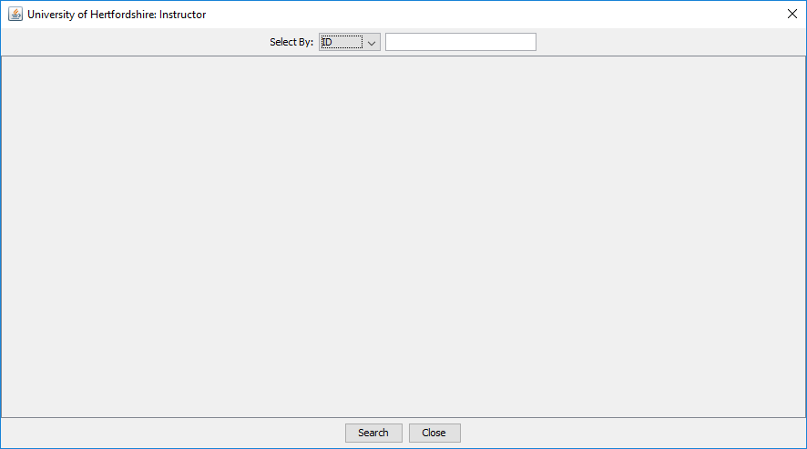

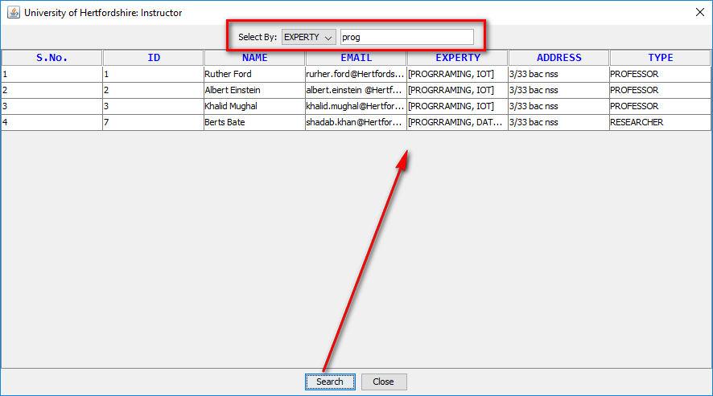

Student also can find all courses.

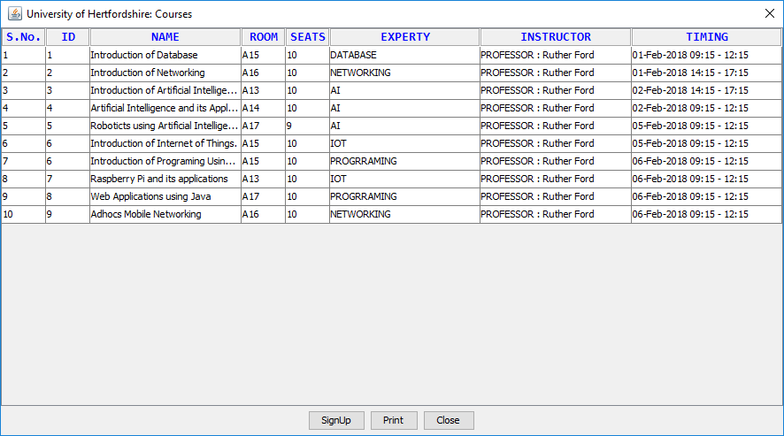

Student sign up courses.

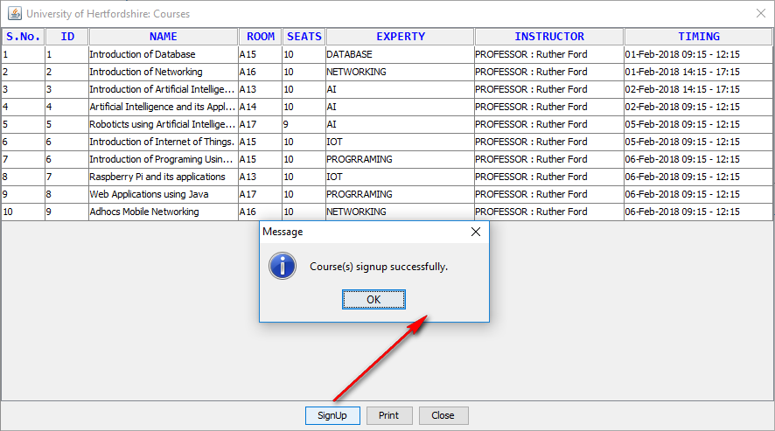

Student can also Print all Reports into pdf or paper if printer is attached.

